Introduction
In accordance with the environmental policy of BP (the operator of AIOC, the Azerbaijan International Operating Company), a benthic survey was carried out in the vicinity of the East Azeri Platform (Figure 1.1) in July and August 2010. Figure 1.2 gives the position of the East Azeri platform in relation to other operation platforms within the ACG contract area.
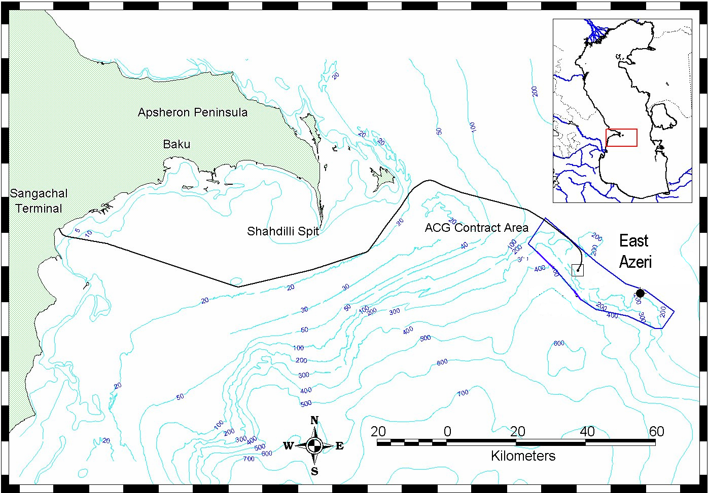
Figure 1.1 Location of Survey Area, East Azeri Survey 2010

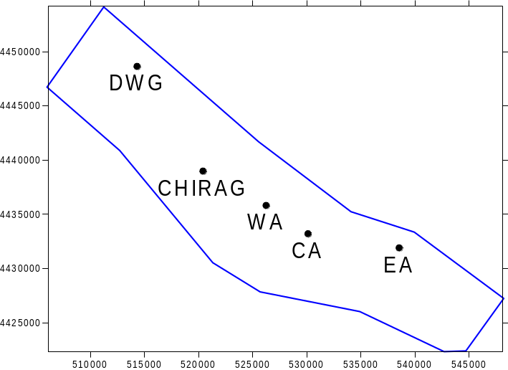

- DWG- Deep Water Gunashli

- CHIRAG- Chirag

- WA- West Azeri

- CA- Central Azeri

- EA- East Azeri
Figure 1.2 ACG Platform Positions

Existing information
Environmental surveys have been conducted in the vicinity of the East Azeri Platform location in 2002, 2006 & 2008.

Scope of work
The objective of the survey is to provide information on the current sediment chemistry, macrobenthic fauna and physical characteristics in the vicinity of the East Azeri platform location, and to compare the data collected with previous data sets from similar surveys completed since 1995, particularly the 2002, 2006 and 2008 East Azeri surveys.
If changes to the sediment chemistry, macrobenthic fauna and physical characteristics in the vicinity of the platform location are identified, assess if they can be attributed to natural or anthropogenic stresses.
If observed changes are considered to be associated with anthropogenic stresses, information on drilling, operational discharges and seabed remedial work provided by BP will be used to assess the potential role of BP’s construction and production activities in this change.

Survey design

The survey consisted of a triangular grid design based on the 2008 survey. The location of actual sample stations is detailed in figure 2.1. The survey, sampling and analytical programme are described in the following section of this report.

Discharge & Spill Data
Drilling discharge data is given in table 1.1. A total of 629.9 metric tons of drill cuttings and 454.5m³ of water based drilling fluids (WBM) were discharged between the 2006 and 2008 surveys.
Table 1.1 Drilling Discharged Data EA 2006-2008

Date | Drill cuttings discharged (MT/day) | Drilling fluids discharged (m3/day) | Chloride concentration on discharge in ppm
4-Jan-07 | 10.0 | 0.0 | -
6-Jan-07 | 9.3 | 0.0 | -
7-Jan-07 | 12.3 | 0.0 | -
8-Jan-07 | 5.9 | 0.0 | -
9-Jan-07 | 4.3 | 0.0 | -
3-Feb-07 | 14.2 | 0.0 | -
4-Feb-07 | 17.9 | 0.0 | -
20-Mar-07 | 1.5 | 9.5 | 18500
22-Mar-07 | 0.0 | 1.6 | 16700
23-Mar-07 | 10.0 | 5.7 | 17100
24-Mar-07 | 44.5 | 8.3 | 17500
25-Mar-07 | 6.4 | 7.2 | 16900
26-Mar-07 | 0.0 | 2.4 | 17000
Table 1.1 (Continued) Drilling Discharged Data EA 2006-2008

Date | Drill cuttings discharged (MT/day) | Drilling fluids discharged (m3/day) | Chloride concentration on discharge in ppm
27-Mar-07 | 0.0 | 4.5 | 17800
29-Mar-07 | 0.0 | 4.5 | 18100
30-Mar-07 | 0.0 | 1.3 | 16700
16-Apr-07 | 14.0 | 0.0 | -
17-Apr-07 | 14.0 | 0.0 | -
16-May-07 | 14.0 | 0.0 | -
17-May-07 | 14.0 | 0.0 | -
18-Jul-07 | 5.8 | 8.0 | 17500
17-Jul-07 | 50.1 | 27.8 | 17800
18-Jul-07 | 88.7 | 52.2 | 18000
12-Oct-07 | 4.0 | 1.6 | 21000
13-Oct-07 | 137.4 | 47.7 | 18600
14-Oct-07 | 5.8 | 11.1 | 19000
15-Oct-07 | 0.0 | 12.7 | 17300
16-Oct-07 | 0.0 | 66.5 | 18100
1-Mar-08 | 4.9 | 8.0 | 14200
3-Mar-08 | 140.6 | 73.6 | 16700
5-Mar-08 | 0.0 | 3.0 | 14600
6-Mar-08 | 0.0 | 97.6 | 15100
 | 629.6 | 454.5 | 364,200

Since the last record in table 1.1, BP reports the following additional discharges:
- 2008: 2 wells drilled, 368 tonnes of drilling fluids and chemicals
- 2009: 3 wells drilled, 372 tonnes of cuttings and associated fluids
- 2010: no wells drilled, 286 tonnes of drilling chemicals

Discharges occurring between the 2008 survey and the 2010 survey are therefore of the same magnitude as those occurring between the 2006 and 2008 surveys.

