Ongoing project preparations and other possibilities for cooperation
(Note by the interim Secretariat)

Introduction
At the 5th meeting of the Conference of the Parties (COP5) to the (Tehran) Framework Convention for the Protection of the Marine Environment of the Caspian Sea (TC), 28 - 30 May 2014, in Ashgabat, Turkmenistan, the Parties welcomed the participation of relevant international organizations and the private sector, including the oil and gas industry and the maritime transport companies, and encouraged them to support the implementation of the Tehran Convention and its Protocols as well as called upon all donors to consider, continue, renew or increase bilaterally or multilaterally their support to the implementation of the provisions of the Tehran Convention and its Protocols.
Since then, in light of the above the interim Secretariat has undertaken various efforts to secure support to the implementation of the provisions of the Tehran Convention and its Protocols. The document provides the information about the potential cooperation with 1) Official Development Assistance of the Russian Federation; 2) Adaptation Fund and 3) Commission for the Conservation and Rational Use of Aquatic Biological Resources and Management of Shared Stocks of such Resources.
Suggested action
The Conference may wish to:
- Welcome the development and approval of the project “Addressing marine litter and marine plastic – a systemic approach in the Caspian Sea” supported by the Official Development Assistance of the Russian Federation
- Welcome the development of the full-fledged project “Urbanisation and Climate Change Adaptation in the Caspian Sea Region” by UN-Habitat, UNEP and IOM and call upon the Adaption Fund to collaborate and support the implementation of the Tehran Convention and its Protocols through the project
- Requested the Secretariat to seek collaboration with the Commission on Aquatic Bioresources of the Caspian Sea and to this end sign a Memorandum of Understanding regulating the cooperation between the Tehran Convention and the Commission;

Addressing marine litter and marine plastic – a systemic approach in the Caspian Sea
Partner: Official Development Assistance of the Russian Federation - via UNDP Trust Fund
The project goal is to prevent and to the maximum extent possible minimize marine litter in the Caspian Sea with special focus on marine plastics. This will be achieved through amending the national policy and regulatory frameworks on waste management, comprehensive promotion of a circular economy/life-cycle approach, carrying out investments in waste management as well as promoting sustainable consumption and productions patterns, by supporting behavioral changes of consumers. The main outputs of the project are 1) comprehensive information and data on marine litter in the Caspian Sea; 2) improved policy and regulatory frameworks for waste management; 3) enhanced circular economy in littoral countries to improve plastic management; and 4) preliminary investments in waste management. The project will also consolidate efforts of the Caspian littoral countries which are already in place towards better waste management. It will furthermore built on previous work of the Caspian littoral countries under the Tehran Convention, in particular the Protocol on Land-based Sources of Pollution and the outcomes of the Strategic Convention Action Programme.
By the letter of 10 March 2021adressed to Permanent Mission of the Russian Federation to International Organizations in Nairobi signed by of Mr. Bruno Pozzi, Director, Europe Office, UNEP and Ms. Agi Veres, Deputy Assistant Administrator, Deputy Regional Director Regional Bureau for Europe and CIS of UNDP the project concept note together with the letters of endorsements from the recipient countries was submitted for possible funding from the Russian Federation Official Development Assistance Programme. The copy of the letter together with the project proposal are contained in Annex I.
On 25 December 2021, a Resolution signed by the Prime Minister of the Russian Federation Mikhail Mishustin approved a federal budget funding of US$ 4,039,200 for the implementation of the joint UNDP-UNEP/Tehran Convention project “Addressing Marine Litter and Marine Plastic – a Systemic Approach in the Caspian Sea”. A copy of the Resolution is contained in Annex II.
At present the UNDP and UNEP are conducting consultations with regard to the implementation of the project.
Urbanisation and Climate Change Adaptation in the Caspian Sea Region
Partner: Adaptation Fund.
The proposed programme’s main objective is to enhance climate change adaptation and resilience of local communities in the Republic of Azerbaijan and the Islamic Republic of Iran while building capacity and knowledge throughout the Caspian Sea region. The project is structured around the following four components: (1) Climate change adaptation planning at the Caspian Sea regional level (2) Climate change adaptation planning at national level in the Republic of Azerbaijan and the Islamic Republic of Iran (3) Implementation of transformative and catalytic projects at national, city and community level addressing urban resilience and climate change adaptation in the Republic of Azerbaijan and the Islamic Republic of Iran (4) Urban resilience, climate change adaptation – partnerships, institutional, legal, research cooperation and knowledge at the Caspian Sea regional level.
The scope of the project is 14 million US dollars, preparation of which is within the UN-Habitat (lead agency). UNEP, through the Tehran Convention interim Secretariat, will be an executing partner responsible for the regional components of the project (component 3 and 4) where the involvement of all five Caspian littoral countries is envisaged. In this context, series of regional stakeholder consultations were held from 2020. The overview of the consultations is contained in Annex III.
On 8 August 2022, the full-fledged project proposal was submitted to Adaption Fund Board for their consideration. Due to an irregularity on the national designated authority (NDA) in the Islamic Republic of Iran the project was not reviewed. The project will be submitted at the next Board meeting of the Adaptation Fund which will be held in January 2023. The copy of the full-fledged project proposal is contained in Annex IV.
Commission for the Conservation and Rational Use of Aquatic Biological Resources and Management of Shared Stocks of such Resources
Article 14.1 of the Framework Convention for the Protection of the Marine Environment of the Caspian Sea (Tehran Convention) stipulates the necessity to protect, preserve, restore, and rationally use marine living resources in the Caspian Sea, and calls upon the Contracting Parties to take appropriate measures along six broadly defined objective areas. Each of these objective areas provides interrelationship between the management of the Caspian Sea fisheries and the protection of the marine environment of the Caspian Sea, as well as the potential for a relationship between the Tehran Convention and the Commission for the Conservation and Rational Use of Aquatic Biological Resources and Management of Shared Stocks of such Resources (in short, Commission on Aquatic Bioresources).
At the 7th meeting of the Preparatory Committee to the 6th Meeting of the Conference of the Parties to the Tehran Convention, held in Baku, Azerbaijan on 16-20 September 2019, the Parties requested the interim Secretariat of the Tehran Convention to seek collaboration with the Commission and conclude a Memorandum of Understanding to that effect. Following this request, the interim Secretariat held consultations with the representatives of Kazakhstan, current Chair of the Commission on Aquatic Bioresources and proposed a draft Memorandum of Understanding. The copy of a draft Memorandum of Understanding is contained in Annex V.
By the letter of 23 February 2022 addressed to the Contracting Parties the interim Secretariat of the Tehran Convention requested assistance of the Tehran Convention Focal Points in transmitting this information to the respective bodies in each Caspian Governments participating in the Commission’s meetings and ensuring their active participation in establishing collaboration between the two regional institutions. In reply to this letter Kazakhstan, a current Chair of the Commission informed that the 6th meeting of the Commission is planned in December 2022 and the issue of cooperation between the Commission and the Secretariat will be discussed. A copy of the letter from Kazakhstan is contained in Annex VI.

Annex I
Russian Federation - Official Development Assistance Program
PROJECT CONCEPT NOTE
ADDRESSING MARINE LITTER AND MARINE PLASTIC – A SYSTEMIC APPROACH IN THE CASPIAN SEA

Project Title: Addressing Marine Litter and Marine Plastics – A Systemic Approach in the Caspian Sea
UNDAF Outcome(s):
- Azerbaijan, Priority III. Environment, climate change, and disaster risk management;
- Kazakhstan, Priority I. Reducing disparities and improving human development and Priority III. Enhanced International and regional co-operation;
- IR Iran Priority I. Environment;
- Turkmenistan Priority III Environmental Sustainability and Energy Efficiency
Expected CP Outcome(s):
- Azerbaijan, Outcome 3.1 “By 2020, sustainable development policies and legislation are in place, better implemented and coordinated in compliance with multilateral environmental agreements, recognize social and health linkages, and address issues of environment and natural resource management, energy efficiency and renewable energy, climate change and resilience to hazards and disasters”
- Kazakhstan, Outcome 1.3 “Ecosystems and natural resources protected and sustainably used, and human settlements resilient to natural and manmade disasters and climate change”;
Outcome 3.1 “The Government, together with partners, promotes the achievement of Sustainable Development Goals (SDGs) in the region, and leads in promoting and implementing United Nations principles, standards and Conventions”
- IR Iran Outcome 1.1 “Integrated natural resource management, Responsible GOI agencies formulate, implement and monitor integrated natural resource management policies and programmes more effectively”.
- Turkmenistan Outcome 5.1 “The national policy legislative and institutional frameworks are aligned to reduce greenhouse gas emission and to promote sustainable practises on energy efficiency, the use of renewables, urban waste and waste management”
Expected Output(s):
- Azerbaijan, Output 3.2: “Number of mechanisms adopted to strengthen application of EIA and SEA procedures according to the Convention on Environmental Impact Assessment in a Transboundary Context (Espoo Convention) and its Protocol on Strategic Environmental Assessment (SEA))”
- Kazakhstan, Output 1.2: “Percentage of settlements and cities that have implemented resilience-building measures as per international recommendations (Sustainable Development Goals, and Sendai Framework for Disaster Risk Reduction)”;
Output 3.2Regional co-operation initiatives in place, promoting East-East/South-South partnerships for implementing Sustainable Development Goals
- IR Iran, Output 1.6 “Number and scope of site specific examples of sustainable development that are identified and promoted with UN agency support”
- Turkmenistan, Output 5.2 “Number of state laws, regulation and procedures developed or amended that incorporate energy efficiency standard and practices, the use of renewables and sustainable waste management”
Implementing Partner: UNDP (Istanbul Regional Hub for Europe and the CIS)
Responsible Party: UN Environment administered Secretariat of the Tehran Convention
Other Partners: Ministry of Ecology and Natural Resources of Azerbaijan (MENRA), Department of Environment of Iran (DoE), Ministry of Ecology, Geology and Natural Resources of Kazakhstan (ME), Ministry of Natural Resources and Environment of Russian Federation (Minprirody), Ministry of Transport of the Russian Federation, Ministry of Agriculture and Environmental Protection of Turkmenistan (MAE)

Executive Summary (as a Box with 2-3 paras)

Marine litter, including plastic and microplastics, represent one of the main pressures to marine and coastal environment. Significant efforts are ongoing at national, regional and global levels aiming at preventing and reducing their generation. Despite these articulated efforts the problem of marine litter is persisting and strengthened actions are required to be taken at all levels and across sectors.
The project aims to improve the management of the land-based sources of pollution that are likely to affect the marine environment of the Caspian Sea. This will be achieved through amending the policy and regulatory frameworks on waste management, comprehensive promotion of a circular economy/life-cycle approach, carrying out investments in waste managements as well as strengthening sustainable consumption and productions patterns, in particular changing behavioral consumers’ change. Since the marine litter is a transboundary issue both a national and regional efforts should be undertaken. Thus, the project will have both regional and national activities.

Project Location: Caspian littoral countries
Project Duration: 2021-2024
Funding Requested: US 4 039 200
Potential Co-financing (indicative): US$ 3 600 000 out of which, UNDP US$600,000; UNEP TC US$600,000; MENRA - US$600,000; DoE - US$600,000; ME - US$600,000; MAE- US$600,000

B. BACKGROUND (Situation Analysis)
The Caspian Sea is the largest water body on the Planet which is not connected with the World Ocean and located on the southern border of Asia and Europe. Due to its size, natural conditions peculiarities and complexity of hydrological processes it belongs to the class of closed inland seas. It occupies a vast depression area in the Earth's crust. The Caspian Sea level is currently 27 m below the MSL. In these conditions, the entire territory of the Caspian Sea covers more than 390 thousand km², volume of water is about 78 thousand km³, average depth is 208 m, and the greatest depth of the Sea reaches 1025 m. From North to South the Caspian Sea stretches for 1030 km, with a width of 200 to 400 km.
The five littoral states – Republic of Azerbaijan, Islamic Republic of Iran; Republic of Kazakhstan, Russian Federation, Turkmenistan - have highly uneven population densities surrounding the Caspian with some regions with high population levels such as big urban centres like Baku and others sparsely populated. The general population distribution along the Caspian costs concentrates around the major urban centers like Absheron Peninsula (Baku), Astrakhan, Makhachkala, and many towns along the south cost of the Caspian See, with very small populations in the rural areas along the northern and eastern costs (see Fig. 3.1 Number of population in the Caspian Sea region per cities and administrative units). Marine litter is a new and emerging concern to all Caspian littoral states. Despite its importance, the data on the amount, levels or impacts of ML in the region are very sparse.
The pollution of the world’s seas and oceans with marine litter today is considered one of the major global environmental concerns. Addressing marine pollution of all kinds is a key target of goal 14 of the UN Sustainable Development Goals (SDGs). At the UN Ocean Conference in June 2017, specifically convened to address SDG 14, member states agreed to urgently take action “to prevent and significantly reduce marine pollution, including marine debris, plastics and microplastics, […] solid waste discharges, and […] pollution from ships” and called for the implementation of long-term and robust strategies to that effect.
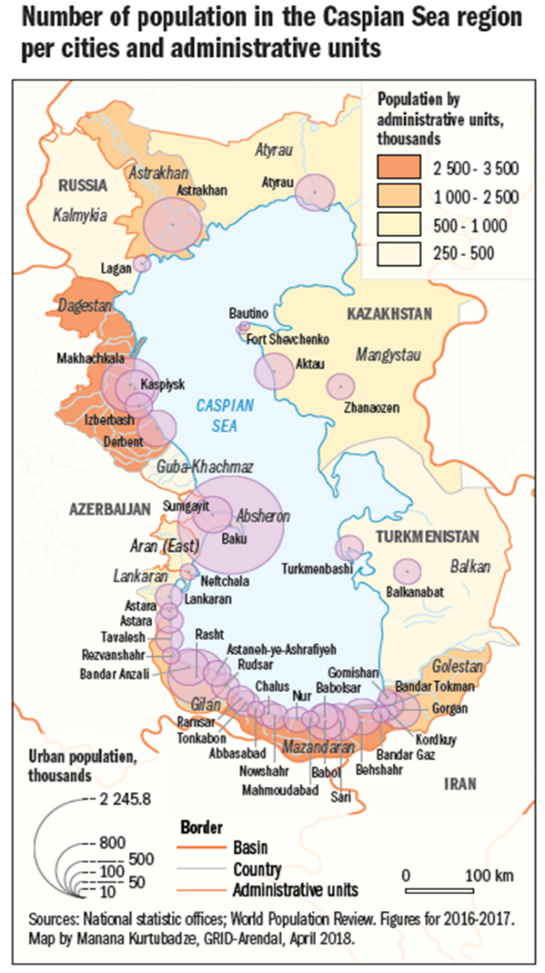
While addressing marine litter a special attention must be given to plastic waste. For the past 60 years plastic has brought economic, environmental and social advantages. However, the increase in use and the promotion of products as “disposable” have caused an exponential increase in the amount of plastic waste generated, which brings with it economic, environmental and social issues. Marine plastic litter is generated by both land-based and sea-based activities and requires holistic approach.
Marine litter, micro and macro-litter of all human made waste that is discharged into coastal or marine environments, is a largely ignored and an increasingly problematic issue for the Caspian region. The problem is growing in certain parts of the sea, and no regional action has been taken to address the problem. Marine litter can take a variety of forms, such as textile, rubber, metals and plastics. Sources of marine litter in the Caspian Sea originates such as from urban waste management, coastal tourism, improperly disposed hazardous waste, fishing, and shipping as well as many others. It is reported that plastic items, including PET bottles, glass, paper and cardboard, tins and cans, textiles and wood are the most common items composing marine litter in the Caspian region. No reliable quantitative information is available on marine litter at the regional level although the reports do indicate high accumulation in a number of Hot Spots. National Reports further indicate that with the economic recovery in the region the marine litter is on the increase. Since data on marine litter is scarce, it is likely that the extent of marine litter is even greater than visual observation, and that sources such as illegal dumping from vessels might contribute significantly to marine litter (Caspian Environment Programme, 2009).
Most of the marine debris and litter appears to have been generated from land-based sources and are connected to specific activities in the region. Waste generation varies across the region. Although some countries may experience stagnant levels of waste generation there are others with increasing levels due to higher consumption patterns and increased urbanization as more people move to the cities. Marine litter hot spots in the Caspian Sea region appear to reflect the population distribution and are reported as follows:
One of the major sources of marine litter comes from the industrial waste is linked to the overall regional economic development. The countries are generating immense amounts of industrial waste, which is partly linked to the oil and gas sector in the Caspian Sea. A common practice of solid waste management is landfills which provide limited options for recycling valuable secondary materials. The landfills are reported to be overexploited, in poor technical conditions and not following sanitary epidemiological requirements; there is little waste being separated and recycled.
In Russia, the main environmental problem regarding waste management is use of landfills that do not meet the established requirements or other sites that are not intended for this purpose. One of the reasons for this issue is the lack of sufficient number of special landfills for waste disposal. Wild or unauthorized dumping is also an issue in the region which leads to littering of the local terrestrial and marine ecosystems.
The countries are aware of the growing solid waste challenges served by outdated and inadequate infrastructure; therefore, waste management is set as a priority in Caspian countries. With emphasis on landfill management and waste-to-energy projects. In 2014, Kazakhstan kicked off a Solid Waste Management Program (National Report of Kazakhstan under TC) in Atyrau district with the aim of building 10 new landfills. Since 2012, an incinerator is serving Baku citizens and turning household waste into energy. With the help of the World Bank, Azerbaijan has supported the rehabilitation of the Balakhani landfill as well as the closure and remediation of 154 ha of wild dumps. In Russia, it is planned to establish 2 new special waste disposal sites in Astrakhan oblast and in Kalmykia. 4 landfills (all of them in the coastal areas) are also scheduled to be built in Dagestan in the near future. In Astrakhan oblast and Dagestan, it is, furthermore, planned to build 22 waste sorting complexes, 8 of them will be located in the coastal areas. In all administrative districts of Kalmykia (including coastal district) it is planned to install waste-handling stations.
According to the Marine Litter Vital Graphics on the global scale the most common items, constituting over 80 per cent of the litter stranded on beaches are cigarette butts, bags, remains of fishing gear, and food and beverage containers. 90 per cent of the litter collected from sea floor trawls is made up of plastic (Derraik, 2002 and Galgani et al., 2015). Likewise, in the Caspian Sea plastic is the biggest share of marine litter; it is linked to land-based pollution sources. The major focus, therefore, should be given to prevent and reduce plastic waste generation which constitutes a lion share of the marine litter.
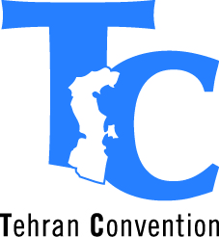
In order to effectively and sustainably address marine litter coordinated regional efforts by all Caspian littoral states are needed. The Framework (Tehran) Convention for the Protection of the Marine Environment of the Caspian Sea ratified by all Caspian states is the appropriate legal instrument for environmental cooperation in the Caspian Sea region.
The Tehran Convention, under article 7, commits the Contracting Parties to take all appropriate measures to prevent, reduce and control pollution of the sea from land-based sources.
The (Moscow) Рrotocol for the Protection of the Caspian Sea Against Pollution from Land-based Sources and Activities to the Framework Convention for the Protection of the Marine Environment of the Caspian Sea was adopted at the 3rd Meeting of Conference of the Parties to the Tehran Convention. The main objective of the Moscow Protocol is to prevent, control, reduce and to the maximum extent possible eliminate pollution of the marine environment from land-based sources and activities in order to achieve and maintain an environmentally sound marine environment of the Caspian Sea (Art.1).

The Protocol covers the categories of substances, identified on the basis of their hazardous or otherwise harmful characteristics, including marine litter, which is defined as “аny persistent manufactured or processed solid material which is discarded, disposed of, or abandoned”.

The Annex 1 of the Moscow Protocol stipulates that “priorities for action should be established relative importance of impacts upon marine and coastal ecosystems and resources, public health, socio-economic benefits, including cultural values (item 6 of the section B, Annex 1).

The draft Caspian Regional Marine Litter Action Plan (CRMLAP) was prepared in 2019-2020 and endorsed on 20 May 2020 by Tehran Convention Interim Secretariat (TCIS) and an official national expert from each of the Caspian countries, who were designated to develop a draft CRMLAP. Preparation of the draft CRMLAP was guided by an international expert. The objective of the CRMLAP is to prevent, control, reduce and to the maximum extent possible eliminate pollution of the marine environment from marine litter in order to achieve and maintain an environmentally sound marine environment of the Caspian Sea. The CRMLAP contains 9 topics/sections and 86 actions. With TCIS and the national experts having reviewed and accepted the draft plan the CRMLAP was submitted to Tehran Convention Parties by the letter of 10 June 2020. The draft CRMLAP will be submitted to the 6th Meeting of the Contracting Parties for its consideration and possible adoption. The Project components and main activities listed in the section D of the project proposal were prepared to support the implementation of the objectives of the draft CRMLAP and should be regarded as means of implementing the draft CRMLAP.

The Contracting Parties also established a monitoring Program with a Working Group on Monitoring and Assessment responsible for its implementation, a unified national reporting format and system, complemented by the environment status reporting, and the Caspian Environment Information Centre, in order to ensure proper collection, analysis and exchange of pollution related information. The Conference of Contracting Parties meets every two years to review this information and provides instructions for future action.

The Convention Secretariat is provided on the interim basis by the United Nations Environment Programme (UNEP) from its office in Geneva. It is expected that Convention Secretariat will be relocated to the Caspian region starting from Republic of Azerbaijan and will rotate every four years. In its work the Convention Secretariat is not only relying on the collective work and input from relevant Ministries and designated focal points in the Caspian riparian countries. It has also concluded a number of collaborative arrangements and memoranda of understanding with specialized institutions and organizations both from within and outside the United Nations, IMO, CaspCom and Grid Arendal.
Thanks to being integrated into the UN system and in particular UNEP, the Convention Secretariat enjoys access to and knowledge of the leading global environmental authority that sets the global environmental agenda, promotes the coherent implementation of the environmental dimension of sustainable development within the United Nations system, and serves as an authoritative advocate for the global environment. UNEP is also a leading agency in implementing the SDGs 14 “Life below Water”
Funding for the work of and coordinated by the Convention Secretariat comes from the annual contributions of the Contracting Parties and additional sources of income and support from donor countries and institutions. For instance, while the framework and institutional setting for addressing marine litter issues is available, additional support and resources are needed to make the agreed intentions operational.

C. PROJECT GOALS AND OBJECTIVES
The project goal is to prevent and reduce and to an extent possible minimize marine litter in the Caspian Sea with special focus on marine plastics. This will be achieved through amending the policy and regulatory frameworks on waste management, comprehensive promotion of a circular economy/life-cycle approach, carrying out investments in waste managements as well as sustainable consumption and productions patterns in particular, by supporting behavioral consumers’ change.
The mains outputs of the project are to:
- comprehensive information and data on marine litter in the Caspian Sea
- improved policy and regulatory frameworks on waste management
- enhanced circular economy to improve plastic management
- preliminary investments in waste management
The project will also consolidate efforts with already in place actions of the Caspian littoral countries towards better waste management. It will furthermore be built upon the previous work of the Caspian littoral countries under the Tehran Convention, in particular the Protocol on Land-based Source of Pollution and the outcomes of Strategic Convention Action Programme.
D. COMPONENTS AND MAIN ACTIVITIES (10 pages max)
The project activities will be clustered in six components:
Component 1 Collection and assessment of information and data relevant to the Caspian marine litter. (UN Environment TC Secretariat)
Activities under this component will be aimed at obtaining a comprehensive information on marine litter in the Caspian region. In order to understand the overall view of the marine litter issue and effectively address it in the following stages of the projects additional data and information have to be gathered. The main objective of this component is to gather already existing information in a cohesive manner and further analyze it. This will also help in filling the knowledge gaps as well as identify further scientific research. The knowledge and data gathered under this component will serve as basis for an effective implementation of the subsequent components.
Activity 1 Comprehensive review of marine litter information in the Caspian Sea. Under this activity, the following information should be collected: 1) quantitative information on the volume, distribution, composition, sources and pathways of the marine litter; 2) information on the governmental institutional structures as well as key academic and non-governmental organizations addressing waste management and marine pollution issues in the Caspian littoral countries; 3) information on the national and local legal and regulatory settings and governance frameworks related to waste management and 4) information on the most problematic products and polymers in different countries,
Activity 2 Marine Plastics Value Chain mapping and hotspots identification. Since the plastic is the major component of the marine litter a special attention will be given to this material to reduce plastic pollution in the coastal zone of the Caspian Sea and Caspian marine environment. This activity will be undertaken to comprehend the life cycle of the most used plastic items with the purpose to increase the possibility of reusing or recycling them. It is also expected to draw international expertise on the policy, technology and awareness with reference to the identified value-chain hotspots.
Activity 3 Development of monitoring tools of the marine litter. Under this activity, the Working Group on Monitoring and Assessment of the Tehran Convention will be tasked to develop the monitoring tools of the marine litter in the Caspian Sea. Comprehensive guidelines for data collection for the Caspian Sea will be developed taking into account the experience of the other seas as well as the Caspian Sea region context.
Activity 4 Identify further scientific research to address the gaps in knowledge. Given the international experience as well as previous endeavors of the Caspian countries to address the marine litter issue, there is a significant gap in knowledge especially with regards to the economic damages associated with the marine litter impacts on the ecosystem, human health, recreational & leisure, agriculture and animal husbandry, fishery industry or navigation. A special focus will be put on the impact of plastic and microplastics.
Component 2 Policy, Legal and Regulatory Reforms. (UN Environment TC Secretariat)
Major incentive of any change is information-based legal framework directing toward more environmental sound governance. For regulatory reforms to be beneficial, the regulatory regimes need to be transparent, coherent, and comprehensive, spanning from establishing the appropriate institutional framework to liberalizing network industries, advocating and enforcing competition policy and law and opening external and internal markets to trade and investment.
Activity 1 Review of the national waste legislation. The project will provide assistance to the Caspian countries to review their waste legislation on both national and local level. In doing so, minimum requirements, based on existing best practice will be used to maximize their effectiveness considering different local contexts. It is also envisaged to draw the technical support from the UNEP-administrated Global Programme of Action for the Protection of the Marine Environment from Land-Based Activities.
Activity 2 Supporting the development and approval of container deposit laws. Under this activity, the project will directly assist the Caspian countries to in development of the container-deposit legislation to encourage recycling and complement existing curbside recycling programs and reduce beverage container litter along the coastal zone, main rivers, and on other public or private properties likely affected the marine environment.
Activity 3 Supporting law enforcement to combat illegal dumping. Illegal dumping is considered one of the major source of marine litter and waste management issue at large. It will be addressed by developing enforcement measures to combat illegal dumping in accordance with national and regional legislation. The following illegal practice in the Caspian region should be given a special attention: illegal landfills in located in proximity to the sea, illegal sewage disposal in the sea, illegal dumping in the coastal zone and rivers fluxing in the Sea as well as littering on the beach and other leisure facilities located in proximity to the sea.
Activity 4 Promote ban on the sales, manufacturing and import of plastic bags. Plastic shopping bags are made from high-density polyethylene (HDPE) plastic. Because this substance does not biodegrade, plastic bags can last up to 1,000 years in the environment. Apart from that, plastic bags are common cause of clogged drainage systems, sewers, and waterways in many developing countries. Under this activity, the project will promote ban on the sales, manufacturing and import of plastic bags by, among others, developing case studies on scenario of plastic bags free Caspian, building the local movement in major cities, reaching out to the supermarkets and other retailers.
Component 3 Improving management of the plastic waste in the coastal regions (UNDP)
Activity 1 Promote the separate collection of plastic waste in the coastal regions of the Caspian Sea. The project will identify, develop and apply, in consultation with national focal points and selected local authorities, cost-effective tools and means to convince and assist waste collectors and the locals at designated demonstration sires to separate storage and collection of plastic from other waste; develop and conduct public information campaigns to mobilize and generate support for these approaches in other parts of the cities and along the entire coastal areas.
Activity 2 Identification and implementation of innovative solutions for advanced sorting, chemical recycling and improved polymer. The project will conduct an analysis and organize demonstrations of prevailing techniques and practices within the region and in other parts of the world, including the cost effectiveness of using and applying them in the diverse locations and settings of the coastal areas of the Caspian Sea countries.
Activity 3 Development of Innovative approaches. The project will be seeking to develop innovative business models, reverse logistics or designing for sustainability, to help minimize plastic waste at source, while achieving further economic, environmental and social benefits. To this end, an analysis of prevailing policies and practices within the region and in other parts of the world, including incentives for feasibility and applicability in the national and local context of the Caspian Sea countries will be conducted. It is envisaged to organize workshops to identify and select best practices.
Component 4 Private Sector Engagement (UNDP)
Activity 1 Identification of market for recycled and innovative plastics. The main purpose of the activity is to analyse and organize a review of waste recycling capacities – collection; processing; re-use and marketing – in the Caspian countries’ most densely populated parts of their coastal areas. It is expected to identify market possibility for recycled and innovative plastics to be further take up by private sector.
Activity 2 Development of an Extended Producer Responsibility (EPR) schemes in the Caspian states. EPR can provide economic incentives for businesses to develop more sustainable plastic products. In this connection, the project will analyze and review the system and potential of economic incentives for EPR in the individual countries of the Caspian Sea region, including the necessary development or changes in legislation and enforcement and compliance measures.
Activity 3 Connect the Caspian states and industries to a global alliance. Under this activity, the project will seek possible partnerships with the global alliance from plastics value chain, including major plastic-producing and plastic-using corporations and processing companies. In doing so the project will encourage and promote membership and participation of the Caspian States and industries in relevant multi regional and global initiatives and alliances for the sustainable management and reduction of waste generation and disposal, including meetings of the Parties o the Tehran Convention and its LBS Protocol.
Component 5 Empowering local communities and enterprises to improve waste management (UNDP)
Managing waste properly is essential for building sustainable and livable cities, but it remains a challenge for many countries and cities including in the Caspian Sea region. Effective waste management requires significant initial investments in building up the necessary infrastructure. Apart from it, comprehensive waste management should address the entire lifecycle of the product—from its design to collection and transportation, reuse, recycling and finally treatment and disposal.
Activity 1 Small Grant Programs in coastal communities. The Small Grant Programme will provide financial and technical support to projects aiming at improving separate containers collection and waste management at large. The priorities will be given to the community actions, young entrepreneurs.
Activity 2 Identification of needed waste management investments. The main output of this activity will be information on the required investments in waste management on the local and national level. This information will include financing and policy recommendations with regards to the further improvement of the waste management in the Caspian countries. The information will be submitted to and reviewed by a workshop/investment forum at which policy makers, local authorities and the private sector will be encouraged to exchange information and identify suitable sustainable waste management tools and practices.
Component 6 Communication and Stakeholder Involvement (UN Environment TC Secretariat)
Stakeholder engagement and stakeholder management are arguably the most instrumental for successful project delivery. The importance of the stakeholder engagement cannot be underestimated in such a complex issue as life cycle of the product and waste management. In addition, the involvement of the public and making the people responsible for their waste foot print is crucial for changing the status quo.
Activity 1 Establishment of a Regional network of regional and local stakeholders. The regional network will be established to boost cooperation on reduction and prevention of marine litter and marine plastics in the Caspian Sea. It is envisaged to involve the regional network to the maximum extend in implementing the current the project to ensure adequate ownership of different players. The network will also serve as a platform for engaging in a dialogue and enhanced cooperation with the business and industry, sea users, local communities and other relevant civil society groups as well as national stakeholders focusing on marine litter, at the appropriate level, to among others, share best experience. In addition, the network will be responsible for identifying projects for public-private-partnerships to reduce and prevent marine litter in selected Caspian states and recommend projects for small grant programme.
Activity 2 Awareness raising and advocacy. The purpose of this activity is mainly to demonstrate to stakeholders the issue and the utility of container deposit laws as part of an overall plastics reduction. It will be achieved by show cases of already existing practices in different countries where the container deposit laws were adopted. Under this activity the public awareness plan will be developed and implemented. It is a crosscutting issue requiring new ideas and approaches on education, campaigns and information packaging to change social behavior.
Activity 3 Development of communication and awareness raising strategy. Under this activity, the vigorous the awareness raising instruments will be carried out to disseminate the information on negative effects of the inappropriate waste management as well as simple solution which could make an immense impact on addressing marine litter especially plastic. In addition, is it envisaged to reinforce activities carried out on the Caspian Sea Day Celebration with a special attention on beach cleaning campaign with local stakeholders. In order to enlarge the ownership of the local communities the programme of “Adopt Your Beach” will be implemented.
E. POTENTIAL COOPERATION WITH THE RUSSIAN FEDERATION
This project proposal is in line with the Russian Federation’s international development assistance priority aimed at improving social and economic conditions in CIS and nearby countries as well as to adopt measures to protect the environment and to solve transboundary environmental problems.
The proposed project provides opportunities for technical cooperation and knowledge transfer from the Russian Federation to the Caspian littoral countries. Russian government agencies and academic institutions have strong technical expertise and comparative advantage in the areas waste management. It is suggested to use their expertise to improve the waste management in the Caspian littoral countries and marine environment protection at large. Under this project expertise of the following entities is expected to be drawn:
- P.P.Shirshov Institute of Oceanology of the Russian Academy of Sciences
- Roshydromet, KaspMNIZ .
- PAO “Ecosystema”
- Astrakhan" Eco Servis“
- Center of International Projects
- International Environmental Fund “Clean Seas”

Moreover, it is also suggested that the Russian experts who have experience from different regional seas as Baltic Sea, Black Sea and Northwest Pacific Region will be drawn into the project. The project will further use the expertise of Russian private companies working on waste managements.

The Russian Federation, Azerbaijan, Kazakhstan, IR of Iran and Turkmenistan are Parties to the "Framework Convention for the Protection of the Marine Environment of the Caspian Sea, the Tehran Convention” and its ancillary Protocols, one of each is the Protocol for the Protection of the Caspian Sea against Pollution from Land-based Sources and Activities ("Moscow Protocol").

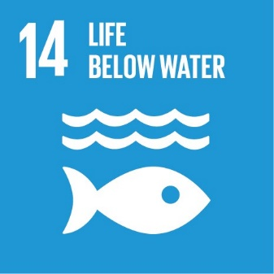
F. SUSTINABLE DEVELOPMENT GOALS
The project directly contributes to the Sustainable Development Goal (SDG)14 “Life below Water” target 14.1 “By 2025, prevent and significantly reduce marine pollution of all kinds, in particular from land-based activities, including marine debris and nutrient pollution”.

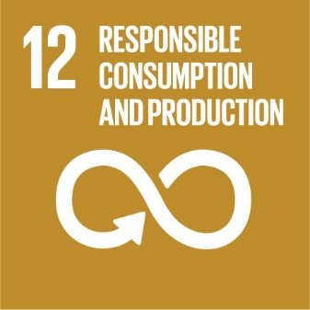
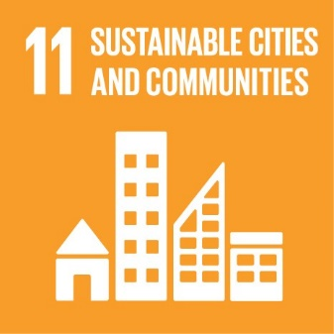
The project also contributes to the Sustainable Development Goal (SDG) 11” Sustainable cities and communities” target 11.6 “By 2030, reduce the adverse per capita environmental impact of cities, including by paying special attention to air quality and municipal and other waste management” and the Sustainable Development Goal (SDG) 12” Responsible Consumption and Production” target 12.5 “By 2030, substantially reduce waste generation through prevention, reduction, recycling and reuse”.
G. PROJECT MANAGEMENT STRUCTURE
The project will be managed by UNDP Istanbul Regional Hub (IRH) for Europe and CIS and some components will be implemented by the UNEP administered Secretariat of the Tehran Convention.. A workplan will be developed and a Steering Committee consisting of the representatives of the partner agencies and the designated focal points of the Caspian countries will be established to oversee and provide guidance on its implementation. The end responsibility for the project including the accountability and reporting to the donor will be with UNDP IRH. A Project Management Unit (PMU) will be established by IRH in coordination with the Teheran Convention (TC) Secretariat.
H. SUMMARY BUDGET
Component | Requested budget | Potential Co-financing
Component 1. Collection and assessment of information and data relevant to the Caspian marine litter. | US$ 370,000 | US$580,000
Component 2. Policy, Legal and Regulatory Reforms. | US$670,000 | US$ 900,000
Component 3 Improving management of the plastic waste in the coastal regions. | US$450,000 | US$400,000
Component 4 Private Sector Engagement. | US$350,000 | US$350,000
Component 5 Empowering local communities and enterprises to improve waste management. | US$900,000 | US$470,000
Component 6 Communication and Stakeholder Involvement: | US$400,000 | US$500,000
Project Management, monitoring and evaluation | US$600,000
UNDP Indirect Costs | US$ 299,200
TOTAL: | US$ 4,039,200 | US$3,600,000

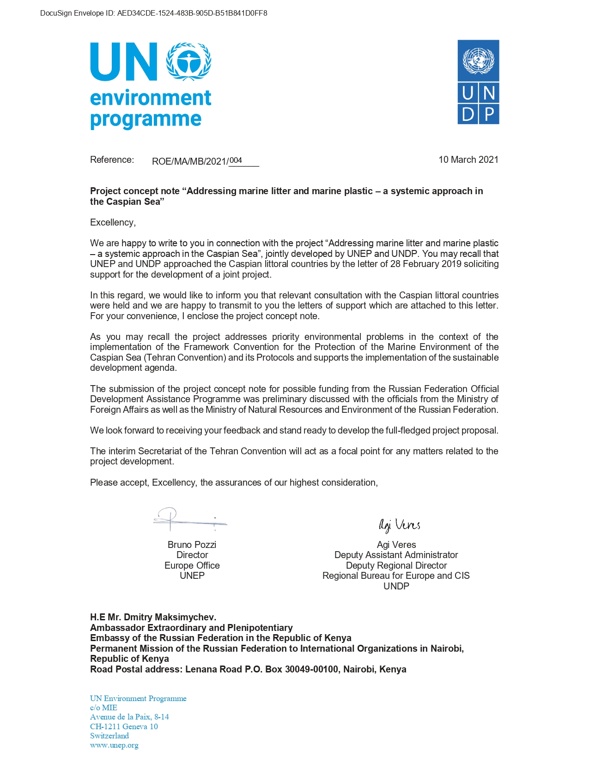

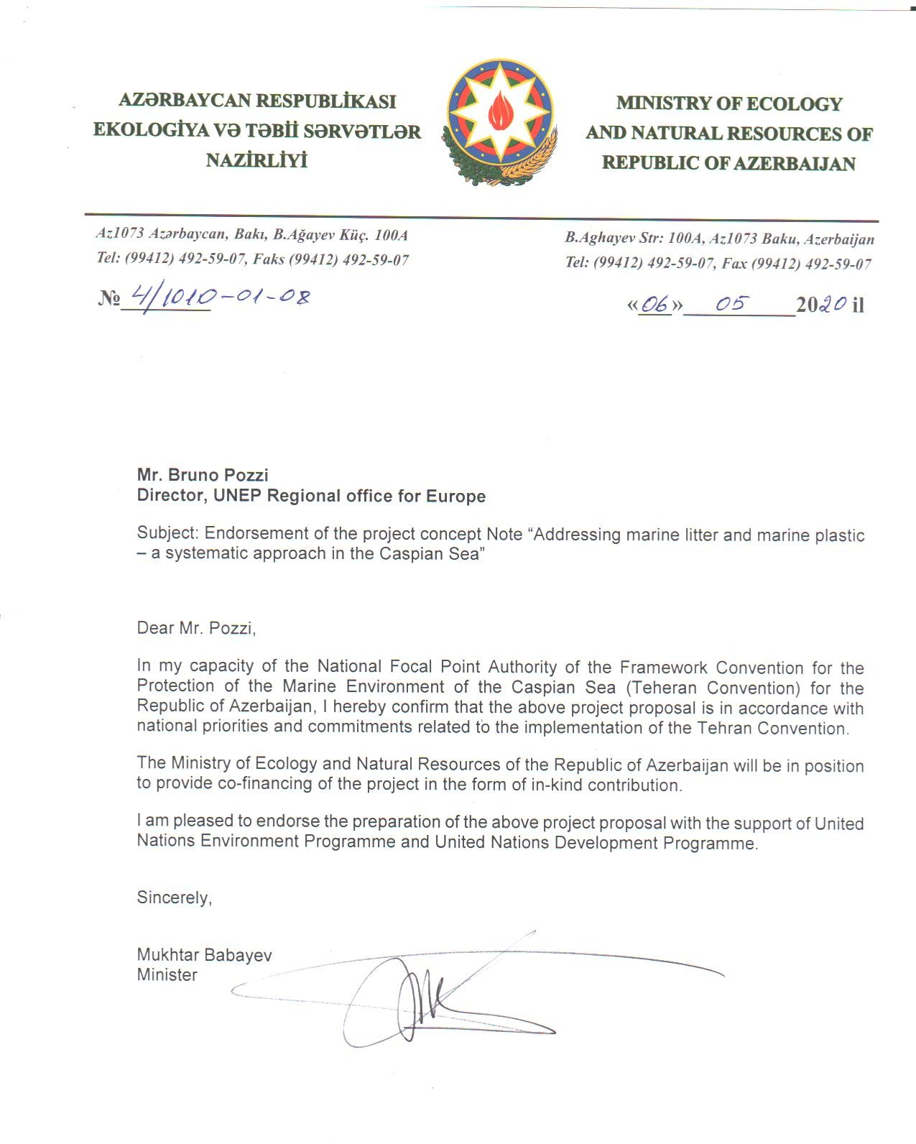

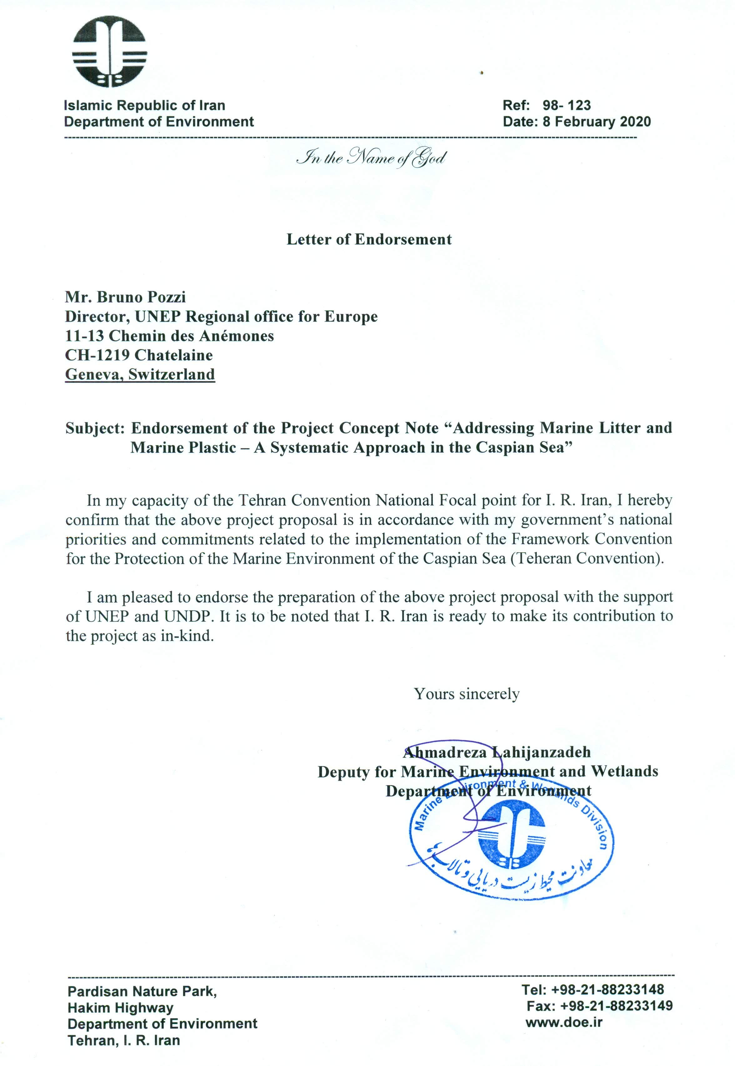
Unofficial translation

Ministry of Ecology, Geology and Natural Resources of the Republic Kazakhstan, having considered your project developed by UNEP and UNDP and aimed at addressing the environmental problem of the Caspian Sea with the active participation of the relevant countries within the framework of the Tehran Convention, would like to inform on the following.

Given that you are considering the possibility of financing the project from the Official Assistance Programme, the Kazakh side expresses its approval and support for the further implementation of this regional project.

With kind regards,

A. Primkulov Vice-Minister

To: Interim Secretariat
Framework Convention for the Protection of the Marine Environment of the Caspian Sea

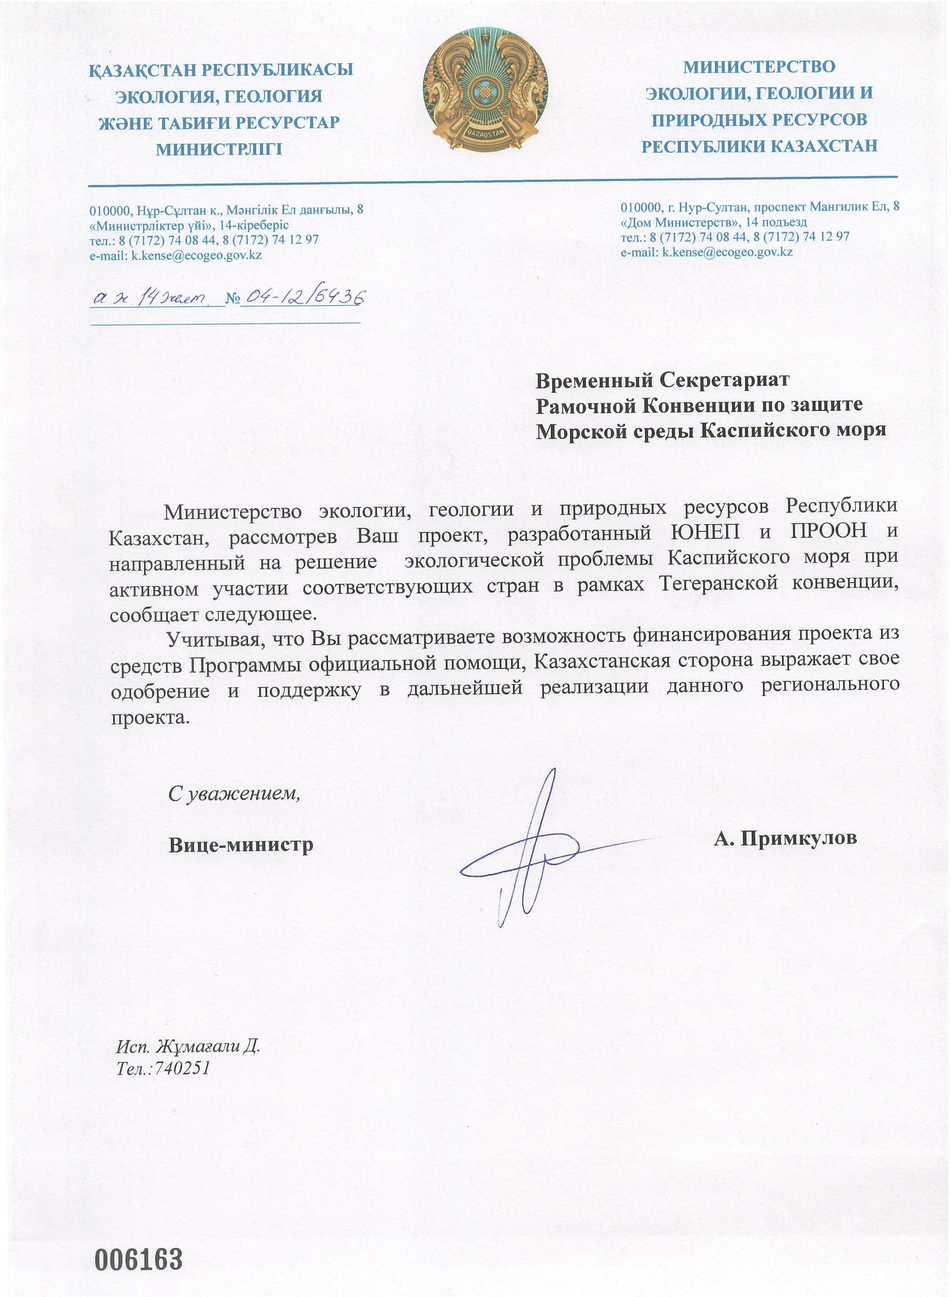
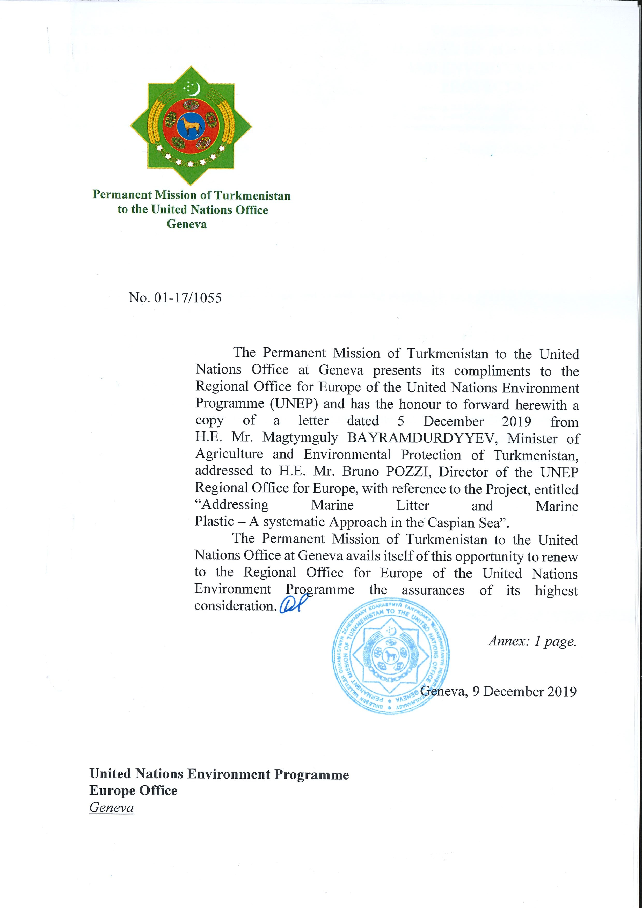
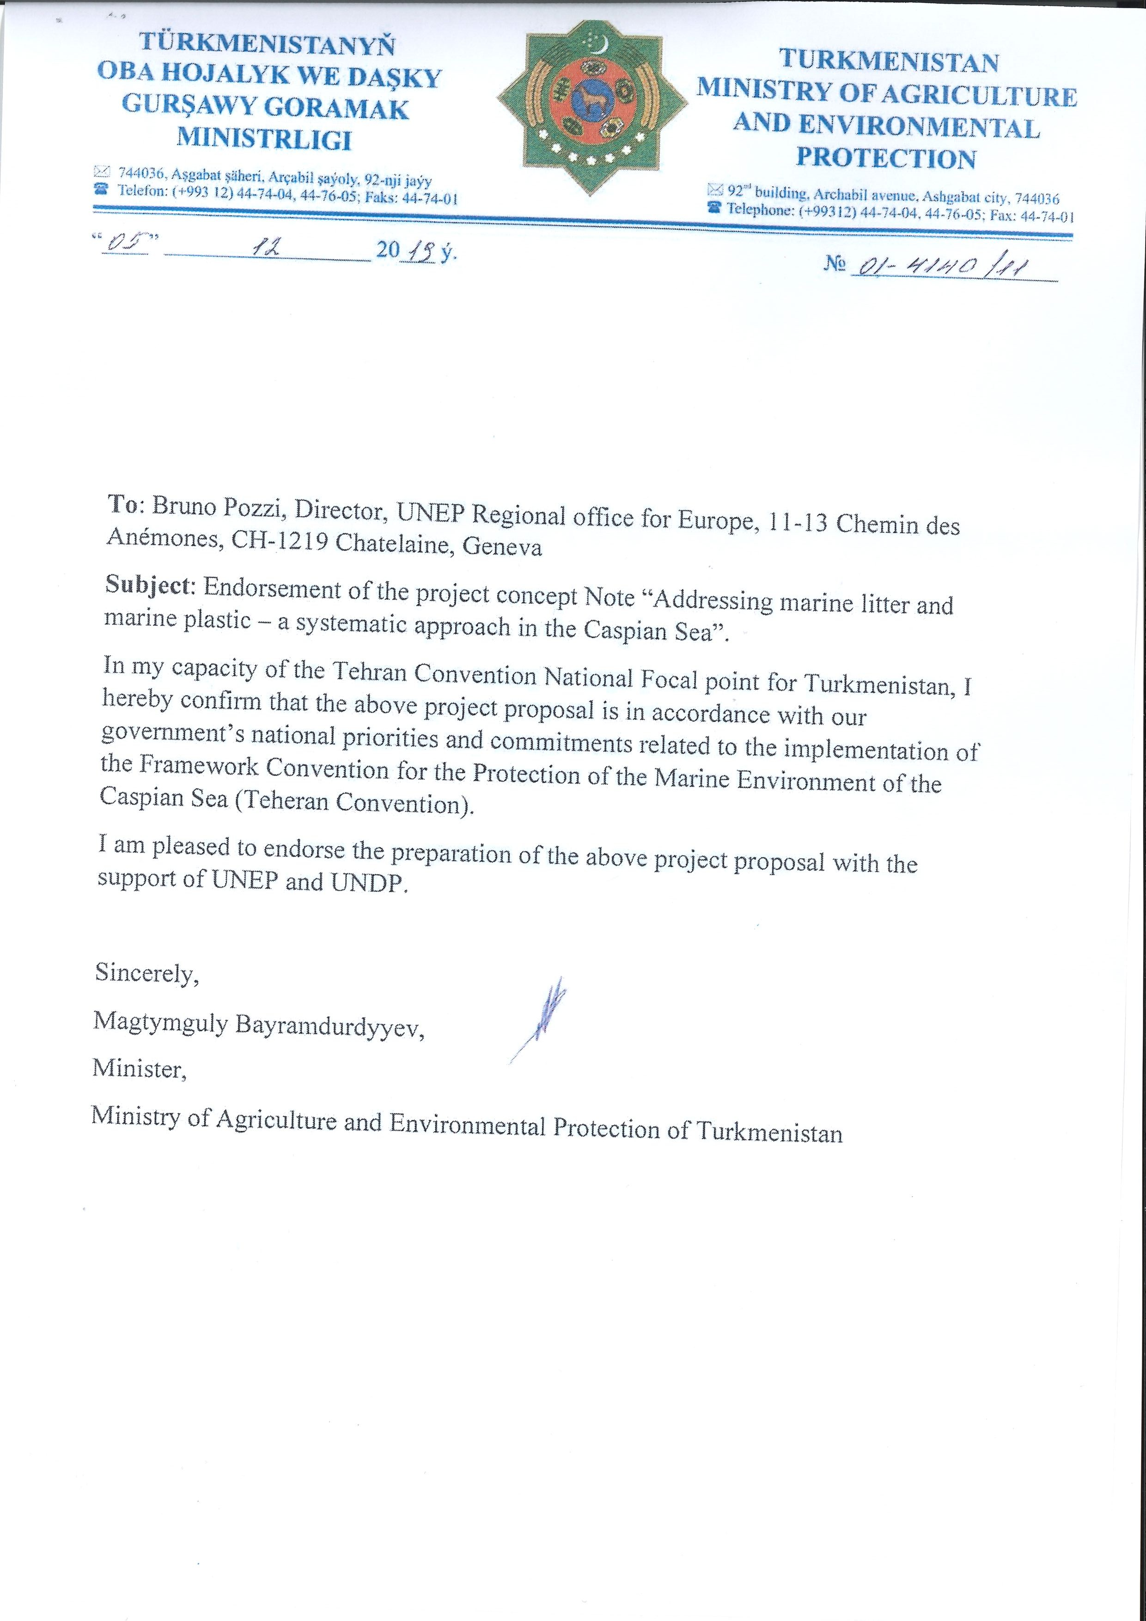
Annex II
Government of the Russian Federation

Order

December 25, 2021 № 3872-p

Moscow

1. To contribute in 2021-2024, at the expense of the federal budget, up to 4,039,200 USD to the budget of the United Nations Development Programme to finance the costs associated with the implementation of the joint project of the United Nations Development Programme and the United Nations Environment Programme “Addressing Marine Litter and Marine Plastics – A Systemic Approach in the Caspian Sea”, including: in 2021 - up to 744,800 USD, in 2022 - up to 1,084,800 USD, in 2023 – 1,349,800 USD, and in 2024 - up to 859,800 USD.

2. To the MFA of Russia:
- to inform the United Nations Development Programme and the United Nations Environment Programme about the decision taken;
- to finance the expenses specified in paragraph 1 of this Order at the expense of budget allocations provided for the MFA of Russia in the federal budget for the corresponding year under the subsection “International relations and international cooperation” of the section “General governmental issues” of the classification of budget expenditures;
- to coordinate jointly with the Ministry of Finance of Russia the procedure for transferring of funds provided in paragraph 1 of this Order.

Chairman of the Government of the Russian Federation
M. Mishustin.

Annex III
Regional stakeholder consultation overview for “Urbanization and Climate Change in the Caspian Sea region” programme”
Consultative meetings for “Urbanization and Climate Change in the Caspian Sea region programme” were planned and organized based on the initial stakeholder analysis and involved participation of high-level representatives of 5 Caspian littoral countries and consultants engaged in the program development process. The reports of the consultations are contained in Appendix I. To adequately engage them, the project team conducted stakeholder mapping and created a diverse working group of people with representing environmental ministries and local institutions dealing with the environmental issues of the Caspian Sea.
The project implies that regional decision makers in the Caspian Sea will be enabled and capacitated with knowledge to be able to prepare enhanced strategies at the regional and national level. Those strategies and guidelines will be aligned with the normative frameworks, urban development and national climate change adaptation and agreed through continuous discussions and meetings.
The participants of the consultation process were nominated by the Caspian Governments in reply to the letter of 16 July 2021 from the Tehran Convention Secretariat approval of the project concept note by Adaptation Fund and requesting the nominate focal points assisting to ensure the active participation of various stakeholders at the regional consultations. All meetings were led by TC officer and international consultant, the discussions were held in English with simultaneous translation (Russian). Most meetings were attended by more than 10 people with majority being women.
The first regional consultative meeting was held in February 2020 in an online format due to raising Covid-19 risks. The stakeholders were informed about project submission and steps of development of project pre-concept note. It also included discussion of the results of the desk reviews taken place within the first stage of concept note development. The stakeholders got an opportunity to discuss objectives of the project concept to tackle the impacts of the main identified climate change related hazards:
- Sea level fluctuation and potential decrease;
- Increased floods;
- More intense droughts; and
- Desertification in the Caspian Sea coasts, particularly in Azerbaijan and Iran;
As discussed with regional stakeholders, adaptation measures for the above-mentioned hazards will be considered and implemented through Integrated Coastal Zone Management. During the second consultative meeting that was held in July 2020 it was agreed to involve different ministries for the regional component of the project including ministries responsible for economic development.
Following this meeting and every subsequent one, participants were encouraged to review the minutes and any developed documents and give their feedback. The Secretariat and the project team arranged bilateral meetings with country representatives upon request to clarify their questions and integrate relevant comments and feedback into the project proposal. Starting from the third consultancy meeting participants started the discussions related to the draft project proposal. Project team and consultants developed the work-plan and list of activities based on their feedback. During the following two consultancy meetings held in November and December 2021 respectively stakeholders made their comments towards improvement of the work-plan and list of activities that were later integrated into the project proposal.
The last consultancy meeting took place in February 2022 where the project team presented the final version of the work-plan and measures to be implemented in the framework of the project. Stakeholders revised the documents and agreed that the final versions could be incorporated into the final draft of the overall project proposal.

Appendix I
1st Consultative Meeting of the Tehran Convention Interim Secretariat on the Adaptation Fund proposal I Urbanisation and Climate Change Adaptation in the Caspian Sea Region

Aide-Memoire

Meeting Participants

Azerbaijan | Mr. Faig Mutallimov  Head  International organizations and projects subdivision
Iran | Ms. Farnaz Shoaie  National (Tehran) Convention Liaison Officer  Marine Environment & Wetland Division  Department of Environment  Tehran, Iran
Kazakhstan | Mr. Serik Akhmetov  National (Tehran) Convention Liaison Officer  Kazakhstan
Russian Federation | Mr. Alexander Postnov  On behalf of the National (Tehran) Convention Liaison Officer of Russian Federation
Turkmenistan | Ms. Gozel Orazdurdiyeva  National (Tehran) Convention Liaison Officer  Turkmenistan
Tehran Convention Interim Secretariat | Mr. Mateusz Benko  Tehran Convention Officer  UN Environment, Regional Office for Europe
Coordinating Committee on  Hydrometeorology of the Caspian Sea (CASPCOM) | Ms. Elena Ostrovskaya  Director  Caspian Marine Scientific Research Centre  Roshydromet
UN Habitat | Ms. Katja Schäfer  Inter-Regional Advisor

Meeting Summary

The meeting took place on 25 February 2020 and was conducted via an online platform with simultaneous English-Russian interpretation. The estimated duration of the meeting was 2h.

The objective of the meeting was to carry out regional consultations on the pre concept note” Urbanization and Climate Change in the Caspian Sea region” which is joint proposal of UN Habitat and UN Environment.

The meeting participants received information on:

- Adaptation Fund and the submission procedure of the pre-concept note” Urbanization and Climate Change in the Caspian Sea region”;
- Process of developing of a project concept note” Urbanization and Climate Change in the Caspian Sea region” including planned national, regional consultations as well as desk reviews;

- Scope of the project concept, including information related to three geographical scopes of the project:
- Regional (five Caspian countries);
- National (Azerbaijan and Iran);
- Local (Caspian littoral provinces of Azerbaijan and Iran);

- Objectives of the project concept to tackle the impacts of the main identified climate change related hazards:
- Sea level fluctuation and potential decrease;
- Increased floods;
- More intense droughts; and
- Desertification in the Caspian Sea coasts, particularly in Azerbaijan and Iran;

- Proposed adaptation measures for the four above-mentioned hazards will be considered in relation to urbanization processes and through the Integrated Coastal Zone Management;
- Mains streams of work under the regional components including but not limited to:
- Strengthened scientific knowledge on the climate change and its impact in the Caspian region;
- Development, application and capacity building for coastal area planning (Integrated Coastal Zone Management);
- Knowledge sharing and upscaling of the national (Azerbaijan and Iran) intervention to other Caspian countries using the findings of the interventions;
Subsequently, the discussion was opened where the following matters were discussed as per specific questions from meeting participants:
- National experience Caspian countries in coastal area planning in particular the experience of Iran;
- Regional components of the project and request to strengthen it;
- Role of other Ministries in coastal are planning such as the Ministries of Economy
- Exchange and collection of climate related date on the regional level;
- Key documents to be reviewed and stakeholders to be engaged;
- Role of the Caspian Environment Information Centre in the project implementation;
- Proposed adaptation interventions including infrastructure related interventions.

2nd Consultative Meeting of the Tehran Convention Interim Secretariat on the Adaptation Fund proposal “Urbanisation and Climate Change Adaptation in the Caspian Sea Region”

Aide-Memoire

Meeting Participants

Azerbaijan | Mr Rasim Sattar-zada, Head of Environmental Policy Division, National (Tehran) Convention Liaison Officer  Mr Faig Mutallimov, Head of International organizations and projects subdivision  Mr Fuad Humbatov, National Hydrometeorology Service, head of international relations and public relations subdivision  Mr Rafig Verdiyev, National Hydrometeorology Service, Head of Centre  Mr Vugar Hasanov, National Hydrometeorology Service, Head of marketing subdivision  Mr Akber Asgarov, National Hydrometeorology Service, Head of division
Iran | Ms. Farnaz Shoaie, National (Tehran) Convention Liaison Officer  Marine Environment & Wetland Division, Department of Environment
Kazakhstan | Mr. Serik Akhmetov, National (Tehran) Convention Liaison Officer  Kazakhstan
Russian Federation | Ms. Tatiana Butylina, Deputy Director, Center for International Projects, National (Tehran) Convention Liaison Officer  Mr. Alexander Postnov, Acting Chairman, Working Group on Monitoring and Assessment
Turkmenistan | Ms. Gozel Orazdurdiyeva, National (Tehran) Convention Liaison Officer
Tehran Convention Interim Secretariat | Mr. Mateusz Benko, Tehran Convention Officer, UN Environment, Regional Office for Europe  Mr. Daniel Nixdorf, Advisor, Tehran Convention Interim Secretariat
UN Habitat | Ms. Katja Schäfer, Inter-Regional Advisor  Mr. Hamidreza Ghaffarzadeh, Regional consultant

Meeting Summary

The meeting took place on 28 July 2020 and was conducted via an online platform with simultaneous English-Russian interpretation. The estimated duration of the meeting was 2h. The objective of the meeting was to carry out regional consultations on the concept note” Urbanization and Climate Change in the Caspian Sea region” which is joint proposal of UN Habitat and UN Environment.

At the regional consultation on the pre concept note, 28 February 2020, the participants were informed of:
- Adaptation Fund and the submission procedure of the pre-concept note” Urbanization and Climate Change in the Caspian Sea region”;
- Process of developing of a project concept note” Urbanization and Climate Change in the Caspian Sea region” including planned national, regional consultations as well as desk reviews;
- Scope of the project concept, including information related to three geographical scopes of the project:
- Objectives of the project concept to tackle the impacts of the main identified climate change related hazards:
- Sea level fluctuation and potential decrease;
- Increased floods;
- More intense droughts; and
- Desertification in the Caspian Sea coasts, particularly in Azerbaijan and Iran;
- Proposed adaptation measures for the four above-mentioned hazards will be considered in relation to urbanization processes and through the Integrated Coastal Zone Management.
Since the consultation on the pre concept note the meeting participants had sufficient time to familiarize themselves with the activities planned under the project concept note. In general, the participants found the presented regional part of the concept note well drafted and acceptable.
During the discussion following matters were raised as per specific questions from meeting participants:
- Involvement of different ministries in the regional component of the project including ministries responsible for economic development;
- The potential support of the project to develop a climate change adaptation related axillary Protocol to the Tehran Convention; it was suggested to exclude this activity from the project concept note as it may be to premature to look at the possibility to start working on the climate change adaptation related axillary Protocol to the Tehran Convention
- Cooperation between TCIS/UNEP and UN Habitat in development of the project concept note; and
- Implementation modalities planned under the Project; it was mentioned that the team working on the project development is investigating different options for the implementation modalities; the chosen option will be presented in the later version of a draft project concept note.
It was agreed to share the more advanced draft concept note containing the information on the national interventions planned in Azerbaijan and Iran with the meeting participants.
The meeting participants were also encouraged to send their additional comments in writing.

3rd Consultative Meeting of the Tehran Convention Interim Secretariat on the Adaptation Fund proposal I Urbanisation and Climate Change Adaptation in the Caspian Sea Region

Aide-Memoire

Meeting Participants

Azerbaijan | Mr. Faig Mutallimov, Head of International organizations and projects subdivision
Iran | Ms. Farnaz Shoaie, National (Tehran) Convention Liaison Officer  Marine Environment & Wetland Division, Department of Environment  Mr. Hamid Lahijani, Iranian National Institute for Oceanography and Atmospheric Science, member of the organizing committee of Scientific Conference
Kazakhstan | Mr. Bekbergen Kerey, Deputy Head, Department of International Cooperation, Ministry of Ecology, Geology and Natural Resources of the Republic of Kazakhstan (MEGNR RK)  Mr. Askar Nugmanov, Department of Climate Policy and Green Technologies, Head of the Low Carbon Development Division, Ministry of Ecology, Geology and Natural Resources of the Republic of Kazakhstan (MEGNR RK)
Russian Federation | Ms. Tatiana Butylina, Deputy Director, Center for International Projects, National (Tehran) Convention Liaison Officer
Turkmenistan | Mr. Serdar Eyeberenov, Deputy Head of Administration for Environment and Hydrometeorology, Ministry of Agriculture and Environmental Protection of Turkmenistan  Ms. Gozel Orazdurdiyeva, National (Tehran) Convention Liaison Officer
Tehran Convention Interim Secretariat | Mr. Mateusz Benko, Tehran Convention Officer, UN Environment, Regional Office for Europe  Mr. Frits Schlingemann, Senior Advisor, Tehran Convention Interim Secretariat  Ms. Kristina Russkikh, Communication officer, Tehran Convention Interim Secretariat
UN Habitat  IOM | Ms. Tomris Bayramova, Regional consultant  Ms. Julie Greenwalt, Leading consultant  Mr. Yashar Karimov, National consultant  Mr. Mehrdad Rahmani, National consultant  Mr. Telman Maharramov, Intern  Mr. Vladimir Georgjiev, Chief of Mission Azerbaijan

Meeting Summary

The meeting took place on 25 October 2021 and was conducted via an online platform with simultaneous English-Russian interpretation. The estimated duration of the meeting was 2h. The objective of the meeting was to carry out regional consultations on the concept note and to develop the activities under the regional component of the program “Urbanization and Climate Change in the Caspian Sea region” which is a joint proposal of UN Habitat and UN Environment.

At the previous regional consultations, the participants were informed of:
- Scope of the project concept, including information related to three geographical scopes of the project:
- Objectives of the project concept to tackle the impacts of the main identified climate change related hazards:
- Sea level fluctuation and potential decrease;
- Increased floods;
- More intense droughts; and
- Desertification in the Caspian Sea coasts, particularly in Azerbaijan and Iran;
- Proposed adaptation measures for the four above-mentioned hazards will be considered in relation to urbanization processes and through the Integrated Coastal Zone Management.
The regional component and outcomes were presented to the meeting participants and they were encouraged to share their opinions and questions concerning different outcomes of the program.
Meeting participants were informed that they will receive the full project proposal in December, so the stakeholders would have enough time to comment on the document. It was proposed to send the project documents section by section to Project Steering Committee.
During the discussion following questions were raised by the project team:
- Is there a need to involve other Ministries to achieve the indicated objectives?
- What are the ways to ensure participation of civil society towards implementation and monitoring?
- What should be the tentative timeline for achieving the objectives (outputs)?
- What would be suggested operational schemes for achieving objectives in the regional components? (National consultancies, national focal points, contracts with national institutions, national or regional workshops)?
Meeting participants suggested that the project team could develop specific measures before the next meeting. It was agreed that the project team would share a more advanced draft of the list of activities that would display the interplay between regional and national components, including the timeline of the regional component before the next consultancy meeting in mid-November. It was also discussed and agreed that the operational schemes can be defined after the final list of the activities would be ready.
It was suggested that the other Ministries and stakeholders who could be involved in the project could be identified after the work plan of the project becomes more concrete. Meeting participants welcomed the idea of the involvement of NGOs on the regional level in the project implementation.
The project team proposed to have the fifth consultancy meeting at the end of November or the beginning of December to finalize the process.

4th Consultative Meeting of the Tehran Convention Interim Secretariat on the Adaptation Fund proposal I Urbanisation and Climate Change Adaptation in the Caspian Sea Region

Aide-Memoire

Meeting Participants

Azerbaijan | Mr Rasim Sattar-zada, Head of Environmental Policy Division, National (Tehran) Convention Liaison Officer
Russian Federation | Ms. Tatiana Butylina, Deputy Director, Center for International Projects, National (Tehran) Convention Liaison Officer  Ms. Elena Ostrovskaya, Director of the Federal Institution "Caspian Marine Research Center" of the Hydrometeorological Service of the Russian Federation  Mr. Alexander Postnov, Acting Chairman, Working Group on Monitoring and Assessment  Ms. Yelena Akentyeva, The Federal State Budgetary Institution "Voeikov Main Geophysical Observatory"
Turkmenistan | Mr. Serdar Eyeberenov, Deputy Head of Administration for Environment and Hydrometeorology, Ministry of Agriculture and Environmental Protection of Turkmenistan  Ms. Gozel Orazdurdiyeva, National (Tehran) Convention Liaison Officer
Tehran Convention Interim Secretariat | Mr. Mateusz Benko, Tehran Convention Officer, UN Environment, Regional Office for Europe  Ms. Kristina Russkikh, Communication officer, Tehran Convention Interim Secretariat
UNEP | Ms. Tomris Bayramova, Regional consultant  Mr. Hamidreza Ghaffarzadeh, Regional consultant

Meeting Summary

The meeting took place on November 10, 2021 and was conducted via an online platform with simultaneous English-Russian interpretation. The estimated duration of the meeting was 2h. The objective of the meeting was to carry out regional consultations on workplan of the regional component of “Urbanization and Climate Change in the Caspian Sea region” programme which is a joint proposal of UN Habitat and UN Environment. Measures and deliverables were provided to the participants of the event in advance.

It was decided to go through every output of the project and collect the comments.
Mr. Postnov proposed to simplify the wording of the activity “Report on Lessons Learnt and the Expectations of the Stakeholders of the project Outcomes.” and add that it is about the experience of other countries and territories. He also said that the data to be analyzed and the database to be created is not a baseline data base, but climate data. It is necessary that climate data be generated from the source data. Data exchange can be carried out on a legal basis and therefore CASPCOM plays an important role in this project.
Also, Mr. Postnov asked to clarify the reason for the need to prepare a document or a catalog of coastal pollution sources, it would be important to clarify how this is related to climate change.
Mr. Postnov proposed to create 3 working groups as a mechanism for implementing the regional component:
The first group should include climatologists who will work with climate data, databases, agree on climate assessment procedures, etc.
The second group, will be related to modeling. Here it is necessary to agree on what models will be used to assess future changes, whether they exist in the Caspian region at all, or whether they need to be created. This group should work closely with the first group as the underlying data will be required for the modeling.
The last third group is actually a group that will develop adaptation measures, this is no longer a hydrometeorological direction, it should include complex specialists who will create scenarios based on what the first two groups will provide.
Mr. Benko answered to the question of Mr. Postnov about the inventory of land source pollution - which is part of Moscow Protocol. Project is trying to build a case on resilience, basically meaning that a healthier is the ecosystem of the Caspian Sea the easier and more efficiently it can adapt to the climate change.
Ms Butylina emphasized that the Russian side is pleased that the project activities supporting the implementation of the Tehran Convention have resumed after a rather long break, and this was a great merit of the Interim Secretariat. She also noted that the Russian side gave its comments after previous meetings in 2020 and 2021. First of all, the project should be based on the main provisions of the Tehran Convention, since its main goal is to support the implementation of the Tehran Convention.
The second direction is actually now connected with the fact that it is necessary to intensify the activities of the signed Protocols; in fact, it is necessary to work out the connection with climate issues.
As for the Protocols, in each Protocol there is a reference to climate change in particular articles associated with the impact of climate on certain components. The project should get those results that can be further claimed and they need to be thought out to the end. The Russian Federation did not support the creation of new institutional structures and data centers, and this was accepted by the project, and it was proposed to perform these functions on the basis of existing capabilities, but now those functions have been transferred to CEIC. It is necessary to organize this process so that it is understandable for both IT specialists and ordinary users.
It is also important to show the connection between the national and regional components. It would also be more understandable if the activities of the regional component began to be developed after the action plan of the national component of the project is ready, although this should be due to the fact that the financial components of the project should be weighed in advance.
Ms Butylina said that they understand the activities that the secretariat has formulated and that this draft, which should be edited once again. For this reason, they provided their example in writing of how a plan can be made in a more understandable format in both languages.
Ms Butylina also said that within the framework of the CEP specific questionnaires were developed for different countries, and the information should be provided by experts nominated by the countries, then it is easier for the regional expert to summarize the information and it will be easier to coordinate it at the national level. She stressed that perhaps the meaning of some of the activities was lost due to translation.
Regarding the questions raised at the last meeting, the Russian side proposes to involve a national coordinator appointed by the Ministry of Natural Resources and Environment, who, in turn, will work with other agencies and bodies in accordance with local procedures. As for the issue of nonprofits, this mechanism has already been worked out within the framework of the Tehran Convention, and representatives of scientific institutes and universities can be involved in it. Ms Butylina also noted that from the point of view of timing, it would be difficult to give any information at the moment.
Mr. Benko suggested that there should be some explanatory notes on implementation modalities, where it should be mentioned that there would be focal points/coordinators from each Caspian country. Those coordinators will assist in implementing the regional components of the program.

Ms. Ostrovskaya touched upon some of the issues that were previously discussed at the last session of CASPCOM and overlapped with the activities outlined in the project work plan. In particular, she noted that the CASPCOM database does not fully meet the needs for assessing climate change and that some products should be prepared within the framework of CASPCOM in order for them to provide some kind of climate overview on a regular basis.
Ms. Ostrovskaya said that some of the data specified in the work plan had been collected for a long time, but, for example, now CASPCOM does not collect data on hazardous weather conditions (storm, wind speed, etc.), and data collection on precipitation will begin next year. Another thing is that since this is an intergovernmental agreement that functions within the framework of a government agreement on cooperation in the field of hydrometeorology, there is a certain procedure for agreeing on proposals for the introduction of new catalogs or for the creation of new information products. Coordination of these procedures takes time and this will need to be considered in the project, since according to the project plan, the data is needed already in the first half of the project and therefore a mechanism is needed to coordinate CASPCOM's participation in the project. It is necessary to establish a working mechanism with the project team in order to coordinate and simplify work with CASPCOM. To simplify the work with CAPSOM, it is necessary to clearly understand what kind of activity and to what events CASPCOM will be involved.
Having defined the scope of CASPCOM's activities, it will be possible to understand the level of its participation in this project. Since it operates within the framework of an intergovernmental agreement, all decisions must be made unanimously and all requests within the framework of the project will be to the countries accordingly. It is important to know the scale of the data that will be requested. Mr Benko said that the separate meeting on cooperation with CASPCOM will be organized as soon as possible.
During the discussion, it was said that the project will not make any changes to the existing rules and regulations specified in Outcome 3.1, but will provide recommendations for future changes in various documents.
Ms Butylina said that the Russian side can give its own wording for Outcome 3.1, since this wording does not reflect the requirements of the project and it needs to be changed in accordance with the theme of the project.
Ms. Butylina also asked for information on how the activities of CEIC within the framework of the project will be organized.
Mr. Benko said that there is an importance of having a needs assessment for CEIC and project can help to implement it. In ideal scenario protocol on monitoring, assessment and information exchange could help, but unfortunately the protocol is still being developed.
Mr. Postnov proposed to change the wording of Output 2.12, not to mention the exact name of the document and not create a drag by some countries that do not agree on this point and simply indicate the working group dealing with the monitoring.
Ms Ostrovskaya asked to revise the translation of Output 3.15 and to clarify the wording in Russian.
Ms Butylina also asked for clarification about the work of the trust fund, as well as about micro-grants that were launched through public organizations. Mr. Benko said that currently it is not possible to answer that question, and due to that the first activity of this output is to develop ToR for the Trust Fund.
Ms Ostrovskaya asked about the feasibility of holding the Investment Forum in the margins of the Caspian Economic Forum within the regional component of the project, if there will be discussion of pilot activities carried out in only two countries of the region (Output 3.17) and whether the conference will be held twice within the project.Mr. Benko said that the idea is that the pilot interventions will be further upscaled to other 3 three countries. Also Mr. Benko said that the event will happen only once in the end of the project and that will be noted in the project work-plan.
Ms. Ostrovskaya proposed to hold another scientific conference with the participation of the Caspian countries within the framework of the project, similar to the one which was held in October 2021. Mr. Benko agreed that it was a good idea.
Mr. Eeberenov asked for an explanatory note on the meetings and conferences. Mr. Benko said that the project team will prepare such an explanatory note, which will not be part of the project document, but will be useful for general understanding.
Ms. Gozel Orazdurdyeva proposed to find information, or rather regional reports, which were prepared in Iran under the CEP on Integrated Coastal Zone Management and use them in the current project to avoid duplication. This will allow to compare the situation at that time and at the moment.
Mr. Postnov asked for clarification about the countries that are not the main beneficiaries of the project, whether it is planned to hire experts from these countries who will participate in the project. He noted that it is important from the point of view that the transfer of official data can be carried out only through government agencies and therefore they must agree on the procedures for paying these experts.
Mr. Benko said that financial resources to the other countries will be administered by UNEP Tehran Convention Secretariat and experts hired from Russian Federation, Kazakhstan and Turkmenistan will be contracted by UNEP.
It was decided to extend the deadline for providing comments on the work plan until November 16. It was also agreed that after November 16, the project team will consider all proposals and provide the final draft of the work plan for discussion before the next meeting, which will be held in late November or early December.

5th Consultative Meeting of the Tehran Convention Interim Secretariat on the Adaptation Fund proposal Urbanisation and Climate Change Adaptation in the Caspian Sea Region

Aide-Memoire

Meeting Participants

Azerbaijan | Mr Rafig Verdiyev, Deputy Head of the National Hydrometeorology Service
Russian Federation  Iran | Ms. Tatiana Butylina, Deputy Director, Center for International Projects, National (Tehran) Convention Liaison Officer  Ms. Elena Ostrovskaya, Director of the Federal Institution "Caspian Marine Research Center" of the Hydrometeorological Service of the Russian Federation  Mr. Alexander Postnov, Acting Chairman, Working Group on Monitoring and Assessment  Ms. Yelena Akentieva, The Federal State Budgetary Institution "Voeikov Main Geophysical Observatory"  Ms. Farnaz Shoaie, National (Tehran) Convention Liaison Officer  Marine Environment & Wetland Division, Department of Environment
Turkmenistan | Ms. Gozel Orazdurdiyeva, National (Tehran) Convention Liaison Officer
UNEP/Tehran Convention Interim Secretariat | Mr. Mateusz Benko, Tehran Convention Officer, UN Environment, Regional Office for Europe  Ms. Kristina Russkikh, Communication officer, Tehran Convention Interim Secretariat  Mr. Frits Schlingemann, Senior Advisor, Tehran Convention Interim Secretariat
UN HABITAT | Ms. Tomris Bayramova, Regional component consultant  Ms. Cerin Kizhakkethottam - Programme Management Officer  Ms. Julie Greenwalt - Leading consultant

Meeting Summary

The meeting took place on December 7, 2021 and was conducted via an online platform with simultaneous English-Russian interpretation. The estimated duration of the meeting was 1h. The objective of the meeting was to carry out regional consultation on workplan of the regional component of “Urbanization and Climate Change in the Caspian Sea region” programme which is a joint proposal of UN Habitat and UN Environment Progamme.

It was decided to go through the workplan and collect the comments.

Ms. Bayramova presented the agenda of the meeting. The agenda of the meeting consisted of draft plan and activities to be implemented during the project, what to be expected during the next regional meeting, timeline of the project and explanatory notes presented earlier.
The work plan starts with the inception meeting that covers all project. The work plan and timeline would be presented and confirmed at that meeting. Activities and deliverables were separated as recommended before. One of the changes made was the decreasing the number of the reports, presenting the concrete topics for the meetings. More changes would be expected in Outputs 1.2, 1.3. and 1.4. The comments received before the meeting would be applied before the next meeting. 2 scientific conferences were added to the 4th component of the project. The Russian text will be also sharpened in the final version.
Ms. Butylina noted that she discussed the draft work plan with the national coordinator. She noted the complexity of the project, pointing out 2 thematic areas - the synergy of urbanization and climate change. Ms. Butylina suggested making some changes to the text of the project. It is advisable to separate the collection of data and the creation of databases from the creation of maps.
Ms. Butylina proposed not to include items on land-based sources of pollution and the Moscow Protocol. She said that the clauses on integrated coastal zone management should be revised. Ms. Butylina stressed that 3.1 is also an ambitious item and should be revised. She informed the meeting participants that the Ministry of Natural Resources wants to revise this document for consideration.
Mr. Frits Schlingemann suggested to scale down the ambition of the project. Agreeing 5 guidelines might be too hard to fulfill under one project. Development of scenarios on short-term and long-term perspectives on too many elements might take much more time than expected.
Ms. Farnaz Shoaie also agreed that the deliverables of the project might be too ambitious and the project needs some prioritization.
Mr. Rafig Verdiyev suggested to conduct a better research when it comes to scenarios, it would be good to consider water use and evaporation changes, depending on the real temperature and precipitation changes. He also said it is important to consider the level of Caspian Sea, as when the adaptation measures are being developed, the cases when sea water entered Kura river.
Ms. Akentieva said that it would be very difficult to achieve positive results within the framework of the project without recommendations for updating regulatory documents. This approach has a practical solution. Using the example of colleagues from Hamburg and other cities, she said that all participants in the adaptation process identified the most important characteristics that changed in their cities and took them into account in the development of regulatory documents. For this reason, riparian countries should define specific characteristics and take them into account in the recommendations.
Ms. Bayramova informed the meeting participants that the final draft document of the entire programme will be provided in March.
Mr. Benko said that the work plan for the development of the project will be provided in the coming week. The meeting participants agreed to send comments and ideas to the workplan by December 10th. The next regional meeting will be held in January or February 2022.

6th Consultative Meeting of the Tehran Convention Interim Secretariat on the Adaptation Fund proposal Urbanisation and Climate Change Adaptation in the Caspian Sea Region
Aide-Memoire
Meeting Participants
Azerbaijan | Mr. Rafig Verdiyev, Deputy Head of the National Hydrometeorology Service
Russian Federation  Iran | Ms. Tatiana Butylina, Deputy Director, Center for International Projects, National (Tehran) Convention Liaison Officer  Ms. Elena Ostrovskaya, Director of the Federal Institution "Caspian Marine Research Center" of the Hydrometeorological Service of the Russian Federation  Mr. Alexander Postnov, Acting Chairman, Working Group on Monitoring and Assessment  Ms. Yelena Akentieva, The Federal State Budgetary Institution "Voeikov Main Geophysical Observatory"  Ms. Farnaz Shoaie, National (Tehran) Convention Liaison Officer  Marine Environment & Wetland Division, Department of Environment
Turkmenistan | Ms. Gozel Orazdurdiyeva, National (Tehran) Convention Liaison Officer
Kazakhstan | Ms. Aynur Kopbayeva, Deputy Director of the Department on Climate Policy and Green Technologies of the Ministry of Ecology, Geology and Natural Resources of the Republic of Kazakhstan
UNEP/Tehran Convention Interim Secretariat | Mr. Mateusz Benko, Tehran Convention Officer, UN Environment, Regional Office for Europe  Ms. Kristina Russkikh, Communication officer, Tehran Convention Interim Secretariat  Mr. Frits Schlingemann, Senior Advisor, Tehran Convention Interim Secretariat
 | Ms. Tomris Bayramova, Regional component consultant
Meeting Summary
The meeting took place on February 9, 2022 and was conducted via an online platform with simultaneous English-Russian interpretation. The estimated duration of the meeting was 1.5 h. The objective of the meeting was to carry out regional consultation on development of the final list of activities planned under the regional component of “Urbanization and Climate Change Adaptation in the Caspian Sea region” programme which was a joint proposal of UN Habitat and UN Environment Programme.
Ms. Bayramova briefed meeting participants on the development of the list of the activities. She explained that there were several changes to improve the language of the document, but she would present only those activities and outputs where substantial changes were made, or if the output was displaced under different component. She started from the Activities 1.2.3, 1.2.4 and 1.2.6 which where suggested to be included by Russian experts and Mr. Schlingemann. Activity 1.2.3 was moved under Output 1.2 from the Component 4.
Ms. Bayramova explained that after the suggestion of the Russian experts “fisheries and pollution” were removed from the Output 1.4. Also, based on comments received from Russian experts’ language of the activities under the Output 1.5 was softened and new activity “including development of the pollutants list based on Annex 1, list B (Categories of Substances) incoming through rivers and watercourses (Art. 7) in line with the Moscow Protocol” was added.
Afterwards Ms. Bayramova explained that activities under Output 3.1 had been redrafted, and “coastal zones” were substituted to “coastal areas” after the suggestions of the Russian experts. She asked from the stakeholders to give their comments on the Russian wording for “guidelines”, and asked them to share the best word that could fit. It was mentioned that the Russian version of the document was needed only for the internal discussions.
Mr. Rafig Verdiyev mentioned that he had a comment on Output 3.1, that he would like to see the Caspian Sea level adaptation strategy or roadmap. Mr. Benko explained that Coastal Zone Management Plan should cover sea level fluctuation and climate change adaptation measures.
Mr. Schlingemann stressed that it was important to have an indication that in the end, the project would have an outcome that the parties would be able to adopt. Mr. Benko said that the advisory documents prepared in the framework of the project would be presented to the contracting parties, who would decide how to apply them.
Ms. Butylina noted that the work of the Tehran Convention would be impossible without financial and organizational support of international projects. International projects have their own goals, objectives and priorities, which were wider than the interests of the Tehran Convention. For this reason, the Adaptation Fund's approach differs from that of GEF project development. She added that international projects often support the development of official legal documents that were advisory in nature. From the point of view of this project, one of the important fields was taken as the subject.
Mr. Postnov proposed to use the word "recommendations" in the Russian version of the draft, as it was less binding and would pass through governmental structures faster. In his opinion, it was still not very clear how all the project would be carried out technically. Mr. Benko suggested that Mr. Postnov could send his comments in written format.
Ms. Butylina said that in order to talk about the mechanism and structure of the implementation of this project, it was necessary to see this project in its entirety, including the national component.
Mr. Benko said that there was no possibility to expect that automatically the results of the project would be approved by the Tehran Convention process. The project was meant to support the Tehran Convention by developing technical documents. Mr. Benko said that the full project proposal had not been presented yet, as the project development team led by UN Habitat was still working on it.
Ms. Bayramova presented the changes in the Output 3.2 where the Russian experts’ comments were accepted. New activity on Caspian Environmental Information Center was added under the Output 1.10, as before it was a separate output. Also, she highlighted that based on the comments of experts from Russia, project development team added the word “support” to the Output 3.12 to indicate that the project can only support the scientific collaboration. Outputs on public awareness were combined and indicated under the Output 3.13. New activities were added under after the comments of Mr. Schlingemann: “Creating and demonstrating investment opportunities for private sector intervention in climate change mitigation and adaptation in urban settlements in coastal areas”. The lists on investment needs and opportunities would be developed under this output.
Ms. Ostrovskaya proposed to add participation of CASPCOM under the Output 3.12.
Ms. Gozal Orazdurdiyeva asked to review Russian version again, as an example the activity 1.2.3 could be simplified and improved.
Mr. Benko explained that the full fledge project proposal was developed based on the concept note which was based on the pre-concept. Pre-concept was developed and approved by the Adaptation fund. Then a concept note was also developed and approved with adaptation fund and in the same time the Adaptation fund had provided the project development team with several comments, including comments on national and regional components. List of activities that was just presented was based on those previous consultations. The full fledge project proposal would be developed and sent officially to the Adaptation Fund. They would send their questions back to the project development team.
It was agreed that the updated list of the activities and work plan of the project development team would be provided shortly. The stakeholders would have two weeks to provide their feedbacks on the updated list of the activities of the regional component.

Annex IV
“Urbanisation and Climate Change Adaptation in the Caspian Sea Region”

Due to its large size the project proposal cannot be inserted in the current document. Please download the project from the following link.
https://unitednations.sharepoint.com/:u:/r/sites/AFCaspianSeaIprogrammedocument/Shared%20Documents/General/FINAL%20Proposal%20ALL%20Sections/Caspian%20Sea.zip?csf=1&web=1

Annex V
Memorandum of Understanding
Between
the Secretariat of the Framework Convention for the Protection of the Marine Environment of the Caspian Sea
and
the Commission for the Conservation and Rational Use of Aquatic Biological Resources and Management of Shared Stocks of such

Recognizing the uniqueness and integrity of the Caspian Sea, its significant natural resource and economic potential, whose rational use is of paramount importance for the sustainable development of Caspian littoral states;

Noting the common interest in development of agreed scientific research for conservation, reproduction of aquatic biological resources of the Caspian Sea and its rational use;

Emphasizing the importance of protection, preservation, restoration and rational use of aquatic biological resources which are the common heritage of the Caspian littoral countries
Acknowledging the assistance from the international organizations, foundations, and donors towards solution for conservation and rational use of the aquatic biological resources;

Relying on commitments of the Caspian littoral states to render support to activities towards the sustainable development of the Caspian Sea region
the Secretariat of the Framework Convention for the Protection of the Marine Environment of the Caspian Sea (Tehran, 2003) and the Commission for the Conservation and Rational Use of Aquatic Biological Resources and Management of Shared Stocks of such, hereinafter referred to as the “Parties”, have agreed as follows:

• The Parties will provide effective contributions to implementation of the objectives under the Framework Convention for the Protection of the Marine Environment of the Caspian Sea, as well as the objectives under the Agreement on Conservation and Rational Use of Aquatic Biological Resources of the Caspian Sea;

• The Parties will promote mutual cooperation towards fulfilment of mandate and objectives of the Parties, including, but not limited to, the following areas:

- Improving scientific understanding and assessment of fisheries and marine ecosystems as a basis of effective conservation, management and sustainable use of the aquatic biological resources;
- Identification, establishment and managements of marine protected areas to protect and conserve aquatic biological diversity, essential fish habitats, and suitable use of aquatic biological resources;
- Development of sustainable aquaculture in the Caspian Sea region;
- Capacity building for the purpose of developing skills, expertise and experience appropriate to the Caspian context in conservation, management and sustainable use of aquatic biological resources;
- Monitoring, control and mitigation of the aquatic invasive species in the region;
- Active and regular exchange of relevant meeting reports, information, research data and results, project plans, documents, and publications regarding matters of mutual interest;

• The Parties will undertake appropriate administrative measures to ensure their participation in the sessions and meetings of mutual interest;

• The Parties will appoint their authorized focal points for keeping contacts on the issues of mutual interest.

Signed in the city of ……….. on ………… 20__ in two English copies.

For  Commission for Conservation and Rational Use of Aquatic Biological Resources and Management of Shared Stocks of such | For  Secretariat of Framework Convention for the Protection of the Marine Environment of the Caspian Sea

Annex VI
Unofficial translate

To the Correspondent of the Interim Secretariat of the Tehran Convention, Mahir Aliyev.

Dear Mahir Aliyev!
The Ministry of Ecology, Geology and Natural Resources of the Republic of Kazakhstan, having considered the letter on cooperation between the Secretariat of the Framework Convention for the protection of the marine environment of the Caspian Sea and the Commission on the conservation and rational use of aquatic biological resources (hereinafter the Commission), reports the following.
Within the framework of the Agreement on conservation and rational use of aquatic biological resources of the Caspian Sea, it is stipulated that all decisions of the Commission are taken unanimously in a five-sided format and executed in written form.
In December this year, the 6th meeting of the Commission is planned to discuss the issue of cooperation between the Commission and the Secretariat of the Framework Convention for the protection of the marine environment of the Caspian Sea. The taken decision will be communicated to you through diplomatic channels.

Vice Minister A. Shalabekova

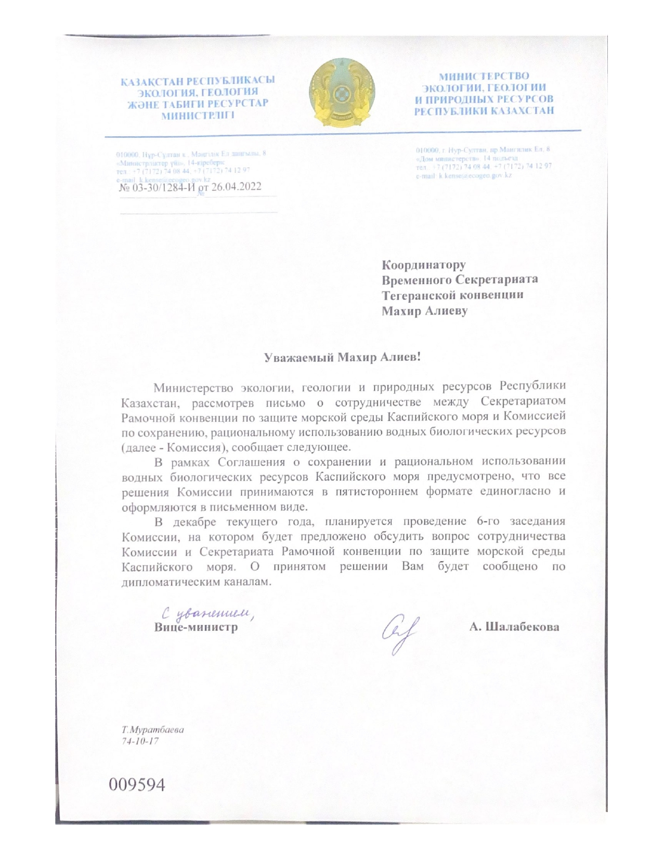

All co-financing figures to be confirmed during project document development
This is a preliminary budget; detailed budget at activity level, including coordination and implementation costs will be prepared during the project document development.
As per Executive Board Decision 2013/9

