INFORMATION NOTE FOR PARTICIPANTS

GENERAL

- The Sixth Meeting of the Conference of the Parties to the Framework Convention for the
Protection of the Marine Environment of the Caspian Sea is scheduled to be held from 19 to 21
October 2022 at Fairmont Hotel in Baku, Azerbaijan.

MEETING SCHEDULE
- The tentative schedule for the Conference is as follows.
- The working sessions will be opened at 9 a.m. on Wednesday, 19 October 2022, in Uzeyir Hajibeyov Hall of the Fairmont Hotel. Guiding signs will show the way to the Conference Hall.
- The Inaugural Session (High-level segment) will start at the Uzeyir Hajibeyov Hall on 21 October 2022, at 10 a.m. with a welcome note from the host Government.

PRE-REGISTRATION OF PARTICIPANTS

- A registration desk will be set up at the entrance of the Meeting Hall on the following day during the
hours indicated:

19 October 2022 08:30-08:50 a.m.

Participants attending the events are required to register and obtain meeting badges prior to the opening of the Conference on 19 October 2022.
- SITE VISITS
- Site visits to be organized by Ministry of Ecology and Natural Resources of the Republic of Azerbaijan on October 19-21, 2022 to some industrial and commercial facilities as indicated below. Participants may choose the appropriate visits in terms of their interest and inform the organizers about the definite visit date and time in advance.
- “Nerekend” sturgeon fish-breeding complex: Approximately 60 km from the city center. The
complex is situated in Pirallahi district
- Azerbaijan Fish Farm LLC: You can find more information about the facility at http://aff.az/. Approximately 60 km from the city center.
- Sumgait Chemical Industrial Park (SCIP) LLC: Approximately 40 km from the city center. You can find more information at https://scip.az/en
- Alat Free Economic Zone (AFEZ): Approximately 40 km from the city center. More
information at https://afez.az/
- Alif Hajiyev Research Vessel: More information at
http://eco.gov.az/index.php?ln=az&pg=700 .

- EXCURSION IN THE BAKU CITY
7. An excursion to some sightseeing and historical places of Baku will be organized for the guests on
October 19-21, 2022. Participants may choose the appropriate visits in terms of their interest and
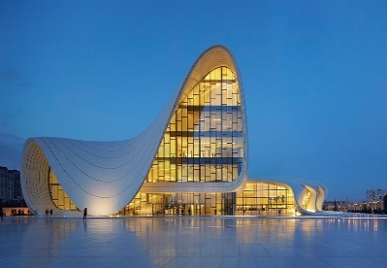
inform the organizers about the definite visit date and time in advance.
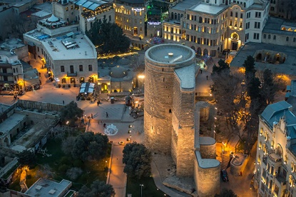
“HEYDAR ALIYEV CENTER
https://heydaraliyevcenter.az/#main
“ICHERISHEHER (Old City)”
https://icherisheher.gov.az/en/

WEATHER
8. October to be moderately hot and dry in Baku. Average temperature is fluctuating between 21.5°C (70.7°F) and 25.2°C (77.4°F). Current weather conditions in the area can be found at:
https://meteo.az/

FOREIGN EXCHANGE AND BANKING FACILITIES

- The currency in Baku is Azerbaijani manat (AZN). Foreign currency can be exchanged at exchange counters and in hotels without restriction upon presentation of ID. The current rate of exchange against the United States dollar is approximately 1USD=1,70 AZN as of 22 September
2022.

- You may pay also with card, MasterCard and Visa are commonly accepted, though cash payments are more common and preferable in most cases. Recently Google Pay is also working in Azerbaijan.

HOTEL ACCOMMODATION

- Official hotels include:
№ | Hotel | Price | Rate | Location
1 | Midway Hotel | 55 USD (Breakfast included) | **** | 1.7 km to the conference venue
2 | City Park Hotel | 57 USD (Breakfast included) | **** | 1.4 km to the conference venue
3 | Qafqaz Point Hotel | 63 USD (Breakfast included) | **** | 1.9 km to the conference venue
4 | Park Inn Hotel | 90 USD (Breakfast included) | **** | 2.5 km to the conference venue
5 | Intercontinental Hotel | 150 USD (Breakfast included) | ***** | 2.1 km to the conference venue
6 | Fairmont Baku Hotel | 180 USD (Breakfast included) | ***** | Conference venue

PAYMENT OF HOTEL ACCOUNTS

- Before departing from Baku, participants are expected to settle directly with the respective hotels all accounts, including room charges and other expenses, such as for local and long-distance telephone calls, internet use, business center use, laundry, room service, and hotel transportation services, as well as mini-bar items and restaurant and bar services. Participants are also responsible for any charges incurred with respect to rooms remaining vacant owing to their late arrival or rescheduled departure for which inadequate prior notice is given.

AIRPORT PICK UP

- Transportation for participants from/to the airports are provided. However, participants are responsible for arranging their own transportation between respective accommodation and the meeting venue.

LOCAL TRANSPORTATION
- Baku has one international airport - Heydar Aliyev International Airport located in the 20 km far from city center. Taxis can be hired at the airport and prices vary depending on the time of day, but usually stay within the 15-25 range.

- Baku has a well-developed public transport system with the Baku Metro and Baku Bus servicing the city. The prices for public transport start at 0.30 AZN or 30 qəpik (coin version of manat) covering the cost of a one-way ticket. For easy travel, there is also the possibility of purchasing a BakıKart (2 AZN plus reusable credit or a disposable card allowing up to 4 rides costing 1.2 AZN + 0.3 ANZ card fee). They can be used interchangeably for both buses and metro.

- Taxis within the city can be ordered in hotel lobbies, on the streets, by phone call, or via mobile apps. Prices depend on the Taxi Company and distance. The standard fare is around 0.70 AZN per kilometer. There are so-called London cabs, purple, white or red (usually equipped with a card machine), local taxi companies, as well as apps such as Uber or Bolt. It is recommended to ask for the price before entering the vehicle since some taxis are not equipped with taximeters.

- COVID-19 REGULATION

- Please find the most recent information regarding COVID-19 regulations on the website (English) https://azerbaijan.travel/covid-19-en and (Russian) https://azerbaijan.travel/covid-19-ru
For further information related to COVID-19 entry regulation, participants are kindly asked to familiarize themselves with regulation of the respective airlines for any country-specific inquiries pertaining to their travel arrangements.

MEETING DOCUMENTS

- All information and documents of the event will be made available in English and
Russian at http://www.tehranconvention.org.

INQUIRIES

- Participants desiring further information or assistance may contact the following persons:

- Ms. Aynur Mutallimova
Head advisor of Division for international cooperation under MENR
E-mail: aynur.aliyeva@eco.gov.az
Tel: (+99451) 312 12 92 (WhatsApp)

- Ms. Sanubar Samadova
Head advisor of Division for Ecological Policy under MENR
E-mail: sanubar.samedova@eco.gov.az
Tel: (+99455) 797 69 25 (WhatsApp)

