24 November 2021

Caspian Sea Plan Concerning Regional Co-operation
in Combating Oil Pollution in Cases of Emergency

1. INTRODUCTION 2
1.1. Background 2
1.2. Definitions, Acronyms and Abbreviations 3
1.3. Purpose and Objectives 7
1.4. Scope and Geographical Coverage 8
2. POLICY AND RESPONSIBILITIES 9
2.1. Basis for the Plan 9
2.2. Exchange of information 9
2.3. Meetings of Operational Authorities responsible for the implementation of the Plan 10
2.4. Joint training and exercises 10
2.5. Revision and amendment of the Plan 11
3. RESPONSE ELEMENTS AND PLANNING 13
3.1. Mechanism for Activating the Plan 13
3.2. Assumption of the Role of the Lead State 13
3.3. National On-Scene Commander (NOSC) / Supreme On-Scene Commander (SOSC) 14
3.4. Emergency Response Centres/Joint Emergency Response Centre 14
3.5. Support Teams 15
3.6. Command Structure 16
3.7. Communications arrangements 16
3.8. Response Planning 17
3.9. Response strategy 17
4. RESPONSE OPERATIONS 21
4.1. Response Phases 21
4.2. Response Procedure 21
4.3. Spill Surveillance 23
4.4. Requests for Assistance within the Framework of the Plan 24
4.5. Joint Response Operations 25
4.6. Use of Dispersants 25
4.7. Request for Additional Assistance from Other Parties 26
4.8. Termination of Joint Response Operations and Deactivation of the Plan 26
5. COMMUNICATIONS AND REPORTING 28
5.1. Communications System 28
5.2. Pollution Reporting System (POLREP) 28
5.3. Situation Reports (SITREPs) 29
5.4. Post Incident Reports 29
6. ADMINISTRATION, LOGISTICS AND FUNDING 31
6.1. Logistics 31
6.2. Financial Procedures 31
6.3. Transboundary Movement of Response Personnel, Equipment, Products and Self-Contained Units 34
6.4. Health and Safety, Medical Insurance and Medical Assistance 36
6.5. Responsibility for Injury and Damage 36
6.6. Documentation of Response Operations and Related Costs 36
7. PUBLIC INFORMATION 38
7.1. Public Relations Officer (PRO) 38
7.2. Press Releases 38
7.3. Press Conferences 39

- INTRODUCTION
  - Background
The Caspian Sea is an enclosed body of water that is undergoing a rapid increase in oil and gas exploration and production activities.
Several thousand ships per annum cross the Caspian Sea, many of which are oil tankers and it is estimated that millions of tons of oil are transported annually. The shipping traffic is expected to increase substantially in the near future with the growth of the oil industry in the Caspian Sea region. The permanent presence of risk associated with this industry calls for co-ordination of all emergency response resources at both national and regional level.
The Framework Convention for the Protection of the Marine Environment of the Caspian Sea (Tehran Convention) and its Protocol concerning Regional Preparedness, Response and Co-operation in Combating Oil Pollution Incidents provides the legal framework for actions concerning regional co-operation in combating marine pollution. These legal instruments oblige the Contracting Parties to initiate, both individually and jointly, the actions required in order to effectively prepare for and respond to marine oil pollution incidents.
According to the Aktau Protocol, the littoral States agree upon certain obligations which primarily concern: the development of their national contingency plans and pollution response capabilities; the distribution of information to the other Parties regarding the national organisation and competent national authorities; informing the other Parties of all oil pollution incidents, their subsequent development and the actions taken; and the provision of assistance to a Party which so requests. Furthermore, every coastal State shall endeavour to maintain and promote, either individually or through bilateral or multilateral co-operation, their contingency plans and means for combating pollution of the sea by oil. These means shall include, in particular, equipment, ships, offshore units, aircraft and manpower prepared for operations in cases of emergency.
In order to comply with their obligations, the States must be prepared for the intervention of their authorities and strike teams both at national and regional level. National arrangements for preparedness and response are essential for quick and efficient action. They include clear responsibilities of the various authorities for taking actions and coordinating the follow-up of such actions. Also essential is the existence of the pollution response equipment that allows the threatened Party to initiate response operations and to protect the most sensitive sites during the crucial first hours. Meanwhile, pooling of resources and expertise provides a cost-effective and efficient way of combating a major spill that can not immediately be dealt with by the existing resources of a single country. Organising such co-operation requires detailed planning and can only be achieved through operational arrangements adopted at the regional level. The arrangements in this Caspian Sea Plan Concerning Regional Co-operation in Combating Oil Pollution in Cases of Emergency (the Plan) are intended to facilitate the development of joint response operations and to co-ordinate the use of the available resources in the region. They also outline in advance the financial conditions and administrative clauses of the actions, thus permitting rapid intervention in case of emergency by removing the need for lengthy negotiations during the course of the event.
The Republic of Azerbaijan, the Islamic Republic of Iran, the Republic of Kazakhstan, the Russian Federation and Turkmenistan agree to adopt, aimed at the implementation of the Aktau Protocol to the Tehran Convention, this Plan for responding promptly and effectively to major marine oil pollution incidents affecting or likely to affect the Caspian Sea, its coasts and the related interests of any of the five countries concerned.
  - Definitions, Acronyms and Abbreviations
For the purpose of this Plan:
Oil means petroleum in any form including crude oil, fuel oil, sludge, oil refuse and refined products.
Maritime casualty means a collision of ships, stranding or incident of navigation, or other occurrence on board a ship and offshore unit or external to it resulting in material damage or imminent threat of material damage to a ship, offshore unit or cargo.
Ship means a vessel of any kind that operates in the marine environment, including hovercraft, hydrofoil boats, submarines, towed and self-driving boats.
Offshore unit means any platforms and other manmade offshore structures, fixed or floating offshore installations or structure engaged in exploration, exploitation or production activities related to hydrocarbon resources or their loading or unloading.
Oil pollution incident means an occurrence or series of occurrences having the same origin, which results or may result in a discharge of oil and which poses or may pose a threat to the marine environment, or to the coastline or related interests of one or more States, and which requires emergency action or other immediate response.
Related interests means the interests of a Caspian Sea littoral State directly affected or threatened by an oil pollution incident including, among others:
  - the health of the coastal population;
  - the conservation of biological diversity and the sustainable use of marine and coastal biological resources;
  - maritime activities in coastal waters, in ports or estuaries, including fishing activities;
  - the cultural, aesthetic, scientific and educational value of the area;
  - the historical and touristic appeal of the area in question, including water sports and recreation;
  - industrial activities which rely on the intake of seawater, including desalination plants and power plants.
The Aktau Protocol means the Protocol concerning Regional Preparedness, Response and Co-operation in Combating Oil Pollution Incidents.
The Plan means the Caspian Sea Plan Concerning Regional Co-operation in Combating Oil Pollution in Cases of Emergency.
Parties means the Republic of Azerbaijan, the Islamic Republic of Iran, the Republic of Kazakhstan, the Russian Federation and Turkmenistan.
Territory means the geographic area covered by the procedures in the Parties’ National Contingency Plans.
Lead State means the Party in whose territory a maritime casualty or an oil pollution incident has occurred and which has activated the Plan and/or asked for assistance within the framework of the Plan, or the Party to whom the lead role has been transferred. The Lead State exercises the Operational Command of the Joint Response Operations and designates the Supreme On-Scene Commander (SOSC).
Lead Authority means the Operational Authority of the Lead State.
Governmental Authority means the competent national authority having the governmental responsibility for dealing with marine oil pollution incidents as specified in Article 5 (1) (a) and 5 (1) (c) of the Aktau Protocol. This authority may be shared between different Ministries or departments.
Operational Authority means the national entity designated by the Government, having the operational responsibility for dealing with marine oil pollution incidents. This entity may fulfil the role of national operational contact point as specified in Article 5 (1) (b) of the Aktau Protocol.
Operational Command means overall co-ordination and control of joint response operations, including both national resources and strike teams, equipment and other resources (aircraft, vessels) rendered as assistance by other Parties. It is exerted by the Operational Authority of the Lead State, through the Supreme On-Scene Commander (SOSC).
Operational Control means direct control over personnel, means and units taking part in the joint response operations, including giving orders and supplying information necessary for the execution of response operations. It is exerted by the National On-Scene Commanders (NOSC) of the Parties taking part in the operations, or by officers designated by them.
Tactical Command means directing and supervising the execution of specific tasks by teams and/or units on the scene of operations. It is exerted by the leaders of such teams and/or commanders of units.
Supreme On-Scene Commander (SOSC) means a designated officer of the Lead State, having the overall operational command of all joint response operations undertaken within the framework of the Plan.
National On-Scene Commander (NOSC) means an officer, designated by the Operational Authority, having operational control of all national pollution response resources which might, if so requested, participate in joint response operations. (Note: NOSC is preferably, but not necessarily, the same officer who performs the duty of Supreme On-Scene Commander under the National Contingency Plan) Following the activation of the Plan, the NOSC of the Lead State assumes the role of SOSC, while NOSCs of the assisting countries, operating under the operational command of the SOSC, nevertheless retain the operational control over their respective strike teams and self-contained response units (vessels, aircraft).
Liaison Officer means an officer from an assisting Party participating in the joint response operations, who is integrated in the staff of the SOSC with a view to providing necessary information on national resources rendered as assistance to the Lead State and to facilitate communications with his/her respective NOSC.
Public Relations Officer means an officer in charge of informing the public and the media on the course of events and advising the SOSC on public reaction.
Emergency Response Centre means an office, manned 24 hours a day and equipped with appropriate communications equipment, which has been set up, for the purpose of the Plan, by each Party and which will serve as the operations room of the NOSC or SOSC respectively, whenever the Plan is activated.
Joint Emergency Response Centre (JERC) means the Emergency Response Centre of the Lead State during joint response operations.
Strike team means a group of personnel sent as assistance from one Party to another in order to take part as an independent unit in joint response operations. It may include personnel on board vessels, aircraft or other self-contained units or personnel assisting in shore clean-up operations. During joint response operations, strike teams work under the tactical command of their leaders, the operational control of their respective NOSCs, and under the overall operational command of the SOSC.
Operations at sea means any measures, including intervention on the source of pollution, aerial surveillance, containment of the pollutant, recovery of the pollutant, application of treatment agents from vessels and aircraft, or any other action taken in the open sea (offshore) in order to respond to an oil pollution incident, restrict the spreading and facilitate the removal of the oil and mitigate the consequences of the incident.
Operations on shore (shore clean-up operations) means any action taken on shore, or in the sea immediately adjacent to the shore, in order to recover, remove or destroy the oil and reduce its impact or effects.
Pollution Report (POLREP) means the incident report by which one Party warns the other Parties of a spill and through which it notifies the other Parties of the activation of the Plan and requests assistance.
Situation Report (SITREP) means the report by which the Lead State keeps the other Parties informed about the situation.
Regional Mechanism means the procedures decided by the Conference of the Parties to the Tehran Convention to assist the Parties in reacting promptly and effectively to oil pollution incidents, with functions as described in Article 13 of the Aktau Protocol.

The following are the main Abbreviations used in this document:

ERC Emergency Response Centre
IMO International Maritime Organization
IOPC FUND International Oil Pollution Compensation Fund
JERC Joint Emergency Response Centre
NCP National Contingency Plan
NOSC National On-Scene Commander
OPRC International Convention on Oil Pollution Preparedness, Response and Co-operation, 1990
POLREP Pollution Report
PRO Public Relations Officer
SITREP Situation Report
SOSC Supreme On-Scene Commander

  - Purpose and Objectives
The purpose of this Plan is to establish, in order to implement Articles 4 (4) and 8 (1) (d) of the Aktau Protocol to the Tehran Convention, a mechanism for mutual assistance, under which the competent state authorities will co-operate in order to co-ordinate and integrate their response to marine oil pollution incidents affecting or likely to affect the territory and related interests of one or more of these authorities, or to incidents exceeding the available response capacity of each of these countries individually.
The general objective of the Plan is to organise a prompt and effective response to major oil spills affecting, or likely to affect, the territory of one or more of the countries concerned and to facilitate co-operation in the field of preparedness and response for pollution by oil.
For this purpose, the following specific objectives are defined:
- to define the extent of co-operation for the implementation of the Plan between the responsible authorities at the operational level;
- to divide the responsibilities and to anticipate the transfer of responsibility from one Party to another;
- to establish the principles of command and liaison, and to define the corresponding structures;
- to provide arrangements concerning the operation of ships and aircraft of one of the Parties within the territory of the other Parties;
- to specify the type of assistance which might be provided and the conditions under which it will be provided;
- to determine in advance the financial conditions and administrative modalities related to co-operative actions in case of emergency.

In order to achieve these objectives, the following actions are intended to be taken through the implementation of the Plan:
- developing appropriate preparedness measures and effective systems for detecting and reporting oil pollution incidents affecting or likely to affect the responsibility zone of the Parties;
- promoting and implementing regional co-operation in marine pollution contingency planning, prevention, control and clean-up operations;
- establishing the necessary measures to restrict spreading and to minimize the hazard posed by oil spills;
- developing and implementing a programme of training courses and practical exercises for different levels of personnel involved in oil pollution prevention and combating;
- developing procedures to increase regional co-operation.

Nevertheless, the Parties agree that response operations in case of a marine oil pollution incident which occurs within the territory of one of the Parties will be conducted in accordance with the provisions of the National Contingency Plan of the Party concerned.
  - Scope and Geographical Coverage
This Plan applies to oil pollution incidents in the Caspian Sea. It will apply to oil spills which cause or could cause damage to the environment in countries neighbouring the source of the incident. It will also apply when only one country is affected but the magnitude of the spill is such that the incident requires assistance upon request from another country.
This Plan is intended to be a regional co-operation arrangement for the implementation of the Aktau Protocol between the following countries:
The Republic of Azerbaijan
The Islamic Republic of Iran
The Republic of Kazakhstan
The Russian Federation
Turkmenistan
This Plan organises the activities of responsible authorities in each country, prescribes a response structure and establishes a method of operation for personnel responding to an incident.

- POLICY AND RESPONSIBILITIES
  - Basis for the Plan
The essence of the oil spill response planning framework of the Caspian Sea is that each Party shall have its own National Contingency Plan (NCP) and resources to respond to marine oil spills in its territory. The purpose of this Plan is to provide the basis for interaction and describe the procedures for giving effect to joint response operations. Such operations may occur when a Party whose coasts and related interests are threatened by a spill and its own resources are inadequate or inappropriate to deal with it effectively. In such cases, the Party at risk may call for assistance from the other Parties and will normally be responsible for organising the joint response operation.
  - Exchange of information
In accordance with Articles 5 and 6 of the Aktau Protocol in order to implement this Plan, each Party shall inform the other Parties, either directly or through the Regional Mechanism, of:
    - the competent Governmental Authority with overall responsibility for preparedness and response to oil pollution incidents including responsibility for the implementation of this Plan and, where appropriate, the names of the responsible officers within these authorities (Annex 1). Unless otherwise determined, the Governmental Authority will be the authority entitled to act on behalf of the State to request assistance or to decide to render assistance when requested;
    - the National Operational Authorities, responsible at the operational level for the implementation of this Plan and in particular for exercising Operational Command in case of Joint Response Operations and, where appropriate, the names of the responsible officers within these Authorities (Annex 1);
    - the national operational contact points responsible for receiving and transmitting reports on oil pollution incidents on a 24-hour basis (Annex 1);
    - the designated national Emergency Response Centres (Annex 1);
    - the designated National On-Scene Commanders (Annex 1);
    - the designated competent customs authorities and immigration authorities (Annex 1);
    - at least those parts of their respective National Contingency Plan which might be relevant in cases of conducting joint response operations and, in particular, a description of the administrative organization and the responsibilities of each of the constituent authorities in preparing for and combating oil pollution incidents (Annex 2);
    - inventories of pollution response equipment and products, as well as other means (for example, vessels and aircraft) in each country, which may be available for use in joint response operations (Annex 3);
    - directories of experts, trained personnel and strike teams designated by each Party to take part in joint response operations (Annex 3).

The information listed above is attached to this Plan in Annexes 1, 2 and 3.
Parties shall inform each other of any changes in the information listed above as soon as these occur, using routine communication channels and supplying relevant changes to the applicable annexes.
Each Operational Authority is responsible for the accuracy of information pertaining to its Party.
Each Operational Authority shall acknowledge receipt of any changes and/or modifications regarding the above information and is responsible for updating its respective copy/copies of the Plan accordingly.
Official versions of this Plan will be made available in the official working languages of the Convention.
The English and Russian languages shall be used in all communications related to the Plan. The Regional Mechanism shall provide the translation of documents into English or Russian languages as appropriate.
  - Meetings of Operational Authorities responsible for the implementation of the Plan
The Operational Authorities shall meet regularly, and as a minimum once in two years, in order to discuss questions related to the implementation of the Plan, to share information on the response to actual incidents, and to organize training courses and/or exercises and other relevant matters.
Regular meetings shall be hosted in turn by each Party in alphabetical order of the names of the Parties in the English language.
The final report of each meeting shall be prepared by the Party organizing the meeting in agreement with the other Parties. The Operational Authority of the host Party shall provide the necessary logistic support for the smooth running of such meetings.
  - Joint training and exercises
The Parties shall conduct as agreed (at least once in three years) joint training courses and/or joint exercises. The main objectives of these training courses and exercises shall be:
- to improve the level of co-operation and co-ordination among operational personnel and, in particular, the strike teams of the different Parties;
- to test the command structure of the Plan;
- to achieve a satisfactory level of communication among personnel and, in particular, the strike teams designated to take part in joint response operations;
- to acquire knowledge in handling equipment, products and other means which might be used in joint response operations;
- to enable the personnel from different Parties to gain experience in working together.

The Parties shall host such joint training courses and exercises alternately. The Regional Mechanism shall organise the joint training courses or exercises and provide necessary logistic support. The expenses of the participants and means deployed in joint exercises shall be borne by the respective Parties. Scheduling the joint training and exercise programmes, their duration and other relevant details shall be decided at the biennial Conference of the Parties of the Aktau Protocol. Changes to scheduling the joint training and exercise programmes, their duration and other relevant details shall be decided by confirmation and submission of the agreed changes by the National Competent Authorities in writing to the Regional Mechanism.
The Regional Mechanism may also assist Parties to organise national training courses and exercises.
Training courses and exercises carried out in accordance with this Plan shall be based on the IMO OPRC Model Training Courses. Annex 9 provides for the Guidelines for Oil Spill Exercises under the Caspian Sea Plan Concerning Regional Co-operation in Combating Oil Pollution in Cases of Emergency.
  - Revision and amendment of the Plan
a) Final provisions
- If the need arises for changes in the provisions of the Plan, the Governmental Authority of the Party proposing such changes shall request the Regional Mechanism to place the matter on the agenda of the next meeting of the Operational Authorities.
- The draft proposal of a Party for any revision of or amendment to the Plan shall be circulated by the Tehran Convention Secretariat to the other Parties at least two months before the meeting of the Operational Authorities.
- All changes to the Plan are agreed at the meetings of the Operational Authorities by unanimous decision.
- The changes to the Plan shall come into effect immediately following confirmation and submission of the agreed changes by the National Competent Authorities in writing to the Regional Mechanism.
- If an unanimous decision concerning the revision and amendment of the Plan cannot be reached, the Parties agree to observe and retain its original provisions.
b) Operational provisions
The accuracy of the information concerning the operational provisions of the Plan pertaining to each Party is the sole responsibility of the respective Party.
Changing, modifying and updating of such information shall be done, as necessary, by the Operational Authority of the Party concerned, who shall ensure that other Parties and the Regional Mechanism are duly informed of such changes as soon as these are made.
c) Annexes
Information contained in the Annexes to the Plan shall be updated as necessary by the Operational Authorities of the Parties.
The Parties shall inform each other and the Regional Mechanism of any changes in the Annexes as soon as these are made.

It shall be the responsibility of the Operational Authorities to distribute copies of this Plan to appropriate officials and organizations within their country. It will be the responsibility of each plan holder to incorporate amendments to it in loose-leaf folders and to keep his copy of the Plan up to date.
- RESPONSE ELEMENTS AND PLANNING
  - Mechanism for Activating the Plan
The Plan shall be activated by the Operational Authority of one of the Parties in the following cases:
- occurrence, within the territory of the Party who activates the Plan, of an oil pollution incident which threatens to affect or has already affected the territory of another Party;
- occurrence, within the territory of the Party who activates the Plan, of an incident which severity surpasses the response capabilities of the Party concerned alone;
When, in the opinion of the Operational Authority of one of the Parties, its interests are threatened by an oil pollution incident which has occurred within the territory of another Party, and when the other Party/ies have not taken appropriate action to respond to it, that Party may, after consulting/agreeing with the affected Party/ies and other Parties concerned, activate the Plan.
The Operational Authority of the Party who has activated the Plan shall immediately inform the Operational Authorities of the other Parties that the Plan has been activated. Notification, which shall be formulated in accordance with the provisions of section 5.2, shall be transmitted to the Operational Authorities of the other Parties through the designated national contact points listed in Annex 1.
  - Assumption of the Role of the Lead State
The lead role in the implementation of the Plan shall be assumed by the Operational Authority of the Party whose territory or related interests have been affected, or are likely to be affected, by an oil pollution incident and who has activated the Plan.
The Lead State shall be responsible for:
- initiating the response to the spill;
- activating the Plan;
- surveillance of the pollution;
- assessment of the situation;
- spill movement forecasting;
- reporting regularly on the situation to the other Parties, particularly those whose interests may be threatened by the oil pollution incident;
- exercising Operational Command over joint response operations.
The lead role shall be transferred from one Party to another, when the major part of the pollutant has moved from the territory of the Party initially affected and who has activated the Plan, to the territory of another Party, and/or when the main response activities have moved to such other Party.
When the oil pollution incident which has occurred in the territory of one of the Parties directly (imminently) threatens the interests of another Party, the Parties may also agree, in direct contacts between their Operational Authorities, that the threatened Party will assume the lead role.
  - National On-Scene Commander (NOSC) / Supreme On-Scene Commander (SOSC)
For the purpose of the Plan, the Operational Authority of each Party shall nominate an officer who will exercise operational control over all response activities of that Party, including control over personnel (strike teams), equipment and self-contained units (vessels, aircraft). These officers shall be called National On-Scene Commanders (NOSC).
After the activation of the Plan and commencement of the joint response operations, the NOSC of the Lead State shall assume the role of the Supreme On-Scene Commander (SOSC). The SOSC shall have the overall responsibility for all decisions and actions taken in order to combat the pollution and to mitigate its consequences and as well as for the co-ordination of joint response operations. The SOSC, working in liaison with his/her Lead Authority, exerts Operational Command over joint response operations.
The NOSCs of the assisting Parties shall operate under the overall Operational Command of the SOSC, but shall nevertheless retain operational control over personnel, equipment and self-contained units of their respective Parties.
In order to relieve the SOSC of a part of his/her duties concerning operational control of national resources, the Lead Authority may, at the time of the activation of the Plan, designate another officer who will have direct operational control of the national resources taking part in the joint response operations and who will act as the NOSC of the Lead State.
In exercising his/her functions, the SOSC shall be assisted by a support team (see section 3.5).
Relevant information concerning NOSCs is given in Annex 1. It is the responsibility of the Operational Authority of each Party to keep this information up-to-date at all times.
  - Emergency Response Centres/Joint Emergency Response Centre
For the purpose of this Plan, each Party shall set up/designate an Emergency Response Centre (ERC) manned 24 hours a day, which will be equipped with an appropriate communications system and have the necessary facilities to be used as the operations room of the Operational Command during joint response operations.
If deemed necessary, each Party may decide to establish more than one ERC.
In cases of activation of the Plan, the ERC of the Lead State shall serve as the Joint Emergency Response Centre (JERC). The JERC shall serve as the base of the Supreme On-Scene Commander (SOSC) and the main communications centre for all communications related to the implementation of the Plan.
Alternative sites for the JERC, closer to the scene of the incident, may be specified if appropriate at the discretion of the Lead State.
When the lead role is transferred from one Party to another, the ERC of the Party assuming the lead role shall automatically become the JERC.
Relevant information concerning ERC(s) of each Party is given in Annex 1. It is the responsibility of the Operational Authority of each Party to keep this information up to date at all times.
  - Support Teams
With a view to assisting NOSC and/or SOSC, each Party shall set up its national support team composed of the representatives of various relevant public authorities, national services and industry including, in particular, the oil and shipping industries.
In cases of activation of the Plan, support teams shall operate from their respective national Emergency Response Centres.
The role of the support teams is advisory, and their functions include:
- providing assistance to the NOSC/SOSC in cases of activation of the Plan;
- providing advice to the NOSC/SOSC concerning, in particular, methods and techniques for combating pollution by oil, safety of navigation and salvage, knowledge of the marine environment (especially the potential biological impact) and fisheries, (radio) communications, public information and compensation for oil pollution damage;
- providing support in coordinating the activities of national public authorities, services and industry which might take part in joint response operations, concerning in particular the provision of personnel, equipment and other resources, logistic support, immigration and customs formalities;
- monitoring incoming reports and assessing the situation;
- coordinating all reporting on the status of the oil pollution incident to their respective national authorities.
After the termination of response operations, the support team shall, together with their respective NOSC:
- review post-incident reports from the NOSC/SOSC on the handling of the oil pollution incident for the purpose of analysing and introducing recommendations and improvements needed in the Plan and in their respective National Contingency Plans;
- forward to their respective national authorities relevant reports and recommendations, including NOSC/SOSC post-incident reports, support team debriefing reports and recommendations concerning amendments to the Plan or its Annexes.
  - Command Structure
The Command Structure for Joint Response Operations is shown in Diagram 1.
The Command Structure consists of 3 components:
- Operational Command which consists of taking decisions concerning the response strategy, defining the tasks of various groups of teams and units and having overall command and co-ordination over all resources taking part in the Joint Response Operations. Following the activation of the Plan, Operational Command over joint response operations is exercised by the Lead Authority through its NOSC who, once the Plan has been activated, assumes the role of SOSC.
- Operational Control which consists of giving orders to specific groups of teams and units, in accordance with the strategy and the tasks defined by the Operational Command. Operational Control over national resources is exercised by the NOSCs of the respective Parties. Operational Control over the resources of the Lead State is exercised by an officer designated to act as NOSC in lieu of the officer who has assumed the role of SOSC.
- Tactical Command which consists of directing and supervising the actions of each team or unit. Tactical Command is exercised by the Leader of each team or the Commander of each unit taking part in the response operations.
Liaison between the Lead Authority and the assisting Parties shall be maintained, according to the circumstances and to the type and importance of the assistance rendered, in one of the following ways:
- by direct telex, telefax, telephone and/or radio contacts between the Lead Authority (SOSC) and Operational Authorities (NOSCs) of the assisting Parties;
- by a Liaison Officer, sent to the Lead State by the Operational Authority of the Assisting Party with a view to being integrated in the staff of the SOSC. His/her duties shall be to provide necessary information on resources rendered as assistance and to facilitate communication with his/her respective NOSC, ERC and/or Strike Teams and self-contained units taking part in the operations;
- by the NOSC of the assisting Party who personally attends at the spill site and participates in the joint response operations.
  - Communications Arrangements
The communications network established by the Parties in accordance with section 5.1 shall be used for all exchanges of information pertinent to the implementation of the Plan.
- Telex, telefax or electronic communications shall be used for all communications between the Operational Authorities, SOSC, NOSCs and their respective Support Teams, particularly in cases of emergency.
Telephone and radio communications could also be used; however, all decisions, information relevant to the situation at the site of operations and, in particular, requests for assistance and replies to such requests shall be confirmed by either telex or telefax.
- Operational communications between JERC, SOSC, NOSCs, team and unit leaders and other participants in response operations shall be made by using pre-selected VHF channels (see Annex 4), mobile telephones and other appropriate means.
Lines of communication to be used in cases of Joint Response Operations are shown in Diagram 2.
- The English and Russian languages shall be used in all communications related to the Plan. The Regional Mechanism shall provide the translation of documents into English or Russian languages as appropriate.

  - Response Planning
The response to an oil pollution incident within the territory of each Party shall be conducted in accordance with the provisions of the NCP of the Lead State under the overall Operational Command of the Lead Authority exercised through the SOSC.
In order to facilitate the smooth proceeding of joint response operations, the Parties shall inform each other on the relevant parts of their NCPs and, in particular, those parts describing the national response organisation.
Copies of these parts of NCPs are attached to the Plan in Annex 2.
Maps showing possible sources of pollution, environmentally sensitive areas (see IMO Resolution A.927(22) “Guidelines for the Designation of Special Areas under MARPOL 73/78 and Guidelines for the Identification and Designation of Particularly Sensitive Sea Areas”, adopted on 29 November 2001), priorities for protection and areas where the use of dispersants is allowed, restricted or forbidden, within the territory of each Party, are given in Annex 5.
Deciding upon the response strategy to be applied in each particular oil pollution incident and the planning of specific operations shall be the responsibility of the SOSC. In taking such decisions, the SOSC shall follow the outline given in section 3.9.
  - Response Strategy
The main outline of the strategy which shall be applied by the Operational Authorities of the Parties in responding to marine oil pollution incidents within the framework of the Plan shall be as follows:
- assessment of the severity of the incident, taking into consideration, at least, the following criteria:
  - position at which the incident occurred;
  - type of oil;
  - amount of oil which has been released and/or is likely to be released;
  - the movement of the oil slick;
  - the degree of risk to human life and/or potential health hazard;
  - the fire/explosion hazard;
  - the toxicity of the released oil;
  - the potential to damage fisheries and natural resources, especially internationally protected sites such as those under the Ramsar Convention and the Protocol on the Conservation of Biological Diversity;
  - the potential to damage valuable property and/or to have serious economic consequences;
- activation of the National Contingency Plan and notification of other Parties;
- evaluation of available and required response resources;
- selection of appropriate response methods;
- activation of the Plan and request for assistance;
- implementation of selected response methods, making use of national resources and resources from assisting Parties;
- re-assessment of the situation and making necessary modifications (if necessary) of response actions;
- termination of response operations;
- de-activation of the Plan;
- the return to the country of origin of personnel, equipment and other means rendered as assistance by the other Parties.
Diagram 1: COMMAND STRUCTURE
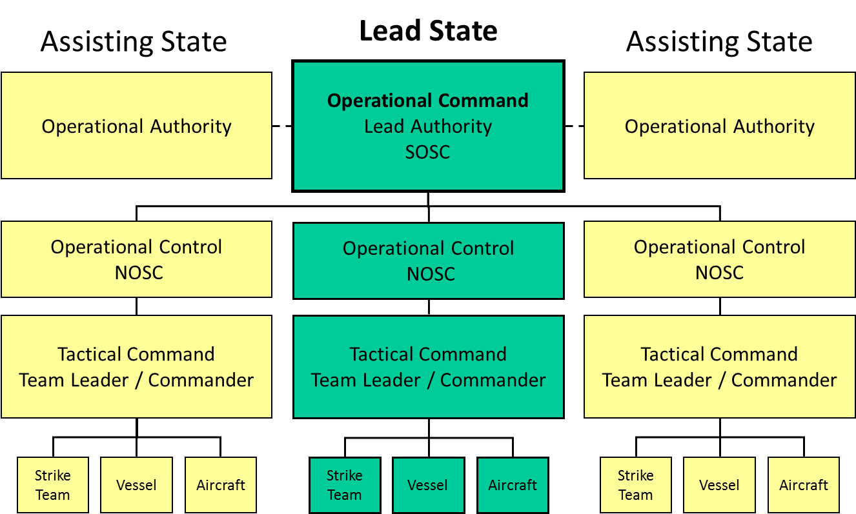

Diagram 2: LINES OF COMMUNICATION
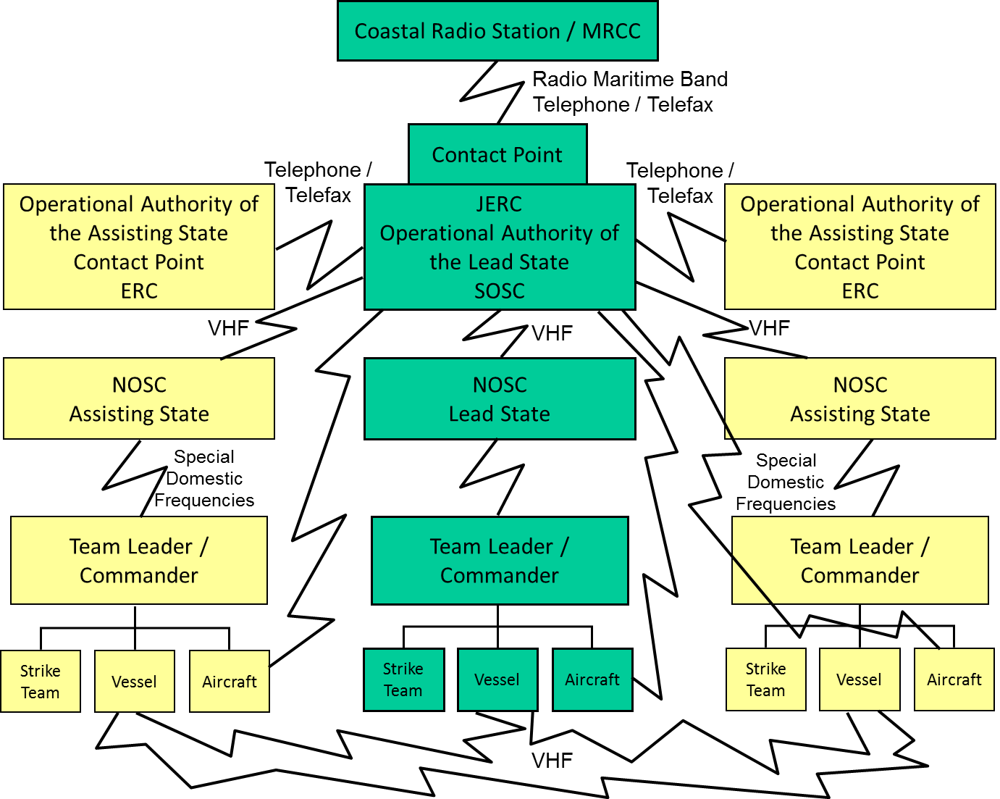
- RESPONSE OPERATIONS
  - Response Phases
For the purpose of the Plan, pollution response operations have been divided into six distinct phases:
Pre-activation of the Plan
Phase I Evaluation
Phase II Notification and consultation
Activation of the Plan
Phase III Activation of the Plan
Phase IV Request for assistance
Phase V Joint response operations at sea
Phase VI Joint response operations on shore
It is understood that, according to circumstances, entire phases or parts thereof may take place concurrently with one or more other phases.
  - Response Procedure
4.2.1 Pre-activation of the Plan
Phase I: Evaluation
Notification and verification of the initial information concerning oil pollution incidents shall be done, at the national level, in accordance with the provisions of the NCP.
Before activating the Plan, the Operational Authority of the Party concerned shall activate its NCP and alert other relevant authorities in its own country, including the NOSC.
Phase II: Notification and consultation
Regardless of the need for the activation of the Plan, the Operational Authority of the Party in whose territory the oil pollution incident has occurred shall, after receiving and verifying the incident report, immediately inform the Operational Authorities of the other Parties through their National Contact Points. It shall also alert the Regional Mechanism.
If the Operational Authority of the Party concerned considers that it might be necessary to activate the Plan, it shall immediately consult the Operational Authorities of the other Parties, clearly indicating the extent of the planned response measures and of the assistance which might be required.
4.2.2 Activation of the Plan
Phase III: Activation of the Plan
The decision to activate the Plan shall be taken by the Operational Authority of the Party affected by the incident or likely to be affected first, in accordance with the principles outlined in section 3.9.
After taking the decision to activate the Plan, the Operational Authority of the Party concerned shall assume the role of Lead Authority and shall:
- notify the Operational Authorities of the other Parties, through their designated National Contact Points and in accordance with the procedure described in section 5.2, that the Plan has been activated;
- activate its own ERC which shall assume the role of JERC;
- activate its own support team;
- appoint the SOSC who shall, in liaison with the Lead Authority and his/her support team, formulate the strategy for dealing with the incident and evaluate the need for assistance from other Parties. The SOSC shall initiate phases IV, V and VI of the response respectively.
Phase IV: Request for assistance
The request for assistance, on the basis of the SOSC's requirements and advice, shall be sent following the activation of the Plan by the Governmental Authority of the Lead State (designated in accordance with Article 5 (1)(c) of the Aktau Protocol) to the Governmental Authority of the other Parties in accordance with the procedure outlined in Annex 6 and taking into consideration the previous consultations (if any) with the Operational Authorities of the other Parties.
Phase V: Joint response operations at sea
The main objectives of the joint response operations at sea are to stop the spillage of the pollutant from the source, to restrict its spreading and movement and to remove as much pollutants as possible from the sea surface before it reaches the shores of one of the Parties.
Joint response operations at sea shall be conducted in accordance with the procedures described in the NCP of the Lead State. Operational Command over the joint response operations shall be exercised by the Lead Authority through the SOSC. Use shall primarily be made of the national resources of the Party concerned, which shall be supplemented as necessary by the personnel and means of the other Parties rendered as assistance upon the request of the Lead Authority. The personnel and means of the assisting Parties shall work under direct Operational Control and Tactical Command of their respective NOSCs and unit commanders or team leaders.
During the joint response operations, the ERC of the Lead State, which has assumed the role of JERC, shall serve as the main communications centre and headquarters of the SOSC.
Phase VI: Joint response operations on shore
The main objectives of joint response operations on shore are to protect environmentally sensitive coastal areas and other vulnerable resources, including islands, from the impact of the pollutant and to remove the pollutant which has reached the shore in order to prevent recontamination of other coastal areas.
This phase also includes treatment and final disposal of collected pollutant and/or contaminated beach material.
The principles of command outlined under Phase V shall also apply for the entire duration of Phase VI.
In order to increase the effectiveness of joint response operations on shore, JERC may be transferred, at the discretion of the Lead Authority, to adequate alternative premises closer to the site of operations (see section 3.4). In such cases, the Lead Authority shall duly inform the Operational Authorities of the assisting Parties of the move.
  - Spill Surveillance
For the surveillance of spill movement and behaviour, priority shall be given to aerial surveillance, although any other suitable means (ships, vessels) might also be used if the aircraft are not immediately available.
The surveillance of the spill and its movement, and the transmission of relevant reports to the other Parties, prior to the activation of the Plan, is the responsibility of the Party in whose territory the oil pollution incident has occurred. Following the activation of the Plan this responsibility rests with the SOSC, who shall take all necessary measures to ensure regular surveillance of the spill and its movement and behaviour, in order to properly assess the situation and decide on adequate response measures. For this purpose, the SOSC may request assistance from other Parties.
When deemed necessary, Parties agree to undertake measures to obtain urgent permission for flights over their territory by aircraft of the other Parties for the purpose of surveillance of spills within the framework of the Plan and following the specific request put forward by the Party in whose territory the oil pollution incident has occurred. In its request, the Lead Authority shall define precisely the aim of the mission and flight plan.
Information concerning aircraft suitable for spill surveillance (including their technical characteristics and specialized equipment), to which each Party has access, is given in Annex 3.
Airports within the territory of the Lead State, which might be used by surveillance aircraft of assisting Parties operating upon request in the air space of the Lead State, are listed together with relevant navigational and technical information, in Annex 3.
Guidelines for spill assessment and aerial surveillance are given in Annex 7.
  - Requests for Assistance within the Framework of the Plan
Following the activation of the Plan, the Party who has activated it may request assistance from the other Parties in any of the cases described in section 3.1.
Assistance might be requested in the form of:
- trained response personnel and, in particular, strike teams;
- specialized oil pollution combating equipment;
- oil pollution treatment products;
- other means, including, in particular, self-contained units such as vessels and aircraft;
and/or any combination thereof.
The request for assistance shall be formulated in a clear and precise manner, using the standard form defined in the POLFAC section of the POLREP in Annex 6. It shall contain a detailed description of the kind of assistance required and the purpose for which personnel, equipment, products and/or other means will be used.
The Party receiving a request for assistance shall immediately acknowledge receipt.
It is the duty of the Party or Parties receiving a request for assistance to offer it to the requesting Party with the shortest possible delay, taking into consideration that it should not deplete its own national resources beyond a reasonable level of preparedness.
With a view to being able to respond promptly to requests for assistance, Parties shall have part of their national response equipment, products and other means ready for transportation, at short notice, to the other Parties, except for force majeure situations, other emergencies and repair/maintenance situations.
Any response personnel and/or means, rendered as assistance within the framework of the Plan, will act under the overall Operational Command of the SOSC and the Lead Authority. However, their respective NOSCs shall retain operational control over them.
Following a decision to render assistance, liaison between the Lead State and the assisting Parties shall be maintained, according to the circumstances and to the type and importance of such assistance, in one of the ways described in section 3.6.
  - Joint Response Operations
For the purpose of the Plan, joint response operations are all oil pollution response operations in which personnel, equipment, products and/or other means of at least two Parties are involved.
Joint response operations can be carried out at sea and on shore, and include specific operations described in section 4.1.
The Lead State shall be in full charge of joint response operations. The command structure of the joint response operations is described in section 3.6 and Diagram 1.
Personnel, equipment and other means rendered as assistance by the other Parties within the framework of the Plan, shall execute their tasks and duties following the decisions of the SOSC, under the direct operational control of their NOSCs and the tactical command of their respective team leaders and unit commanders (see section 3.6). If strike teams or self-contained units are put at the disposal of the Lead State, the assisting Party will issue instructions to their respective team leaders and unit commanders who will then exercise tactical command over the details of the operations.
During joint response operations the SOSC shall, in addition to assuming overall Operational Command, be specifically responsible for coordinating the actions taken by national means (strike teams, vessels, aircraft) of the Lead State with those taken by the means of the assisting Parties.
The liaison between the assisting Party and the Lead State during joint response operations shall be maintained, according to the circumstances, either through direct contacts, through the Liaison Officer of the assisting Party integrated in the staff of the SOSC, or through NOSCs if these are personally taking part in the operations (see section 3.6).
The Lead Authority shall appoint an officer responsible for receiving the personnel, equipment, products and/or other means from the assisting Parties and for facilitating their participation in joint response operations from the moment of their arrival in the country to the moment of their departure. This officer shall work closely with the Liaison Officer of the assisting Party.
  - Use of Dispersants
Each Party shall define its policy regarding the use of dispersants in combating oil pollution and describe it in its NCP. For this purpose the Parties shall take account of the ”IMO Dispersant Guidelines in three parts: I Basic information on dispersants and their application; II Outline for a national policy on the use of dispersants: Proposed template for national policy for the use of dispersants; III Operational and technical sheets for surface application of dispersants” and other suitable international guidelines (e.g. IPIECA and IOGP Good Practice Guidelines for Dispersants, available at the official website of IPIECA).
Each Party shall inform the other Parties (see section 3.8) on its policy regarding the use of dispersants. The information shall include the list of dispersants approved for use in the territory of the Party and an indication of the zones where the use of dispersants is allowed, restricted or prohibited.
The Parties shall develop and agree upon a list of dispersants for use in case of an oil pollution incident.
In case of joint response operations, the Parties shall observe the principle of prior authorization for the use of dispersants. This authorization can be given only by the SOSC or by a person designated by him/her.
In the territory of each particular Party, dispersants shall always be used in accordance with the provisions of the NCP of the Party concerned.
If a Party has prohibited the use of dispersants in its waters, other Parties participating in joint response operations shall observe this decision.
  - Request for Additional Assistance from Other Parties
In the case of an oil pollution incident of such magnitude and nature that, in the opinion of the Lead Authority, the joint capabilities and resources of the Parties are not adequate to deal with it, the Lead State may request additional assistance from other States or other resources of equipment and strike teams outside the Caspian Sea region.
In such circumstances, and after consultations with the Lead Authority, other Parties may also request, in accordance with their needs, such additional assistance.
If more than one Party requests assistance from other States or other resources of equipment and strike teams, co-ordination of these actions between the Parties shall be made at the level of their Operational Authorities.
For this purpose, the Parties shall take account of the IMO “Guidelines on International Offers of Assistance (IOA) in Response to a Marine Oil Pollution Incident” and take note of the lexicon in section 11 and Appendix 5 of the guidelines.
  - Termination of Joint Response Operations and Deactivation of the Plan
The SOSC shall terminate the joint response operations when:
- pollution response measures have been finalised and the pollutant no longer threatens the interests of any of the Parties; or when
- pollution response measures have been completed to a point where response capabilities and resources of the Lead State are sufficient for successfully finalising the response activities.
When considering the termination of joint response operations, the SOSC shall take into account, in particular, the financial consequences of the continuation and whether continued action would be reasonable.
After taking the decision to terminate joint response operations, the SOSC shall immediately inform the NOSCs of the other Parties and their respective Operational Authorities of this decision and of the deactivation of the Plan.
Following the deactivation of the Plan, all personnel, equipment, unused products and other means which were involved in the joint response operations shall return or be returned to their respective countries of origin.
The Party who requested assistance shall take the necessary measures for the prompt return of the personnel of the assisting Parties, although the co-ordination and preparation of the necessary arrangements for their return remains the responsibility of their respective Operational Authorities.
Unless otherwise agreed, the Party who requested assistance shall be responsible for returning to the country of origin all equipment, rendered as assistance and all unused treatment products. All equipment and other means shall be returned clean and in the best possible working order.
The Operational Authorities of the Parties concerned may decide, in direct contacts between them, that unused treatment products remain in the country that requested the assistance.
Self-contained units (vessels, aircraft) shall return to their country of origin using their own power. The Party who requested assistance is responsible for facilitating formalities related to leaving its territory/airspace, for all units rendered as assistance.
The Party who requested assistance shall prepare a report on the effectiveness of the personnel, equipment, products and other means received as assistance. These reports shall be circulated to the other Parties.
- COMMUNICATIONS AND REPORTING
  - Communications System
Each Party shall establish and maintain an efficient communications system, operational 24 hours a day, which shall serve for:
- receiving reports on oil pollution incidents and transmitting these reports to the Operational Authorities and to other interested parties within the country;
- activation of the Plan, requesting assistance and the exchange of operational messages during joint response operations.
The system shall comprise national ERCs together with the National Contact Points for receiving reports on oil pollution incidents, if these are different from the ERCs.
Elements of this communications system which each Party shall establish, including telephone, telefax and telex numbers, e-mail addresses and websites, and the allocated radio frequencies and channels pertinent to each Party, are given in Annex 4.
  - Pollution Reporting System (POLREP)
For the exchange of information concerning oil pollution incidents, the Parties shall use the pollution reporting system (POLREP) which has been agreed for use within the framework of this Plan. The POLREP is divided into three parts:

Part I (POLWARN) is an initial notice (first information or a warning) of an oil pollution incident.

Part II (POLINF) is a detailed supplementary report to Part I (within 24 hours of the oil spill).

Part III (POLFAC) is used for requesting assistance from other Parties and for defining operational matters related to this assistance.

A detailed description of all three Parts of the POLREP is given in Annex 6. In situations where the type and extent of the required assistance have not yet been determined, the Party who takes the decision to activate the Plan shall utilize line 53 of the POLINF part of the POLREP message to inform the other Parties that the Plan has been activated.
  - Situation Reports (SITREPs)
During the entire period between the activation of the Plan and its deactivation, the Lead State keeps the other Parties informed on:
- the development of the situation regarding the oil pollution incident;
- the actions taken to combat pollution;
- the progress of the joint response operations;
- any decisions regarding future response activities;
- all other relevant information including, in particular, information concerning environmental impact, effects on marine and coastal resources, and the economic consequences of the oil pollution incident; and
- any other incidents occurring during or related to the response operation.
Such information shall be transmitted by the SOSC to the Operational Authorities of the Parties and to the Regional Mechanism either in the form of POLINF (see Annex 6) or as a text in the form of a situation report (SITREP).
The Lead Authority shall endeavour to transmit a POLINF and thereafter a SITREP at least once a day.
Before dissemination, each report shall be verified by the SOSC.
If pollution combating operations continue at the national level after the deactivation of the Plan, the Party affected by the incident shall continue to inform the other Parties and the Regional Mechanism of the situation until the final termination of all pollution response operations.
It is the responsibility of the Operational Authority of each Party to ensure that the situation reports are transmitted to all interested parties within its respective country.
  - Post Incident Reports
Following the termination of pollution response operations, taken at both national level and within the framework of the Plan, the NOSC and/or the SOSC respectively shall prepare a final report including:
- a description of the oil pollution incident and development of the situation;
- a description of the response measures taken;
- a description of the assistance rendered by the other Parties;
- an assessment of the complete response operation;
- an assessment of the assistance rendered by the other Parties;
- a description and analysis of the problems encountered in responding to the oil pollution incident;
- recommendations regarding the possible improvement of existing arrangements and, in particular, of the provisions of the Plan.
The final report may also include:
- an account of the costs incurred during the response by each Party;
- an estimate of environmental and economic damage.
Copies of the post-incident reports shall be sent to all Parties and to the Regional Mechanism.
The reports shall be analysed at the national level by the members of each support team and their respective NOSCs, who shall prepare recommendations concerning amendments and improvements of the Plan, and if necessary, of their NCPs (see sections 2.5 and 3.5).
The conduct of joint response operations and other questions of common interest shall be reviewed during the biennial Conference of the Parties of the Aktau Protocol.
- ADMINISTRATION, LOGISTICS AND FUNDING
  - Logistics
The Lead Authority is responsible for providing all the logistic support necessary for conducting joint response operations.
The Lead Authority shall, in particular:
- make the necessary arrangements for accommodation and transportation, within the assisted country, of all assisting personnel;
- when equipment and other means are received from the assisting Parties, take the necessary measures to provide:
- safe storage or parking places, as appropriate, including cranes, fork-lifts and other handling equipment, as necessary;
- fuel, lubricants, basic repair and maintenance facilities.
As regards the stay in the territory of the Lead State of vessels and aircraft rendered as assistance by other Parties, the Lead Authority shall take the necessary measures to ensure assistance to the crews at airports and in ports, as appropriate, and to provide security services for ships, aircraft and related equipment, while these are in ports or at airports of the Lead State.
  - Financial Procedures
The Parties shall observe the general principles as laid down in Article 11 of the Aktau Protocol concerning the reimbursement of costs related to mutual assistance as follows:
- The Party who has requested assistance shall reimburse to the assisting Party all expenses incurred in rendering such assistance, according to the invoice submitted by the assisting Party unless otherwise decided on a case-by-case basis.
- At the time of incident, the assisting Party shall provide information on the wages of personnel, the rental rates for equipment and other means and the cost of treatment products, which might be rendered as assistance.
The Parties shall endeavour to harmonise their rates and discuss all relevant questions during the meetings of the Operational Authorities.
- The assisting Party shall, immediately following receipt of a request for assistance, submit to the requesting Party an offer of the personnel, equipment and other means which can be provided and an estimate of the costs of such assistance.
- If the Party who requested assistance decides to withdraw the request for whatever reason, it shall nevertheless pay to the assisting Party all the expenses incurred up to the moment when the request was withdrawn or the personnel and equipment return to their country of origin, as appropriate.
- In the event of the transfer of responsibility of Lead State from one Party to another, the costs incurred by requests for assistance by the Lead State shall remain that State's responsibility up to the time of transfer of Operational Command. Any continuation of assistance provided at the confirmed request of the Party taking over responsibility as Lead State shall also take over responsibility for the reimbursement of the costs of assistance from the time of transfer of Operational Command. Such transfer of responsibility shall be realized through an official request, including the date of transfer and description of the financial considerations before and after that.
- The Parties shall resolve all questions related to financial matters after the termination of joint response operations.
The provisions of this paragraph shall not prejudice the resolution of any dispute involving third parties that may arise regarding liability and compensation for damages resulting from any oil pollution incident.
In the case of joint response operations, the Lead State (the Party who has requested assistance) shall directly cover the following expenses related to the stay in its territory of personnel, equipment and means (including vessels and aircraft) of the assisting Party:
- board and lodging and/or daily subsistence allowance as appropriate, of all response personnel other than the crews of ships and vessels;
- any port dues for vessels and ships rendered as assistance;
- any airport dues for aircraft rendered as assistance;
- necessary fuel for all equipment and means including, in particular, vessels and aircraft, engaged in joint response operations;
- medical services provided to injured and ill personnel of the assisting Party;
- costs related to repatriation of any personnel who died, were injured or taken ill during joint response operations;
- maintenance costs for any piece of equipment, vessel and aircraft engaged in joint response operations;
- repair costs for any piece of equipment, vessel or aircraft damaged in its territory during and due to the joint response operations, if such repair needs to be made prior to returning to the country of origin of such equipment and means;
- costs of communications related to the joint response operations that have been incurred by the personnel of the assisting Party in the territory of the Lead State.

The assisting Party shall directly cover the following expenses related to the sending to the country that requested the assistance of its personnel, equipment, products or other means including, in particular, vessels and aircraft:
- the mobilization of personnel, equipment, products or other means;
- the costs of transport of personnel, equipment and products to and from the country where joint response operations are taking place ;
- fuel for self-contained units (vessels, aircraft) which travel to the scene of joint response operations using their own power;
- costs of communications related to joint response operations that are originating from the territory of the assisting Party;
- insurance of the personnel of the strike teams;
- medical services rendered, following their return to their country of origin, to response personnel who were injured or taken ill during joint response operations;
- maintenance and repair costs for equipment and means engaged in joint response operations which were incurred after the return of such equipment and means to the country of origin.

Following the termination of the joint response operations and the return of all personnel, equipment and other means which were engaged in the joint response operations, each assisting Party shall prepare a detailed invoice including the costs of assistance rendered to the Lead State and other expenses related to this assistance. The following items shall be included in the invoice:
- wages of personnel engaged in the joint response operations, calculated on the basis of the prices given to the Lead State when assistance was requested, and the daily work logs approved by the SOSC or another responsible officer of the Lead State;
- costs of rental of equipment and means calculated on the basis of the prices given to the Lead State when assistance was requested, and the daily work logs approved by the SOSC or another responsible officer of the Lead State;
- cost of treatment products used during joint response operations calculated on the basis of the prices given to the Lead State when assistance was requested, and the daily work logs approved by the SOSC or another responsible officer of the Lead State;
- all expenses incurred by the assisting Party as listed above;
- costs for replacement of equipment damaged beyond repair during joint response operations.

Upon receipt of such an invoice, the Party who had activated the Plan and requested assistance shall reimburse the expenses incurred by the assisting Parties in relation to the pollution response measures undertaken by these Parties following the activation of the Plan. The Party who activated the Plan shall subsequently include such invoices in its own claim for reimbursement of pollution response related costs, submitted to the party liable for the oil pollution incident, its insurers or an international system for compensation for pollution damages, as appropriate.
Alternatively, the Parties may agree that the claims for reimbursement of such expenses shall be submitted directly to the party liable for the oil pollution incident, its insurers or an international system for compensation for pollution damages, by each Party separately.
Regardless of the party to whom such claims are submitted, they shall be prepared in accordance with the guidelines provided by the IOPC Fund in its "Claims Manual" and attached to the Plan as Annex 8. An updated version of the IOPC Fund “Claims Manual” can be found on the IOPC Fund official website.
  - Transboundary Movement of Response Personnel, Equipment, Products and Self-Contained Units
In order to facilitate the movement of response personnel, equipment and other means to the place where the assistance is required, the requesting Party will:

- make arrangements for the rapid entry of equipment, products and personnel prior to their arrival and ensure that customs formalities are facilitated to the maximum extent. Equipment and products should be admitted on a temporary basis in accordance with the national law on customs duties of the requesting Party. Such equipment and products should be admitted free of excise and duties wherever possible.

- ensure that, should ships and aircraft be provided, ships are granted all necessary authorisations and aircraft cleared to fly in the national air space. A flight plan or a flight notification will be filed and accepted as an authorization for aircraft to take off, land ashore or at sea outside regular customs airfields.

    - Immigration and customs formalities
Each Party shall endeavour to make, at the national level, special arrangements applicable in emergency situations, concerning provisions for rapid granting of entry visas and work permits for personnel, as well as permits necessary for the transit or temporary importation of the requested equipment and material.
Details of such arrangements shall be included in the National Contingency Plan of each Party and are reproduced in Annex 2 to the Plan. This refers, in particular, to information which the assisting Party has to provide to the appropriate national authorities of the requesting Party in order to facilitate the implementation of these special arrangements.
The Parties shall designate competent customs authorities, responsible for the prompt clearing of customs formalities related to transboundary movement of response personnel and means in cases of activation of the Plan. The Parties shall keep each other permanently informed on such customs authorities, and this information (name of the office and of the responsible officer, address, telephone, telex and telefax number) shall be included in Annex 1.
Prior to sending assistance to the Party who so requests, the Operational Authority of the assisting Party shall establish direct contact with the competent customs authority of the requesting Party in order to obtain the necessary clearance for the entry of equipment, products and other means into the country.
    - Overflight procedures
Within the framework of the Plan and upon a specific request of the Lead State, aircraft of the other Parties might be allowed to enter and operate in the airspace of the Lead State for one or more of the following purposes:
- search and rescue;
- surveillance flights;
- transportation of response personnel, equipment and products;
- spraying of dispersants or other treatment products;
- other flights related to pollution response operations.
Each Party shall make, in advance, necessary arrangements concerning rapid granting of permits and clearances for civil aircraft (fixed wing or helicopters) of other Parties, who might be requested to take part in response operations within its airspace. Similar arrangements shall be made for the use of airport facilities by civilian fixed wing aircraft and helicopters engaged in joint response operations.
Overflight for the above-mentioned purposes, of the territory of one of the Parties, by military and state-owned aircraft of the other Parties, shall be decided on a case-by-case basis by the Parties over the territories of which the overflight would occur.
    - Navigation procedures
Within the framework of the Plan and upon the request of the Lead State, vessels of the other Parties might enter and operate in the territory of the Lead State for one or more of the following purposes:
- search and rescue;
- salvage operations;
- pollution response operations, including containment and recovery of spilled products, spraying of dispersants or other treatment products, storage and transportation of recovered pollutant;
- transportation of response personnel, equipment and products;
- any other voyage related to pollution response operations.
Each Party shall make, in advance, the necessary arrangements concerning the rapid granting of permits and clearances for the navigation of civil vessels (ships, boats, specialised anti-pollution vessels) of the other Parties who might be requested to take part in response operations within its territory. Similar arrangements shall be made for the use of port facilities by civilian vessels engaged in joint response operations.
Navigation for the above-mentioned purposes, in the territory of one of the Parties, by naval and state-owned vessels of the other Parties, shall be decided on a case-by-case basis by the Parties concerned.
In all cases the provisions of the International Convention on Facilitation of International Maritime Traffic, as amended, shall be observed by the Parties concerned.

Each Party shall exercise state border crossing and sojourn of foreign vessels, aircrafts and other transports means involved in combating oil pollution incidents, as well as personnel cargos, materials and equipment required to deal with such incidents pursuant to the regulations of the Party.
  - Health and Safety, Medical Insurance and Medical Assistance
Each Party shall ensure that proper health and safety procedures, including the wearing of protective clothing and safety equipment, are followed by its personnel at all times.
Each Party shall take the necessary measures to insure against death, illness and injury, its personnel who might participate in joint response operations, joint exercises and joint training courses.
The Lead State shall endeavour to offer the best possible initial medical care and services to any person from another Party who was injured or taken ill during his/her participation in joint response operations.
The Lead State shall facilitate the repatriation of assisting personnel who are injured or taken ill during joint response operations.
The costs of hospitalization and medical assistance rendered within the territory of the Lead State to injured or ill personnel of the assisting Party shall be borne by the Lead State. The Lead State might decide to claim the reimbursement of all such costs from the party responsible for the oil pollution incident, its insurer or an international system for compensation of pollution damages, as appropriate.
The Parties shall waive the right to make claims against each other for the reimbursement of costs of medical care rendered to persons injured and taken ill during joint response operations.
  - Responsibility for Injury and Damage
If assisting strike teams cause any damages to third parties at the time when they are going to or leaving the site of operations, or when they are engaged in oil spill combating and clean-up, the responsibility for such damages shall rest with the respective authority of the assisting Party.
Each Party shall be responsible for damages caused to third parties by its national strike teams during joint exercises.
  - Documentation of Response Operations and Related Costs
Full documentation of response activities is vital to facilitate the subsequent pursuance of claims for compensation.
The SOSC shall take all necessary measures to ensure that detailed records of all actions taken in order to respond to an oil pollution incident, within the framework of the Plan, are accurately kept. For this purpose, the SOSC will include a record keeping officer/financial controller in his/her support team.
As a minimum, the following records shall be regularly kept:
- Description of the situation (including photographs and video records where available), decisions taken and the response measures implemented;
- Daily work log giving details of:
  - operations in progress (place, time, purpose);
  - equipment and other means in use (place, time, purpose);
  - personnel employed (place, number, time);
  - response products and other material (e.g., fuel) consumed (type, quantity, purpose).
- Records of all expenditures made in relation to the pollution response operations.
Following the termination of the response operations, such records shall be made available to the national authority responsible for the submission of claims for compensation.
In cases where the Parties have agreed that the assisting Party will submit a separate claim for compensation, the authorities of the Lead State shall make available to the authorities of the assisting Parties copies of relevant records.
PUBLIC INFORMATION
  - Public Relations Officer (PRO)
After the activation of the Plan, the Lead Authority shall designate a Public Relations Officer (PRO) who shall be seconded to the SOSC's support team.
The PRO shall be responsible for:
- maintaining contacts with the press and other media including radio and TV;
- preparing press releases on behalf of the SOSC and the Lead Authority;
- following the information released by the press and the media and clarifying any possible misunderstandings.
  - Press Releases
Press releases shall be prepared and distributed to the press at least once a day during the entire period between the activation and the deactivation of the Plan.
Press releases shall be prepared by the PRO on the basis of accurate facts provided by the SOSC and/or his/her support team. They shall contain information concerning:
- the oil pollution incident and the development of the situation;
- technical data on vessels involved, type and characteristics of the pollutants, etc.;
- the measures taken to combat pollution;
- the progress of the response measures;
- injuries of personnel and damage to vessels, equipment, etc.
The following guidelines shall be observed when preparing press releases:
- prepare titles/headlines;
- give priority to the most recent and important information;
- use simple sentences and give only one idea per sentence;
- avoid quoting estimates, conjectures and suppositions;
- avoid giving opinions on environmental or other unquantifiable damages;
- draft final wordings very carefully.
Maps showing the area of incident, the evolution of the spill and the sites of the response operations should accompany press releases whenever possible.
All press releases shall be vetted and approved by the SOSC before distribution to the press.
  - Press Conferences
After the activation of the Plan, the Lead Authority may decide, in consultation with the SOSC, to organise one or more press conferences for briefing the media.
The following persons may take part in such press conferences:
- SOSC
- specially designated expert members of the support team
- PRO
- representative(s) of the Lead Authority
- representative(s) of the other Parties (e.g., Liaison Officers or NOSCs)
- representative(s) of ship, offshore units and cargo owners and/or their insurers.
Written information on the main facts concerning the oil pollution incident and the joint response operations, maps and photographs may be prepared in advance by the PRO and approved by the SOSC for use during the press conference.
The guidelines concerning the preparation of press releases (section 7.2) are also applicable to participants in press conferences.

List of Annexes of the Caspian Sea Plan Concerning Regional Co-operation

in Combating Oil Pollution in Cases of Emergency

Annex 1:

Directory of Competent National Authorities, Contact Points, Emergency Response Centres, National On-Scene-Commanders and Other Relevant Addresses

Annex 2:

Extracts of Relevant Sections of the National Contingency Plans

Annex 3:

Directory of Response Personnel and Inventory of Response Equipment, Products and Other Means which Each Party Might Offer as Assistance in the Event of Activation of the Plan

Annex 4:

Communication System

Annex 5:

National Maps

Annex 6:

Pollution Reporting System (POLREP)

Annex 7:

Spill Assessment and Aerial Surveillance

Annex 8:

Claims Manual – International Oil Pollution Compensation Fund

Annex 9:

Guidelines for Oil Spill Exercises under the Caspian Sea Plan Concerning Regional Co-operation in Combating Oil Pollution in Cases of Emergency

Annexes I-V are national annexes and are provided as separate documents.

Annex 6

POLREP

Pollution Reporting System

POLREP (Caspian Sea Report Format)

Note: It is the responsibility of the designated National Governmental Authority as the competent national authority with overall responsibility for preparedness and response to pollution incidents at sea, to act on behalf of each Party to request assistance from external sources and to decide whether to render assistance when requested by a neighbouring State.

POLLUTION REPORTING SYSTEM (POLREP)

1 The pollution reporting system is for use between Contracting Parties to the Emergency Protocol of the Framework Convention themselves and between the Contracting Parties and the Regional Centre, for exchanging information when pollution of the sea has occurred or when a threat of such is present.

2 The POLREP is divided into three parts:

.1 Part I or POLWARN POLlution gives first information or warning
(figures 1-5) WARNing of the pollution or the threat

.2 Part II or POLINF POLlution gives detailed supplementary report
(figures 40-60) INFormation as well as situation reports

.3 Part III or POLFAC POLlution is used for requesting assistance
(figures 80-99) FACilities from other Contracting Parties and
for defining operational matters
related to the assistance

3 A summarized list of POLREP is given below.

Address from .... to ....
INTRODUCTORY Date Time Group
PART Identification
Serial number
________________________________________________________________
1 Date and time
2 Position
PART I 3 Incident
(POLWARN) 4 Outflow
5 Acknowledge
________________________________________________________________
40 Date and time
41 Position
42 Characteristics of pollution
43 Source and cause of pollution
44 Wind direction and speed
45 Current or tide
46 Sea state and visibility
PART II 47 Drift of pollution
(POLINF) 48 Forecast
49 Identity of observer and ships on scene
50 Action taken
51 Photographs or samples
52 Names of other States informed
53-59 Spare
60 Acknowledge
________________________________________________________________
80 Date and time
81 Request for assistance
PART III 82 Cost
(POLFAC) 83 Pre-arrangements for the delivery
84 Assistance to where and how
85 Other States requested
86 Change of command
87 Exchange of information
88-98 Spare
99 Acknowledge

EXPLANATION OF A POLREP MESSAGE

INTRODUCTORY PART

__________________________________________________________________________________

Contents Remarks
__________________________________________________________________________________

ADDRESS Each report should start with an indication of the country whose competent national authority is sending it and of addressee e.g.:

FROM: KAZ (indicates the country which sends the report)
TO: IRAN (indicates the country to which it is sent) or
ERC (indicates that the message is sent to the Regional Centre).
__________________________________________________________________________________

DTG The day of the month followed by the time (hour and minute) of drafting
(Day Time Group) the message. Always a 6-figure group which may be followed by month indication. Time should be stated either as GMT, e.g. 092015Z june (i.e. the 9th of the relevant month at 20.15 GMT) or as local time e.g. 092115LT june.
__________________________________________________________________________________

IDENTIFICATION "POL..." indicates that the report might deal with all aspects of pollution (such as oil as well as other harmful substances).

".....REP" indicates that this is a report on a pollution incident.
It can contain up to 3 main parts:

Part I (POLWARN) - is an initial notice (a first information or a warning) of a casualty or the presence of oil slicks or harmful substances. This part of the report is numbered from 1 to 5.

Part II (POLINF) - is a detailed supplementary report to Part I. This part of the report is numbered from 40 to 60.

Part III (POLFAC) - is for requests for assistance from other Contracting Parties, as well as for defining operational matters related to the assistance. This part of the report is numbered from 80 to 99.

FRAMEWORK CONVENTION indicates that the message is sent within the framework of the Emergency Protocol of the Framework Convention for the Protection of the Marine Environment of the Caspian Sea.

Parts I, II and III can be transmitted all together in one report or separately. Furthermore, single figures from each part can be transmitted separately or combined with figures from the two other parts.

Figures without additional text shall not appear in the POLREP.

When Part I is used as warning of a serious threat, the message should be headed with the traffic priority word "URGENT".

All POLREPs containing ACKNOWLEDGE figures (5, 60 or 99) should be acknowledged as soon as possible by the competent national authority of the country receiving the message.

POLREPs should always be terminated by a message from the reporting State, which indicates that no more operational communication on that particular incident can be expected.

__________________________________________________________________________________

Contents Remarks
__________________________________________________________________________________

SERIAL NUMBER Each single report should be possible to identify and the receiving agency should be in a position to check whether all reports of the incident in question have been received. This is done by using a nation-identifier:

Azerbaijan ?
Iran ?
Kazakhstan KAZ ?
Russian Federation ?
Turkmenistan ?

Caspian Emergency Response ERC
Centre

The nation-identifier should be followed by a stroke and the name of the ship or other installation involved in the accident and another stroke followed by the number of the actual report concerning this particular accident. For example:

KAZ/POLLUX/1 indicates that this is the first report from Kazakhstan concerning the accident of MT "POLLUX".

KAZ/POLLUX/2, in accordance with the described system, indicates the second report on the same incident.
__________________________________________________________________________________

Part I (POLWARN)

__________________________________________________________________________________

Contents Remarks
__________________________________________________________________________________

1 DATE AND TIME The day of the month as well as the time of the day when the incident took place or, if the cause of the pollution is not known, the time of the observation should be stated with 6 figures. Time should be stated as GMT for example, 091900z (i.e. the 9th of the relevant month at 1900 GMT) or as local time for example, 091900lt (i.e. 9th of the relevant month at 1900 local time)
__________________________________________________________________________________

2 POSITION Indicates the main position of the incident in latitude and longitude in degrees and minutes and may, in addition, give the bearing of and the distance from a location known by the receiver.
__________________________________________________________________________________

3 INCIDENT The nature of the incident should be stated here, such as BLOWOUT, TANKER GROUNDING, TANKER COLLISION, OIL SLICK, etc.
__________________________________________________________________________________

4 OUTFLOW The nature of the pollution, such as CRUDE OIL, CHLORINE, DINITROL, PHENOL, etc. as well as the total quantity in tonnes of the outflow and/or the flow rate, as well as the risk of the further outflow. If there is no pollution but a pollution threat, the words NOT YET followed by the substance, for example, NOT YET FUEL OIL, should be stated.
__________________________________________________________________________________

5 ACKNOWLEDGE When this figure is used the telex should be acknowledged as soon as possible by the competent national authority.
__________________________________________________________________________________

Part II (POLINF)

__________________________________________________________________________________

Contents Remarks
__________________________________________________________________________________

40 DATE AND TIME No. 40 relates to the situation described in figures 41 to 60 if it varies from figure 1.
__________________________________________________________________________________

41 POSITION AND/OR Indicates the main position of the pollution in latitude and
EXTENT OF longitude in degrees and minutes and may in addition give
POLLUTION ON/ the distance and bearing of some prominent landmark known
ABOVE/IN THE SEA to the receiver if other than indicated in figure 2. Estimate amount of pollution (e.g. size of polluted areas, number of tonnes of oil spilled if other than indicated in figure 4, or number of containers, drums etc. lost). Indicates length and width of slick given in nautical miles if not indicated in Fig. 2.
__________________________________________________________________________________

42 CHARACTERISTICS Gives type of pollution, e.g. type of oil with viscosity and
OF POLLUTION pour point, packaged or bulk chemicals, sewage. For chemicals give proper name or United Nations number if known. For all, give also appearance, e.g. liquid, floating solid, liquid oil, semi-liquid sludge, tarry lumps, weathered oil, discolouration of sea, visible vapour. Any markings on drums, containers, etc. should be given.
__________________________________________________________________________________

43 SOURCES AND For example, from vessel or other undertaking. If from vessel,
CAUSE OF say whether as a result of a deliberate discharge or casualty.
POLLUTION If the latter, give brief description. Where possible, give name, type, size, call sign, nationality and port of registration of polluting vessel. If vessel is proceeding on its way, give course, speed and destination.
__________________________________________________________________________________

44 WIND DIRECTION Indicates wind direction and speed in degrees and m/s. The
AND SPEED direction always indicates from where the wind is blowing.
__________________________________________________________________________________

45 CURRENT Indicates currents direction and speed in degrees and m/s.
DIRECTION AND The direction always indicates the direction in which the
SPEED AND/OR TIDE current is flowing.
__________________________________________________________________________________

46 SEA STATE AND Sea state indicated as wave height in metres. Visibility in
VISIBILITY nautical miles.
__________________________________________________________________________________

47 DRIFT OF POLLUTION Indicates drift course and speed of pollution in degrees and knots and tenths of knots. In case of air pollution (gas cloud) drift speed is indicated in m/s.
__________________________________________________________________________________

48 FORECAST OF LIKELY For example, arrival on beach with estimated timing. Results
EFFECT OF POLLUTION of mathematical models.
AND ZONES AFFECTED
__________________________________________________________________________________

49 IDENTITY OF Indicates who has reported the incident. If a ship, name,
OBSERVER/REPORTER home port, flag and call sign must be given. Ships on
IDENTITY OF SHIPS scene can also be indicated under this item by name, home
ON SCENE port, flag and call sign, especially if the polluter cannot be identified and the spill is considered to be of recent origin.
__________________________________________________________________________________

50 ACTION TAKEN Any action taken in response to the pollution.
__________________________________________________________________________________

51 PHOTOGRAPHS OR Indicates if photographs or samples from the pollution have
SAMPLES been taken. Telex number of the sampling authority should be given.
__________________________________________________________________________________

52 NAMES OF OTHER
STATES AND
ORGANIZATIONS
INFORMED
__________________________________________________________________________________

53 - 59 SPARE FOR ANY OTHER RELEVANT INFORMATION (e.g. results of sample or photographic analysis, results of inspection of surveyors, statements of ship's personnel, etc.)
__________________________________________________________________________________

60 ACKNOWLEDGE When this figure is used the message should be acknowledged as soon as possible by the competent national authority.

Part III (POLFAC)
__________________________________________________________________________________

Contents Remarks
__________________________________________________________________________________

80 DATE AND TIME No. 80 is related to the situation described below, if it varies from figures 1 and/or 40.
__________________________________________________________________________________

81 REQUEST FOR Type and amount of assistance required in form of:
ASSISTANCE
- specified equipment
- specified equipment with trained personnel
- complete strike teams
- personnel with special expertise
with indication of country requested.
__________________________________________________________________________________

82 COST Requirements for cost information to requesting country of delivered assistance.
__________________________________________________________________________________

83 PRE-ARRANGEMENTS Information concerning customs clearance, access to
FOR DELIVERY OF territorial waters, etc. in the requesting country.
ASSISTANCE
__________________________________________________________________________________

84 TO WHERE ASSISTANCE Information concerning the delivery of the assistance, e.g.
SHOULD BE RENDERED rendez-vous at sea with information on frequencies to be
AND HOW used, call sign and name of supreme on-scene commander of the requesting country, or land-based authorities with telephone, telex and fax numbers and contact persons.
__________________________________________________________________________________

85 NAMES OF OTHER Only to be filled in if not covered by figure 81, e.g. if
STATES AND further assistance is later needed by other States.
ORGANIZATIONS
__________________________________________________________________________________

86 CHANGE OF COMMAND When a substantial part of an oil pollution or serious threat of oil pollution moves or has moved into the zone of another Contracting Party, the country which has exercised the supreme command of the operation may request the other country to take over the supreme command.
__________________________________________________________________________________

87 EXCHANGE OF When a mutual agreement has been reached between two
INFORMATION parties on a change of supreme command, the country transferring the supreme command should give a report on all relevant information pertaining to the operation to the country taking over the command.
__________________________________________________________________________________

88 - 98 SPARE FOR ANY OTHER RELEVANT REQUIREMENTS OR INSTRUCTIONS
__________________________________________________________________________________

99 ACKNOWLEDGE When this figure is used the telex should be acknowledged as soon as possible by the competent national authority.

POLREP
Example No.1
Full Report (Parts I, II and III)

Address From: KAZ
To: IRAN and ERC
Date Time Group 181100z june
Identification POLREP FRAMEWORK CONVENTION
Serial number KAZ/POLLUX/2 (KAZ/POLLUX/1 for ER CRTC)

1 Date and time 1 181000z
2 Position 2 43°31'N - 09°54'E
3 Incident 3 Tanker collision
4 Outflow 4 Crude oil, estimated 3000 tonnes
__________________________________________________________________________________
41 Position and/or extent of 41 The oil is forming a slick 0.5 nautical
pollution on/above/in sea miles to the south-west. With up to 0.3 nautical miles.
42 Characteristics of pollution 42 Tengiz crude. Viscosity 3780 cSt at 37.8°C. Rather viscous.
43 Source and cause of pollution 43 Azerbaijan tanker POLLUX of Baku, 22000 GRT, call sign xxx in collision with Russian bulk carrier CASTOR, 30000 GRT, call sign yyy. Two tanks damaged in POLLUX. No damage in CASTOR.
44 Wind direction and speed 44 90 - 10 m/s.
45 Current direction and speed 45 180 - 0.3 knots.
and/or tide
46 Sea state and visibility 46 Wave height 2 m. 10 nautical miles.
47 Drift of pollution 47 240 - 0.5 knots.
48 Forecast of likely effects 48 Could reach Iranian coast on the 21st of
of pollution and zones this month
affected
49 Identity of observer/reporter 49 CASTOR, figure 43 refers.
Identity of ships on scene
50 Action taken 50 3 Briggs antipollution vessels with high oil recovery and dispersant spraying capacity on route to the area.
51 Photographs or samples 51 Oil samples have been taken. Telex 123456 XYZ KAZ.
52 Names of other States and 52 Russian Fed; ERC
organizations informed
53 Spare 53 Kazak national contingency plan is activated.
_________________________________________________________________________________
81 Request for assistance 81 Russian Fed is requested for 1 surveillance aircraft with remote sensing equipment. with remote sensing equipment.

82 Cost 82 RF is requested for an approximate cost rate per day of assistance rendered.
83 Pre-arrangements for the 83 RF plane will be allowed to enter
delivery of assistance Kazakh air space for spill surveillance and Kazakh airports for logistics, informing NOSC beforehand.
84 To where assistance should be 84 Rendez-vous 43°15'N - 09°50'E.
rendered and how Report on VHF channels 16 and 67. NOSC, Comm.X in M/V CASPAR call sign x
99 Acknowledge 99 ACKNOWLEDGE
POLREP
Example No. 2
Abbreviated Report (Single figures from Part III)

Address From: KAZ
To: IRAN

Date Time Group 182230z june
Identification POLREP FRAMEWORK CONVENTION
Serial Number Your KAZ/POLLUX/2

80 Date and Time 80 182020z
82 Cost 82 Total cost per day will be approx...
84 To where assistance should be 84 ETA RUS unit at POLREP FRAMEWORK
rendered and how CONVENTION KAZ/POLLUX/2 will be 190700z.

POLREP
Example No. 3
Exercise Report

Address From: TURK
To: AZER

Date Time Group 210940z june
URGENT

EXERCISE
Identification POLREP FRAMEWORK CONVENTION
Serial Number Your AZER/xxx/1

1 Date and Time 1 210830
2 Position 2 44°50'N - 13°02'E
3 Incident 3 Tanker collision
4 Outflow 4 Not yet
5 Acknowledge 5 Acknowledge

EXERCISE EXERCISE EXERCISE

POLREP FORM

INTRODUCTION
 | URGENT ☐
ADDRESS | FROM: AZ ☐; IRAN ☐; KAZ ☐; RUS ☐; TUR ☐  TO: AZ ☐; IRAN ☐; KAZ ☐; RUS ☐; TUR ☐; ERC ☐
DTG | Date Time Month  Choose 0000 Choose Click
Identification | Click
Serial Number | Choose / Click
POLWARN (Part I)
1. Date and Time  (of incident or spill observation) | Date Time Month  Choose 0000 Choose Click
2. Position | Latitude Longitude  Click Click  in degrees and minutes  Or  Distance Bearing  Click Click  From: Click
3. Incident | Blowout ☐  Pipeline Rupture ☐  Tanker Grounding ☐  Tanker Collision ☐  Hull failure ☐  Fire, Explosion ☐  Oil Slick ☐  Other ☐  Indicate Click
4. Outflow | NOT YET ☐  Oil type: Click  Quantity tonne Click if known  Size of polluted areas  Length Click  Width Click in nautical miles
5. Acknowledge

POLINF (Part II)
40. Date and Time | Date Time Month  Choose 0000 Choose Click  Relates to the situation described in line 41 to 60, if it varies from line 1
41. Position and/or extent of pollution on/above/in the sea | Latitude Longitude  Click Click  in degrees and minutes  Or  Distance Bearing  Click Click  From: Click  Quantity tonne Click  Size of polluted areas  Length Click  Width Click in nautical miles
42. Characteristics of pollution | Oil type:  Bunker ☐  Crude Oil ☐  Weathered Oil ☐  Liquid Oil ☐  Other ☐  Viscosity cSt Click  Pour point °C Click  Name of oil Click  Other Characteristics:  Click
43. Source and cause of pollution | Vessel ☐ Tanker ☐ Other: Click  Deliberate discharge ☐  Casualty ☐  Name Click  Type Click  Size Click  Call sign Click  Nationality Click  Port of registration Click  Speed Click  Course Click  Port of destination Click
44. Wind direction and speed | Direction from which the wind is blowing Click  Speed Click
45. Current | Direction Click  Speed Click
46. Sea state and visibility | Wave height Click  Visibility Click
47. Drift of pollution | Course Click  Speed Click  Speed air pollution Click
48. Forecast of likely effect of pollution and zones affected | Results of mathematical models  Can be affected Quantity Hours Days  Arrival on beach Click Click Click  Arrival on reedbeds Click Click Click  Arrival on seal habitat Click Click Click  Arrival on sturgeon farms Click Click Click  Arrival on sturgeon habitat Click Click Click  Arrival on Park/Reserve Click Click Click  Arrival on river Click Click Click  Other: Click Click Click Click
49. Identity of observer/reporter. Identity of ships on scene | Click  Vessel ☐  Name Click  Home port Click  Flag Click  Call sign Click
50. Actions taken | Click
51. Photographs or samples | Done Not done  Photographs ☐ ☐  Samples ☐ ☐  Where to find:  Authority Click  Contact Click
52. Names of other States and organizations informed | Click  Click  Click  Click
53-59. Any other relevant information | As an example results of sample or photographic analysis, results of inspection of surveyors, statements of ship's personnel, etc.
53. | Click
54. | Click
55. | Click
56. | Click
57. | Click
58. | Click
59. | Click
60. Acknowledge | Yes ☐  No ☐
POLFAC (Part III)
80. Date and Time | Date Time Month  Choose 0000 Choose Click  Relates to the situation described in line 81 to 99, if it varies from line 1
81. Request for assistance | Requirements for cost information to requesting country of delivered assistance  Click  Click  Click
82. Cost | Click  Click  Click  Click
83. Pre-arrangements for delivery of assistance | Information concerning customs clearance, access to territorial waters, etc. in the requesting country  Click  Click  Click
84. To where assistance should be rendered and how | Information concerning the delivery of the assistance, e.g. rendezvous at sea with information on frequencies to be used, call sign and name of supreme on-scene commander of the requesting country, or land-based authorities with telephone numbers, email and contact persons  Click  Click  Click
85. Names of other States and organizations informed | Only to be filled in if not covered by line 81, e.g. if further assistance is later needed by other States.  Click  Click  Click
86. Change of command | Threat of oil pollution moves or has moved into the zone of another Contracting Party  Yes ☐  No ☐  What country is taking command  AZ ☐; IRAN ☐; KAZ ☐; RUS ☐; TUR ☐
87. Exchange of information | When a mutual agreement has been reached between two parties on a change of supreme command, the country transferring the supreme command should give a report on all relevant information pertaining to the country taking over the command.  Click  Click  Click
88-98. | For additional instructions
88. | Click
89. | Click
90. | Click
99. Acknowledge | Yes ☐  No ☐

Annex 7

Spill assessment and aerial surveillance
The following text is adapted from the Bonn Agreement Aerials Operations Handbook. Further information concerning the use of remote sensing and the organization of aerial surveillance for oil spills is available in the following documentation:
Bonn Agreement Aerials Operations Handbook:
http://www.bonnagreement.org/site/assets/files/1081/ba-aoh_revision_2_april_2012-1.pdf
Bonn Agreement Oil Appearance Code Photo Atlas:
http://www.bonnagreement.org/site/assets/files/1081/photo_atlas_version_20112306-1.pdf
ITOPF Technical Information Paper on Aerial observation of marine oil spills:
http://www.itopf.com/knowledge-resources/documents-guides/document/tip-1-aerial-observation-of-marine-oil-spills/
IPIECA-IOGP Good Practice Guidance on Aerial observation of oil spill at sea:
http://oilspillresponseproject.org/sites/default/files/uploads/Aerial%20Observation%20GPG.pdf

Introduction
Visual observation of pollution and polluter provides essential information about appearance, size and coverage of the spill that are used to identify the substance and to calculate the initial estimate of the volume.
The visual form of an oil slick may also suggest the probable cause of pollution:
- A long and small thin slick of oil sheen suggests a possible illegal discharge of oil from a ship. The cause is obvious if the ship is still discharging, as the slick will be connected to the ship, but the slick may persist for some time after the discharge has stopped; it will subsequently be broken up and dispersed by wind and waves.
- A triangular slick with one side aligned with the wind and another aligned with the prevailing current suggests a subsurface-release, such as that from a sub-sea pipeline or oil slowly escaping from a sunken wreck.
- Slicks seen some distance ‘down current’ of oil installations, particularly in calm weather, may be caused by re-surfacing of dispersed oil from permitted discharged of produced water.
The observation can be influenced by several factors, cloud, sunlight, weather, sea and angle of view, height, speed and local features as well as the type of oil or substances. The observer should be aware of these factors and try to make the adjustments for as many as possible.
It is recommended that the slick should be viewed from all sides by flying a racetrack pattern around the oil. The best position to view the oil is considered to be with the sun behind the observer and the observer looking at the object / subject from an angle of an angle of 40° to 45° to the perpendicular. It is suggested that the ideal height to view the oil will vary from aircraft to aircraft, but for an aircraft with a speed of around 150 knots a height of 700 to 1,000 feet (200 to 300 metres) is suggested.
For evaluation of the data collected, including the imagery, it is strongly recommended to take still photographs or record a video with a down-ward looking camera and not only oblique as the angle of view will be effected by incoming light.
The oil appearances will generally follow a pattern. The thinner oils, sheen, rainbow and metallic, will normally be at the edges of the thicker oils, discontinuous true colour and true colour, all the codes will be defined in the following paragraph. It would be unusual to observe thick oil without the associated thinner oils; however, this can occur if the oil has aged and/or weathered or if the oil is very heavy and viscous. Heavy oil will tend to be mainly true colour and have very sharp defined edges, due to the high viscosity of Heavy Fuel Oil, and its tendency/potential to form stable without emulsions, although there might be some sheen at the edges.
Extra caution should be used when emulsion is present. Aircrew should use all the available information or intelligence to estimate the volume.

The Bonn Agreement Oil Appearance Code (BAOAC)
Since the colour of the oil itself as well as the optic effects is influenced by meteorological conditions, altitude, angle of observation and colour of the sea water, an appearance cannot be characterised purely in terms of apparent colour and therefore an “appearance” code, using terms independent of specific colour names, has been developed.
The Bonn Agreement Oil Appearance Code is used widely internationally including in the North Sea, the Mediterranean Sea, the USA and others areas. The code was been developed as follows:
- In accordance with scientific literature and previously published scientific papers,
- Its theoretical basis is supported by small scale laboratory experiments,
- It is supported by mesoscale outdoor experiments,
- It is supported by controlled sea trials.
Due to slow changes in the continuum of light, overlaps in the different categories were found. However, for operational reason, the code has been designed without these overlaps.
Using thickness intervals provides an estimation of volumes that can be used both for legal procedures and for response.
The Parties may consider using the lower figure is used in official statements whereas the upper figure is used to indicate the required response measures.
Five levels of oil appearances are distinguished in code detailed in the following table:

Code | Description - appearance | Layer thickness interval (μm) | Litres per km²
1 | Sheen | 0.04 to 0.30 | 40 – 300
2 | Rainbow | 0.3 to 5.0 | 300 – 5,000
3 | Metallic | 5.0 to 50 | 5000 – 50,000
4 | Discontinuous True Oil Colour | 50 to 200 | 50 000 – 200,000
5 | Continuous True Oil Colour | More than 200 | More than 200,000
The appearances described cannot be related to one thickness; they are optic effects (codes 1-2-3) or true colours (codes 4-5) that appear over a range of layer thickness.
There is no sharp delineation between the different codes; one effect becomes more diffuse as the other strengthens.

Description of the Appearances
Code 1 – Sheen (0.04 μm – 0.3 μm)
The very thin films of oil reflect the incoming white light slightly more effectively than the surrounding water (Figure 1) and will therefore be observed as a silvery or grey sheen. The oil film is too thin for any actual colour to be observed. All oils will appear the same if they are present in these extremely thin layers.
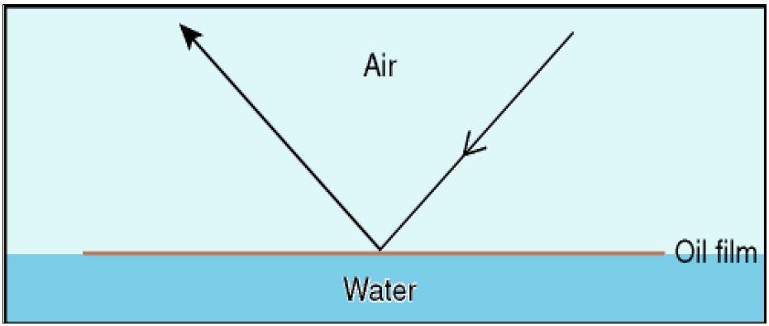
Figure 1 Light Reflecting From Very Thin Oil Films

Oil films below approximately 0.04-μm thickness are invisible. In poor viewing conditions even thicker films may not be observed. Above a certain height or angle of view the observed film may disappear.
Code 2 – Rainbow (0.3 μm – 5.0 μm)
Rainbow oil appearance represents a range of colours: yellow, pink, purple, green, blue, red, copper and orange; this is caused by constructive and destructive interference between different wavelengths (colours) that make up white light. When white light illuminates a thin film of oil, it is reflected from both the surfaces of the oil and of the water (Figure 2).

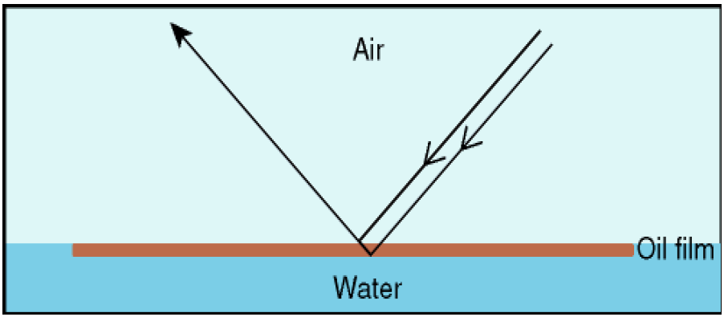
Figure 2 The Rainbow Region
Constructive interference occurs when the light that is reflected from the lower (oil / water surface combines with the light that is reflected from the upper (oil / air) surface. If the light waves reinforce each other the colours will be present and brighter (Figure 3).
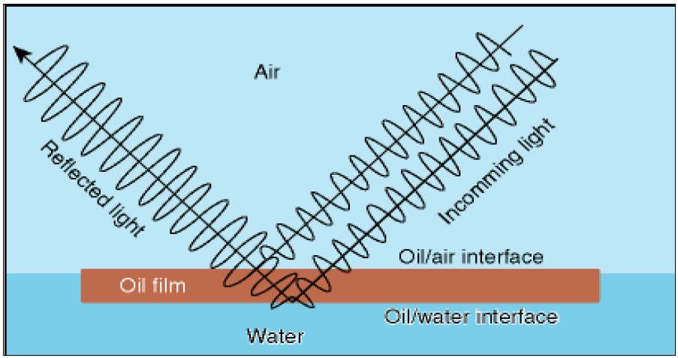
Figure 3 Constructive Interference
During destructive interference the light waves cancel each other out and the colour is reduced in the reflected light and appears darker (Figure 4).

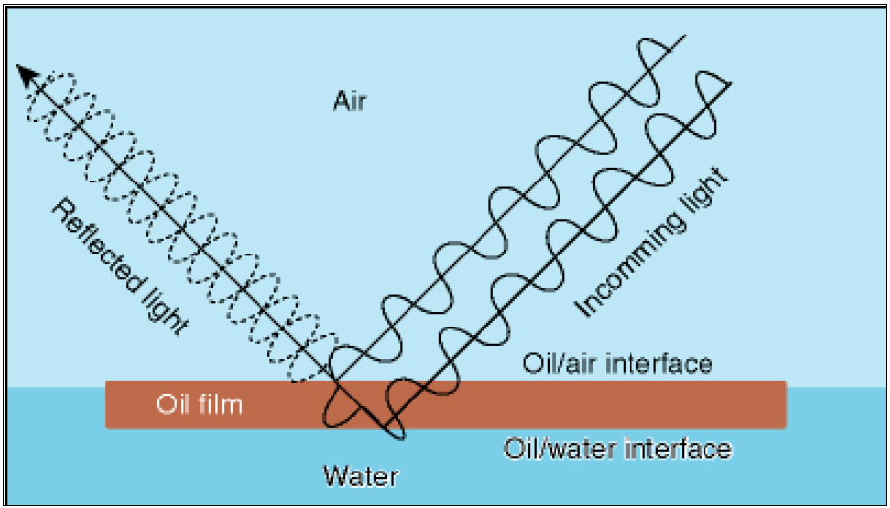
Figure 4 Destructive Interference
Oil films with thicknesses near the wavelength of different coloured light, 0.2 μm – 1.5 μm (blue, 400nm or 0.4 μm, through to red, 700nm or 0.7 μm) exhibit the most distinct rainbow effect. This effect will occur up to a layer thickness of 5.0 μm. All oils in films of this thickness range will show a similar tendency to produce the “rainbow” effect.
A level layer of oil in the rainbow region will show different colours through the slick because of the change in angle of view. Therefore if rainbow is present, a range of colours will be visible.

Code 3 – Metallic (5.0μm – 50 μm)
The appearance of the oil in this region cannot be described as a general colour. The true colour of the oil will not be present because the oil does not have sufficient optical density to block out all the light. Some of the light will pass through the oil and be reflected off the water surface. The oil will therefore act as a filter to the light (Figure 5).

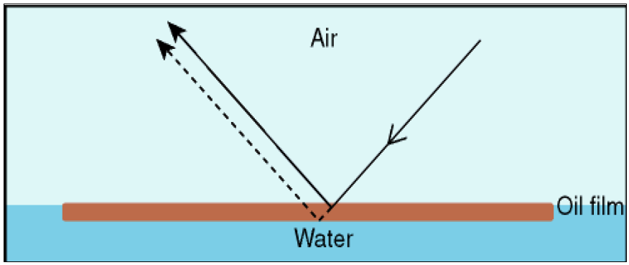
Figure 5 The Metallic Region
The extent of filtering will depend on the optical density of the oil and the thickness of the oil film.
The oil appearance in this region will depend on oil colour as well as optical density and oil film thickness. Where a range of colours can be observed within a rainbow area, metallic will appear as a quite homogeneous colour that can be blue, brown, purple or another colour. The „metallic‟ appearance is the common factor and has been identified as a mirror effect, dependent on light and sky conditions. For example blue can be observed in blue-sky.
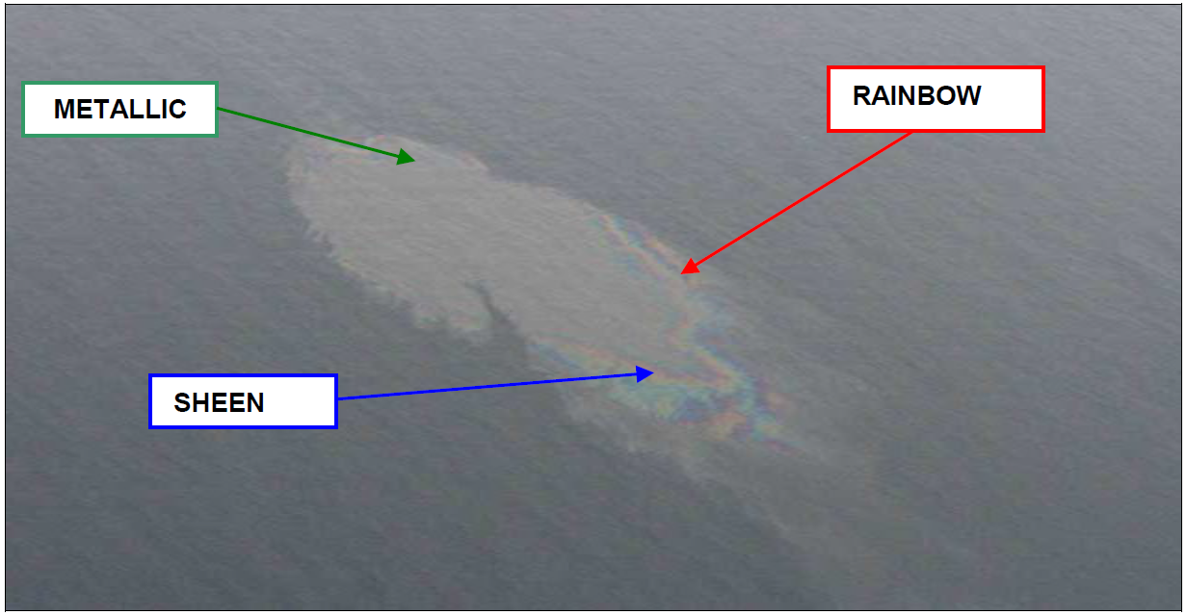
Code 4 – Discontinuous True Colours (50 μm – 200 μm)
For oil films thicker than 50 μm the light is being reflected from the oil surface rather than the sea surface (Figure 6).

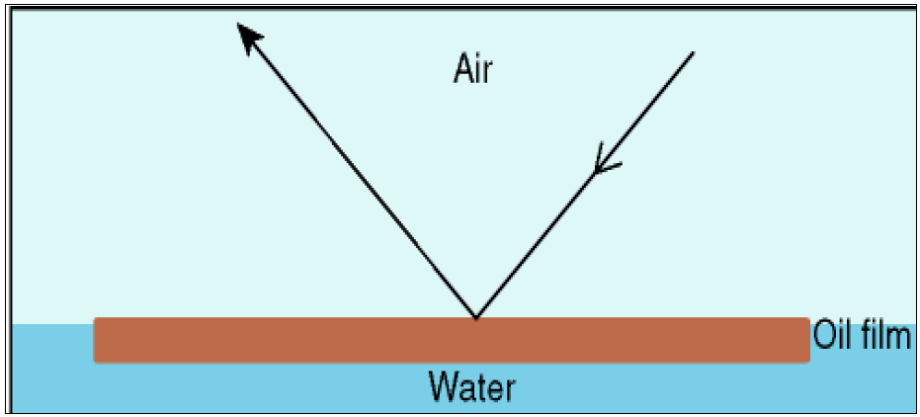
Figure 6 Thick Oil Films
The true colour of the oil will gradually dominate the colour that is observed. Brown oils will appear brown, black oils will appear black. In this appearance category the broken nature of the colour, due to thinner areas within the slick, is described as discontinuous. This is caused by the spreading behaviour under the effects of wind and current.
“Discontinuous” should not be mistaken for “coverage”. Discontinuous implies colour variations and not non-polluted areas.
“Discontinuous true colour” appeared to be a difficult appearance to describe and through imagery it may continue to get a clearer picture of what is meant. For now the best result of the elaborations is: “true oil colour against a background of metallic”.
When oil is moved by waves, the oil layer obviously is thicker in the wave-trough then on the wave-top. This variation of the “oil appearance” may be understood by indicating “discontinuous”.
Code 5 – True Colours (>200 μm)
The true colour of the specific oil is the dominant effect in this category. A more homogenous colour can be observed with no discontinuity as described in Code 4. This category is strongly oil type dependent and colours may be more diffuse in overcast conditions.

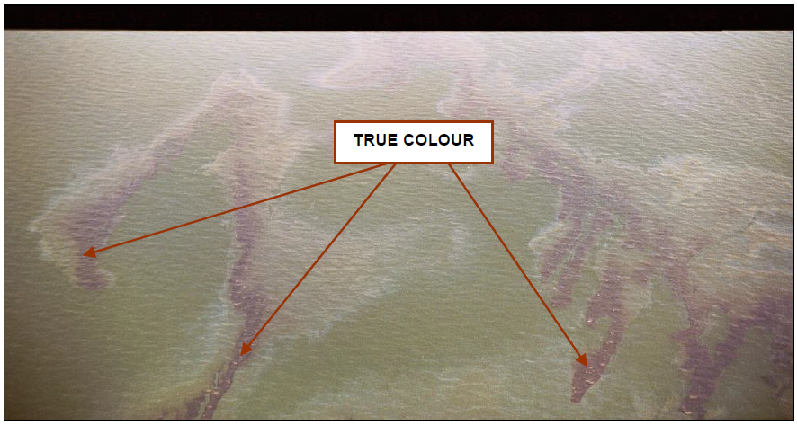

Annex 8

I. International Maritime Organization. Guidelines On International Offers of Assistance in Response to a Marine Oil Pollution Incident.

II. International Oil Pollution Compensation Funds. Claims Manual. 2019 Edition. The document can be downloaded by the link: https://iopcfunds.org/wp-content/uploads/2018/12/2019-Claims-Manual_e-1.pdf

Annex 9

Draft
GUIDELINES FOR OIL SPILL EXERCISES UNDER
THE CASPIAN SEA PLAN CONCERNING REGIONAL COOPERATION IN COMBATING OIL POLLUTION IN CASES OF EMERGENCY
‘AKTAU PROTOCOL IMPLEMENTATION PLAN’

Background

1. In developing the draft Guidelines it was recognized that there is extensive experience of regional oil spill exercising around the world and that in drawing up the draft Guidelines the working group should utilize this experience. Three highly relevant references were:
- HELCOM Manual on Co-operation in Combating Marine Pollution, Volume I, Chapter 10, Exercises and Related Guidelines
- IMO/IPIECA Report Series Volume 2: Guide to Oil Spill Exercise Planning.
- Guidelines for oil spill exercises under the Black Sea Contingency Plan

2. In addition, as the Russian Federation is participating in the Black Sea, the Baltic Sea and the Caspian Sea regional arrangements it was felt that the HELCOM guidelines would be particularly valuable. Also, Russian Federation’s contribution and experiences in connection with the development on exercise guidelines for the NOWPAP (Northwest Pacific Action Plan) Region could be useful for the Caspian Sea and the experiences of the I.R. of Iran for the ROPME Sea Area.

3. For this reason, much of the text and terminology used by HELCOM has been adopted in the Caspian Sea draft Guidelines for consistency.

*******

Guidelines for Oil Spill Exercises under the
Aktau Protocol Implementation Plan

Introduction
The Guidelines are to be used in the development and implementation of regional cooperation under the Caspian Sea Plan Concerning Regional Co-operation in Combating Oil Pollution in Cases of Emergency (Caspian Sea Plan) in conformance with its Section 2.4 on Joint Training and Exercises.
In designing, developing and executing oil spill exercises the following eight guiding principles have been agreed by the International Maritime Organization (IMO) and IPIECA (the global oil and gas industry association for environmental and social issues). The same guiding principles have been adopted for use in connection with all exercises carried out under the framework of the Tehran Convention as follows:

- Ensure that management from the top down supports the exercise activity.
2. Set clear, realistic and measurable objectives for an exercise.
3. The thrust of exercising is to improve—not to impress.
4. Simpler, more frequent exercises lead to faster improvements initially.
5. Do not tackle complex exercises until personnel are experienced and competent.
6. Too many activities, locations and participants can overcomplicate an exercise.
7. Evaluating the exercise successfully is as important as conducting it successfully.
8. Planning and conducting a successful exercise is a significant accomplishment.

The activities under the Astrakhan Agreement may be taken into account when developing the long-term exercise schedule as per Annex 1.

Types of Exercises

Under the framework of the Caspian Sea Plan the following types of combating exercises have been agreed upon:
CASPIAN SEA ALPHA: Synthetic or Table-top Exercise
CASPIAN SEA BRAVO: Alarm or Communication Exercise
CASPIAN SEA CHARLIE: Equipment Deployment Exercise
CASPIAN SEA DELTA: Operational Exercise
CASPIAN SEA ECHO: State-of-the-art Exercise
Decisions on the exercise programme including the types of exercises, aims and goals for the exercises, time for the execution and appointment of Lead Countries are taken during the meetings of the National Operational Authorities. CASPIAN SEA BRAVO, CHARLIE, DELTA and ECHO exercises can be executed independently or in combination with each other.
A proposed Long-term Plan of Exercises in the Caspian Sea region has been attached as Annex 1 to the present Guidelines.

Synthetic or Table-top Exercise (CASPIAN SEA ALPHA)
This exercise type is a ‘paper exercise’, the aim of which is to create a base for discussion on matters relating to organization, communication, logistics, etc. in combating actions involving two or more Contracting Parties.
The exercise will normally take place during meetings of the National Operational Authorities.
The outline of the exercise is pre-planned in such a way that the players will be presented with a scenario of a pollution incident giving such facts of the incident that most probably would be at hand in the initial phase.
The situation in the initial phase will be followed by presentations of the situation as it has developed at certain chosen later stages.
After each presentation, the players are given the necessary time to consider their national follow-up action in relation to the incident situation.
The national follow-up actions are then presented and discussed.

Alarm or Communication Exercise (CASPIAN SEA BRAVO)
The aim of this exercise type is to test the agreed procedures and lines of communication for reporting, requesting and providing assistance, and to get a picture of the current response readiness of the Contracting Parties when called to assist.
The exercise further aims at familiarizing the personnel with the use and national handling of the adopted POLREP reporting form.
It is not the intention with this exercise that combating equipment and its handling personnel should be activated.
When receiving an exercise POLREP (POLWARN) the participating Contracting Parties should record the time of receipt, time of transmission to the responsible national authority and time of the receipt of POLREP (POLWARN) by the person responsible for initiating further national action.
When receiving an exercise POLREP (POLINF/POLFAC) in addition to the times recorded as for POLREP (POLWARN) the participating Contracting Parties should make a realistic evaluation of the types and the amount of equipment and personnel at their disposal for rendering assistance called for, as well as the time for its arrival at the scene of the accident.
After the termination of each exercise the participating Contracting Parties shall submit a report containing the above-mentioned times and evaluations to the Lead State. The Lead State should compile this information in a report, which should be sent to the Regional Mechanism for further circulation to other Contracting Parties in order to have the report presented and discussed at the following meeting of the National Operational Authorities.
CASPIAN SEA BRAVO Exercises are executed without notice but within a specified period of time (normally with in a calendar week).
CASPIAN SEA BRAVO Exercises can be carried out in turn between two or more Contracting Parties, and the arrangement and the initiation of the exercise are undertaken by representatives of the Parties involved and assisted by the Regional Mechanism, if needed.
The Initiating Party shall develop a realistic exercise scenario, on which the CASPIAN SEA BRAVO Exercise is based.
CASPIAN SEA BRAVO Exercises shall be initiated with a POLREP (POLWARN) message submitted by the Initiating Party to National Contact Points of participating Parties and identified in Annex 1 of the Caspian Sea Plan.
The initial POLREP (POLWARN) and subsequent messages related to the present CASPIAN SEA BRAVO Exercise shall be submitted in writing by a relevant electronic means of communication to the National Contact Point(s) identified in Annex 1 of the Caspian Sea Plan or any other address identified during the present CASPIAN SEA BRAVO Exercise.
In cases where e-mails are used as means of communication an “Automatic confirmation of receipt” could be used. However, a request for “acknowledge” should always be responded to.
The Competent National Operational Authorities of the Parties shall ensure that all operational duty personnel are familiar with these Exercise Guidelines, and the communication procedures set out in the Caspian Sea Plan.

Equipment Deployment Exercise (CASPIAN SEA CHARLIE)
The purpose of this exercise is to test the co-operation between the combating units of the Contracting Parties with respect to both communication and equipment. Involvement of personnel - except those needed for running the equipment - should be very restricted.
CASPIAN SEA CHARLIE Exercises are carried out between two or more Contracting Parties with bordering Areas of Responsibility.
Notice as to the time and event is to be given well in advance of the exercise, and the Contracting Parties not taking part in the exercise and the Regional Mechanism shall be invited to send observers to the exercise.
When planning the date for the execution of the exercise a back-up date should be held in reserve. The participating Contracting Parties must be informed as soon as possible and at least three days in advance if the exercise has to be executed on the back-up date or altogether cancelled.
Reports on the exercise should be sent from the Lead State to the Regional Mechanism for further circulation to other Contracting Parties in order to have the report presented and discussed at the following meeting of the National Operational Authorities.
CASPIAN SEA CHARLIE Exercises are arranged and executed after direct consultation between the Contracting Parties involved.

Operational Exercise (CASPIAN SEA DELTA)
The aim of this exercise type is partly to test the alarm and communication procedures, the response capability, and the response time of the Contracting Parties, partly to test and train the staff functions and the co-operation between response units (including the response equipment) of the Contracting Parties.
CASPIAN SEA DELTA Exercises are carried out every three years, with the execution of exercises rotating between the Contracting Parties. The meetings of the National Operational Authorities will develop and agree to an Exercise Programme covering three years or more ahead, as appropriate. The Exercise Programme will state who should arrange and host the coming exercises and what should be the aims of these exercises.
The Long-term Exercise Plan is set out in in Annex 1 of the present Guidelines.
The agreed Lead State has the overall responsibility to plan and execute the exercise. At the discretion of the Lead State other relevant and realistic elements of an accident at sea may be included in the Exercise CASPIAN SEA DELTA scenario, i.e.: Search and Rescue (SAR), firefighting, emergency transfer of cargo, claims and compensation, shore-line clean-up, wild life protection and restoration etc.
Also, custom and immigration procedures in connection with import and export of emergency response personnel and equipment might be considered as exercise elements.
Further, the application of dispersants might be considered as a response option during a CASPIAN SEA DELTA Exercise. If this option is used, national procedures of approval and spraying limitations should be included as incidents in the exercise planning.
Taking into consideration that different Time Zones apply to the Caspian Sea region the “Exercise Time” in use should be clarified. The use of UTC-time as “Exercise Time” should be considered as an option.
Custom and Immigration clearance for participating units of other Parties could be time consuming, which is why it is recommended to allow one extra day for foreign units prior to the execution day of the CASPIAN SEA DELTA Exercise.
A report, evaluating the results of the exercise and making recommendations for improvements to the Caspian Sea Plan, as appropriate, should be distributed to the Contracting Parties in order to have the report presented and discussed at the following meeting of the National Operational Authorities (see further section on Planning and Evaluation of CASPIAN SEA DELTA Exercises).
While participation in the exercise is voluntary, it is recommended that at least the neighboring countries participate.

State-of-the-art Exercise (CASPIAN SEA ECHO)
The aim of this exercise is to demonstrate the state-of-the-art of a specific topic, e.g. a type of equipment, a response method, and means of communication or scientific tests. Traditional operational response activities will not form a part of this type of exercise.
As the aim of CASPIAN SEA ECHO Exercises is to demonstrate the-state-of-the-art, great emphasis should be given to inviting relevant observers from the Contracting Parties and relevant international organizations, as appropriate.
The exercise should be followed by an immediate exercise briefing in order to benefit from the remarks from the observers. The Lead State should send a report of the exercise to the Contracting Parties in order to have the report presented and discussed at the following meeting of the National Operational Authorities.

Procedures for the Exercises
To identify exercise traffic and to avoid conflict with exercises undertaken within other agreements, the text of all messages (both to and from the Lead State) shall begin with the words:
"EXERCISE CASPIAN SEA"
All messages shall end with the words:
"EXERCISE-EXERCISE-EXERCISE"
At the end of each exercise the Lead State shall send a final "End of exercise" message to all Parties concerned.
In cases where e-mails are used as means of communication an “Automatic confirmation of receipt” could be used. However, a request for “acknowledge” shall always be responded to.

Exercise Reports
After an exercise the Lead State shall prepare a brief report for submission the other Contracting Parties and to the National Operational Authorities for consideration at its next meeting. The final report, including comments by the National Operational Authorities shall be submitted to the next Meeting of the Contracting Parties for information and approval/adoption, as appropriate. (for reports from CASPIAN SEA DELTA Exercises, see further section on Planning and Evaluation of CASPIAN SEA DELTA Exercises).
The report should, as a minimum, cover the following items:
- Preparation of the exercise
- a short description of how the exercise was prepared and relevant references
- Implementation of the exercise
- date and period of exercise,
- a brief description of how the exercise was initiated
- Participating Contracting Parties
- names of participating Parties with a description of participating units, equipment items and personnel
- Running and finalization of exercise
Under this heading a brief description of following items (if applicable) should be given:
- scenario
- command
- communications
- finalization of exercise
- Comments of the participating Contracting Parties
A brief summary of comments received from each participating Parties. Only comments
on important matters should be mentioned.
- Conclusion
- a general conclusion from the Lead State’s point of view on lessons learned
- suggestions and recommendations on how to improve exercises in the future.
- suggestions and recommendations for improvements or amendments to the Caspian Sea Plan.
Tables, statistics, figures or pictures can be added as necessary under each item as annexes at the end of the heading.

******

APPENDIX 1

Checklist of Administrative and Organizational Problems, which could arise in an Operational Exercise (CASPIAN SEA CHARLIE or DELTA)

In general, it is up to each littoral State to take care of all formalities itself. But it is advisable that the Lead State undertakes to make precautions in order to facilitate the granting of all clearance and permissions required.
This checklist is to help the Lead State arranging an operational exercise and the participating Parties not to forget issues of importance:
- diplomatic clearance
- customs questions
- general health and safety issues
- conditions of work
- insurance of personnel
- civil liability for injuries or damage
- accommodation and meals
- medical treatment
- equipment and repairs
- report to the meeting of the National Operational Authorities
- share general programme well in advance, including:

* exercise condition | * exercise command | * hotel reservation
* briefing/debriefing | * liaison officer | * transports
* operational command | * communication | * observers
* participating units | * recommended charts | * social events
* timetable | * required diplomatic clearance | * information service
* pilot regulation | * applicable customs and immigration regulations | * moorage
* time zone | * supplies | * first aid

******

APPENDIX 2

Planning and Evaluation of CASPIAN SEA DELTA Exercises

Planning
First announcement and invitation to participation should be sent to the Contracting Parties six months in advance of the exercise. This first announcement should:
- inform on the aim, the date, including a back-up date, and place of the exercise; and
- call for participation of ships and observers.
Announcements of participation should be made to the Lead State four months in advance of the exercise.
Having received the announcements of participation the Lead State should send out practical information about the exercise. Examples of such information are given in the preceding section. This information should not include details of the exercise scenario.
In general, it is up to the Lead State to plan the exercise scenario.
Although the aim of a CASPIAN SEA DELTA Exercise is to check and train the operational system as a whole, efforts should also be made to change the tasks of the participating units during the exercise, in order for personnel to gain as much experience as possible from the exercise.
The participating Parties must be informed as soon as possible and at least three days in advance if the exercise has to be executed on the back-up date or altogether cancelled.
Recognizing that most Parties have in place special national custom and immigration procedures for use in case of any real civil emergency, it is however recommended that the Lead State allocate a day Zero minus one (Day 0 ÷1), allowing ample time for necessary custom and immigration procedures applicable to non-real emergency situations.

Exercise Evaluation
An Exercise Evaluation Team (EET) shall, be established, to enable beforehand comments on the exercise scenario, and thus ensure the best benefits of the scheduled exercise. The exercise scenario shall be sent in due time to the members of the EET to enable them to comment thereupon.
The EET normally consists of three members, of which one is from the Lead State, one from the Contracting Party who arranged the previous exercise, and one from the Contracting Party who will arrange the next exercise.
The EET shall, in order to strengthen the operational co-operation between the Contracting Parties, prepare an unbiased evaluation of the exercise.
This evaluation is to be conducted in two steps; as an intermediate evaluation and as a final evaluation.
For the intermediate evaluation the tasks of the EET are:
- to be present during the exercise; and
- to give an oral presentation of the findings and a preliminary evaluation of the exercise to the participants immediately after the exercise (at the Exercise debriefing).
For the final evaluation the task of the EET is:
- to make a written report of the final evaluation including lessons learnt and proposals for future similar activities. The report should be submitted by the Lead State for further circulation to other Contracting Parties in order to have the report presented and discussed at the following meeting of the National Operational Authorities.
The members of the EET agree between themselves on the designation of a Team Leader or Spokes Person and decide between themselves their individual tasks and their geographical location(s) during the execution of the exercise.
APPENDIX 3

FINANCIAL CONSIDERATIONS
IN CONNECTION WITH EXERCISE PLANNING

Planning and implementation of regional exercises might have substantial financial impact on the Lead and Host Country as external funding is not considered as an option. The provision and approval of adequate funding is to be considered as an internal national issue, which will require approval from national fiscal authorities well in advance of the exercise and prior to accepting the role as Host/Lead Country.
The following is a non-exhaustive list of expenditures for consideration in connection with planning and implementation of a Regional Exercise.

ITEM | COST ITEM
Exercise planning | Personnel costs:  - Salary  - Travel  - Accommodation  - DSA  - Local transportation  Meeting facilities  - Food and refreshments  - Secretariat support  Necessary trainings and workshops  Planning meetings with national and local authorities  Printing of exercise documents  New documentation, charts, maps etc.
Exercise execution | Personnel costs:  - Salary  - Travel, international/national  - Accommodation  - DSA  - Local transportation  Ships :  - Participating units  - Boats  - Observer vessel  - Fuel, bunkers, water etc.  - Port fees  - Pilotage  - Charts and maps  - Loading & unloading equipment  - Food and refreshments  Exercise Control Room  - Personnel costs  - Photo copying  - Printing  - Security guards  - Charts, maps, black boards etc.  - Food and refreshments  - Local transportation  - Equipment rent  Other government agencies, observers and guests  - Accommodation  - Local transportation  - Food and refreshment  - Exercise dinner or reception  - Briefing facilities  - Travel, national and international  - Information and assistance  Response equipment rent  Lifting, transportation and equipment handling, trucks  First aid  Shore line response equipment handling and transportation  Air planes and helicopters  Press/Public information  - Briefing facilities  - Food and refreshments  - Phone and Internet  Private contractors  Logo, certificates, exercise souvenirs  - Carrier bags  - T-shirts, caps etc.
Post Exercise | Personnel costs  Travels  Local transportation  De-briefing facilities  Dinner / Reception  Reporting and Printing  Photograph and video recording of exercise events  Gifts  De-commissioning, cleaning, repair and conservation of equipment

________________

Long-term Plan for Oil Spill Preparedness Exercises in the Caspian Sea

(The Guidelines and Long-term Plan will be inserted to Annex 9 of the Aktau Regional Implementation Plan)

The responsibility for the planning of the exercises will generally rotate among the Parties in alphabetical order. However, if a Party is unable to plan and host a scheduled exercise (i.e. due to financial constraints), a volunteer will be sought.

Long-term Exercise Schedule

States/Exercise | AZ | IR | KZ | RU | TK
Alpha | Once per year in conjunction with a meeting of the National Operational Authorities.
Bravo | Twice per year.
Delta | Once every three years.

