**Meeting of the Working Group on Monitoring and Assessment**

**March 2024**

*A tentative annotated agenda*

***Opening***

The Chair will open the meeting and remind the WGMA members that a key recommendation of the previous WGMA meeting on November 7, 2023, was to draft an EMP, Phase I, which would be based on EMP-2012 but taking into account the present monitoring capabilities of the Caspian littoral states. To proceed with this recommendation most effectively, it is advisable, as the first step, to coordinate (agree upon) the structure (contents) of the Programme and key principles which it should contain. To this end, the meeting will be invited to review and agree upon the title of the Programme and subtitles and main features of the programme’s sections (chapters).

**Title of the EMP**

The Chair will suggest to retain the title of the EMP as it was welcomed by COP-4 (Moscow, December 2012) with a reference to Phase I, namely “Unified, Integrated, and Affordable Caspian Environment Monitoring Programme among Contracting Parties to the Tehran Convention - EMP, Phase I”.

**Introduction**

The introduction will cite Article 19 of the Tehran Convention stipulating the main commitments of the Contracting Parties regarding marine environmental monitoring and assessment. It will further refer to the *Caspian Sea Monitoring Programme (EMP)* prepared in 2012 and welcomed by COP-4 (Moscow, December 2012) emphasizing that it was not implemented because of the insufficient monitoring potential of the Caspian littoral states and that the present EMP-Phase I is a simplified version of the initial EMP which takes into account the existing monitoring capabilities and thus may be feasible to implement by the Caspian littoral states. The development and implementation of the EMP to Phase II is expected in future, as soon as the littoral states attain the necessary technical potential and degree of capacity.

**Objectives**

In line with an recommendation by the 2nd Technical Meeting under EMP (12 October 2021) to harmonize the objectives of the EMP fully with the definition of EMP in the draft *Protocol on Monitoring, Assessment and Data Exchange*, this section is proposed to read as follows:

“*Monitoring of the environmental conditions of the Caspian Sea is generally viewed as a system of regular and/or periodical observations and measurements of physical, chemical and biological characteristics of the marine environment of the Caspian Sea in accordance with agreed environmental monitoring programmes to assess its current state, trends and predict future changes. The Caspian Environmental Monitoring Programme (EMP) represents an agreed document containing main directions of coordinated environmental monitoring activities and measures implemented by the Contracting Parties in support of national and regional policies and decision making*”. In addition, this section may include a reference that the EMP information can be used to evaluate the effectiveness of policies, and eventually determine long-term trends and identify action to be taken at national and regional level for remediation and mitigation of the pollution effects (this reference originates from the inintial EMP version, i.e., from EMP-2012).

**Rationale**

This section is proposed to read as follows:

“*The EMP, Phase I is based primarily on the existing national monitoring capabilities and capacity with a limited but feasible list of the observed marine parameters, quality management and information exchange schemes. As soon as the Parties to the Tehran Convention improve their capacities allowing them to extend the list of the observed marine parameters, both chemical and biological, the EMP, Phase I could be revisited and further EMP phases negotiated and implemented by the Parties*”.

**Observed parameters**

In line with the recommendation by the WGMA meeting of November 7, 2023, the EMP, Phase I will cover only water media with the following parameters being obligatory to observe by all Parties: *Temperature, Salinity, pH, NO2, NH4,**Total Phosphorus****,*** *O2, Total Hydrocarbons, Fe.* The Parties are encouraged to observe and report any optional parameters in addition to the obligatory ones.

**Geographical Coverage, Station Locations and Frequency of Observations**

This section will summarize the metadata on the nationally maintained monitoring stations which the Parties are prepared to include into a Regional Monitoring Network (RMN) under EMP, Phase I. The section will contain a description of the RMN under a format given below (Table 1) as well as a map (maps) showing the RMN as a whole and the location of stations managed by each Party. It is expected that the metadata on the stations as of the end of 2023 will be provided by the Parties in line with a recommendation by the WGMA meeting on November 7, 2023. A draft RMN map based on the metadata for 2022 is given on Fig. 1 to illustrate the idea.

Table 1 - National Pollution Monitoring Stations to be included into Regional Monitoring Network under EMP, Phase I.

Country:

|  |  |  |  |  |  |  |  |  |  |  |  |  |  |  |  |  |  |  |  |
| --- | --- | --- | --- | --- | --- | --- | --- | --- | --- | --- | --- | --- | --- | --- | --- | --- | --- | --- | --- |
| St № | Names of Sampling Stations | Coordinates | | Observed Parameters | Sampling Frequency |  |  |  |  |  |  |  |  |  |  |  |  |  |  |
| North | East |  |  |  |  |  |  |  |  |  |  |  |  |  |  |
|  |  |  |  |  |  |  |  |  |  |  |  |  |  |  |  |  |  |  |  |

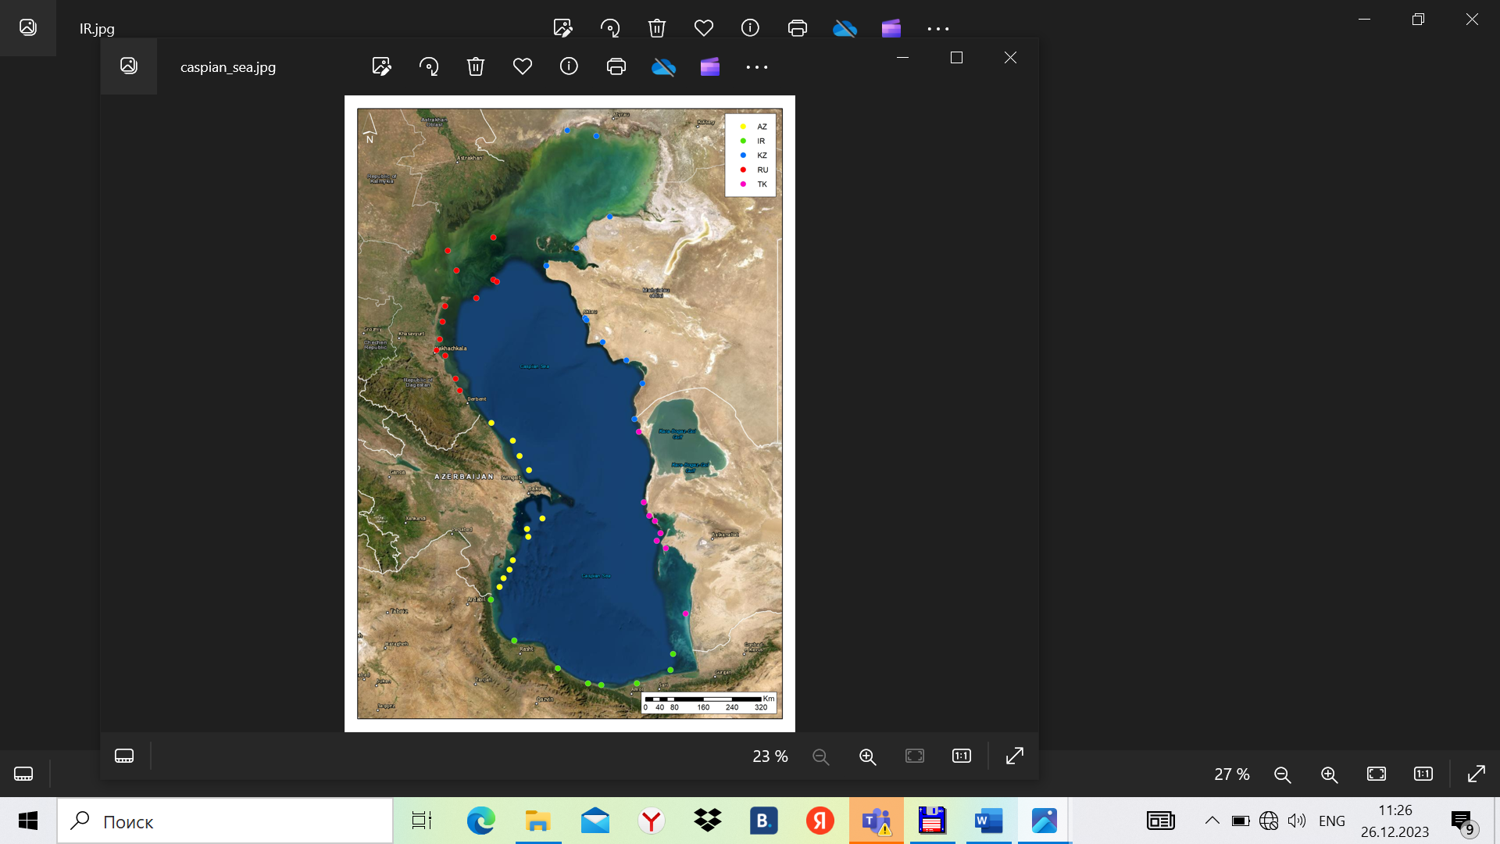

Fig. 1 – A draft Regional Monitoring Network under EMP based on the nationally maintained stations earlier proposed by the Parties of the Tehran Convention (as of 2022).

**Guidelines for monitoring procedures**

This section is proposed to read as follows.

“*Common guidelines for monitoring procedures are needed to ensure comparability of the derived environmental information across the Caspian region. Such common regional guidelines on monitoring could, inter alia, include a set of laboratory quality assurance procedures as well as minimum data quality control procedures which were to be applied to the monitoring data at the national level. Those regional guidelines shall be applicable exclusively to the monitoring activities related to the Tehran Convention implementation, shall be harmonized to the maximum extent with the national practices and not be supreme to them in domestic activities.*

*However, developing and coordinating such common guidelines among the Tehran Convention Parties would take much time preventing any regional EMP to come into force. For that reason, in implementing the EMP,Phase I, the Parties can follow their respective national practices provided that the other Parties are informed of them. The common guidelines for monitoring procedures will be developed and coordinated in paralell to the EMP, Phase I implementation and will be applied to further phases of the Caspian EMP*.”

**National Responsible Body/Bodies for Data Management and Reporting under the Caspian EMP**

This section of the programme will provide the information on the national organizations responsible for making observations, running analytical laboratories, providing data management, assessment and reporting. Such information will be presented in the following format (Table 2).

Table 2 - National responsible organizations/institutions for implementation of Caspian EMP, Phase I

|  |  |  |  |  |
| --- | --- | --- | --- | --- |
| Country | Main Responsible Organization (Programme management, financing and coordination) | Maintenance of the observational network and vessels | Maintenance and  Quality Management of Analytical Laboratories | Data Management, Environmental Assessment  and Reporting |
|  |  |  |  |  |

**Data reporting and exchange procedures**

The Chair will express an opinion that any international monitoring programme is useless if the nationally collected data is not pooled together to form joint information products. He will also recall that the data reporting and information exchange procedures are a matter of continued discussions within the negotiations on the *Protocol on Monitoring, Assessment and Data Exchange* and no agreement has been reached so far as to what will be exchanged – initial data of observations (with due methodological corrections having been introduced in the data) or summarized (according to the agreed principles) information (e.g., monthly/annual averages/other statistics). However, development of EMP, Phase I requires an agreement, even a prelimenary one, on the form of the data/information exchange. Unless this issue is settled (at least in respect to EMP, Phase I exclusively), the Programme could not be finalized.

The Chair will invite the participants to express their opinions on the issue of the observed data/information exchange to be applied to the EMP, Phase I.

**Information Products Inferred from the Jointly Collected Data**

The Chair will reiterate his opinion that a mere collecting and storaging the data/information emerging from the EMP-Phase I implementation awaiting their future use in preparation of the forthcoming Caspian State of Environment Reports (SOE) would not serve the interests of promoting international cooperation in the field of the Caspian monitoring. Instead, he will propose to consider a possibility of including into EMP, Phase I a reference to information products (e.g., maps displying the marine parameters at a whole Caspian region scale) to be produced based on the internationally pooled environment data. Though these products will be only few, they could show the benefits of the joint observation products to the policymakers in the Caspian littoral states and facilitate a future upgrading of the limited-parameter EMP, Phase I to a full-fledged EMP.

The Chair will invite the meeting to discuss his proposal on an inclusion of joint information products into EMP, Phase I.

**Wrapping Up**

The Chair will summarize the discussion and provide preliminary wording for the meeting recommendations. A final meeting report will be agreed upon by correspondence as it was made earlier.