**THE “CASPIAN SEA DAY”-2019 CELEBRATION**

**UNDER THE TEHRAN CONVENTION**

**IN THE RUSSIAN FEDERATION**

The Caspian region is a priority region for Russia in ecological, marine and economic aspects. This is confirmed by the implementation of federal and regional programs, the development of academic and applied research in the Caspian Sea region of Russia, the regular various national/international meetings on the Caspian Sea issues and by the public active involvement.

The Tehran Convention, being a legal tool of the regional environmental cooperation, has a pivotal role to play in preventing and overcoming the region’s ecological problems. The effective use of its mechanisms will make it possible to contribute to the implementation of the national project “Ecology” and the federal project “Clean Country”.

The Caspian Sea Day, held in the Caspian Sea constituent entities of the Russian Federation since 2008, is a continuing priority for the Republic of Dagestan, which declared 2017 the “Year of the Caspian Sea” by a decree of the Head of the Republic of Dagestan, and the Republic of Dagestan has always taken an active part in the events under the Caspian Sea Day, which took place in previous years in Astrakhan city.

In 2019, the event**“The Significance of the Tehran Convention for the Conservation of the Caspian Sea Marine and Coastal Environment with a View to Implement the National Project “Ecology” and the Federal Project “Clean Country”** dedicated to the Caspian Sea Day was held on August 6-7, 2019, in Makhachkala city( Republic of Dagestan) More than 50 participants contributed to the discussion

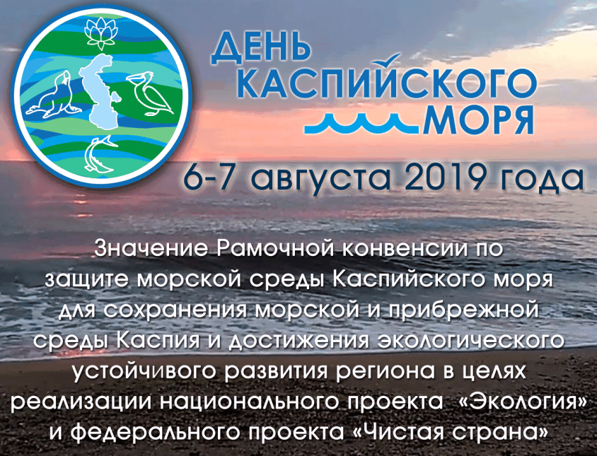

*Banner of the measure*

There were representatives of the interested federal agencies, including the Ministry of Natural Resources and Environment of the Russian Federation (Minprirody of Russia), the Ministry of Transport of the Russian Federation (Mintrans of Russia), the Federal Service for Hydrometeorology and Environmental Monitoring (Roshydromet), the Federal Agency for Fisheries (Rosrybolovstvo), regional executive bodies of the Caspian Sea littoral constituent entities of the Russian Federation, including regional ministries of tourism, ministries of construction and housing and public utilities (the Republic of Dagestan, the Republic of Kalmykia and the Astrakhan region), reserves, the oil business, scientific and educational organizations, business entities and academics, the expert community and non-governmental organizations

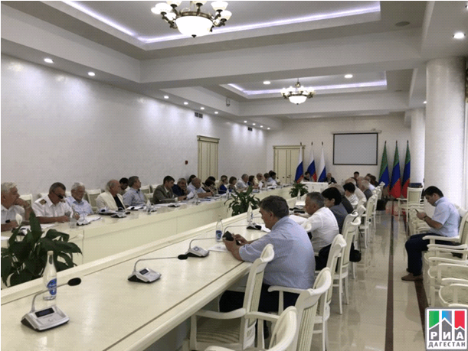

*In the boardroom*

The purpose of the event was to discuss the role and activity areas of the Tehran Convention and its protocols as an effective mechanism to conserve and prevent the Caspian Sea marine and coastal environment pollution and to achieve ecologically sustainable development of the Caspian Sea constituent entities of the Russian Federation in connection with the implementation of the national project “Ecology” and the federal project “Clean Country”

The event was organized by the Ministry of Natural Resources and Environment of the Russian Federation and the Government of the Republic of Dagestan through the National Convention Liaison Office- Center for International Projects. I was held within the framework of meeting the national obligations under the Tehran Convention.

The meeting was opened by the Minister of Natural Resources and Environment of the Republic of Dagestan **N. Karachaev** by a welcoming speech.

Also, the opening session was addressed by the Deputy Minister of Natural Resources and the Environment Protection of the Republic of Kalmykia **Mr.** **K. Batyrov**, the Head of the Department of Housing and Public Utilities of the Ministry of Construction and Housing and Public Utilities of the Astrakhan region **Mr. S. Gut**, the National Coordinator of the Tehran Convention of the Ministry of Natural Resources and Environment of the Russian Federation **Ms.** **N. Tretyakova**, Deputy General Director of LLC “LUKOIL-Nizhnevolzhskneft” **Mr.** **Sh. Suleimanov**.

The meeting was presided over by the Minister of Natural Resources and Environment of the Republic of Dagestan and the National Coordinator of the Tehran Convention of the Ministry of Natural Resources and Environment of the Russian Federation. They delivered introductory reports.

The Minister of Natural Resources and Environment of the Republic of Dagestan **N. Karachaev** made a presentation on **“Integrated Waste Management in the Republic of Dagestan”**.In his report he noted that due to unauthorized waste disposal sites in mountainous areas, all the litter is transported by numerous rivers into the Sea, creating a significant threat to the Caspian Sea biodiversity. Within the framework of the national project “Clean Country”, 8 plants for municipal solid waste processing will be launched in the Republic, including in the mountainous regions. . All litter will be sorted and processed, constructing a sewer collector from Makhachkala to the Caspian treatment facilities. is in its final stage.

In the report of **Ms. N. Tretyakova,** devoted to **“The Significance of the Tehran Convention for the Conservation and Prevention of the Caspian Sea Marine and Coastal Environment Pollution with a View to Implement the National Project “Ecology” and the Federal Project “Clean Country”**, the waste management system was characterized with account of the latest legislative acts. Besides, the information on the **National Project “Ecology” and the Federal Project “Clean Country”** in the context of the provisions of the Tehran Convention and its protocols was presented.

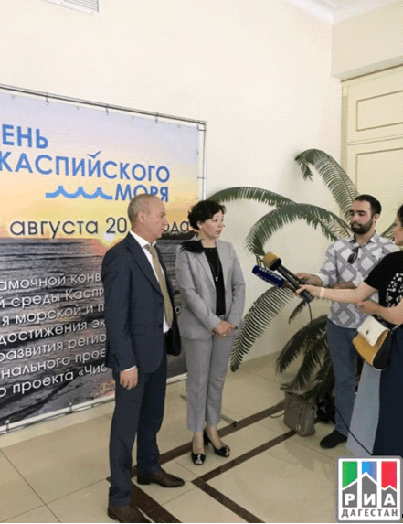

*Going to the press- The Minister of Natural Resources and Environment of the Republic of Dagestan* ***N. Karachaev*** *and the National Coordinator of the Tehran Convention of the Ministry of Natural Resources and Environment of the Russian Federation* ***-N. Tretyakova***

Within the framework of the stated theme, the **issues of preventing and reducing pollution by litter from ships under the regional marine conventions and programs** were discussed. Representatives of the Marine Rescue Service (Moscow) and the Administration of the Caspian Sea Ports of the Ministry of Transport of the Russian Federation covered the issue in their reports.

Presentations of the Deputy Head of the Administration of the Caspian Sea Seaports **Mr. M. Gereykhanov** and the Advisor to the Head of the Marine Rescue Service of the Ministry of Transport of the Russian Federation **Ms. N. Kutaeva** were related to the **characteristics of international and national requirements to minimize the Sea pollution from ships**.

It was noted that within the framework of IMO, an action plan was approved to tackle the problem of pollution of the sea with plastic garbage from ships for 2018-2019. It was adopted by the Marine Environment Protection Committee 73 (MEPC) in October 2018. The Action plan is to be applied to all ships, including fishing ones. It is also planned to conduct studies on the pollution of the sea with plastic waste from ships with the aim to better understand the role of ships in the pollution of the sea with plastic waste.

Reports on **the Caspian Sea marine and coastal environment pollution monitoring, including pollution with municipal solid waste and *inter alia* with marine litter**, were delivered by the Astrakhan State Natural Biosphere Reserve of the Ministry of Natural Resources and Environment of the Russian Federation (Astrakhan), Dagestan Centre for Hydrometeorology and Environmental Monitoring of Roshydromet (Makhachkala), Astrakhan State Technical University (ASTU) and etc.

A presentation of the Deputy Director of Astrakhan State Natural Biosphere Reserve **Ms.** **K. Litvinova** dealt with a **review of sources of pollution of the Volga River delta and the Caspian Sea northern area with municipal solid waste**.

Also, under the theme on the Caspian Sea marine and coastal environment pollution monitoring, including pollution with municipal solid waste and inter alia with marine litter**,** **Mr.** **A. Churaev,** a representative of the Public Chamber of the Republic of Dagestan, informed about the ecological status of the Dagestan coast of the Caspian Sea, and representatives of the Roshydromet office in Dagestan (**Mr. A. Dadashev, Ms. E. Batmanova**) submitted information on changes in the level of the Caspian Sea in 2009-2019 and about monitoring of the aquatoria of the Caspian Sea middle area.

**Dr. V. Zaitsev** (Astrakhan State Technical University) characterized the situation connected with **natural and technogenic pollution of the Caspian Sea ecosystem by heavy metals**, dwelled upon the specifics of microelement migration in trophic chains of the studied sturgeon species of the Caspian Sea.

The participants of the round table discussion also touched upon problems of conserving birds and bioresources of the Caspian Sea.

Reporters from the Volga-Caspian branch of the Caspian Research Institute of Fisheries – the Russian Federal Research Institute of Fisheries and Oceanography (VNIRO - CaspNIRKh), (Makhachkala), the Caspian Institute of Biological Resources of the Dagestan Scientific Center of the Russian Academy of Sciences (Makhachkala), the Astrakhan regional branch of the All-Russian Society for Nature Protection and others made presentations on the **impact of the Caspian Sea marine and coastal environment pollution, including marine litter, on the status of the region biodiversity including aquatic biological resources of the Sea**.

Speakers from the Volga-Caspian branch of VNIRO - CaspNIRKh (**Dr. A. Abdusamadova**) and the Astrakhan regional branch of the All-Russian Society for Nature Protection (**Mr. A. Sokolsky**) characterized **the status of the Caspian Sea aquatic biological resources and their habitat, as well as considered ways to conserve aquatic biological resources of the Volga-Caspian fishing region**.

**Dr. E. Vilkov** (Caspian Institute of Biological Resources of the Dagestan Scientific Center of the Russian Academy of Sciences) presented the project to **organize a natural park the “Ornithopark – Turalyn Lagoon”** between the cities of Makhachkala and Kaspiysk.

Most of the presentations and reports were made on **ecological rehabilitation of water objects of the Caspian Sea region through preventing and mitigating the potential adverse impact of pollution on the Caspian Sea marine and coastal environment** (**oil pollution, discharge of polluted wastewater, municipal solid waste, including plastic**). They were submitted by the Caspian Marine Research Center of Roshydromet, (Astrakhan), LLC LUKOIL-Nizhnevolzhskneft, LLC SINTEKO-N (Makhachkala), OJSC Geothermneftegaz (Makhachkala), the Caspian Branch of the P.P. Shirshov Institute of Oceanology of the Russian Academy of Sciences (Astrakhan), etc.

A report on **“Scientific Research to Ensure the Safety of Marine Industries, the Conservation and Rational Use of the Caspian Sea Resources”**, made by the Director of the CaspMNITS of Roshydromet **Ms. E. Ostrovskaya**, contained data on the level of aquatoria pollution in the Russian part of the Caspian Sea based on the pollution index, included information about the pollutants ingress to the northern part of the Caspian Sea with the Volga River runoff, as well as on the content of pollutants in the Sea bottom sediments.

A presentation of **Ms. A. Mungieva** (LLC SINTECO-N) was focused on the **industrial and biological waste neutralization and disposal** and included information on the corresponding activities at the SINTECO-N landfill.

An intervention on **“Ensuring the Ecological Safety of the Implementation of Energy-based Potential in the Region, Including Consideration of Environmental Risks Connected with the Production Wastes at Developing Hydrocarbons”** was made by **Mr. A. Ismagulov**, a representative of LLC “LUKOIL-Nizhnevolzhskneft”, who presented a scheme for implementing the principle of “zero discharge” in the Caspian Sea

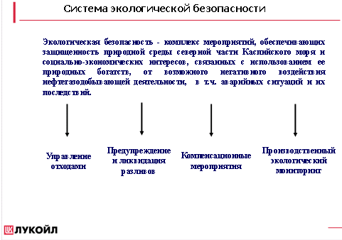

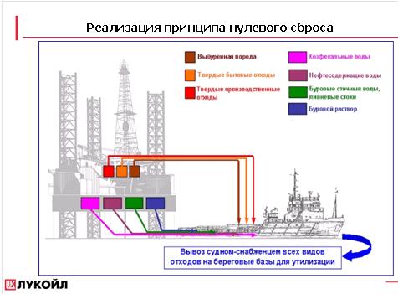

**Mr. Yu. Bezrodny,** in hispapertitled“**A Method for Wells Constructing with “Zero Discharge” of Drilling Waste at Developing Hydrocarbons”,** presented a new approach to the use of a “zero discharge” technology in the development and operation of oil fields. It is especially important for conserving the Caspian Sea marine environment.

**Ms. T. Butylina** touched on approaches to **integrated management of coastal marine areas under the Tehran Convention in the context of achieving the UN 2030 Sustainable Development Goals**, and on methods which are used in the marine environment management, such as marine spatial planning, etc. The contribution was made within the thematic activity on **the integrated management of coastal marine territories in the context of achieving the Sustainable Development Goals of the UN 2030 Agenda for Sustainable Development for the period up to 2030 to conserve the coastal marine areas of the region as the basis for the development of tourism/recreation sectors in the region, for the reduction of the marine environment pollution, resulting *inter alia* from land-based sources, including marine litter.**

In total, more than 20 reports were delivered and discussed.

Recognizing the essential role of the Tehran Convention and its protocols as an effective mechanism for the conservation of the Caspian Sea marine and coastal environment and the sustainable development of the coastal areas of the Caspian region of Russia, the following **recommendations** **based on the discussions** were elaborated by the participants of the event

- The mechanisms of the Tehran Convention and its protocols can be used to achieve sustainable development of the Caspian region of Russia, taking into account the UN Agenda for Sustainable Development Goals for the period up to 2030;

- The most important task of the international environmental cooperation in the Caspian Sea region is to form coherent and cost-effective integrated approaches to managing the status of the Caspian Sea marine and coastal environment in order to achieve the necessary conditions for the sustainable development

- It is necessary to improve the marine coastal management system in order to enhance effectiveness of the management which should be based on synergy of the natural resources environment and socio-economic development.

For the Caspian Sea region, the sustainable development of its coastal areas should take into account the region peculiarities, rely upon an integral information base, which includes different levels of interconnected institutional mechanisms for the efficient collection and exchange of information; besides, a cadastre of the coastal zone should be prepared.

- It is important to develop regional guidelines for planning the integrated coastal management and to assess the vulnerability of the coastal areas in the context of the Sea level rise and subsequent potential economic losses;

- There is a need to develop effective nature management criteria within the framework of strategies for socio-economic development of the Caspian Sea littoral constituent entities of Russia; to carry out zoning based on the natural resources degradation assessment and their ecological sustainability (including small rivers), taking into account ecologically high-risk areas, water protection zones; to determine the maximum permissible regimes for the natural resources withdrawal and the ecological load on the components of the environment (pollution, depletion, etc.).

- National strategies and programs should include information on the coastal area management, including on biodiversity conservation, management of specially protected natural areas, sustainable and rational use of the biological resources.

A special role in stabilizing the dramatic reduction of the aquatic biological resources of the Caspian Sea northern area is played by the optimization, in the fisheries interests, of the release schedules during the spring-summer flood on the Volga River;

- For adequate management of the Caspian Sea marine and coastal environment and regulation of anthropogenic impacts on the Caspian Sea ecosystem, it is necessary to improve the marine and coastal environment pollution monitoring system;

- It is also important to encourage early launching the implementation of the Caspian Sea Environmental Monitoring Program (EMP) of the Tehran Convention at the national level, the results of which should serve the basis for assessing the status, identifying ecological risks and developing measures to protect the marine and coastal environment of the Caspian Sea. It is also significant to support the development of the national systems of integrated ecological monitoring at various levels, including industrial ecological monitoring, which is carried out during the geological research, exploration and production of hydrocarbons

- At the national level, in accordance with the obligations under the Tehran Convention, all stakeholders should undertake necessary measures to prevent,

reduce and control the Caspian Sea pollution, to protect, conserve and restore its marine environment and to use its resources rationally;

- Addressing the problem of the prevention, reduction and control of pollution in the result of contaminated wastewater discharge, depletion and pollution of the surface and groundwater, as well as oil pollution, should, in accordance with the provisions of the Convention, be based on reducing the discharge of untreated or insufficiently treated wastewater into the Caspian Sea and water bodies connected with it; on ecological safety of oil and gas industries with account of the ecological, recreational and fishery peculiarities of the region;

Oil companies, operating in the Caspian Sea region, envisage a number of measures, including these related to the improvement of technologies, which should include:

-reducing the number of offshore platforms and the length of subsea pipelines through maximum integration with fishing facilities and communications;

-the use of the best available technologies; optimization of the design and number of producing wells at developing of fields;

- In order to prevent and mitigate the potential adverse impact of the production and consumption waste on the marine and coastal environment of the Caspian Sea, it is important to fully use the considerable scientific potential and to organize research on the impact of marine litter on the marine and coastal biodiversity, on habitats, as well as to conduct research on the rate of degradation and fragmentation of litter under various conditions;

- The development and adoption of normative legal acts to establish the responsibility of various authorities for the cleaning of the coastal territories and aquatoria from marine litter is also important;

- Scientific research is needed to study microplastics as persistent pollutants, which are available in all marine habitats, trophic transmission of microplastics through benthic and pelagic trophic chains, as well as to study marine litter as a vector of invasive alien species movements;

- In order to conserve the Caspian Sea marine environment, to prevent and reduce pollution by litter from ships, the Caspian Sea littoral states must make an agreed decision related to the application of the International Maritime Organization (IMO) mandatory tools in the Caspian Sea region;

- Issues of preventing and reducing pollution by litter from ships under the regional marine conventions and programs;

- The coastal marine areas are the focus for the development of tourism. It should be kept in mind that an exponential growth in the number of tourists can cause damage, including to a protected area. It is necessary to develop sustainable, environmentally-oriented tourism.

- It is necessary to maintain and enhance effective engagement of the public of the Caspian Sea littoral states when discussing economic projects that can have a negative impact on the status of the Caspian Sea marine environment

- It is important to improve a variety of education and practical training programs for various groups of society in order to enhance everyone's awareness of the obligation to prevent the marine environment pollution, especially regarding marine litter. Raising public awareness can help decision-making to improve control and prevent pollution of the marine environment;

- Capacity building in the field of education and enlightenment, dissemination and promotion of scientific knowledge will contribute to the implementation of the strategy for sustainable development of the Caspian region of Russia.

- For the effective functioning of the public network for the Tehran Convention support, it is necessary to consolidate the efforts of the public, state and private sector, including the oil and gas sectors, to address the environmental problems of the Caspian Sea, and to create public-private partnerships, i.e. public – business – government partnership.

In general, the event dedicated to the **Caspian Sea Day-2019** and related to the achievement of the Caspian region of Russia ecological sustainable development through the implementation of the national project “Ecology” and the role of the Tehran Convention in conserving the Caspian Sea marine and coastal environment, demonstrated and confirmed the relevance and importance of the pollution problem for the western part of the Northern Caspian Sea, including marine litter challengers. It revealed for various regional stakeholders the specifics of this problem in the context of the Caspian Sea peculiarities.