Detailed Report on the Caspian Day - 2013

Year 2013 was declared by the Edict of the President of the Russian Federation as the Year of the Environment aimed at the implementation of one of the principle rights provided by the Constitution of the Russian Federation – “ensuring the right of every person for favourable environment”. The executive authorities of the subjects of the Russian Federation have been carrying out the relevant activities and events all the year round, which were planned in the frameworks of the Year of the Environment in Russia.

It is especially important that such a decision has been made at the background of the similar declaring of 2013 as the Year of Environmental Culture and Protection within the Commonwealth of Independent States.

Caspian is not only the largest in the world internal water body, unique ecological system rich in natural resources, including oil and biological resources, but is the complicated, contradictory system of interstate relations, the bundle of historical, ethnic, political problems, which have long outgrown the regional frameworks and are at the core of world attention.

Understanding of this specificity through building capacity in the field of education and enlightenment of population, dissemination and propaganda of scientific knowledge in the area of sustainable nature use would allow the formulating of a strategy for the sustainable development of the near Caspian region of the Russian Federation.

It seems necessary to communicate to the people’s consciousness, and especially of young people, the benefits of the clean environment and prove that the Caspian region – is one of the best places on our planet, thereby demonstrating the touristic attractiveness of the near-Caspian and outlining the possible ways to address the socio-economic and environmental problems of the region.

To this end, the efforts of the public, executive authorities and private sector of the near Caspian subjects of the Russian Federation are put together to pay close attention to maintaining the ecological balance in the Northern Caspian, implementation of various in form and content environmental protection activities, in particular, the annual Caspian Day celebrations.

In 2013 in all three near Caspian subjects of the Russian Federation – Astrakhan oblast, Republics of Dagestan and Kalmykia – the bulk of activities and events dedicated to or connected with the Caspian Day were conducted through the organization of different conferences, seminars and workshops for scholars, contests, actions, and arrangements related to cleaning up the coasts of the rivers and the Caspian

Aimed at the support to organization and holding of the aforementioned round table, as well as for the informational support of the ‘Network of the public environmental organizations of the near Caspian subjects of the Russian Federation’ the CIP had developed the informational bulletin on the jubilee decade of the Tehran Convention (attached). This bulletin was disseminated in late July – August of 2013 amongst the most active institutions members of the above named Network.

ASTRAKHAN OBLAST

According to the formal correspondence of the Service for Nature Use and Environmental Protection of the Astrakhan oblast the celebrations of the regional Caspian Day on August 12, 2013, was included into the Astrakhan oblast Plan of Events for 2013 in the frameworks of the Year of the Environment in the Russian Federation.

In the run of the holiday, the Caspian Day formal greeting cable to the Akim of Atyrau oblast of the Republic of Kazakhstan Mr. B. Izmukhambetov from the Astrakhan oblast Governor Mr. A. Zhilkin was submitted with the deep appreciation to the Atyrau oblast administration for the active assistance in organization of the international stage of the environmental act “Clean Coasts”, which is annually held by the Service jointly with the Kazakhstan colleagues-ecologists to improve the ecological situation and maintain the cleanness of transboundary water bodies (Kirgach river, as the instance) in the near border areas of Atyrau and Astrakhan oblasts. The cable also expressed the hope for further development of the oblasts fruitful cooperation aimed at the conservation of the healthy Caspian environment.

Astrakhan ecologists and volunteers to guard the ecological health of the Volga and Caspian

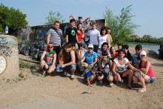

Early morning on August 10, the participants of the next stage of the environmental act “Clean Coasts 2013”, devoted to the forthcoming celebration of the Caspian Day, has gathered on the shore of the Priamaya Bolda river.

Under the frameworks of the act annually carried out by the Service for Nature Use and Environmental Protection of the Astrakhan oblast (hereinafter – Service) it was planned to clean-up the water protective zones at both coasts of the river close to the local bridge and town Svobodny from the solid domestic wastes.

The act involved the participation of over a hundred fighters for ecological health of the region ahead of the Caspian Day. They included the personnel of the Service, the Astrakhan oblast Rescue and Fire Service, Astrakhan Eco-Service JSC, representatives of the Council of Young Scientists and Specialists under the Service, regional branch of the Green Movement of Russia “EKA”, bloggers, and volunteers. The youngest participants were two three-year boys – the children of the Service personnel and volunteers, while the eldest – two local pensioner-habitues who are trying to clean-up around themselves daily and at their best. The composition of participants of the act suggests that environmental perception of the world and love to their native land are not alien to Astrakhanians.

The act location was selected not casually: there are few places to stay near the river remaining this year. The beaches accessible for citizens are experiencing the extreme stress.

The act participants barely seeing the coasts littered with waste were immediately armed with bags and gloves provided by Astrakhan Eco-Service JSC and began to work. There was not just a lot of garbage, but incredibly much. Plastics, glass, bottles, cigarette boxes, packages, napkins, and other trash were all around the coast: in bushes, near water, under the feet.

When in the river these “benefits of civilization” are causing the irreparable damage to not only the Volga river eco-systems, but to, at last, the Caspian Sea, as it is a closed body. Once reaching it waste, especially plastic bottles, will remain there forever. Hardly anybody wants the Northern Caspian close to Russia’s coasts to have a whirlpool of anthropogenic litter, something alike the Pacific “waste-whirl”.

As a result of concerted work made by the ecologists and volunteers at the both sides of Priamaya Bolda river of 4 ha area the participants collected 200 bags of litter. All collected trash was moved to the municipal solid waste landfill using the garbage truck provided by the Astrakhan Eco-Service JSC. Joint efforts prevented four tons of consumer waste to be discarded into the river and their possible getting into the Caspian Sea.

Brief photo report on annual “Clean Coasts 2013” campaign to clean-up the Volga coast from consumer waste in the Astrakhan oblast

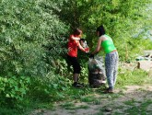 | 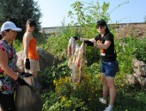 | 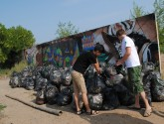
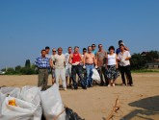 | 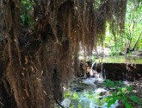 | 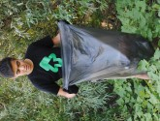
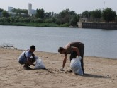 | 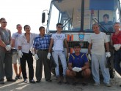 | 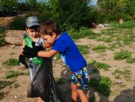
 | 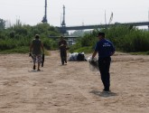 | 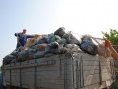
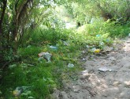 | 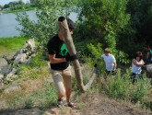 | 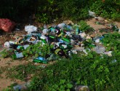
 | 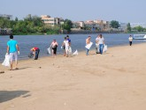

Regional Caspian Day 2013 in the Astrakhan oblast



Within the frameworks of the next stage of the environmental campaign “Clean Coasts 2013” dedicated to the celebration of the regional Caspian Day on August 12 the Service for Nature Use and Environmental Protection of the Astrakhan oblast had called upon the environmental brigades and all regional residents to facilitate the work on cleaning up the water protective zones of Volga and its numerous distributaries, channels, and eriks from consumer waste.

The Russian Federation had signed the second thematic protocol to the Tehran Convention – Protocol for the Protection of the Caspian Sea against Pollution from Land-Based Sources and Activities, adopted during the 4th meeting of the Conference of the Parties in Moscow in December 2012. This document is aimed at playing the crucial role in prevention of the Caspian Sea marine environment pollution, addressing the environmental tasks and provision of the regional ecological safety.

To implement the protocol the countries parties to the Tehran Convention will develop the national action plans on control the pollution sources, including the emission/discharge limit values for the relevant substances, as well as will promote the use of environmentally sound technologies and introduction of environmental quality objectives.

The Astrakhan oblast plays a key part in solution by the Russian Federation of environmental tasks in the Caspian. The implementation of Russia’s international obligations on the prevention of the Caspian marine environment pollution from the land based sources and activities depends on every resident of the oblast. The recent monitoring of the river waters quality evidences on increasing of their pollution. Therefore, the guarantee of the environmental safety in the oblast and environmental debt of every Astrakhanian – do not pollute the coast, and do not discharge sewage and waste into the Volga river.

The municipalities of eight administrative districts, environmental teams and volunteers of the Astrakhan oblast responded to the call of the Service for Nature Use and Environmental Protection of the Astrakhan oblast for participation in the environmental campaign “Clean Coasts 2013” on the eve of the regional Caspian Day.

Summarizing the results of the joint work the Service is reporting that 1,321 persons took part in general in across the Astrakhan oblast in the “Clean Coasts 2013” act, who cleaned-up 273 ha of water protective zones of waterways from consumer waste, collected at coasts and sent for disposal 122.2 tons of waste (119% in compare to the previous year) that would never reach the Caspian Sea. This year the average “junk yield” of the river coasts in the near Caspian areas amounted at 0.6 tons per ha.

Round-table meeting of the Astrakhan Regional Branch of the All-Russian Public Organization “All-Russian Society for Nature Protection” devoted to the Caspian Day 2013

the Caspian Day dedicated round-table event was organized on August 12, 2013 with the support from the UNEP-ROE and NCLO on the basis of the Astrakhan Regional Branch of the All-Russian Public Organization “All-Russian Society for Nature Protection” (hereinafter – ARB ARSNP), in the course of which a number of issues related to the thematic directions stipulated by the Tehran Convention was raised.

The meeting was attended by the members of the ARB ARSNP Oblast Council, Deputy Interdistrict Environmental Prosecutor of the Astrakhan oblast Mr. A. Sekin, representative of the Federal Supervisory Natural Resources Management Service for the Astrakhan oblast Ms. L. Chipinova, Chairperson of the “Znanie” (Knowledge) Society Mr. M. Petrov, Chief Engineer of ‘Podzemgazprom’ LLC Mr. D. Chudnovsky, Director General of the Production Branch of the ‘Astrakhanpodzemgazprom’ LLC Mr. P. Solel’schikov, Head of Division for Ecology of the Production Branch of the ‘Astrakhanpodzemgazprom’ LLC Mr. B. Kuzmin, several specialists from the Astrakhan State Technical University and Astrakhan State University, representatives of the Astrakhan media.

The round table speakers noted the growing urgency of environmental problems in the Caspian, and discussed the possible ways of practical solutions of the issues raised, as well as possible areas of cooperation among the authorities, enterprises of the business sector, public and scientific community.

In addition, the audience was invited to discuss the broadcasting of a series of television programs, which took place on the Russian TV channel ‘REN-TV’, where the problems of the protection of the Caspian Sea marine environment, Tehran Convention etc. were touched upon, and also to provide the proposals on how, in their opinion, the media should cover the environmental issues in general, and those relevant to the Caspian Sea in particular, in order to build the clearest possible awareness of the audience on the problems and available ways and means for their addressing.

At the end of the meeting the participants expressed the view on the necessity in and mandatoriness of the annual holding of such round-table events dedicated to the Caspian Day, as well as to the region’s environmental problems in general, on the basis of both the ARB ARSNP, and the scientific and public organizations of the Astrakhan oblast. The attendants also underlined the importance of expending the coverage of the duly informed population, what would form the solid platform of public support to the implementation of environmental protection activities in the region, including the realization of the Tehran Convention provisions.

The results of tender for grants to implement the environmental projects

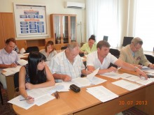

The Service for Nature Use and Environmental Protection of the Astrakhan oblast summarized the results of tender for subsidies to socially oriented non-profit organizations (SONPO) for implementation of innovative eco-projects aimed at the environmental protection and provision of ecological safety in Astrakhan oblast.

This tender was organized by the Service in the frameworks of the integrated targeted programme “State support to socially oriented non-profit organizations of the Astrakhan oblast for 2012-2016” adopted by the Resolution of the Government of the Astrakhan oblast of June 14, 2012 № 253-P.

In mid-August following the decision of the tender committee the SONPO winners list was adopted and the grant amounts for the implementation of three winning eco-projects were fixed.

The Astrakhan regional public organization to promote prevention, fire-fighting and rescue operations “Voluntary Fire Society” will receive the co-financing from the Astrakhan oblast budget of 100.431 thousand rubles for the project “Territorial Fire Safety”, which involves the establishment of a volunteer fire department for fire protection in four settlements of the Ikrianinsky district of Astrakhan oblast (villages Sedlistoe and Vakhromeevo, and towns Tovarniy and Petrovsky).

The Astrakhan Regional Branch of the All-Russian Public Organization “All-Russian Society for Nature Protection” will get the co-financing from the Astrakhan oblast budget of 80 thousand rubles for the publication of the monograph “Modern State of Caspian Seal Population and Activities for its Protection”.

The non-profit partnership “Caspian Association of Auditors of Energy-Auditing and Expert Organizations” will receive the budgetary support of 100 thousand rubles for the implementation of the project “Clean Water” developed by the young scientists of the Astrakhan State Technical University, who are actively working in the Council of the Young Scientists and Specialists under the Service. The goal of this project is testing of biological method for integrated treatment of domestic sewage by the local installations on the basis of the higher aquatic vegetation (biosorbers) proposed by the authors.

The establishment of the administration of the ‘Volga-Akhtuba Interfluve’ natural park

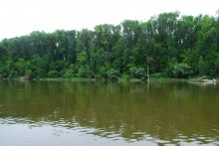

Following the Resolution of the Government of the Astrakhan oblast of July 18, 2013 № 257-P “On the establishment of the Natural Park ‘Volga-Akhtuba Interfluve’” the Service for Nature Use and Environmental Protection of the Astrakhan oblast adopted the Charter of the Administration of this newly organized natural park, which was established on the basis of the “Peski Berli” zakaznik (Sands of Berli refuge).

The ‘Volga-Akhtuba Interfluve’ natural park administration jointly with the previously established administration of the “Peski Berli” zakaznik is set to be located in the city of Akhtubinsk aimed at the implementation of the state function on compliance with the regime of specially protected areas.

The ‘Volga-Akhtuba Interfluve’ natural park with area of 194.87 thousand ha is located within the borders of the Akhtubinsky and Chernoyarsky municipal districts for the restoration of natural complexes, conservation of the environment and landscapes, protection of flora and fauna objects, as well as maintenance of ecological balance in the Volga floodplain, which is experiencing the big anthropogenic load. The regime of special protection is introduced in the SPA with allocation of three zones: recreational (80 thousand ha), agro-economical (116 thousand ha), and specially protected (260 thousand ha). The sheep grazing, commercial fishing, and construction and reconstruction of capital construction objects are restricted to all zones. The quota for amateur fishing is set as no more than 5 kg per day.

Some 24 inspectors from the administration will control the compliance with the requirements for performing activities in the natural park. The special protection regime would allow safeguarding the unique natural landscapes against careless tourists who are leaving the trash behind in the Volga-Akhtuba floodplain – the so called “wild tourism”. It is expected to use the efforts of the administration to provide for the conditions for the organized sightseeing-and-touring recreation (including the mass) that is not destructive for the unique natural landscapes. The administration personnel will organize the regional population awareness on the necessity in providing the environmental and ecological safety and conservation of biological diversity, what is the primary task of the multilateral environmental conventions and agreements.

The establishment of the administration of the ‘Volga-Akhtuba Interfluve’ natural park and the state natural zakaznik ‘Sands of Berli’ along with the adoption of the new Charter is providing the significant step towards the development and introduction of efficient methods for nature protection and maintenance of ecological balance in terms of recreational use of the unique Volga-Akhtuba floodplain area.

All-Russian litter clean-up action “Do It Together!”

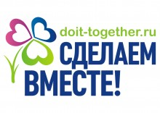

The “Do It Together!” trash clean-up campaign was carried out in early September in the frameworks of the Year of the Environment across the whole country. In the near Caspian subjects of the Russian Federation this campaign was devoted to the Caspian related events as well.

The all-Russian action was organized by the environmental movement “Do It Together!” jointly with the project “Ecology of Russia”, union of public associations “People’s Majority of Russia” and social platform of the “United Russia” political party.

The action received the support from the Federal Supervisory Natural Resources Management Service, international environmental movement ‘Terra Viva’, All-Russian Society for Nature Protection and other public organizations.

The Service for Nature Use and Environmental Protection of the Astrakhan oblast called for the Astrakhanians to support this important campaign. The clean-up acts – the so called subbotniks (community work day) – had took place in Astrakhan oblast like they did across the country aimed to make the country cleaner and pay the population attention to the systematic problems in the sphere of waste management.

The results of this campaign are expected to be finalized at the ceremony in the State Kremlin Palace in mid December 2013.

The more detailed information about the act is provided at www.doit-together.ru.

REPUBLIC OF DAGESTAN

In early August 2013 the Ministry of Natural Resources and Environment of the Republic of Dagestan organized the extended meeting related to the implementation of the priority presidential projects (PPPs). It was attended by the Ministry staff-members responsible for the implementation of these PPPs, heads of subordinate enterprises and institutions, members of the Public Council under the Ministry of Natural Resources and Environment of the Republic of Dagestan.

The Ministry prepared the respective materials for six priority projects of subsoil use, as well as the draft programme of prospecting works to identify and assess the reserves of mortar sand and saw limestone at alternative sites in substitution of the sites developed in the recreational area in the Caspian Sea coast.

Also the Minister focused on the necessity to further develop and actively include of the Republican projects/activities in the area of ecology, environment and nature use into the implementing and developed federal and sectoral targeted programmes. As a follow up, the special attention was put to the progress in the implementation of the Republican Targeted Programme “Development of the water sector of the Republic of Dagestan in 2012-2020”.

The activities under this Programme include, among other, the capital reconstruction of water-work facilities and water-protective banks at several sites along the left coast of the Terek river, completion of construction of the channel reservoir at the Khala-Gork rover aimed at the water supply of the settlements in the Karabudakhkentsky district of Dagestan, etc.

It was also stressed that the General scheme for sanitary cleaning of the territory of the Republic of Dagestan was elaborated under the Republican targeted programme “Integrated system of waste and recyclable material resources management of the Republic of Dagestan for 2012-2016”. This scheme is aimed at addressing the complex of issues related to the collection, disposal, neutralization, and recycling of waste, as well as area clean-up in settlements for the 20 year period (through 2029), with updating it each five years. This document specifies the stages for implementing activities, amounts of sanitation related activities, methods for the waste collection, disposal, neutralization and recycling, required number of specific vehicles, expediency of projecting, construction or reconstruction of sanitation system facilities, estimated investments. It was additionally said that the preliminary negotiations are currently taking place with the German HanseAtic, Portuguese AguasdePortugal, and Czech Diterm companies on potential investments in the construction of the waste storing and treatment facilities in the Republic.

Further, the priority project “Enlightened Dagestan” was discussed, and it was underlined that the increase of level of environmental enlightenment/education and environmental culture of the republican population is the integral part of this project and one of the priority directions for the Dagestan Ministry of Natural Resources and Environment.

It was further revealed that a serious work was done in the first part of 2013: the scientific and practical conferences were held as follows – ‘SPAs problems and ways to address them’, ‘Environmental problems of the water resources of Dagestan. Projects and ways to address them’, ‘Ecology in the modern world’; activities for the improvement of regional natural monuments in the municipalities of the Republic; contests among school and preschool institutions of the Republic on the ‘Best Propaganda of Environmental Knowledge’, children’s creativity ‘Nature and Me’, best amateur photo-work in nominations “Beauty of the homeland”, “Nature – SOS”, “Household pet” and others; in addition to traditional annual acts “Day of Water”, “Day of Earth”, “Bird’s Day” devoted to the “green” dates in calendar the actions “Clean Coasts”, “Day of Clean Water” (linked to the Caspian Day as well), “Bird’s House”, “Plant Your Tree”, “March of Parks” were carried out; annual Republican environmental quiz “Experts of Nature” among students of secondary schools of cities and districts of Dagestan; as well as participation in the All-Russian movement “Do It Together!”, in the framework of which the “Days of ecology of consciousness” were organized in 47 various educational institutions with participation of over 1,300 students.

Moreover, the active work in the field of environmental awareness, enlightenment and education of the population is performing jointly with the representatives of the Open Youth Government (eco-sector), bloggers community, representatives of scientific and higher educational institutions.

Young people are invited to take part in the contest “Innovation in ecology and nature use”



The international contest of youth projects “Innovation in ecology and nature use” took place in Dagestan in summer 2013. It was aimed at increasing the level of development of environmental education and enlightenment of young people, rational use of natural resources in the subjects of the Russian Federation and CIS countries in the frameworks of the Year of the Environment declared in Russia.

It was organized by the Youth Innovation Center of the Committee for Youth of the Republic of Dagestan with the assistance of the Ministry of Natural resources and Environment of the Republic of Dagestan and expert-methodic partner ANO “Northern Caucasus Center of Project Management”.

Young people aged between 18 through 30 years were able to participate in the contest. To apply it was necessary to submit the drat project in one or several contest directions according to the respective requirements. The project should represent the actual, oriented at the practical implementation solution with identification of its resourcing and concrete mechanism for implementation.

The contest had two stages:
- the 1st – selection (early August 2013) of the most actual projects;
- the 2nd – final that took place in the frameworks of the youth forum “Caspian - 2013” in September 2013 as the full-time protection of the contest projects by the finalists.

The following directions were available for the contestants: Environmental protection; Rational natural resources use; Waste disposal; Social ecology; and Ecosystem of the Caspian Sea.

The main criteria for evaluation of the contest projects – are the relevance of the problem to be addressed by the project, quality of its substantiation, novelty of the project, availability of organizational mechanisms for project implementation, financial and economic rationale, possibility of practical and financial implementation of the project, perspectives for its self-funding.

The youth forum “Caspian - 2013” that covered the final stage of the contest was held in September 2013 and involved the young people from different regions of Russia and CIS countries. This forum was attended by the well-known politicians, ministers, sportsmen, and teachers. Also on the opening day it was attended and welcomed by the President of the Republic of Dagestan Mr. Ramazan Abdulatipov.

The final stage of the contest collected 35 projects. Each contestant had five minutes to briefly present his/her project relevance, usefulness, and innovativeness. As the result five winners were identified in five nominations: Environmental protection – Ms. Saida Rasulova; Rational natural resources use – Mr. Saadu Kaziev; Waste disposal – Mr. Magomed Akhmedov; Social ecology – Ms. Tiana Kholmirzaeva; and Ecosystem of the Caspian Sea – Ms. Nailia Aephendieva. The awarding of the winners took place during the closing ceremony.

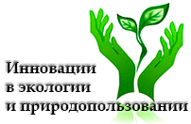

Environmental campaign “oBEREGAi” in the city of Kaspiysk

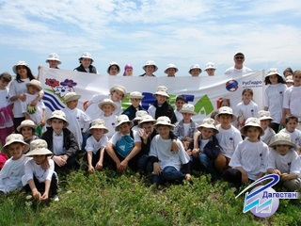

The Dagestan branch of the RusGidro, JSC has carried out the environmental campaign “oBEREGAi” (in Russian it is a mixture of words protect and COASTS) at the coasts of the Sulfatnoe lake in the city of Kaspiysk near the Caspian Sea. This year over 60 children aged between 9 and 14 from different schools of the city participated in the campaign, as well as the educators from the Young Naturalists Station. Before starting the clean-up the kids observed the part of the lake that was cleaned last year under this campaign. Unfortunately, they found that the citizens did not managed to keep the shore cleaned, and the eco-troopers commenced their job to help the water body

They children were provided with the necessary gear, while the special transport was provided by the city administration. Even the rainy weather did not scare the participants of the campaign, and in two hours they managed to clean out the lake’s coast adjacent to the city from the domestic and construction garbage filling up the truck completely with lots of strange things in addition to regular plastic bottles and packages like mousetraps, chargrill, travelling bags, bumpers etc. They also found the nest with the quail eggs near the lake.

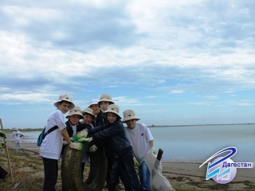

After the work was done all kids were gifted with the memorabilia gift – a book telling about how the water serves the people – from the organizers of the campaign. In Dagestan this act, organized by the representatives of the hydropower sector, is taking place annually since 2007. Few thousands of scholars from a number of settlements like Chirkei, Gelbach, Bavtugai towns, several viallges of Untzukulsky district, and from Kaspiysk took part in it during these years collecting totally 21 big garbage trucks of consumer trash.

The “oBEREGAi” charity environmental campaign through cleaning rivers and other water bodies involves the participation of children from orphanages, boarding schools, and children's environmental organizations to foster youth social activism, environmental outlook, skills of careful attitude to water bodies and coastal areas, interest and love to the environment, and patriotism.

Environmental action in the Kumtorkalinsky district

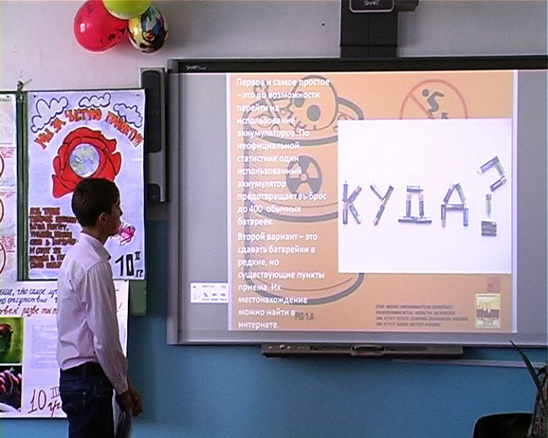

As part of the Caspian Day events scheduled for 2013, the original eco-action “Ecology of Consciousness” was held in the Korkmaskala town school, organized by the district division of youth policy and teachers. The main objective of this event was attraction of scholars’ attention to the problems of environmental pollution. The children organized the theatrical performances, fashion shows of outfits made of disposed materials, as well as presentation of concrete nature conservation projects.

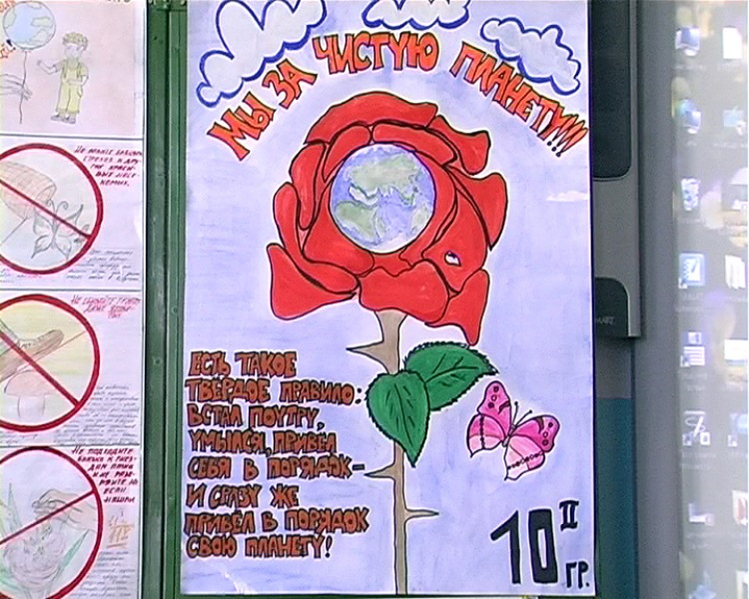

One of the projects on the separate disposal of hazardous materials such as batteries, mirrors, plastic, the district administration is planning to implement in practice.

Taking care of the environment should be one of the elements of person’s education, the human being should not only be a patriot of his homeland, his district or settlement, but he should be a patriot of nature – this is the primary motivation of the organizers of the event, and they promised to hold such actions on a regular basis.

REPUBLIC OF KALMYKIA

Fishermen Day celebration in Lagansky district

Festive ceremony “Fishermen Day” – one of the most popular among the locals – took place in Lagansky district among the various events devoted to the Caspian Day scheduled in Kalmykia this year.

In Lagan there is almost no person who somehow is not associated with fishing. It’s either a professional fisherman, or an amateur. Due to the popularity of fishing a monument to the fisherman was built up in the city center.

The Head of the Republic of Kalmykia Mr. Alexey Orlov and the First Deputy of the Chairperson of the Government Mr. Peter Lantzanov, as well as heads of several other districts were also among the participants of the ceremony.

The event has commenced with the traditional contest of amateur fishermen for the biggest yield. Further there was a set of formal greetings from the authorities followed with the awarding of diplomas and valuable and memorable gifts to fishermen and fishing enterprises that achieved the highest production indices.

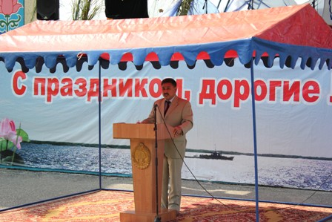

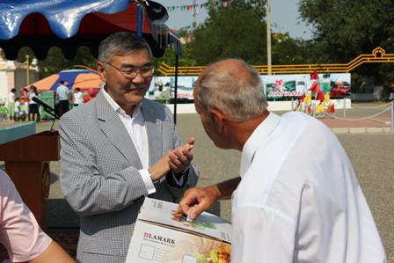

After, the event has continued with various celebrative actions with the participation of almost all district residents. Those included the exhibition and sale of crafts “Lagan craftsmen” organized by the educational institutions of the district, children school of arts, public organization “Women Council of Lagan District”, and residents. This exhibition featured original items: crafts from wood, plastic, paper, dough, decor items, clothes, confectionery and fish products, flower arrangements.

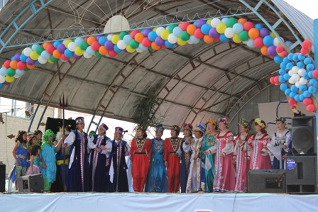

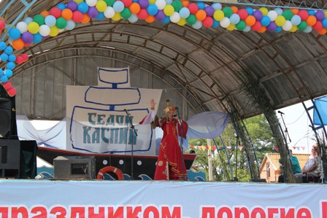

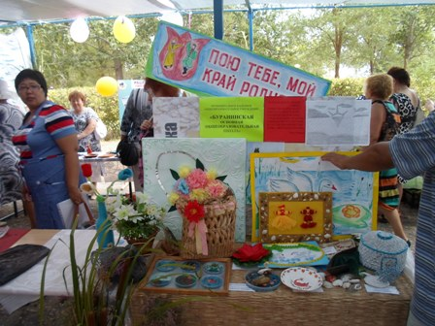

The Severnoe, Djalykovo, Ulan-Khol villages presented the decorated kibitkas (nomad wheeled tents) where one could also get acquainted with the work of rural craftsmen and taste the delicious fish cuisine. Businessman A. Sherstyukov treated everyone with the freshly cooked ukha (field fish chowder) in the fishing camp, located in the courtyard of the Children House of Creativity, which was decorated by the Lagan museum.

The personnel of the Lagan library traditionally organized the the decorated field reading room for the district residents, which was completely dedicated to the Caspian Sea and people inhabiting and working at its coasts.

Eco-talk “Clean Coasts – Clean Water”

On August 12 – the Caspian Day – the Central Lagan Library organized the environmental review discussion with the library visitors. This event was dedicated to the natural resources of the Caspian Sea, and the ecological condition of the Caspian coastal area. The discussion was held by the district activists of the Association of Children Organizations “NIITzL”.

Over 20 readers of junior and senior school age were familiarized about the Caspian Sea ecology, environmental problems related to the biodiversity conservation of marine and coastal ecosystems, as well as the Caspian Day and its background.

The Caspian Day dedicated book exhibition “In the depth of waves”

In the period of August 12 through 17 the book exhibition was organized in the Central Lagan Library. The stands demonstrated the fictional, scientific and non-fictional literature dedicated of the Caspian Sea and the North-West of the near-Caspian.

The main objective of the exhibition was to familiarize the readers of the library with the unique values of the Caspian Sea. Everyone could get acquainted with the old books, as well as the book novelties devoted to the Caspian Sea. The exhibition organizers believe that the citizens of the Lagan district should not only know the nature of the native land, but carry out the environmental protection activity. The exhibition was quite popular in Lagan.

“Clean Water Day” action

On August 12, 2013, the “Clean Water Day” action was organized and held in the children health improvement camp ‘Salute”, located in the Lagan district. The programme of this action included – informational discussion themed as “My Caspian”, presentations by the groups on “My fishing homeland”, and the contest of paintings “I am living at the Caspian”.

The “My Caspian” informational discussion was held by the camp instructors with the kids. There were short presentations made dedicated to the wildlife and fish stocks, as well as the environmental problems of the Caspian Sea were explained to children. The instructors in their presentations invited the kids to respect the environment, and do not discard trash in not only the streets of Lagan, but in the Caspian Sea and its coastline.

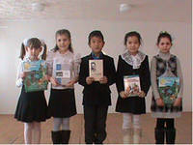

The presentations of groups under the “My fishing homeland” theme included the improvised scenes related to the fishing. The children depicted fishermen returning from the sea with their catch, and the underwater world of the Caspian in the fairy version.

The contest of paintings “I am living at the Caspian” was between the camp groups. Various paintings made by the young artists of different age were presented.

The action had a culminated in the festive dinner.

Contest on the protection and restoration of the water resources

The Republican contest of scientific, research and applied projects by senior scholars related to the protection and restoration of the water resources was organized on the basis of “Ecology-Biological Centre of Students”. The jury included the specialists from the Ministry of Natural Resources and Environmental Protection of the Republic of Kalmykia and the Department of the Federal Supervisory Natural Resources Management Service for the Republic of Kalmykia.

Some 19 projects were submitted for the contest by the senior classes students from Yustinsky, Gorodovikovsky, Yashaltinsky, Tzelinny, Chernozemelsky, Maloderbetovsky, and Lagansky districts of Kalmykia and from Elista, the capital city.

Among others two submitted projects were directly dedicated to the Caspian Sea problems.

Photo contest “Positive and negative through the green lens: environmental problems of Kalmykia”

The Kalmykia State University had organized the photo contest “Positive and negative through the green lens: environmental problems of Kalmykia” dedicated to the natural values of the Republic. A lot of works presented at this contest were devoted to the Caspian Sea and the Lagan district – the only district of the Republic with the access to the Caspian Sea.

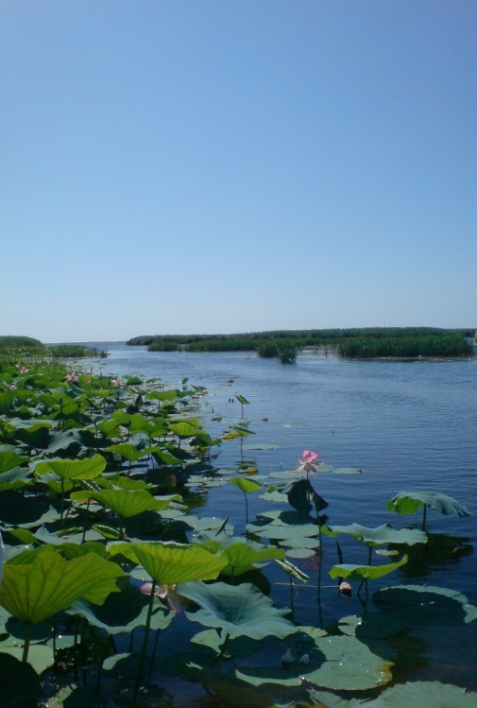

Eco-meeting “Learning to love, understand and protect the nature of the homeland”

Few days prior to the Caspian Day the specialists-ecologists from the Ministry of Natural Resources and Environmental Protection of the Republic of Kalmykia carried out the eco-meeting with the kids from the children summer camp “Saigachonok” (baby saiga) located in the Tzelinny district under the activities stipulated by the Year of the Environment in the Russian Federation. Such activities are part of the continuous work on the environmental enlightenment and education carried out by the personnel of the Ministry.

The homeland nature is unique, as are the water bodies, animals and birds inhabiting it. The Ministry’s specialists explained the young audience their significance and protection. The environmental experts believe that the most important thing is to convey to each child the simple truth that man, being part of nature, often has a devastating effect on her it. Namely this is the cause why today there is the urgent need in environmental education and enlightenment beginning from the school.

The children were also told about the Caspian Sea and necessity in its protection. The ecologists offered the kids to prove through the personal instance their respect to what surround us and is in need for care, including in the course of the Caspian Day related activities both in this year, and in years to come.

Final word

Being in the relevance with the principle 10 of the Rio Declaration on Environment and Development, as well as the UN Millennium Development Goals, the principle of public participation in environmental management is the one of the basic principles of a whole number of modern international documents in the area of sustainable development, for instance those like the Arhus Convention on Access to Information, Public Participation in Decision-making and Access to Justice in Environmental Matters, documents of the UN Commission on Sustainable Development related to the implementation of the Agenda 21 and decisions of the World Summit for Sustainable Development.

In the development of the aforesaid the Tehran Convention also included the public participation as the one of main principles that serve as the base ground for the activity on its implementation, and is stipulated by its Article 21, pursuant to which “The Contracting Parties shall endeavour to ensure public access to environmental conditions of the Caspian Sea, measures taken or planned to be taken to prevent, control and reduce pollution of the Caspian Sea in accordance with their national legislation and taking into account provisions of existing international agreements concerning public access to environmental information”.

Despite the active growth of self-consciousness within the society the public participation still is facing different obstacles like low priority, capacity and funding insufficient for organization of participation, inadequate scope of wider public strata with non-governmental institutions and associations, opposition to the concept of participation from several group(ing)s, political and institutional barriers on the way to participate and concentration on other short-term priorities dictated by the economic situation.

Nevertheless, the public participation in the Tehran Convention implementation in general meet the national legal frameworks of the public environmental activity and UNEP approaches to participation of stakeholders in multilateral international environmental agreements. Among other, this has been once again confirmed by the activities aimed at supporting the implementation of the Tehran Convention, conducted in 2013, and in particular, those associated with the Caspian Day and the decade of signing the Convention itself.

It should be noted that by the current momentum the interaction between the executive authorities of the national and regional levels in the context of organization and implementation of the activities related to the Caspian Day and the Convention anniversary has reached the new level and entails an increase in activity.

Besides, the invitation to the corresponding dialogue of the representatives of the big business, in a first turn enterprises of the oil-and-gas sector, had a positive effect on such interaction.

In particular, in Astrakhan in the course of the activities devoted to the Caspian Day and the Convention jubilee the round table meeting was held with participation of the representatives from the local authorities, public, academia, NCLO and oil and gas companies. Its outcomes have become a sort of a basis for further development of the interaction among them both at the bilateral basis, and in a multilateral format. This would serve as an additional incentive for the implementation of the strategy of the private sector involvement into the Tehran Convention realization process.

The systematic development of the “public diplomacy” institution as one of the components of activation of population involvement in the development of multifarious links and contacts both inside the country, and within the frameworks of the near-border cooperation is worth noticing as well. It is related to the expansion of the national capacity in addressing the international, in particular, environmental problems, including in the most vulnerable from the point of view of biodiversity conservation in the significant ecosystems. The examples, successful in the recent years, of such cooperation in the Astrakhan oblast evidence of the correctness of the selected directions for cooperation.

The relevant outreach and awareness work is required to ensure the effectiveness of public environmental activity and “public diplomacy”. In its turn, the corresponding informational, coordination and organizational support, formation of the modern network structure of such activity, development of the constructive dialogue between the society and the authorities, and assistance form media are crucial to provide the efficacy of Russian public participation in addressing the environmental problems.

Operation of the network of public environmental organizations, which perform their activity in the near-Caspian subjects of the Russian Federation, do also confirm the growth of efficiency of public participation in nature protection activity in this region of Russia, availability and development of actual capacity of local public organizations related to addressing environmental issues of the region aimed at the sustainable development, and the basis for systemized awareness and enlightenment of wider strata of population on such activity. The main vector for the development of this network currently is the adjustment of form and content of such organizations’ activity to increase effectiveness of their inter-linkage with decision-makers and among each other, including in the regional scale through the means of the virtual Caspian Environmental Information Centre (CEIC).

So far, the work of environmentally oriented public structures of the region covers the significant number of concrete directions, having at the same time the key, clearly determined priorities and generally promoting quite effectively to the development of the relevant capacity in the field of environmental protection and implementation of the state environmental policy in the region.

The effectiveness of public structures participation in addressing the environmental problems is determined by the complex of various factors: from the significance of either problem of the region in the understanding of public eco-consciousness to the availability of actual sources of financing of their environmental protection activity. Much depends on the experience and interaction with other stakeholders, concerned in solution of such problems (including the authorities and business structures).

In this connection the efficient interaction of stakeholders, concerned in solution of environmental problems in the region is necessary prerequisite for achievement of synergetic effect and success of this activity. Under the current realities the most successful from the environmental positions is the trilateral interaction of business, public, and authorities. The role of “scenes” for such partnerships are played by the public councils/chambers under the executive bodies, public representations of local and regional level, forums and projects patronized by the big business. At the same time the academia is actively involved into the participation in these partnerships.

The significant role in increasing the effectiveness of public participation is played by the so called “feedback channels” of the public and the Convention work bodies: relevant web resources, regional and national media, meetings, conferences, thematic sociological polls, existing forms of association of the scientific community with traditional forms of debates, discussions and publications, etc.

The implementation of the Tehran Convention provisions, as any environmental activity in the Caspian region, is based on accounting of social, cultural, religious and ethnic specificity of local residents, including the cultural and historic traditions of nature use.

In conclusion, it seems expedient to notice the fundamental significance for the provision of the effective implementation of the Tehran Convention and its protocols that belong to the issues related to the formation of adequate eco-consciousness and active civil position of the regional population, including the representatives of the big business and authorities, clearly demonstrated within the frameworks of the respective activities and events devoted to the Caspian Day and the Convention anniversary, and that in general are related to the environmental activity in the wider region of the Caspian Sea.

Annex

August 12,  Caspian Day |  | THE PANDIT SHAKES THE HEAD,  DEPLORES THE WRITER, THE POET GRIEVES,  THAT CASPIAN FROM COASTAL LINE  SHALLOWS OVER YEARS, AND RETREATS.  IT SEEMS SOMETIMES TO ME THAT IT’S A BOSH,  THAT CASPIAN THE OLD COULD NOT GET SHALLOW…  Rasul Gamzatov

Decade of the Tehran Convention

The Framework Convention for the Protection of the Marine Environment of the Caspian Sea (Tehran Convention – www.tehranconvention.org), adopted by five Caspian littoral states – Azerbaijan Republic, Islamic Republic of Iran, Republic of Kazakhstan, Russian Federation and Turkmenistan, in November 2003 in Tehran, and entered into force on August 12, 2006, represents the international legal base for the regional cooperation at the Caspian in the sphere of environmental protection and rational nature use.

The Parties to the Convention had made the decision in the course of the 1st Meeting of the Conference of the Parties (Baku, May 2007) to declare the twelfth of August as the regional Caspian Day and to celebrate it annually with, inter alia, events aimed at raising the awareness on the environmental problems of the Caspian and ways to address them.

This year marks the ten years since signing the Tehran Convention, which became the fundamental for the system of international legal documents regulating the interaction between the Parties to the Convention in the area of environmental protection and rational nature use.

The Tehran Convention was developed following the initiative of the Caspian littoral states under the aegis of UNEP, with the significant contribution to its development and implementation made also by UNDP, GEF etc.

The Convention has made a quite complicated and intense mile in the ten years of its development, becoming and implementation.

Being the largest closed water body with the unique ecosystem on the Earth, with 400 biological species inhabiting it that are endemics the Caspian Sea is currently exposed to the degradation of the sea ecosystem in general, and the threat of extinction of many species characteristic for the Caspian as a result of overexploitation, pollution, and destruction of natural habitats, and climate changes.

The present state of the environment of the near Caspian region of Russia is characterized with high stress resulted from the combined action of a number of adverse natural and anthropogenic factors. Also, the Caspian environmental problems are directly affecting the socio-economic development of coastal areas.

The Caspian Sea is included into the sphere of the Russian national interests due to the significant natural resources, ecological and economic importance, and Russian environmental policy considers the Caspian as the unified, geographically and ecologically systemically-integral body.

The Tehran Convention evidences the acknowledgment of common environmental problems of the Caspian and the necessity in inter-governmental cooperation to address them – its main objective is “is the protection of the Caspian environment from all sources of pollution including the protection, preservation, restoration and sustainable and rational use of the biological resources of the Caspian Sea”. Its distinctive feature in this area is the consistent implementation of ecosystem approach to issues related to fisheries activities in the Caspian. It links the development of the biological resources potential with the restoration of ecological equilibrium, while the maintenance of commercial species population species at levels that can produce the maximum sustainable yield, – with environmental factors that qualify the indicated processes.

The Convention in line with natural and international-and-legal specificities of the Caspian Sea is introducing the modern forms of the regional cooperation to prevent, reduce and control pollution; protect, preserve and restore the marine environment; utilize the assessment of impact on the Caspian Sea marine environment; monitor the state of the marine environment; carry out research and development; exchange of information etc.

The Tehran Convention considers the issues related to the prevention of oil (and other) pollution of the marine environment in the course of implementation of perspective projects on hydrocarbons development and transportation, and it binds to adopt all necessary measures to prevent, reduce and control the Caspian Sea pollution from the sea bed activities.

To this end, issues related to minimization of damage to the biological resources during the expansion of the Caspian Sea marine and coastal oil and gas fields development, in accordance with the letter and spirit of the Tehran Convention should also be considered through the effects of the oil-and-gas related activity on biodiversity, including the safety and integrity of the Caspian habitats.

Being the first legally binding document signed by all Caspian littoral countries, it serves as the common base for identification of primary requirements and institutional mechanisms for the protection of the Caspian Sea marine environment.

The Tehran Convention is a framework in its format, and concrete obligations for its implementation shall be determined by the protocols to the Convention: already signed Protocol Concerning Regional Preparedness, Response and Co-operation in Combating Oil Pollution Incidents (August 2011, Aktau, Kazakhstan), and Protocol for the Protection of the Caspian Sea against Pollution from Land-Based Sources and Activities (December 2012, Moscow, Russia), and yet to be adopted Protocol for the Conservation of Biological Diversity and Protocol on Environmental Impact Assessment in a Transboundary Context.

The important role for the protection of the Caspian marine environment and rational nature use in the region is played by the documents that were and are being developed, prepared and adopted under the Convention at the meetings of its Conference of the Parties, as follows:
- Strategic Convention Action Programme (SCAP) (2nd meeting, November 2008, Tehran, Iran);
- National Convention Action Plans (NCAPs), which are tools for its implementation (2nd meeting, November 2008, Tehran, Iran);
- Draft Caspian Sea Environmental Monitoring Programme (EMP) (4th meeting, Moscow, Russia).

The big significance under the Tehran Convention activity is given to the Public Participation Strategy for the near Caspian subjects of the Russian Federation. Its major goal is establishment of effective mechanism of public participation and its involvement in resolution of environmental issues related to the Tehran Convention and its protocols. This goal is achieved through public awareness on the Tehran Convention activity through the corresponding web resources (web-sites, web-forums, e-conferences), organization of feedback channels between the public organizations and the Convention work bodies etc.

In general, the effective interaction of stakeholders interested in addressing the environmental problems of the region is essential to achieve the synergetic effect and success of such activity. In this context, the most effectual is the interaction of business sector, including the oil and gas industries, public and authorities.

For reference: The Great Pacific Garbage Patch, also described as the Pacific Trash Vortex, was formed by the oceanic currents gradually concentrating the litter discarded into the ocean in the one area. It was predicted in mid 1980s, while it was discovered in 1997. The accumulation of plastic and other waste in the ocean is located roughly between 135°W to 155°W and 35°N to 42°N occupying according to estimates made by the scientists up to 8.1% of the size of the Pacific Ocean.

