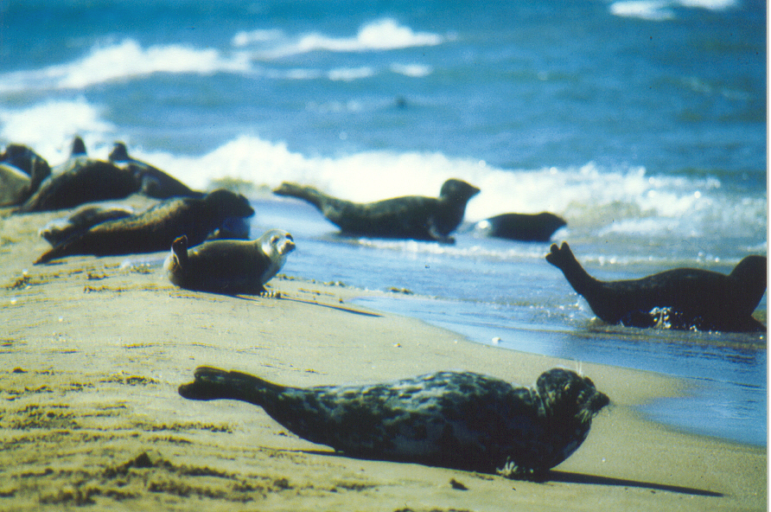

TRANSBOUNDARY DIAGNOSTIC ANALYSIS
FOR THE CASPIAN SEA

Volume Two

THE CASPIAN ENVIRONMENT PROGRAMME
BAKU, AZERBAIJAN

September 2002


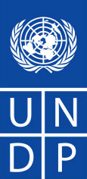


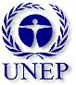

Table of Contents
Volume Two
1.0 The Caspian Sea and its Social, Economic and Legal Settings 1
1.1 Introduction 1
1.2 Physical and Biogeochemical Characteristics of the Caspian Sea 3
1.3 Socio-Economic and Development Setting 23
1.4 Legal and Regulatory Setting 39
2.0 Major Transboundary Perceived Problems and Issues 50
2.1 Introduction 50
2.2 Stakeholder Analysis 51
2.3 Decline in certain commercial fish stocks, including sturgeon: strongly transboundary. 59
2.4 Degradation of coastal landscapes and damage to coastal habitats: strongly transboundary. 69
2.5 Threats to biodiversity: strongly transboundary. 74
2.6 Overall decline in environmental quality: strongly transboundary. 79
2.7 Decline in human health: weakly transboundary. 105
2.8 Damage to coastal infrastructure and amenities: weakly transboundary. 115
2.9 Invasive and Introduced species: strongly transboundary. 122
2.10 Contamination from offshore oil and gas activities: strongly ¶transboundary. 125

List of Figures
Volume Two
Figure 1.2-1 The Caspian Sea 4
Figure 1.2-2 Caspian Sea Water Levels 7
Figure 1.2-3 Caspian Sea Evaporation, 1900-1994 9
Figure 1.2-4 Changes in the Elements of the Water Balance and Water Level of the Caspian Sea, 1990-1998 11
Figure 1.3-1 Relative Population Map 24
Figure 1.3-2 Relative Gross Domestic Product 26
Figure 2.3-1 Estimated Total Stock of Commercial Fishes in the Caspian Sea (excluding Iran) 61
Figure 2.1-2 Sturgeon Catch 1929-1998 (tonnes/year) 62
Figure 2.3-4 Aquaculture production in the USSR and CIS countries (FAO) 66
Figure 2.4-1 Desertification 69
Figure 2.4-2 Regional Desertification Map 70
Figure 2.4-3 Desertification in the Caspian Region 71
Figure 2.6-1 Inorganic Lead in Sediments 84
Figure 2.6-2 A large oil slick in the western Caspian off Baku 85
Figure 2.6-3 Pollution Hot Spots 91
Figure 2.6-4 Uranium in Sediments 92
Figure 2.6-5 Network of Hydrometeorological Stations for the Caspian Sea 96
Figure 2.6-6 Mercury in Sediments 99
Figure 2.6-7 DDT in Sediment 100
Figure 2.6-8 DDT in Seal Tissue 102
Figure 2.6-9 Seal Mortality 103
Figure 2.7-2 Life expectancy at birth (average and Caspian coast) and (years) 107
Figure 2.7-1 Caspian Coastal Region 109
Figure 2.8-1 Water level fluctuations 115
Figure 2.8-2 Potential for coastal inundation (CEP 2001, Schrader) 118
Figure 2.8-3 Caspian Region Earthquake Locations 119
Figure 2.9-1 Mnemiopsis leidyi 122
Figure 2.10-1 A history of exploitation 125
Figure 2.10-2 Danger of leaks 126

List of Boxes
Volume Two
Box 1 Kara Bogaz Gol 9
Box 1 Kara Bogaz Gol 10
Box 2 Sturgeon 17
Box 3 Caspian Seal 18
Box 4 Mnemiopsis leidyi 22

List of Tables
Volume Two
Table 1.2-1 Summary of Caspian Sea Characteristics 12
Table 1.2-2 Invasive Species of the Caspian Sea (Aladin 2001, Mitrofanov 2000) 21
Table 1.4-1 Summary of International Environmental Agreements Ratified By Caspian Littoral States 46
Table 2.2-1 Stakeholder Group Prioritization of MPPI 57
Table 2.2-2 Stakeholder Groups Prioritization of Root Causes 58
Table 2.3-1 Average Annual Caspian Fish Catch CIS Countries 1910-1998 and Iran 1927-1998 (thousand tonnes per year and percent of change compared to 1932-1959 60
Table 2.3-2 Estimated annual juvenile sturgeon release by three hatcheries in Azerbaijan 65
Table 2.3-3 Annual juvenile sturgeon release in Iran 65
Table 2.3-4 Annual juvenile sturgeon release in Kazakhstan 65
Table 2.3-5 Annual juvenile sturgeon release in the Volga River, former USSR and Russia 65
Table 2.4-1 Areas Subject to Heavy and Very Heavy Degree of Desertification 72
Table 2.5-1 List of Approximate Numbers* of Species, Endemic Species, Alien Species, and Listed Species in Different Biota Groups 74
Table 2.5-2 Spawning Grounds of Sturgeon 75
Table 2.6-1 Data and Information Availability and Reliability 80
Table 2.6-2 Air Emission Inventory for Absheron Peninsula including Baku and Sumgait 88
Table 2.6-3 Pollution load from rivers, municipalities and industry in Caspian Sea as well as each country 89
Table 2.6-4 Pollution Hot Spots 90
Table 2.6-5 Nuclear Reactors in the Caspian Sea Vicinity 93
Table 2.6-6 Nuclear Fuel Processing Facilities, Radons, and Other Potential Sources of Radioactive Pollution in the Caspian Sea 94
Table 2.7-1 Survival Rates (UNDP Human Development Report 2001) 106
Table 2.7-2 Leading Global Health Crises and Challenges (UNDP Human Development Report 2001) 106
Table 2.7.3 National and Caspian coastal region birth rates, per 1000 108
Table 2.7.4 National and Caspian Coastal death region rates, per 1000 108
Table 2.7.5 Cases of infections diseases by country 111
Table 2.7.6 Public Health Care by country 111
Table 2.7-7 Descriptive statistics of the data obtained for E. coli and faecal streptococci from sampling sites in Iran, Turkmenistan and Azerbaijan. 113
Table 2.8-1 Most affected geomorphologic structures (CEP 2001, Schrader) 117
Table 2.8-2 Extent of inundation in the five littoral countries (CEP 2001, Schrader) 120
Table 2.10-1 Estimated Total Annual Oil Input to the Caspian Sea (CRTC PC, 2001) 127
Table 2.10-2 Estimated Oil Input from Oil Industry Activities (CRTC PC, 2001) 127

1.0 The Caspian Sea and its Social, Economic and Legal Settings

This section aims to provide background information on the Caspian Sea in order to support the recommendations in the National Caspian Action Plans (NCAPs) and the Strategic Action Programme (SAP). Thus, this TDA is not merely a State of the Environment report, but also a look into the future based on the current political situation, socio-economic conditions, and legal/regulatory framework.

1.1 Introduction

This Transboundary Diagnostic Analysis (TDA) is a scientific and technical assessment, through which the water-related environmental issues and problems of the Caspian Sea region have been identified and quantified, their causes analyzed and their impacts, both environmental and economic, assessed. The analysis involves an identification of causes and impacts at national, regional, and global levels and the socio-economic, legal, political and institutional context within which they occur. The identification of the root causes specifies sources, locations, and sectors.

This TDA provides the technical basis for development of the National Caspian Action Plans (NCAPs) and the Strategic Action Programme (SAP). In this TDA, the specific combination of activities contained in an NCAP or SAP is also determined by both national and regional policy considerations that may affect programme direction, sustainability, and cost effectiveness.

The TDA is based on extensive previous work. First, the Ramsar Steering Committee approved a Framework TDA in May 1998. Next, in May 2000, the Tacis Project prepared a Preliminary Draft TDA, which focused primarily on the significant advances made under Tacis support to the CEP during the previous two years (Tacis Phase I). The TDA is also based on four regional TDA meetings held in Baku, Azerbaijan, to obtain regional input. Finally, the TDA is based on the many basis documents available from the CEP and other sources, gathered during the four years since the Programme’s initiation. Much of the work developed in this section therefore is extracted or summarized from vast resource materials available to the CEP. The existing extent of data and depth of analysis far exceeds the capabilities of this short TDA and therefore it represents a succinct synthesis of this information.

The process of completing the TDA included five Regional TDA Meetings, held in July 2000, December 2000, July 2001, November 2001, and May 2002. At these meetings, attended by representatives of all Caspian littoral states and the international partners, the scope of the final TDA was agreed, the list of Major Perceived Problems and Issues updated, the Causal Chain Analysis completed, and the list of actions/ interventions was developed in concert with the development of five regional Environmental Quality Objectives. Following the December 2000 Regional TDA Meeting, each country held a national TDA Meeting to review progress on the TDA to date, to provide national recommendations for improving the TDA, and to provide general national input on the TDA process. The second draft TDA was reviewed at a week-long meeting in November 2001, where input from all experts was solicited. The draft TDA was then re-visited in May 2002 in a last TDA Regional Meeting. Thus, the TDA process has been inclusive both regionally and amongst the various international partners.

The TDA encountered many challenges as this regional process was carried out. The major international assistance to the CEP (the Tacis and the GEF projects) was not concurrent. Due to their different project cycles, the Tacis project began one year prior to the GEF project, leading to incomplete coordination between the projects. Tacis-assisted CRTCs, for instance, began work earlier than GEF-assisted CRTCs. Tacis then undertook a second tranche of work, which was completed at the end of December 2001, whereas the GEF project continues through September 2002.

Another challenge was the absence of open data sharing. Whereas the basis documents for the international assistance anticipated open sharing of available data, in fact these data have not been made available to the CEP as a whole, and often not to a particular CRTC. Raw data may be sensitive for a variety of reasons, including its value as a real currency in emerging market economies, lack of clarity about ownership of the data, and political or cultural perspectives. Lack of effective intersectoral coordination on a national level also reduced the availability of data in some instances. The extent of this challenge significantly detracted from the work of the TDA. A major priority in the future should be to establish a data-sharing agreement that clearly lays out the regional availability of scientific data (both new and historical).

Another major challenge was the availability and quality of data available to formulate this TDA. This TDA attempts to determine whether or not Major Perceived Problems and Issues (MPPI) are supported by facts. There are common perceptions about environmental matters, which may be colored by varied private interests, media, hidden agendas, lack of knowledge, or ignorance. This TDA points out gaps in our knowledge, where assessments of an MPPI are not possible. The study makes judgments about the scientific utility of various types of data and information in order to reach its conclusions. Historical data may not have had adequate quality control, making them impossible to rely on for this study. Reported data may be averaged such that that they cannot be used scientifically. Documentation of older analytical methods may be missing, thereby reducing credibility of data.

An additional data issue in the Caspian region is that the break-up of the former Soviet Union left a 10-year gap in monitoring of many parameters of concern. Air and water quality were no longer measured routinely, as instrumentation, vessels, reagents, human resources, and infrastructure dispersed or deteriorated. Thus, much of the data are a decade old with sparse data since. Fortunately, the CEP and various international and multi-national concerns have stepped in and provided some data during the past five years, including a Caspian-wide fisheries cruise and a Caspian-wide sediment quality cruise (ASTP).

Geographic Scope

The geographic scope of the Caspian Sea TDA cannot be described simply. A common geographic scope for the Major Perceived Problems and Issues cannot be defind, even though the TDA guidance states that the entire water basin must be covered under the study. Within the Framework TDA approved at Ramsar in May 1998, it was agreed to take the boundaries as far out to sea as can be actively managed, and as far inland as the administrative boundaries of coastal provinces. Where these boundaries impinge too far inland, the TDA should concentrate on a corridor width of between 100 and 200 km. Major rivers will be addressed with their lower reaches as a priority and the remainder only as much as possible.

However, the geographic scope or scale for some MPPI may extend farther or may be less distant. For instance, coastal desertification and water level fluctuations may be caused by climatic events that are global in scale, and thus the appropriate geographic scale is the globe, while many processes specific to coastal desertification (poor land use planning, poor agricultural practices, etc.) may be limited to the coastal administrative units (oblasts, rayons, or provinces). Pollution also has a much broader scale than defined at Ramsar, since rivers may bring pollution from all portions of the drainage basin. For instance, the Volga River services much of interior Russia, and the drainage basin extends beyond Moscow. For the Kura River, which is strongly Transboundary, pollution may emanate from any of the countries through which it passes, including Turkey, Georgia, Armenia, Iran, and Azerbaijan. It simply is not practicable (schedule-wise and budget-wise), however, to include the entire drainage basin in all aspects of the TDA. Therefore, the TDA is limited to the proximate discharges of water and associated pollutants, only in rivers’ lower reaches and the littoral zone. This shortcoming is partly offset by considering river mouths as “point sources” of pollution to the Sea, where sufficient data on river pollution exists. However, the TDA has attempted to make up for these shortfalls by cooperating with ongoing programme focusing on the rivers. For instance, USAID and Tacis projects in the Kura River Basin and the Russian Federation Volga Revival project, focused on obtaining data and developing plans for improved governance of the river basin. Also, GEF has several ongoing studies of the Volga and Ural river deltas and their data were incorporated into the TDA as available.

The exact geographic scopes/scales for specific MPPI are described in the relevant sections. In general, the geographic scope agreed at Ramsar is used where other guidance was not available.

1.2 Physical and Biogeochemical Characteristics of the Caspian Sea

This section provides a brief introduction to the environment of the Caspian Sea. The physical description of the sea provides a context within which to understand the major perceived problems and issues.

Physical Setting

General
The Caspian Sea is the largest inland water body (with no connection to world oceans) in the world, occupying a deep depression on the boundary of Europe and Asia with a water level at present of approximately 27 m below the level of the world oceans (Figure 1.2-1). The Caspian contains more than 78,000 cubic kilometers of brackish water. Having been isolated from the world oceans at the end of the Pliocene epoch (1.8 million years ago), its ecosystem incorporates remnants of the fauna of the larger regional seas (mainly the Mediterranean and the Arctic biogeographic complexes).

A major difference between the Caspian and other large inland water bodies is its meridian orientation and great length (1,200 km), resulting in large differences in climate over the sea and especially over the catchment area; the northern shores are subject to extreme continental climate, while the southern and southwestern coast is in the sub-tropics.
Origin
The modern Caspian Sea originated as part of an ancient, brackish Pontic lake-sea 5-7 million years ago. In the Late Mesozoic and Early Paleocene, the ancient Tethys Sea occupied the area of the present Mediterranean and the Black, Caspian, and Aral seas. During Paleocene and Neocene times, the Black and Caspian seas were joined and separated several times. In the Early Pliocene, the Caspian Sea was separated for the first time from the Black Sea and accordingly, the primary marine fauna was partly eliminated and partly modified. During the Mid-Pliocene, the Caspian Sea was completely isolated from the Black Sea and since that time developments of the two basins, as well as their fauna, have proceeded independently. The typical brackish-water Caspian fauna formed at this time persisting to the present day (Kosarev and Yablonskaya 1994). Occasional connection with the Aral Sea contributed little to the biodiversity to the Caspian Sea.
Figure 1.2-1 The Caspian Sea

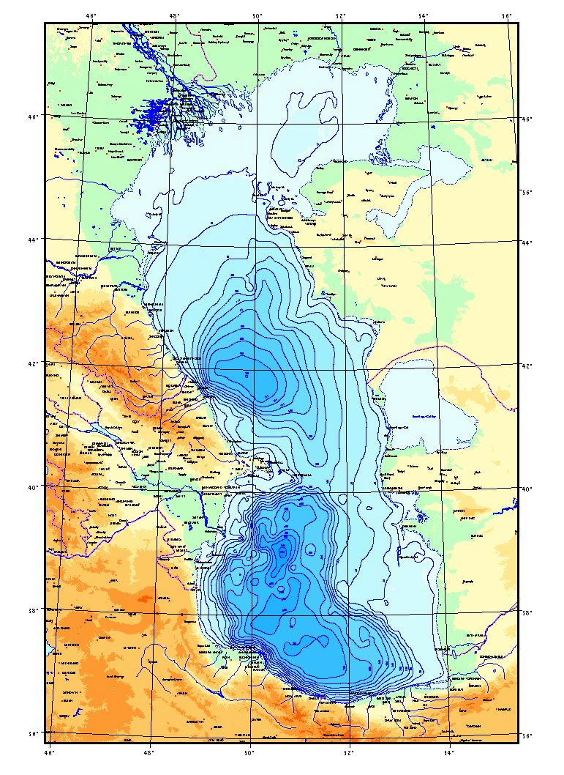

Origin
The modern Caspian Sea originated as part of an ancient, brackish Pontic lake-sea 5-7 million years ago. In the Late Mesozoic and Early Paleocene, the ancient Tethys Sea occupied the area of the present Mediterranean and the Black, Caspian, and Aral seas. During Paleocene and Neocene times, the Black and Caspian seas were joined and separated several times. In the Early Pliocene, the Caspian Sea was separated for the first time from the Black Sea and accordingly, the primary marine fauna was partly eliminated and partly modified. During the Mid-Pliocene, the Caspian Sea was completely isolated from the Black Sea and since that time developments of the two basins, as well as their fauna, have proceeded independently. The typical brackish-water Caspian fauna formed at this time persisting to the present day (Kosarev and Yablonskaya 1994). Occasional connection with the Aral Sea contributed little to the biodiversity to the Caspian Sea.

Geology
The northern part of the Caspian Sea is on the margin of the Pre-Caspian synclinorium of the Eastern European platform. South of this geological feature and dividing the North and Middle Caspian is the Mangyshlak threshold, which is structurally connected to the submerged Karpinski Ridge on the western coast and to the Mangyshlak mountains of the eastern coast. The Middle Caspian floor has a heterogeneous geological structure. The Derbent Depression, the western portion of the shelf, and the continental slope are part of the marginal geosynclinal trough of the Great Caucasus. The Absheron threshold dividing the South and the Middle Caspian is a structure formed as a continuation of folded structures of the Great Caucasus, part of the alpine fold region.

Bathymetry
The Caspian Sea lies between 47°13’ and 36°34’ 35” north latitude and between 46°38’ 39’’ and 54°44’ 19’’ east longitude. The length of the Caspian (north-south) is approximately 1200 km. The greatest breadth of the Caspian from east to west is 466 km; in the region of the Absheron peninsula, its breadth is only 204 km. The average breadth of the Caspian from the west to the east is 330 km. The surface of the Caspian is about 436,000 км², and its volume is about 78,000 км³. The maximum depth of the Caspian is 1025 m, and the average depth is 184 m.

This sea is commonly divided into three portions: the northern, middle and southern parts. The northern part of the sea covers about 80,000 км² It is relatively shallow, averaging about 5-6 m in depth. The Ural Furrow is a slightly deeper (8-10m) structure extending the Ural River trend across the shallow northeast shelf. The middle part of the Caspian Sea is a separate depression totaling about 138,000 км² in area. The western slope of this depression is quite steep, whereas the eastern slope is more gradual. The bottom is a gently sloped plain with depths of 400-600 m. The average depth of the Middle Caspian is 190 m, and its greatest depth is 788 m. The southern part of the Caspian Sea, having a total area of about 168,400 км², is separated from the middle by the Absheron ridge which is a continuation of the main Caucasus range. The deepest part of the Caspian Sea is in the South Caspian.

Coastlines
The coastline of the Caspian Sea is varied. The northern shoreline is strongly undulating, whereas the rest of the shoreline is generally smoother. The deltas of the Volga, the Ural, Emba, and Sagiz rivers lie along the northern shoreline. Kizlyar Bay is on the western shoreline, and Komsomolets Bay and Mangyshlak Bay are on the eastern coast. Two of the largest islands are Tuleni Island and Kulali Island (all told there are some 2000 км2 occupied by islands), and major peninsulas include the Absheron, Agrakhan, Buzachi, Tub-Karagan and Mangyshlak peninsulas. The Middle and South Caspian shorelines are varied, ranging from narrow beaches fronting seacliffs to broad sandy regions near river mouths. Kara Bogaz Gol is a large gulf on the eastern shore that forms an extensive evaporation basin (see box inset 1, page 10). The western coast has a series of terraces, gradually rising to the Great Caucasus Mountains. The western coast is composed of sediments (small-and medium-grained sands) carried by mountain rivers and streams. In the Southern Caspian (mainly Iran), the relatively smooth western coast is composed of small-grained sands and silt. The eastern coast, curved in the northern part with high barchan dunes and smooth in the southern part with sand dunes up to 12 m in height, is composed of sand and shells. The Iranian coast contains extensive barriers and lagoons of value to the biological diversity of the region.

The coastlines of the various countries are uneven, but the lengths are approximately as follows:

Azerbaijan: 825 km
I.R. Iran: 1000 km
Kazakhstan: 2320 km
Russian Federation: 1460km
Turkmenistan: 1200km

The total length of Caspian coast therefore is nearly 7000 km.

The islands of the Caspian Sea play an important role in the biology of the region, providing habitat for seals and migrating birds. Islands in the north Caspian Sea are important for seals resting during their annual northwards migration for pupping, molting, and mating and the islands off Azerbaijan’s Absheron peninsula are a refuge for migrating seals (participating in both the fall and spring migrations). The large Ogurchinsky Island off Turkmenistan’s coast may host a southern seal population, distinct from the northern one. The size and character of the islands fluctuate greatly with water level changes.

Contemporary water Level Fluctuations
One of the most important features of the Caspian is its changing water level, a factor that has a significant effect on biodiversity and coastal management in the extensive shallow areas. The level of the Caspian Sea is below that of the world’s oceans. The highest water level in recent history, -22 m, was reached about 3,800 years ago (Aubrey et al. 1994b), and the level may, depending how far back in history one goes, have been as low as -64 m. Early in the last century (up to 1929), the sea level fluctuated around -26.2 m, later decreasing to -29.0 m in 1977 (Kosarev and Yablonskaya 1994). This is the lowest level reached during the past 400-500 years. In 1978 a rapid rise began, and the sea level reached –26.42 m by 1995. Since 1995 some regression was observed in the sea level. At present the Caspian Sea level stands around the -27 m mark. There are almost no tides in the Caspian Sea.

The causes of sea level change are mainly natural or related to world-wide anthropogenic effects on the climate. As an inland sea, the level naturally changes in response to changes in the balance of inputs (mostly river flow) and outputs (primarily evaporation). Geological instabilities play only a small role in the water level fluctuations. Apart from small annual variations of about 0.20 m, during the past two centuries sea levels have been more than 3.5 m higher (1800) and 2.1 m lower (1977) than the present level (Figure 1.2-2).

Local causes of increased or unnecessary environmental damage resulting from sea level change are:

- Inadequate understanding of the processes causing natural changes in climate and thus changes in sea level.
- Inadequate planning of coastal developments, resulting in unnecessary damage.
- Reduced capabilities in meteorological, hydrological, and oceanographic monitoring, resulting in poor prediction of long- and short-term (surge) sea level changes.
- Deterioration of hydrometeorological organizations and data collection in all CIS countries to the point that they are unable to function properly.
- Lack of regional planning and cooperation in management of long- and short-term sea level changes.

Currents
Currents in the Caspian are primarily wind-generated. Maximum currents in open regions of the North Caspian are about 30 centimeters per second (cm/s) (Kosarev and Yablonskaya 1994). In the coastal regions of the middle and southern parts of the sea, currents correlate with wind direction and are typically toward the northwest, north, southeast, and south. Easterly currents are also observed near the east coast. Along the western coast of the Middle Caspian, the prevailing currents are southeast and south. Current speeds average 20-40 cm/s with a maximum of 50 to 80 cm/s (Aubrey et al. 1994b). In general, the current variability is poorly measured and modeled, and our understanding is based on rather vague generalizations. The Black Sea’s Rim Current is a major biogeochemical boundary for the chemistry and biota. Whether such a rim current exists in the Caspian Sea is unknown.

Figure 1.2-2 Caspian Sea Water Levels

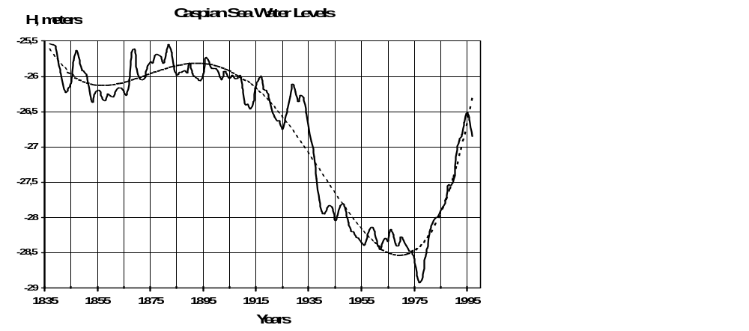

However, as for the Caspian Sea, the currents are controlled by several dominant factors:

- Buoyancy Flux: the influx of riverine discharge to the Caspian Sea in its northeast (the Volga River) provides buoyancy forcing that drives a general cyclonic (anticlockwise) circulation in the Caspian Sea, due to Coriolis forcing. This buoyancy has contributions from other rivers in the region (e.g., Ural, Terek, Sulak, and Kura), which reinforces this general cyclonic circulation. Additional strong sources of buoyancy flux include the north-south gradients in evaporation, heat flux, etc. The existence of winter icing of the North Caspian contributes to strong variations in solar heating of the waters, contributing to the north-south buoyancy gradients.

- Winds: the strong winds of the Caspian help control the basin-wide and the local circulation. The passage of fronts in the winter in general reinforces the cyclonic circulation associated with buoyancy fluxes. The relative importance of the winds versus buoyancy forcing is not quantified, but as in the Black Sea, both are likely nearly equal contributors to circulation.

Rivers
About 130 rivers of various sizes drain into the Caspian with an annual input of about 300 km³. The main rivers are the Volga (80 percent of the total volume of inflow), the Ural (5 percent), the Terek, Sulak, and Samur (total up to 5 percent), the Kura (6 percent), and Iran's small rivers of the Alborz and others (4-5 percent) (CEP 1998a).

Salinity
Salinity in the North Caspian varies markedly, from 0.1 parts per thousand (ppt) at the mouth of the Volga and Ural rivers to up to 10-11 ppt near the Middle Caspian. The middle and southern parts of the sea have only small fluctuations of salinity; surface salinity is about 12.6 to 13.5 ppt, increasing from north to south and from west to east. There is also a slight increase in salinity with depth (0.1 to 0.2 ppt) observed in all regions of the sea. Figure A3.2-1 in Annex 3.2 shows surface water salinity levels during summer in the Caspian Sea.

Water Temperature
Water temperature varies considerably with latitude. This difference is greatest (about 10º C) in the winter when temperatures in the north are 0-0.5º C near the ice and 10-11º C in the south. Freezing temperatures are found in the north and in shallow bays along the eastern coast. The water temperature of the west coast is generally 1-2º C higher than along the east coast. In the open sea, the water temperatures are higher than those near the coast by 2-3 º C in the Middle Caspian and by 3-4º C in the southern part of the sea.

Evaporation
Evaporation from the sea surface represents one of the principal outflow components. Analysis of the interannual variations of evaporation during the current century has indicated that the rate of evaporation was highest during the 1930's, as a result of drier climate from predominant anticyclonic atmospheric circulation over a considerable part of the former USSR European territory. This anticyclonic activity stimulated evaporation not only within the water catchment system of the sea, but also over the sea surface proper. At that time, about 395 km3 of moisture evaporated from the sea surface, exceeding the overall inflow. As a result, from 1930 through 1941 the sea "lost" about 740 km3 of water (about 1.96 m). Evaporation from the Caspian Sea surface (Figure 1.2-3) displays significant interannual variability, reflecting regional climatic patterns. Evaporation rates range from 700 mm/year up to a maximum of about 1400 mm/year. Minimum is in the Middle Caspian Sea, whereas maximum evaporation is in the North Caspian and near Baku. Seasonal variability in evaporation is more pronounced than annual changes. Evaporation is thought to have decreased in the interval of the 1978-1990, while both precipitation and river flow increased dramatically. The increase in precipitation and river flow is attributed to a change in storm patterns for the region. During the period of 1978 through 1993, the atmospheric circulation resulted in a change from largely cyclonic storm activity to anti-cyclonic storm activity, affecting both the total precipitation as well as the wind stress.

Evaporation basins play a significant role in the level of the Caspian Sea, particularly near high sea levels. The two largest evaporative basins are Kara-Bogaz-Gol (see inset box 1 on the next page) and Mertvy Kultuk Sor.

Figure 1.2-3 Caspian Sea Evaporation, 1900-1994
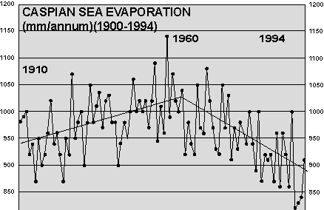
Box 1 Kara Bogaz Gol

KARA BOGAZ GOL:
MODERATOR OF CASPIAN WATER LEVELS

Located along the eastern coast of the Caspian Sea near Turkmenistan’s border with Kazakhstan, the Kara Bogaz Gol mirrors the natural beauty of the Caspian Sea, its uniqueness, and its interaction with humans. Originally fed by the Oxus River (now the Amu Darya River), the Kara Bogaz Gol is a shallow bay whose varying area depends on the water level of the Caspian. It is an evaporate basin, connected to the open Sea only through a short (order of kilometers), narrow (tens of meters), and shallow (order of meters) inlet. In essence, water evaporates faster from the gulf than it can be replaced through the inlet, so the water level of the bay is lower by nearly 3 meters than that of the Caspian. Salinities in Kara Bogaz are high (reaching many tens of parts per thousand), giving rise to an extensive salt-mining industry near the shores. So much water flows into the Caspian Sea and evaporates there, that this Gulf alone removes between 2 and 10 cm of water from the entire Caspian Sea each year.

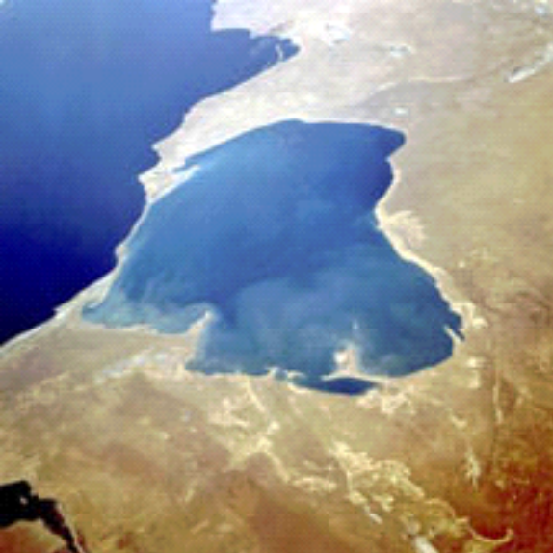

The volume of water evaporating from the Sea depends on the water level and human activity. When water levels in the Sea are high, the flow into the gulf is stronger. When the water level in the Sea is low, the flow to the gulf is lower,(and the area of the gulf gets smaller. After river inflow and evaporation, the Kara Bogaz Gol is the next largest determinant of the water level of the Caspian Sea.

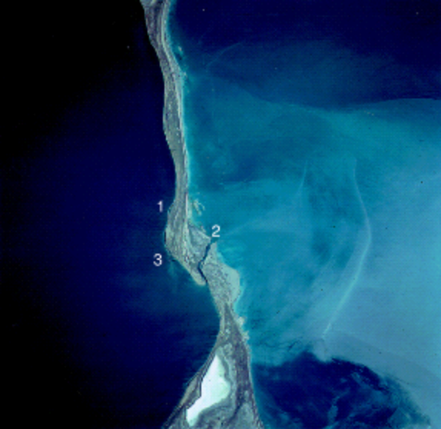

The Kara Bogaz folly illustrates the difficulty of planning major engineering projects in the face of a variable climate. From about 1930 to 1978, the level of the Caspian fell some 2.5 m, as climate variability and dam/reservoir construction combined to rob the Caspian of freshwater inflow. In order to mitigate the serious effects of lowered water levels on the Sea, scientists proposed to close off the Kara Bogaz Gol, thereby retarding the fall of the water levels in the Sea. As luck would have it, the Sea began to rise in 1978. The long-planned dam across Kara Bogaz was finished in March 1980, when it was no longer needed. The closure accelerated the consequent rise of water levels, which continued through 1996. The water level increased by an additional 2-3 cm per year over the entire Caspian Sea, due to closure of Kara Bogaz Gol. Finally, in September 1984, a spillway was opened to allow some minor inflow of Caspian waters to the gulf, but only in June 1992 was the dam removed. This example illustrates the difficulty of anticipating the vagaries of nature.

Photographs from NASA

Figure 1.2-4 Changes in the Elements of the Water Balance and Water Level of the Caspian Sea, 1990-1998

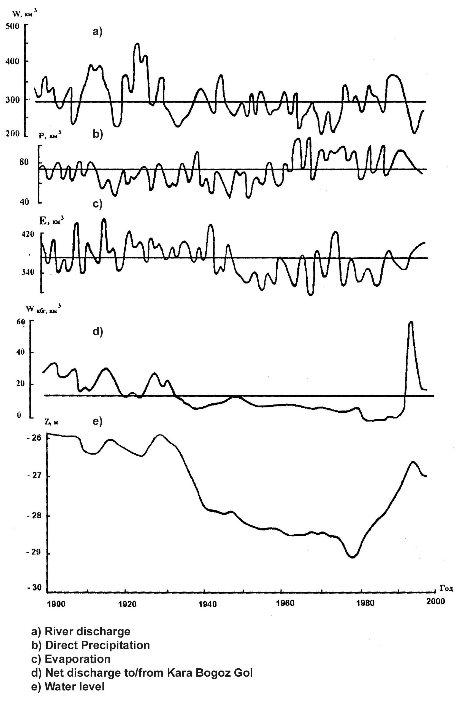

Climate
The climatic conditions of the region are determined by the influence of cold Arctic air, moist sea air masses forming over the Atlantic Ocean, dry continental air masses from Kazakhstan, and warm air masses coming from the Mediterranean Sea and Iran.

The best known synoptic classification of the atmospheric circulation over Russia is the Vangengeim-Girs, which describes the most common types of circulation as follows:

- circulation type W, which is zonal and associated with increased precipitation, warm winters, and moderately hot summers;
- circulation type E, which is meridional and characterized by stable high pressure over European Russia, resulting in cold winters and hot cloudless summers; and
- circulation type C, which is also meridional and characterized by a trough over European Russia, resulting in cyclonic fields over the Volga basin, high precipitation and low temperatures.

Type E is the most common, and has been even more dominant than usual in recent years.

Ice Cover
In the North Caspian Sea, ice appears in November. During severe winters, ice covers the whole surface of the North Caspian Sea. Ice formation in the middle and southern parts of the North Caspian generally occurs in December-January. Near the east coast, the ice is of local origin, whereas near the west coast, the ice mostly drifts in from the northern part of the sea. Along the west coast, drifting ice is found down to the Absheron peninsula. Ice cover disappears in the second half of February or March. Ice cover is of great importance for the biological and biogeochemical condition of the Northern Caspian Sea, as it provides a habitat for Caspian seals and influences early spring river discharges.

Table 1.2-1 Summary of Caspian Sea Characteristics

Bordering Countries | Azerbaijan, I.R. Iran, Kazakhstan, Russian Federation, Turkmenistan
Location | Located between 47º 13' and 36º 34' North latitude and 46º 38' and 54° 44' East longitude
Total sea area  Volume | 436,000 km²  78,000 km³
Mean depth  Max depth | 184 m  1,025 m
Coastal length  Catchment area | 7,000 km  3.5 million km²
Major rivers | Volga, Ural, Terek, Sulak, Kura, Atrek, Sefid-Rud  Annual riverine input ca. 300 km³
Salinity regime | Salinity varies sharply in the North Caspian Sea, ranging from 0.1 parts per thousand (ppt) at the mouth of the Volga and Ural rivers up to 10-11 ppt near the border with the Middle Caspian. The middle and southern parts of the sea have only small fluctuations of salinity; surface salinity is about 12.6 to 13.5 ppt, increasing from north to south and from west to east. There is also a slight increase in salinity with depth (0.1 to 0.2 ppt).
Temperature regime | Water temperature varies considerably with latitude. This difference is greatest (about 10º C) in the winter when temperatures in the north are 0-0.5º C near the ice and 10-11º C in the south. Freezing temperatures are found in the north and in shallow bays along the eastern coast. The water temperature of the west coast is generally 1-2º C higher than along the east coast. In the open sea, the water temperatures are higher than near the coast by 2-3º C in the Middle Caspian and by 3-4º C in the southern part of the sea.
Tidal regime | Almost absent
Nutrient regime | In the North, inorganic phosphate (0.12-0.8 μM), phosphorus in organic form (2-2.5 μM), nitrogen (10-250 μM liter^{–1}, nitrates (0.5 μM) in spring and summer, 7-10 μM in winter, silica 60 μM in winter, 20 μM in summer (Kosarev and Yablonskaya 1994, Dumont 1998).
Seabed types | On the shallow north shelf, sediments are predominately terrigenous shell and oolitic sands. Aleurolites and silt sediments with high calcium carbonate content cover the deeper areas. On some parts of the bottom, there are hard rock outcrops of Neogene age. The sediments of the Caspian Sea also contain rich oil and gas deposits.
Primary  Production | North Caspian – 22.7 mil. tons of organic carbon / year, Middle – 50.9, South – 41 (Kosarev and Yablonskaya 1994).

Biogeography

An extensive treatment of biodiversity and biogeography of the Caspian Sea can be found in the summary report by Aladin (CEP, 2001), which is based on the National Biodiversity reports from the Caspian countries (CEP 1999). An earlier report by Aubrey (1994b) provides additional background information on regional biodiversity, but more from a species perspective. A description of the habitat diversity can be found in the Regional Habitat Report compiled by Ogar (CEP 2001) and is summarized in Volume Three, Annex 3.1 of this TDA.

Biogeographic Distributions

The biological diversity of the Caspian and its coastal zone makes the region one of the most valuable ecosystems in the world, with many endemic species. A diversified range of habitats from vast river systems to extensive wetlands supports a diverse flora and fauna with high natural productivity. Many flora and fauna species contained in red books of the five littoral countries are found in the Sea and coastal zone. The Caspian lies at the crossroads of migration routes of millions of birds and offers refuge for a number of rare and endangered species. At least 15 globally threatened species use the region (geese, ducks, pelican, crane, eagles, etc.) as well as IUCN-listed sturgeon species. The wetlands in the region lie astride the East African flyway, the Mediterranean flyway, and the Central Asian-Indian flyway, involving millions of birds each year (estimates have been made that up to 10 million birds feed and rest here each year in spring and autumn).

One of the most important features of the Caspian biodiversity is its relatively high endemism. Endemic species are represented by the following:

- four species of Spongia,
- two species of Coelenterata,
- 29 species of Turbellaria,
- three species of Nematoda,
- two species of Rotatoria,
- two species of Oligochaeta,
- four species of Polychaeta,
- 19 species of Cladocera,
- three species of Ostracoda,
- 23 species of Copepoda,
- 20 species of Mysidacea,
- one species of Isopoda,
- 68 species of Amphipoda,
- 19 species of Cumacea,
- one species of Decapoda,
- two species of Hydracarina,
- 53 species of Mollusca,
- 54 species of fishes, and
- one species of mammal.

Recent studies suggest the actual endemism may be even higher.

High endemism is one criteria established by the Convention on Biological Diversity as being worthy of special attention (Aladin 2001). The longest established species are among the indigenous, brackish-water flora and fauna. The remainder of the current assemblage of organisms is basically derived from the Mediterranean complex, the Arctic complex, or the freshwater (riverine) complex.

Almost all the autochthonous species are found in the Middle Caspian because of its relative stability over time, its salinity regime (consistently brackish), and its central location. Consequently, the highest number of endemic species is found there. However, the North Caspian has the greatest diversity of both habitat and species. This is due to the presence of the Volga and the Ural, which create a zone where marine and freshwater fauna are mixed. The Volga River system was the ancient route for the penetration of Arctic and Mediterranean species that are still found in the Caspian.

Phytoplankton
The Caspian has about 450 species, varieties, or forms of phytoplankton. The dominant forms are Cyanophyta, Bacillariophyta, and Chlorophyta. Middle and South Caspian phytoplankton are a mix of marine, brackish, and freshwater forms. By contrast, North Caspian phytoplankton are all freshwater forms.

Zooplankton
The zooplankton in the Caspian are representative of Arctic, Mediterranean and endemic species, with a total of 315 species, made up of Rotatoria (135) Cladocera (50), Copepoda (43), Mysidacea (20), Cumacea (18) Amphipoda (73) and Crustacea (236) (Kosarev and Yablonskaya, 1994).

Phytobenthos
There are 87 species of algae in the Caspian, including 29 species of green, 22 of red, and 13 of brown algae. The opening of the Volga-Don canal in 1954 allowed the introduction of new species of algae from the Black Sea.

Zoobenthos
The bottom macrofauna of the Caspian Sea contains 380 species from 13 different classes of animals. The benthic fauna of the North Caspian is much less diverse than that of the Middle and South Caspian. Going from south to north, there is a steady disappearance of indigenous clams and snails, mollusks, nematodes, turbellarians, deepwater amphipods, isopods, and crayfish.

Fishes
The Caspian is characterized by a small variety of fish species compared to open ocean regions, with approximately 133 species from 17 families; 17 species are introduced aliens: the flounders, three salmon species, eel, mullets, mosquito fish, anchovy, and mackerel. Another two – pipefish and Аtherinidae - have intruded into the area themselves. The most diverse are the families of goby, carp, herring, and sturgeon.

Up to 156 subspecies may exist. Most are carp (33 percent), gobies (28 percent) and shads (14 percent) (Aubrey et al., 1994b). Most species are indigenous, with few representatives of the Mediterranean complex. There are four primary groups of fishes: sea fishes (kilka, shad, and most gobies), anadromous fishes (lamprey, salmon, Caspian roach, and all sturgeon except sterlet), semi-migratory fishes (breams, carp, and zander), and river fishes (perch, rudd, tench, and sterlet). Sturgeon are abundant, having originated from freshwater forms and acclimatised to higher salinity so that they now occupy the entire Caspian.

There have been significant alterations in fish populations, particularly fisheries and habitat alteration, during the past 50 years due to human activities. At its peak, the Caspian is said to have held up to 90 percent of the world’s sturgeon. In recent years, however, landings have decreased dramatically: from 30,000 tonnes in 1985 to only 5,672 tonnes in 1995 (Fisheries TDA, 2000). A quota system, introduced together with a temporary ban on pelagic fishing, does not appear to have been effective in reviving the dwindling sturgeon population (see Box 2).

Endangered species of fish include: Caspian lamprey (Caspiomyzon wagneri), bastard or ship sturgeon (Acipenser nudiventris),beluga (Huso huso), Volga shad (Alosa kessleri volgensis), Caspian trout (Salmo trutta caspius), inconnu (Stenodus leucichthys), Caspian schemaya (Chalcalburnus chalcoides chalcoides), Caspian vimba (Vimba vimba persa), Caspian barbel (Barbus brachycephalus caspicus), В. ciscaucasicus, and big-head barbel (В. Capito).

Sturgeons, which spawn in the rivers of the Caspian basin, are the most economically valuable anadromous fishes. They can run upstream for hundreds of kilometers (if not blocked by dams or barrages). Sturgeons prefer pebbly and solid sandy ground for spawning. The close proximity of brackish waters with rivers (the North Caspian being the most important example) is also important. Six species belonging to the genera Huso and Acipenser, exist in the Caspian.

The biggest sturgeon, the beluga (Huso huso), reaches a length of more than 4 m and a weight of 500 kg. Reproduction occurs in the Volga, Ural, Kura, Terek, and Sefidrud Rivers, with the Volga being the most important. With the damming of all the major rivers, the range of migration has been reduced. The beluga feeds on gobies, shad, carp, and, in its first month, Mysidacae. In the early twentieth century, the beluga accounted for nearly 40 percent of the sturgeon catch. At present it accounts for less than 10 percent (in the 2001 Caspian-wide fisheries cruise, few beluga were observed).

Russian sturgeon (Acipenser guldenstaedti) accounts for between 40 percent and 50 percent of the catch (CEP 1998a). It uses the Volga, Ural, and Terek rivers for spawning, the Volga being the most important.

Persian sturgeon (Acipenser persicus) lives mainly in the middle and south Caspian Sea, preferring the warmer waters. It spawns in the Kura, although some older individuals navigate the Volga and a few the Ural. The feeding habits are mixed (benthic invertebrates and other fishes).

Sevryuga sturgeon (or starred sturgeon) is represented by two sub-species, in the North Caspian Sea (Acipenser stellatus stellatus) and the South Caspian Sea (Acipenser stellatus stellatus natio cyrenis), both are widely spread throughout the sea, spawning in the Volga, Ural, Terek, and Sefidrud rivers. The Ural River has become the most important spawning area for the sevryuga. The sevryuga catch has increased greatly, to 45 percent of the total sturgeon catch (Ivanov et al. 1995).

Spiny sturgeon (or bastard or ship sturgeon) (Acipenser nudiventris) is a minor sturgeon of the Caspian Sea. The spiny sturgeon spawns in the Kura, Ural, and Sefidrud rivers, and is rarely seen in the Volga. After damming of the Kura River, the Ural became the most important spawning river for spiny sturgeon. It forages on fishes and bottom invertebrates. Spiny sturgeon fishing is now prohibited in the Ural River because of depleted stocks; it is listed in the National Red Data Books of some Caspian countries (1997).

Sterlet sturgeon (Acipenser ruthenus), like the spiny sturgeon, is a relatively rare type of sturgeon in the Caspian Sea. Two populations exist in the Volga Basin: one limited to the upper and middle Volga, and one semi-migratory type that forages in the brackish Caspian Sea. Middle Volga sterlet stocks decreased dramatically with the initial regulation of the Volga, but lower Volga sterlet flourished. A similar semi-migratory population may exist in the Ural River.

Box 2 Sturgeon

CASPIAN STURGEON: A Dwindling Kind

Six species or subspecies of sturgeon populate the Caspian Sea, more diverse than any other sea in the world. The estimate that approximately 90% of all sturgeon in the world inhabit the Caspian Sea is a popular, if data-poor, claim. The sturgeon are curious creatures: amongst the oldest living animals on earth, they have learned to adapt to the highly variable Caspian environment. As waters rise and fall dramatically, as salinity fluctuates, and, recently, as pollution has increased, somehow these resistant animals have learned to survive. However, their most pressing threat may not be escapable: the widespread poaching of sturgeons throughout the Caspian both to feed the local populace, and also to feed the international market’s demand for “black gold.”

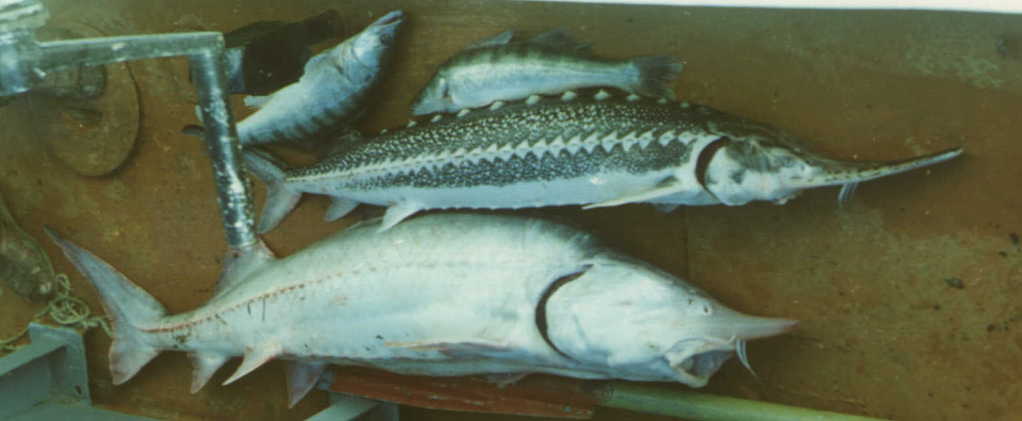

Black gold, or caviar, is one of the most expensive products on a weight basis on the world commodity markets. Derived from sturgeon roe (mainly the Beluga, Sevryuga, and Ossetra), this delicacy can reach prices that are nearly 100 times the price obtained locally for the product. Market prices now run at between $35 and $75 an ounce depending on source and type of sturgeon. Iranian Beluga caviar is the most expensive. Illegal poaching by organized crime to service the eager international market has threatened the integrity of the sturgeon population. At the high price it garners on the world market, it’s just too tempting for organized crime to pass up.



Sturgeon are under stress from other human sources as well. Prime sturgeon habitat has been taken away by the construction of dams along nearly all the Caspian rivers, from Russia south to Iran.

Some estimate that up to 90% of the Beluga spawning grounds are gone due to dam construction on the rivers. Pollution has accumulated in some parts of the Sea (such as near Baku and Sumgait, Azerbaijan), and has been measured in the sturgeon tissue and organs. Regional scientists have observed physiological

responses to pollution, including reduced reproductive capability. All this human activity tests the resilience of this ancient fish.

A recent stock assessment cruise carried out under EU/Tacis support in the year 2001 covered the entire Caspian Sea (excepting Turkmen waters). Although not conlusive, the assessment did find far fewer sturgeon (particularly Beluga) than in earlier years, and a higher ratio of young/adult sturgeon throughout the Sea. The World Wildlife Federation already names the Beluga Sturgeon as the fourth most endangered species on earth. The Caspian Sea sturgeon may follow in the tracks of the other vanishing sturgeon of the Black Sea and North America.

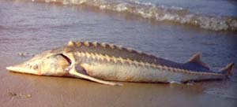

So what can be done to save the sturgeon? The recent interventions by CITES are a step in the right direction, though by themselves may not be sufficient to save the Beluga sturgeon. Listing of sturgeon on national endangered species list and preventing export of their products is another step. Hatcheries in the region already raise and introduce into the Caspian Sea some tens of millions of sturgeon fry each year, but the hatcheries are in poor condition and the utility of these measures unquantified. More attention to enforcing national laws forbidding poaching clearly is required, but whether the resources exist to combat the well-armed and speedy modern poachers is a big question. Survival will require facilitation by the international community. That the task is not fruitless is proven by I.R. Iran’s success in state control of the sturgeon trade. If this recognized success were to be repeated in other Caspian countries, there may be a future for the sturgeon after all these hundreds of millions of years.

Box 3 Caspian Seal

THE CASPIAN SEAL: BELLWEATHER OF THE SEA
(Phoca caspica Gmelin, also known as Pusa caspica)

The Caspian seal is characteristic of much of the flora and fauna of the Caspian Sea: it was originally an import. The seal is thought to have originated from the Arctic Seas during glacial periods; the Arctic seal then is thought to have evolved into both the Baikal seal and the Caspian seal. The Caspian seal is one of the smallest seals (50-60 kg), and has adapted to the rather harsh conditions of the Caspian Sea. The seal is the only marine mammal in the Caspian Sea, feeding on kilka and other small fish, and preyed upon by land animals, both natural and introduced (wolves, dogs, large predator birds, and humans).

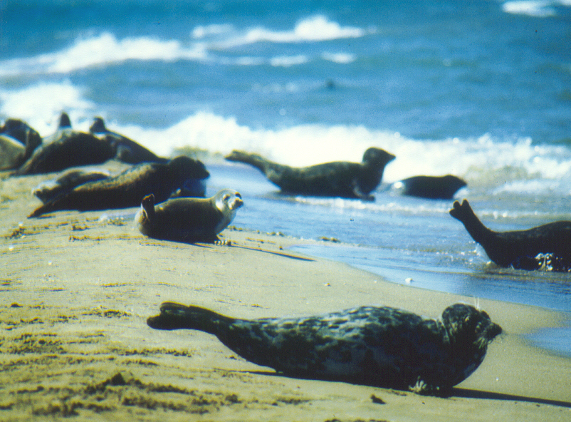

It is unclear how many seals remain in the Caspian Sea. From a population estimated at more than 1 million in the early 20th century, at present population estimates vary from about 30,000 to 400,000. Unfortunately there is no census evidence has been collected on the Caspian seal for the past 15 years or more, and the population size is uncertain. For much of the 19th and 20th century, hunting was carried out in the frozen North Caspian area each winter for seal pups. In the early 20th century, nearly 100,000 seals were taken each year by the hunt; later a quota was set at 40,000 pups per year, and later 20,000 pups. For the past three years, no organized hunting has taken place in the North Caspian, not for lack of a quota, but rather for lack of market for the seal products.

Listed on the IUCN Red List of Threatened Animals as vulnerable, the seal has been the victim of recent mass mortalities that have reduced the population even further. In 2000, a mass mortality caused some tens of thousands of deaths throughout the Caspian (Azerbaijan, Kazakhstan, Russia, and Turkmenistan). Scientists have long known that the region has accumulations of parasitic infection, heavy metals, and organic pesticides (especially DDT and its by-products), but the 2000 mortality was particularly notable for the role played by canine distemper virus (CDV). Nearly all the seals examined by the Ecotoxicology Project of the CEP tested positive for this morbilivirus. Earlier studies have shown that pollution may cause females to become barren (up to 70% of females are thought to be barren).

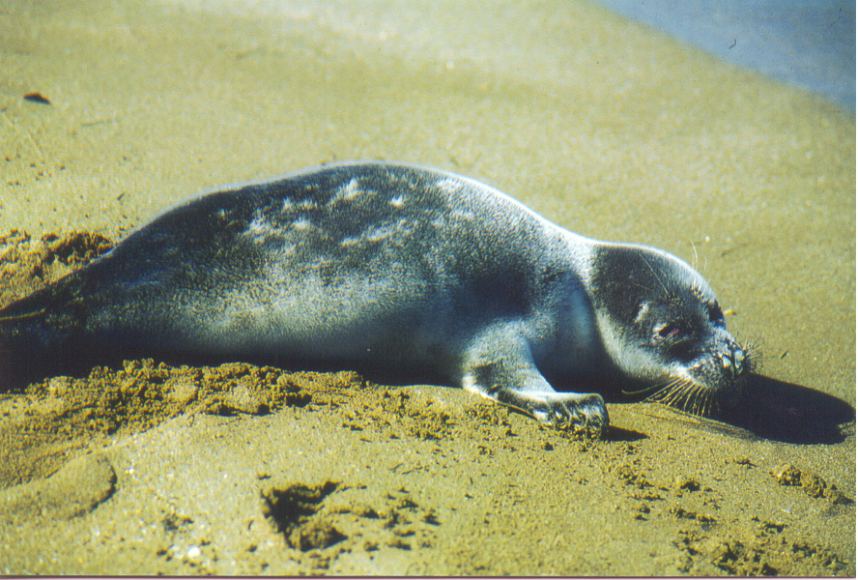

Besides pollution and hunting, other stressors act on the Caspian seal population. A major food source for the seals is the kilka, an anchovy-like fish of the Caspian. For the past two decades, fishing for this resource has expanded explosively, partly to offset decline in other fisheries. In the recent few years, an invader to the Caspian, the ctenophore Mnemiopsis leydyi, has taken hold and may threaten the kilka population itself. The arrival of this ctenophore was expected, as it had devasted the Black Sea in the early 1990s, and the Volga-Don Canal connects the two bodies of water. How damaging the ctenophore will be to the kilka and thence to the seals is at present unknown.

Active conservation efforts will be required to assure the Caspian seal does not follow the plight of the Caspian tiger. As a major mammal anchoring one end of the food web, it plays an important role in the biodiversity of the Caspian Sea.

Mammals
The Caspian’s only marine mammal is the Caspian seal (Phoca (Pusa) caspica – see box 3). This seal is thought to have come from the Arctic during former high stands of sea level. Massive hunting (several hundred thousand per year in the 19th century, tens of thousands per year for much of the 20th century) has steadily reduced the seal population. Thousands of Caspian seals died during spring 2000. An international team of scientists, working as part of the Caspian Environment Programme's Ecotoxicology Project (ECOTOX), has now concluded that canine distemper virus (CDV) was the primary cause of the mortality, although complex factors including a warm winter and absence of sea ice, pollution (mainly from organochlorines), and other factors contributed to the mortality. Estimates of the present population of Caspian seals vary by a factor of 10: between 30,000 and 400,000. No census data on seals are available since the early 1980s; recent estimates of 400,000 seals have not been supported by verifiable data.

Birds
A total of 466 species of birds can be found in the Caspian. Of these, 120 are nesting birds, 68 are wintering birds, and 278 are migratory or summer residents. The region's marine birds include gulls, cormorants, pelicans, geese, swans, ducks, and flamingo. They congregate along the coast. The highest concentrations have been recorded in the Volga and Ural rivers estuaries. The region is of high importance as a site for reproduction, molting, and rest during migrations. At least 15 globally threatened species use the region.

Major bird flyways, of particular importance in the context of bird migration in general in Eurasia, lie in the region of the Caspian Sea (Dolgushin 1960-1974; Belik 1996). In autumn, birds concentrate at the northeastern and northern coasts of the Caspian, then fly southward along the western shore, where the migration divides. One part continues along the western coast of the sea to the south, and the other part migrates westward to Caucasus. Birds from the central regions of Russia and the northwest migrate to the coast along the Volga. In the Volga delta, this migration merges with other migrants from Asia. The channels of the rivers Ural and Emba are important migratory routes.

In summertime (which includes molting aggregations in post-nesting period) and during migration, waterfowl concentrate along the coast of the Northern Caspian. Bird concentrations are especially great in the regions of the deltas of the Volga and Ural, the coast between the Volga and Ural, the spit Zhilaya and along the eastern coast of the gulf Komsomoletz (Kazakhstan). On the western coast, bird concentrations are found in the deltas of large rivers (Terek, Sulak) and in the Agrakhan and Kizlar gulfs. In autumn, in the eastern sector, birds are concentrated along the peninsula Mangyshlak.

The main bird wintering grounds in the Caspian are located in its central and, to a greater extent, southern part. However, some species spend the winter at the Mangyshlak peninsula and in the south of Daghestan (delta of Samur). The birds wintering here mainly include species of diving ducks, swans (Cygnus olor) and other species, such as cormorants (Phalacrocorax carbo). Significant numbers of the Bewick’s swan (Cygnus brewickii) may winter in the Northern Caspian at the edge of the ice cover (Morozov 1996).

The increase in water levels, flooding, and the resulting extension of reed beds and other surface vegetation have led to significant alterations of the ranges of many shore birds. Along with an increase in nesting grounds of the populations of ducks, swans and herons, and emergence of new species (purple gallinule and cattle egret) on nesting grounds, the species are moving to nesting grounds on recently flooded areas, closer to the present coastline. The inundation of shell islands (shalyga) in the northeastern part of the Caspian and the emergence of reed thickets expands the areas suitable for the nesting of many bird species.

Genetic Biodiversity
The genetic biodiversity of Caspian hydrobionts is also high, but not as high as previously thought. Certain Caspian fauna and flora have such clear genetic differences in phenotypes of different populations that some zoologists and botanists mistakenly consider these populations to be independent species (the Persian sturgeon is one example). For a long time, many zoologists regarded a number of fishes and mollusks, which occur both in the Caspian and in neighboring reservoirs, as independent species. They even have developed special morphological diagnostic signs to distinguish these species. However, genetic research shows that some organisms represent geographical races or at the most, subspecies, but not different species. At the same time, research has demonstrated that genetic differences between some hydrobionts really do exist; however, the extent of such differences is insufficient for casting these species as independent species.

Invasive Species
The flora and fauna of the Caspian Sea include invasive species from the Arctic, Atlantic, and Mediterranean complexes. Many of these invasions occurred long in the past (See Table 1.2-2).

Table 1.2-2 Invasive Species of the Caspian Sea (Aladin 2001, Mitrofanov 2000)

Time of Introduction | Species
50,000 BP | Zostera nana (eelgrass), Cardium edule, Fabricia sabella (polycheta worm), Atherina mochon pontica (sand smelt), Syngnathus nigrolineatus (pipe fish), Pomatoschistus caucasicus (transcaucasian goby), Bowerbankia imbricata
Beginning  of 20th century | Rhizosolenia calcar-avis, Mytilaster lineatus (mussel), Leander squilla (euro-african shrimp), L. adspersus (Paleomeon adspersus – European shrimp), Mugil auratus (golden mullet), M. saliens (gray mullet), Pleuronectes flesus luscus (now Platichthys flesus luscus – black sea flounder), Scomber scomber (mackerel), Nereis diversicolor (nereides), Abra ovata (bi-valves)
Middle of  20th century  (after building  Volga-Don canal) | Pleopis polyphemoides (small crustacea – Cladocera), Balanus impovisus (barnacle), B. Eburneus (ivory barnacle), Membranipora crustulenta, Ceramium diaphanum, C. tenuissimum, Ectocarpus confervoides, Polysiphonia variegata, Blackfordia virginica (jelly fish), Rhithropanopeus harrisii (crab), Engraulis encrasichous (European anchovy), Anguilla anguilla (European eel), Gambusia affinis (mosquito fish and top minnow), Oncorhynhus keta (chum salmon and dog salmon)
End of  20th century | Penilia avirostris, Calanipeda aquaedulcis (small crustacea), Acartia clausi (small crustacea), Mnemiopsis leidyi (comb felly), Aurelia aurita (jelly fish), Oncorhynchus keta (chum salmon), Ctenopharyngodon idella (grass carp), Hypophtalmichthys molitrix (silver carp), salmo salar (Atlantic salmon), Aristichthys nobilis (spotted silver carp and bighead), Oncorhynhus gorbusha (pink humpback salmon), O. kisutch (coho silver salmon)
Possible invaders in  21st century | Pseudoevadne tergistina

The deliberate introduction of commercial and food organisms has exerted a strong influence on the biodiversity of the Caspian. Between 1930 and 1970, at least nine species of fishes were introduced into the Caspian: Glos’s flounder (Pleuronectes flesus luscus), topknot (Rhombus maeoticus), mullets (Mugil auratus and M. Saliens), white grass carp (Ctenopharingodon idella), white silver carp (Hypophthalmichtys molitrix), motley silver carp (Aristichthys nobilis), chum salmon (Oncorhyncus keta), and humpback salmon (Oncorhyncus gorbuscha). Of invertebrates, organisms brought from the Azov-Black sea basins include successfully introduced polychaete worms (Nereis diversicolor), bivalves (Abra ovata), and shrimp (Palaemon elegans).

The comb-jelly Mnemiopsis leidyi was first identified in the Caspian Sea in 1998 presumably after being introduced from the Black Sea with ballast waters (see box 4). The Caspian Sea is a completely isolated basin with mostly favorable conditions for Mnemiopsis development throughout the year. Penetration of Mnemiopsis into the Caspian Sea has created a problem for its fisheries, judging from early studies of the region.
Box 4 Mnemiopsis leidyi

Mnemiopsis leidyi: DEADLY INVADER

Except for endemic species developed independently in the Caspian Sea, the flora and fauna of the Caspian emanate from other oceans. During the distant geological past, various species of organisms entered the Caspian, ranging from small plankton up to large mammals (seals). Additional species have been introduced purposefully and inadvertently by humans. Sometimes the result is beneficial to Caspian living resources, but sometimes the result is adverse.
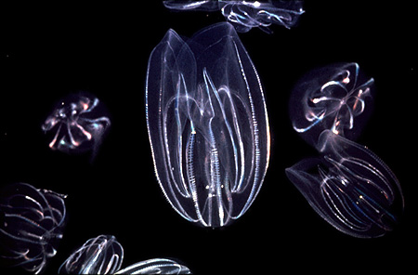

One recent invader of the Caspian is the comb jelly (ctenophore) Mnemiopsis leidyi. This comb jelly is well-known the region because of its well-documented effects on the Black Sea. Introduced from the North Atlantic in the late 1980s and early 1990s, this animal found the Black Sea to its liking, making up about 95% of the total wet weight biomass in the Black Sea in a classic biological invasion. Since moderating its influence in the Black Sea, Mnemiopsis has made its way to the Caspian. First reported in the Caspian in 1998, according to reports from regional experts, the ctenophore is distributed mainly in the middle and southern parts of the Caspian Sea, occurring in water depths up to 50 m, and at densities at times exceeding 1 kg/m2.

The ctenophore itself is a beautiful, creature, some 1 to 10 cm in length, and weighs 3-10 grams. What harm can such a beautiful creature cause? The ctenophore competes for food with ichthyoplankton (fish eggs and larvae), thereby depleting the food sources and reducing fish stocks. In some instances in the Black Sea, the ctenophore actually eats the fish eggs and larvae. The Black Sea example shows the ctenophore even eats heartier zooplankton, such as copepods. With pressure on fish stocks already high from over-fishing and from pollution, any additional pressure on juvenile forms of fish could result in drastic reduction in fish stocks in the Caspian. Eventually the Caspian Seal (see related box), which already is undergoing strong pressures from human activity, may suffer from loss of food resources (kilka) as a result of the ctenophore invastion. Early research suggests that the explosion of ctenophore in the Caspian Sea is even more rapid than in the adjacent Black Sea a decade earlier.

What can be done? As in many biological explosions, the ctenophore will peak to a climax, then reduce its biomass as various moderating factors come into play. However, great ecosystem harm may be caused during the time of the climax, mainly to fisheries. One option that has been discussed has been introduction of another ctenophone called Beroe to the Caspian to control the invasion. Research into the predatory behavor of Beroe ovata on Mnemiopsis is on-going where a Working Group has recommended timely introduction of Beroe to the Caspian Sea.

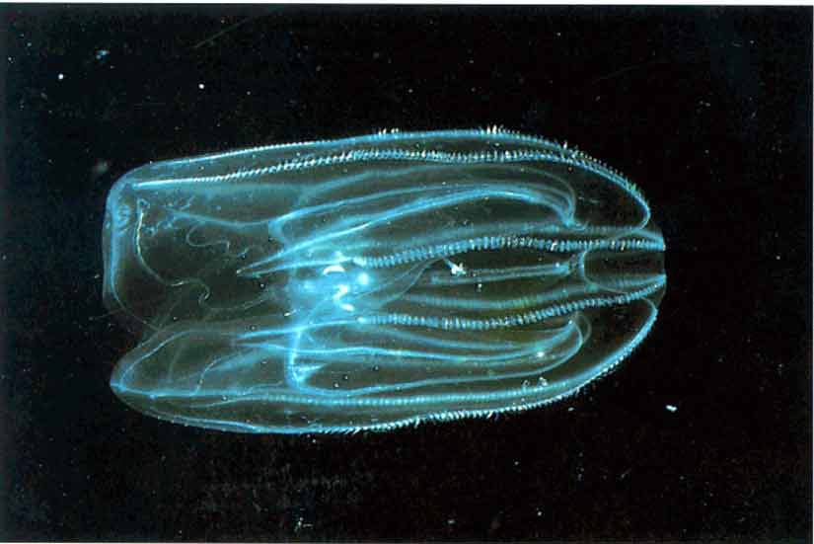

In the future, as the threat from Mnemiopsis runs its course, the Caspian countries should learn their lessons and prevent future accidental introductions of alien species. One major route of introduction is the Volga-Don Canal, linking the Black Sea to the Caspian Sea. Entering the Caspian at Astrakhan, ballast water reception facilities would help to prevent similar emergencies as is happening now with Mnemiopsis.

1.3 Socio-Economic and Development Setting

This section examines the likely implications of interactions between the socio-economic conditions and the environment in the Caspian region. Caspian resources are rich and include sizeable fisheries and other bio-resources, major oil and gas reservoirs, transport networks, and the potential for considerable tourism. Unfortunately, current social and economic conditions generally are not conducive to their sustainable use. Low income, unemployment, and inadequate social services, conditions that are fairly widespread in the Caspian Region, do not encourage the best use of environmental resources. Incomplete or inappropriate development and environmental planning - including the absence of appropriate national and regional policies, legislation, and regulation - hamper optimum use of the resources. Underdeveloped civil society and the consequent lack of accountability and transparency limit public participation in environmental and development planning. Finally, the transitional nature of economic development in all Caspian littoral states has led to substantial social and economic dislocation.

Data and Information

A meaningful analysis of the social and economic conditions of the Caspian region faces two major inter-linked challenges. The first challenge relates to the definition of the term Caspian region. This term is often used loosely and depending upon the objective of any given analyst, it can be interpreted to include varying geographical boundaries. In this section of the report, in order to facilitate the analysis, two additional terms are used: the Caspian Economic Hinterland (CEH) and the Caspian Economic Zone (CEZ). CEH refers to the geographical area where social and economic activities have a noticeable impact on the environment of the Caspian Sea. The CEZ, on the other hand, refers to the geographic area where social and economic activities have a substantial impact on the Sea’s environmental resources.

The second challenge relates to the lack of reliable social and economic information, particularly at the appropriate small-scale geographical level. Due to the absence of operational markets, the economic data collected during the Soviet era often do not reflect ‘real’ values and at best can be treated as artificial ‘shadow’ values. This condition creates a serious problem of comparability with post-Soviet information. The Iranian economic data are relatively more reliable, yet they are distorted by huge subsidies and by artificial pricing. A further complication is the absence of information at the lowest geographical levels (e.g., rayons or oblasts). Most of the information is collected on the basis of politically defined administrative units, which do not necessarily correspond, to the needs of environmental analysis. The analysis is therefore handicapped by the lack of appropriate information, and at times these analyses are based on educated estimates.

Human Development and Sustainable Livelihood

Demography
The Caspian countries are estimated to be home to 224.3 million people in 1999 (figure 1.3-1). Of these 146.2 million lived in Russia, 69.2 million in Iran, 16.3 million in Kazakhstan, 8 million in Azerbaijan and 4.6 million in Turkmenistan. Population density per square kilometer has been estimated as 92.2 in Azerbaijan, 38.8 in Iran, 10.2 in Turkmenistan, 8.7 in Russia and 5.6 in Kazakhstan. The five countries have varied population growth rates: negative growth rates of 1.0 percent and 0.4 percent in Kazakhstan and Russia, versus positive rates of 0.9 percent, 1.3 percent and 1.7 percent in Azerbaijan, Turkmenistan, and Iran, respectively. The population at 2015 is estimated to be 133.3 million in Russia, 87.1 million in Iran, 16.0 million in Kazakhstan, 8.7 million in Azerbaijan, and 6.1 million in Turkmenistan.

Figure 1.3-1 Relative Population Map

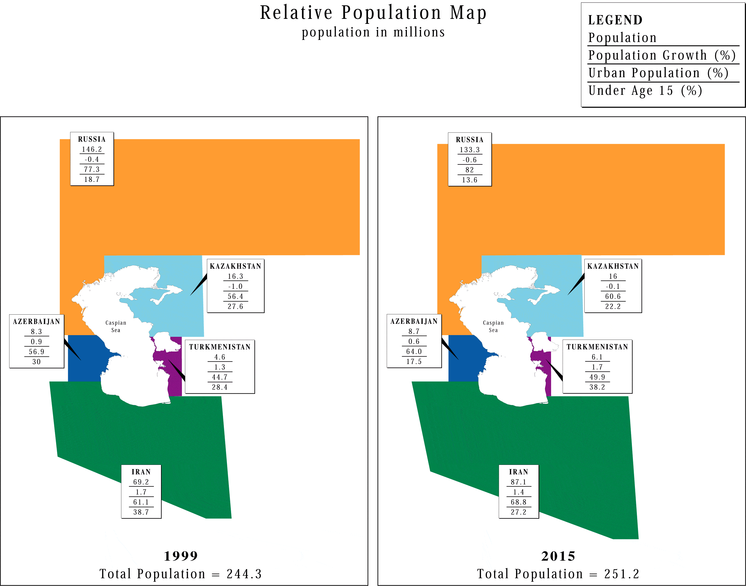

The urban population is also varied across the region. Russia’s 1999 urban population is estimated at 77.3 percent and is projected to rise to 82 percent by 2015. The comparable rates for Kazakhstan are 56.4 percent to 60.6 percent, for Azerbaijan 56.9 percent to 64.0 percent, for Iran 61.1 percent to 68.8 percent, and for Turkmenistan 44.7 percent to 49.9 percent. These figures reveal a noticeable difference between the highly urbanized Russia and the other four states. This is particularly true for Turkmenistan, where the rural population is still considerable. The projected rural to-urban movements, though not large, point to increased demands for urban services in the future that could put additional pressures on the economic resources. The move to the urban areas might also lead to increased calls for enhanced political participation, thereby putting strain on political institutions in certain countries.

The age composition of the population varies considerably from north to south. In Russia the share of population under 15 years of age in 1999 is estimated at 18.7 percent and is projected to fall to 13.6 percent by 2015. These rates are 27.6 percent and 22.2 percent for Kazakhstan, 30 percent and 17.5 percent for Azerbaijan, 38.2 percent and 28.4 percent for Turkmenistan and 38.7 percent and 27.2 percent for Iran. While the population is projected to be aging in the whole region, the aging process is faster in the north, in Russia and Kazakhstan, compared to the south. In the south and in particular in Iran and Turkmenistan, the population is young, and despite the falling growth rates, the overall population will remain relatively young for at least another generation. Although Russia and Kazakhstan might face labour shortages within a generation, in the south economies will need to generate enough jobs for the youth as well as cater to their educational needs. This will increase pressure on the existing economic resources. The other important implication is the potential pressure by the youth on the existing political structures. The youth need to be included in the political decision-making process. One might therefore conclude that the age composition will be a source of potential future instability in some of the Caspian littoral countries.

Economy
The Caspian region, as a whole, is considered to be among the ‘medium human development countries’ when evaluated on the basis of the Human Development Index (HDI) developed by the United Nations Development Programme. Russia ranks 55th, Kazakhstan 75th, Azerbaijan 79th, Turkmenistan 83^{rd,} and Iran 90th on the global HDI list for 2000. These apparently low HDI rankings do not adequately reflect the real global ‘economic’ positions of these countries. The HDI represents a combined measure of life expectancy at birth, adult literacy rate, gross enrollment ratio, and the gross domestic product (GDP) adjusted for purchasing power parity (PPP). The high literacy rates in Russian, Kazakhstan, Azerbaijan and Turkmenistan have helped to raise the HDI for these countries. Iran’s comparatively low literacy rate, on the other hand, contributes significantly to its relatively low HDI rate in the region. The HDI for Russia has fallen from .823 in 1990 to .775 in 1999, reflecting the economic slowdown of the transition years. Although no comparative figures exist for Azerbaijan, Kazakhstan, and Turkmenistan, it is safe to assume that these countries have also experienced similar reductions in their HDI indices, based on overall economic decline and challenges faced by the former Soviet states during the transitional period of the 1990s. In comparison, the HDI for Iran has increased steadily from 1980 onwards, reflecting the considerable investment of the country in education and health sectors after the Islamic Revolution. Nevertheless all the littoral countries fall in the lower half of the ‘medium human development countries,’ thus reflecting the unsatisfactory global human development condition for the region as a whole.

The intraregional ranking changes significantly when the analysis is based on GDP as an index of economic capacity and performance (Figure 1.3-2), but the region as a whole is not, at least for the time being, a major economic power. The GDP for Russia in 1999 was estimated at 401.1 billion USD, which is equal to 1,092.6 billion USD if adjusted for PPP. The comparable figures for Kazakhstan were 15.8 and 73.9, for Azerbaijan 4.0 and 22.8, for Turkmenistan 3.2 and 16.0, and for Iran 110.8 and 348.3. The region’s total GDP was 534.9 billions in 1999, which was equal to 6 percent of the USA GDP and slightly lower than Spain’s GDP of 595.9. (GDP per capita adjusted for PPP mirrors the trends in GDP (both adjusted and not adjusted).)

The regional economic sectors vary significantly. Nevertheless, all rely mostly on the export of primary goods as a major source of revenue: 57 percent in Russia, 74 percent in Kazakhstan and 87 percent in Azerbaijan. To various degrees, all littoral countries are burdened with heavily subsidized and otherwise non-viable industries. In the former Soviet countries, many of these industries are closed for lack of market and finance, adding thousands to the ranks of the unemployed. In Iran, the relatively newer technologies, combined with direct and hidden subsidies, keep most industries functioning, although quite a few cannot be sustained in the long term. The agriculture sector in the former Soviet countries provides many job opportunities, yet is technologically and managerially underdeveloped.
In Iran, industrially-biased pricing systems and unsettled land tenure hamper agricultural development. The service sector appears to be the major growth sector in most of the littoral countries, although the lines between underground and transparent economic activities in certain countries are murky. The service industry in the former Soviet countries depends heavily on the foreign investment lured by oil and gas exploration.
Figure 1.3-2 Relative Gross Domestic Product

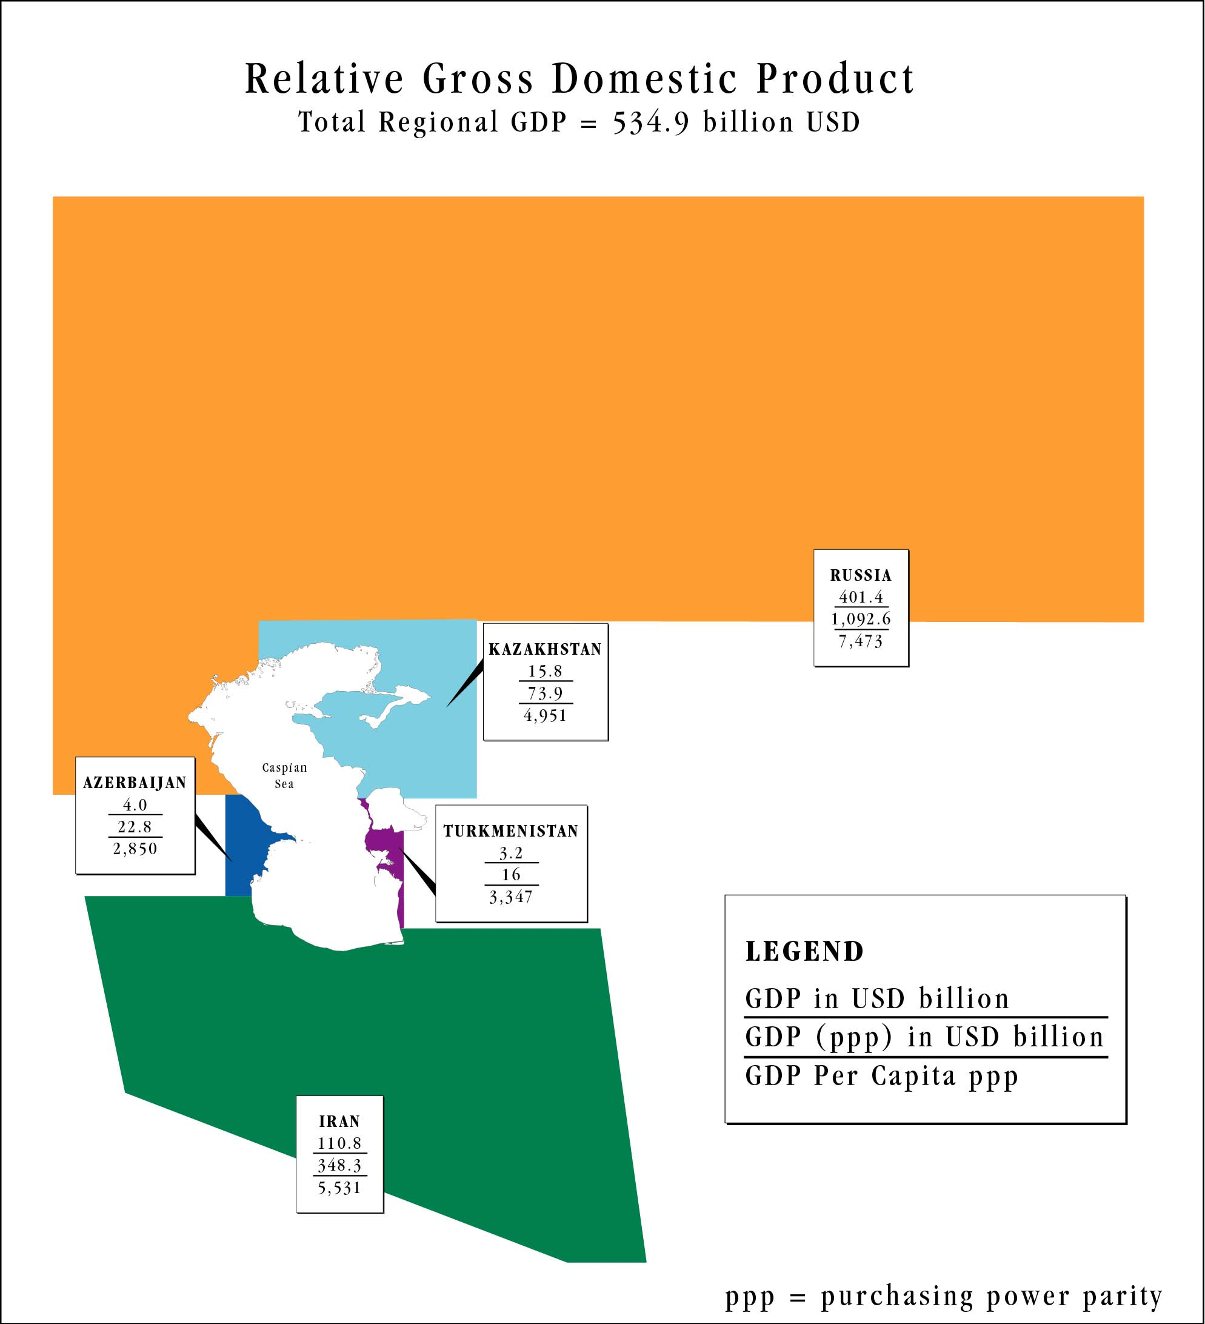

It appears that the transition to the market economy in the former Soviet countries led to a sharp decline in production accompanied by galloping inflation during 1990-1998. The figures for 1999-2000 suggest that the worst inflation might be over, although this conclusion might be optimistic due to the non-quantified effects of the global rise in the price of oil. The Iranian GDP per capita rose by 1.9 percent per annum during the same period, although it had significantly declined after the Islamic Revolution and the subsequent war. Inflation in Iran was estimated at 27.1 percent per annum for 1990-99 but fell to 20.1 in 1998-1999. Like the other littoral countries, the apparent economic recovery in Iran last year is partly due to the global rise in oil prices as well as to the impact of economic policies.

The regional economic situation in general appears to be unhealthy and cause for serious concern. A major result of this unsatisfactory state of affairs is the inability and /or unwillingness of both governments and the people to invest in environmental protection activities.

Sustainable Livelihood
The GDP per capita adjusted for PPP in USD is $7,473 for Russia, $4,951 for Kazakhstan, $2,850 for Azerbaijan, $3,347 for Turkmenistan and $5,531 for Iran. The comparable rates for the USA and Spain are $31,872 and $18,079, respectively. The GDP per capita decreased on average by 5.9 percent in Russia, 4.9 percent in Kazakhstan, 10.7 percent in Azerbaijan and 9.6 percent in Turkmenistan from 1990 to 1999, during the transition to a market economy. During the same period, the average annual change in the consumer price index, an indicator of inflation, was 116.1 percent for Russia, 82.7 percent for Kazakhstan, and 224.9 percent for Azerbaijan. The corresponding figures for 1998-99 are 85.7 percent for Russia, 8.3 percent for Kazakhstan, and -8.6 percent for Azerbaijan. These figures again point to the lack of financial resources available to most people in the region.

The shrinking product and rising inflation have been accompanied by a rise in unemployment. No official figures are available on unemployment in the region. The International Labour Organization (ILO) estimates unemployment to be around 15 percent of the total labor force in Azerbaijan. For Iran similar figures have been suggested. In both countries real unemployment appears to be much larger. In Russian, Kazakhstan and Turkmenistan the situation is not better. Unemployment rates are considerably higher among the women and the internally displaced population. Increased economic inequality has also been a feature of economic development of the past decade in the littoral countries. It is estimated that the wealthiest 10 percent of the population accounted for 38.7 percent of the total consumption in Russia in 1998, while the poorest 10 percent accounted for a mere 1.7 percent. Comparable figures for Kazakhstan were 26.3 percent and 2.7 percent; for Azerbaijan, 27.8 percent and 2.8 percent, and for Turkmenistan, 32.3 and 2.6 percent. No corresponding figures were available for Iran.

The health situation for most of the region is not adequate either. Access to essential drugs is reported to be 66 percent in the new republics and 85 percent for Iran. The number of physicians per 100,000 is 421 for Russia, 353 for Kazakhstan, 360 for Azerbaijan, 300 for Turkmenistan and 85 for Iran. The number of hospital beds appears to be fairly high. However, the problem is the quality of the medical services and the financial burden of these services on the already strained economic resources. With the dissolution of the Soviet Union, access to and quality of healthcare in the four CIS countries declined severely. The economically constrained new republics were unable to finance adequately the existing healthcare system. Emphasis shifted from preventive to restorative care. This shift, combined with an overall lack of nutrition (in 1996 studies determined that half of Azerbaijan’s children were undernourished), and often inadequate access to clean water, has led to increased disease and infant mortality rates in the Caspian region. Tuberculosis and AIDS are beginning to spread fairly rapidly. Typhoid is also a problem in the region, with cases in Daghestan 15 times higher than the Russian average. During the mid-1990s, infant mortality rates in some regions soared to as high as four times the average in industrial countries.

Life expectancy, one indicator of health, fell slightly during the past decade, although it generally remains high across the region, ranging from 64.1 in Kazakhstan to 68 in Iran in 1999. Towards the end of the 1990s, as the economy strengthened, infant mortality rates began to improve slightly and life expectancy began to rise in all Caspian countries. Iran stands as an exception in the region, as life expectancy has increased appreciably in recent years and access to healthcare has improved during the past decade. In Iran the policy shift to reduce health subsidies has created noticeable pressure on household budgets, but the likely impacts on health conditions have not yet been perceptible.

The educational system has also been under serious strain, except in Iran. Many schools and pre-schools have been forced to close throughout the region due to lack of funding. For example, in Daghestan, pre-schools only have enough slots for 30 percent of the children in need of them. As a result, literacy rates and levels of education of the children are dropping. Private educational institutions are opening in certain regions, but are not adequate to fill the gap. This decline in access to education further threatens the future economic security of the region.

An additional burden to Azerbaijan, Iran, and to a lesser extent Russia and Turkmenistan has been financing the social services for the large number of refugees and the internally displaced persons that these countries support. The Nagorno Karabagh conflict in Azerbaijan has led to the displacement of close to one million people. Iran is home to more than two million refugees from Afghanistan and Iraq. Daghestan in Russia is home to more than 100,000 refugees fleeing the Chechen conflict. Turkmenistan is also home to some 19,000 from neighboring Afghanistan. The recent conflict in Afghanistan is certain to increase these numbers.

In general, the income, job, education, and health situation for most of the region is not satisfactory. The implications are twofold: i) for years to come, the littoral governments will give higher priority to job creation, health, and education than to environment protection; and ii) individuals will be less concerned with safeguarding the environment when they are unemployed and faced with finding adequate health, food, shelter, and education for their families. In such situations, it is essential that the limited availability of environmental resources is used sin the most cost effective manner at the policy formulation level. Recognition that environmentally sustainable development is still development, and is a win-win situation, might help alleviate the traditional perceived conflict between environment and development. It is equally essential to mobilize extra-national resources, including international resources, to offset the limited national and regional resources available for environmental management and protection, if the environment is to be adequately protected.

Industries Affected by the Caspian Sea

Oil and Gas
The Caspian Sea is believed to contain considerable oil and gas deposits. The magnitude, value, location, and even ownership of these resources are still unclear. Initially the recoverable oil reserves were estimated to be around 50 billion barrels. The figure was upgraded to 200 billion in the mid-1990s, but has recently been revised downward to 100 billion. The estimates for economically viable production vary from 1 to 10 million barrels a day, although not much can be confirmed to date. Production in the next few years will be restrained by lack of agreed transport corridors.

Kazakhstan appears to have found major oil deposits and is planning to have up to 2 million barrels per day for export by 2010 and perhaps up to 8 million by 2050. For a country of 16 million, this means a total reversal of fortune. In Kazakhstan, the economies of the two oblasts bordering the Caspian Sea are already dominated by the oil sector. From 1991 to 1997, oil production in the region rose from 17.5 kt to 331.6 kt. The new oil finds in Azerbaijan have not been as promising as anticipated by the international companies, but still present considerable potential for increased revenues if the targeted 1.5 to 2 million barrels per day for export are achieved for a country of 8 million. Azerbaijan's oil sector already accounts for more than 50 percent of the country’s industrial production and 10 percent of its GDP. A recent gas hydrate field at Shah Deniz in Azerbaijan promised to broaden hydrocarbon production even more.

Oil-related investment, trade, and service activities account for additional large contributions to the GDP. The approximately $1 billion in annual foreign investment that Azerbaijan is attracting translates into 33 percent of the 1998 GDP. Turkmenistan has also had some oil finds, although the size of these is yet to be determined. Turkmenistan has among the highest per capita natural gas reserves in the world, along with considerable oil reserves. The oil and gas sector represent just over half of the national GDP in Turkmenistan. Since 1995 oil production has increased steadily, primarily due to the reworking of old wells. Iran has conducted some seismic studies in the Caspian Sea and plans exploratory drilling in the near future. Oil and gas exploration in Iranian territorial waters of the Caspian is currently not significant, although the Iranian parliament has passed bills allowing international oil companies to explore the Caspian Sea for oil and gas.

The potentially vast oil and gas resources have already brought in millions of dollars worth of foreign investment into the Caspian region. Most of the money is being spent on the application of high technology to the often daunting task of drilling in the open seas, in which case the money basically reverts to the technology providers of the foreign countries. A small part of the money is being spent in the littoral countries, particularly in the logistical support services, but not much substantial impact has been made at the national level.

There is currently competition in the region over ownership of the reserves lying beneath the Caspian. The dispute, which involves billions of dollars, has soured political relations between certain Caspian littoral states. The continuation of the dispute will deter further investment in the region, but no immediate solution is on the horizon.

The issue of the oil and gas transport routes is equally problematic. Russia currently controls a significant majority of the oil and gas shipped from the region, and is pursuing plans for further enhancement of its carrying capacity. Russia controls exports from Turkmenistan, and is part of the recently opened Caspian Pipeline Corporation that is transporting Kazakh oil to the Black Sea. Alternative plans are in the works to provide alternate means of transporting hydrocarbons from Azerbaijan to Turkey through Georgia, yet it remains to be seen whether such plans will turn out to be economically and politically feasible. The existing tanker route through Iran allows for the swapping of oil delivered to the Iranian ports in the Caspian in exchange for equal amounts at ports in the Persian Gulf. This is economically attractive, but presently faces political obstacles. Routes through China and also through Afghanistan and Pakistan could also be considered as alternatives. The final choices will need to await confirmation of the size of the finds and the market prices. The political situation in the Caspian region, in the Caucasus, Turkey, Afghanistan, and Pakistan will also have a major bearing on the final decision of export routes.

The oil and gas resources provide promising financial opportunities, but at a price. Any lowering of market prices for oil and gas can dramatically affect an oil-dependent nation. For example, when the price of oil dropped to about $10/barrel in 1998, the economies of the Caspian littoral countries were affected because they were not sufficiently diversified. An additional problem is that countries can be more hesitant to halt or limit oil drilling in order to protect natural resources when such drilling could significantly accelerate the economy. A further related problem is the accumulated expectation for an oil bonanza in some of the countries. Since the dissolution of the Soviet Union, the populaces of Azerbaijan, Kazakhstan, and Turkmenistan have been promised substantial improvement in their standard of living to be financed by oil money. Another equally important problem will be the attention of other regional and non-regional powers to the newly found oil riches. Regional labor migration to oil production centres, political and economic ambitions clothed in ethnic and national terminology, and shifting political alliances may prevail. Oil has never been a trouble-free commodity. The region will for some time experience political instability.

The new (post 1995) oil exploration and transport activities have been environment friendly so far. The oil companies have taken steps to ensure that environmental norms have been observed. They have also been keen to be perceived as supporting initiatives to safeguard the Caspian environment. However, difficulties may lie ahead. If and when production increases, the current high standards might ease due to both national and international pressure for increased revenue. Potential human and technological risks will also increase with increased production. Oil transport across the sea can lead to environmental degradation. Earthquakes in the seismically active portion of the Caspian can damage pipelines laid at the bottom of the sea if they are not properly constructed. Transport with vessels could also be problematic. The existing transport fleet is aging and unreliable, and consists of only small vessels (5000 DWT). Nevertheless, it is being put to extensive use already. An additional threat is acts of terrorism that could damage oilrigs, pipelines and vessel transport, and cause substantial oil leakage into the sea. Overall, increased oil exploration and transport in the Caspian poses continued risk to the environment, though perhaps less of a risk than did Soviet practices.

Fisheries
The Caspian Sea is rich in fish. It is home to the world famous caviar-bearing sturgeon as well as other species of fish that feed the coastal communities and beyond. The Caspian also creates thousands of jobs for the fishing industry. The street value of caviar alone can be estimated at close to 3 billion US dollars annually, although only a small fraction of this money will return to the coastal communities at any time.

Fishing has different levels of importance for the littoral countries. It makes up only a small part of Azerbaijan’s national economy, although the ‘shadow’ fishing industry might be substantial. In Turkmenistan, too, the fishing industry makes up only a small part of the national economy. In Russia, Caspian fish catch comprises a significant portion of the regional economy and provides exports to Siberia, the Ural region, and the Central European region of Russia. The Russian Federation accounts for half of the Caspian fish take annually. In 1994, Russia gave up its leading position in the export of caviar to Iran. In the coastal region of the Russian Federation, fisheries are a significant source of income, particularly in Daghestan where fisheries, including poaching, appears to be the major source of income and jobs. Currently in Kazakhstan there are approximately 1500 people officially engaged in fishing and fish processing, although the unofficial figure again is much higher. Fishing is concentrated near the mouths of the Ural and Kygach rivers in the North Caspian; except for those areas, the littoral territories are off-limits to fishing due to the area’s status as a nature reserve. Kazakhstan’s share of the entire Caspian fish-catch, primarily of sprat and sturgeon, is only 8-10 percent. Iranian fishing fleets harvest a number of species, including sturgeon, kilka and herring. The total catch in the southern Caspian Sea over the last two decades has increased due to the rapid growth of the herring fishery, while the sturgeon harvests have decreased markedly. Fisheries provide 7,000 jobs in Iran and perhaps an equal number in related activities.

Fisheries are in an unsatisfactory situation. No regional agreement exists to regulate quota and production levels. Efforts to bring the littoral countries to agreement have so far failed to lead to concrete results. Fish farms, including sturgeon hatcheries, have been abandoned or destroyed in some cases. A number of the farms were flooded by the rising Sea. Most countries lack the financial resources to enforce control over fishing. Uncontrolled poaching has devastated sturgeon populations that were already in decline. Poaching arises largely due to the lack of job opportunities in coastal areas, combined with the presence of illegal networks of caviar exporters. It may result in the total loss of the sturgeons as commercially viable species, which could prove devastating to those coastal residents who rely on the (official and unofficial) caviar economy. In addition to sturgeon, other fish species may also be under threat, for example, the kilka could be impacted by the invasive Mnemiopsis ctenophore.

Transport
The Caspian Sea provides affordable transport of commodities and people between the littoral countries. Furthermore, the sea is strategically located between Europe and southwestern Asia and could become a major transport corridor for the transport of goods from and to Europe and Kazakhstan, Iran, Turkey, the Arabian peninsula, the subcontinent, and east Asia. The existing canal between the Don and Volga rivers also provides for transport between Mediterranean Sea/Black Sea and the Caspian. In the past, the Caspian Sea was an integral component of the Silk Road. It still has the capacity to regain this role. Nevertheless, presently this capacity is not put to effective use.

Generally speaking the trade between the littoral countries at the time of the Soviet Union and during the transition period has been relatively low and mostly limited to road transport. Trade between Iran and the other four Caspian states during the same period was even more limited. One major factor contributing to this unsatisfactory state of affairs was the nature of the Soviet centralized economy, which did not encourage trade outside its southern borders. Inadequate roads leading to the ports, poor port facilities, an unreliable fleet, and a lack of regional transport coordination agreements have contributed to limiting trade.

Since the dissolution of the Soviet Union and the opening of the markets in Central Asia, Caucasia, and Russia, trade appears to be increasing, albeit at a slow pace. Traditional trade routes such as Batumi- Baku-Anzalai are still not fully used due to political instability and the poor road conditions in Caucasia. Not much trade is carried out between Astrakhan and south, again an ancient trade route, due to the absence of a reliable fleet and poor information sharing between potential trade partners. Transport to and from Turkmenbashi port is still irregular, thus discouraging trade. In 2001 Turkmenbashi handled 4 million tones of goods, over 70% of which were oil products. The capacity of the port is limited by technical constraints and the port is currently undergoing reconstruction. Transport between Baku and the Iranian ports of the Caspian Sea is also fairly limited.

Iran has been looking into the possibility of opening a trade corridor between Europe and south and east Asia through the sea route of Astrakhan/Baku-Anzali/Nowshar/Amirabad. Considerable investment has been made in the country to upgrade the port facilities. A highway is under construction to connect Nowshar to inland Iran, and then on to the Persian Gulf. Another highway is under construction east towards the Asian Highway to Pakistan and India. These activities are not matched by similar investment in transport in the other littoral countries, a fact that might render the Iranian effort fruitless. Furthermore, the continuing political instability in Caucasia impedes the chances of a trade revival in the area. It is clear that enhanced transport in the Caspian will depend on regional trade cooperation as well as political stability on its shores. Neither appears to be within reach in the near future. Transport will increase gradually but not at a sustainably high rate.

An exception to this pattern may be the transport of oil and gas and their derivatives. Limited oil and diesel is occasionally shipped across the Caspian Sea from Kazakhstan to the Iranian ports, either for domestic consumption or re-export to Turkey. Oil is also being transported from Kazakhstan to Baku for further transport. Most of this transport is by an aging fleet of small tankers and the ports have less than adequate reception and storage facilities. The risk of a spill during transport or during storage is increasingly serious.

Expansion in transport across the Caspian, if and when it comes, will act as a double-edged sword. On one hand, it may bring prosperity to the coastal areas, which might in turn reduce pressure on natural resources, including fish and forests. On the other hand, transport with the existing aging fleet could lead to an increased risk of pollution. In 1998 the transport of diesel fuel from Kazakhstan to Turkey through the Iranian port of Nowshar led to fairly serious contamination of the port and the surrounding area. It is essential that while transport in the Caspian is put to best use and is encouraged, all efforts are made to reduce the risk of threat to the environment. It should be remembered that the Mnemiopsis ctenophore is believed to have entered the Caspian through the ballast water of transport vessels from the Black Sea via the Volga-Don canal. Any future expansion in transport might enhance the risk of further invasion by species alien to the sea.

Tourism
The environmental quality of the Caspian provides excellent opportunities for tourism. Miles of dune beaches, unique wetlands, and rich forests combined with historical monuments and breathtakingly beautiful scenic views of the coastal area could attract tourists. Despite this, tourism is not well developed in any of the Caspian littoral countries and is basically limited to local tourism. A few resorts exist on the coast, but the tourist industry is not significant. The countries have not had the economic resources to develop the infrastructure necessary for tourism. Additionally, in several areas tourism has been hindered or halted due to sea level rises and the inundation of tourist destinations. Fear of pollution has also played a role in dampening the development of a vibrant tourist industry. The cultural differences across the sea do not provide much encouragement for intercountry tourism. Finally, those most likely to visit Caspian resorts are inhabitants of Caspian littoral or neighboring countries. At this time, given the poor economic situation, there are few able to spend money on vacationing, and those who can, typically have the means to travel farther than the Caspian shores. Having said this, it should be added that local tourism on the Iranian side is a major economic activity that provides the coastal areas with much needed income.

Tourism does, however, have future prospects in the region once the local economies improve, political stability is guaranteed, and more resources and attention are directed towards it. In Azerbaijan, among other regions, there is significant potential for development of the tourist industry, but funds currently do not exist to create the necessary infrastructure. The country plans to focus on attracting international tourists. In Kazakhstan, the possibilities for developing tourism along the coast are hampered by lack of scenic beaches and by the shallow water that extends thousands of meters. However, tourism has potential farther inland along the Ural River and the Volga Delta where hunting and fishing are available. Several recreational complexes have been developed in the Mangistau region. Potential mineral water deposits and areas containing medicinal mud could encourage the development of resorts. Potential for tourism exists in Russia, particularly in Astrakhan, although the trouble in Chechnya coupled with poverty in Daghestan and Kalmykia may deter tourism for some time. In Turkmenistan the clean waters and the dune beaches are attractive but the infrastructure is at present limited. There are new developments planned to improve hotel accommodation and transport along the coast, however, the lack of water supply is a severe constraint to development outside the main cities. The great potential for international tourism on the Iranian side can be achieved with more investment in hotels and resorts, as well as some cultural overtures to potential tourists.

In summary, numerous industries are tied to the Caspian Sea. The sea’s environmental status (pollution, water level, and wealth of biodiversity) may serve to help or hinder these various industries. Only effective intersectoral coordination and cooperation through integrated coastal area planning and management will enhance the future use of the sea.

Caspian Economic Hinterland (CEH) and Caspian Economic Zone (CEZ)

The previous section described the Caspian region, that portion of Central Asia and eastern Europe that is affected by the Caspian Sea. It addressed impacts to Human Development, Health, and Industry, inter alia. The present section reverses the perspective, by identifying how the area around the Caspian Sea has an influence on the sea itself.

The geographical area where economic activities can have a noticeable impact on the environment of the Caspian, i.e., the Caspian Economic Hinterland (CEH), can be defined in a number of ways. One could argue, for example, that the entire basin feeding the rivers flowing into the sea, as well as the basins of rivers connected to the in-flowing rivers, should be considered as the CEH. The underlying logic for such a definition is that agricultural, industrial and urban run-off from farmland and within these basins flows into the rivers and ultimately ends up in the Caspian Sea and thus affects its environment. The advantage of such a definition is its comprehensiveness. It takes into account all point sources of land pollution and the likely entry points for invasive species, for example. CEH defined in this way would comprise an area five times larger than the sea itself, extending to northern Russia, Georgia, Armenia and inland Iran. This definition provides a logical basis for the argument that safeguarding the Caspian would require addressing a much larger geographical area and economic activities that are hundreds of miles away from the coastline.

However, this approach faces at least two problems. First, it is difficult, if not impossible, to collect data and information at this broad level. Second, the natural cleansing capacity of these large river basins is difficult to evaluate, and it can be argued that most of the contaminants entering into rivers are deposited or biogeochemically altered along the way, particularly in the large impediments built on rivers for irrigation and power generation. It can be argued therefore that the CEH includes the drainage basin of all the minor rivers, but for the two major rivers, the Volga and the Kura, only that part downstream of the Volgograd and Mingechevir dams respectively. This definition is more manageable, as it deals with a smaller geographical area and is perhaps more representative of the area of greatest influence.

However, this is still a large area and includes the contributing part of the Kura basin in Turkey and Armenia. Therefore the CEH has been defined as the geographical area of the Velayet, Oblasts, Rayons, autonomous republics, and Ostans - administrative units in the Caspian region - that are adjacent to the Caspian Sea. CEH defined in this way includes Gilan, Mazandaran and Golestan in Iran; Balkan in Turkmenistan; Atyrau and Mangistau in Kazakhstan; Astrakhan, Daghestan and Kalmykia in Russia; and Guba-Khachmaz, Absheron, Central Aran and Lenkoran in Azerbaijan. This area will be referred to as the CEH.

The CEH need not correspond to the Caspian Economic Zone (CEZ), the area where Caspian natural resources will have a noticeable impact on the social and economic conditions of its inhabitants. The CEZ is perhaps more subjective, as it relates to the perceived impact of the Caspian natural resources on the economies of the region and beyond. In the case of Russia and Iran, the importance of the sea resources is limited to the coastal provinces where fisheries, transport, and tourism play major roles in the local economy. On the other hand, the CEZ would not only include all the littoral countries but would extend beyond the national boundaries of the littoral countries if the oil and gas routes crossed into Georgia, Turkey, and possibly Iran. Regardless of the analytical importance of the CEZ, this section will be based on CEH only.

The CEH is home to some 14.7 million people. Iran has the highest population (6.0 million) followed by Azerbaijan (4.1 million), Russia (3.5 million), Kazakhstan (0.8 million), and Turkmenistan (0.4 million). In Azerbaijan close to half of the total population lives in the CEH, in Turkmenistan slightly less than 9 percent, in Iran 8.5 percent, in Kazakhstan 4 percent, and in Russia only 2 percent. The absolute and relatives figures point to the respective importance of the Caspian for the littoral countries. In Azerbaijan close to 68 percent live in urban areas, mostly in Baku. In Kazakhstan 67 percent and in Turkmenistan 72 percent live in urban areas, mostly in a few major cities. In Iran close to 40 percent of the population lives in urban areas, although the total length of the coast is densely populated. In Russia, only Astrakhan can be considered urbanized (73 percent), while in Kalmykia and Daghestan the rates fall to 39 percent and 42 percent respectively. Population density is highest in the Iran CEH (468 per km²). Comparative values for Azerbaijan, Turkmenistan, Kazakhstan and Russia are 320, 13, 6, and 17 per km², respectively.

The rates of population growth vary significantly across the CEH. In Iran the rate is lower than average but still as high as 0.75 percent for Gilan and 1.65 percent for Mazandran. In Azerbaijan and Turkmenistan, the growth rates are falling but still remain positive. The population growth rates in Russia and Kazakhstan are experiencing absolute decline. The general picture is one of high and densely distributed population in the south and southwest, whereas the east, north and northwest appear to have low population concentrated only in a few major cities.

The HDI indices for the smaller administrative units within the CEH, when available, do not noticeably vary from the national ones. In the case of Iran, the Caspian provinces have a higher value, reflecting the relative development of these provinces. In Turkmenistan the reverse is true. The figures, however, tend to gloss over the specific characters of the local components of the CEH.

In general terms, the economic picture in the Azerbaijan CEH is not much different from that of the country as a whole. The CEH includes the capital Baku, the industrial heartland of Sumgait, and most of the arable land. The Baku-Sumgait area is home to most of the national industries, including obsolete land-based industries and the onshore and offshore oil and gas installations. Industrial effluent, oil leakage, and urban sewage from Baku have combined to turn the Bay of Baku into a major pollution hotspot. The general economic decline of the 1990s, including the closure of industries in Sumgait, have led to massive layoffs and increased unemployment that is estimated to be around 15 percent in general and up to two-thirds amongst the Internally Displaced Population (IDP) from the Nagorno Karabagh conflict. Poverty and poor social services are evident in Sumgait and among the IDPs.

The impact of the economic decline on the environment has been mixed. On one hand the consequent poverty might have led to less concern for the environment in general. This might be seen in the increased deforestation and increased poaching. The direct impact on the Caspian Sea has been uncontrolled sturgeon fishing which in the early 1990s pushed the street price of caviar in Baku to its lowest levels. On the other hand, the closure of the industries, many of which had been using environment unfriendly technologies, has led to decreased release of pollutants to the environment in general and into the Caspian in particular. Falling income and higher prices have also forced farmers to use fewer chemicals. The poor economy has provided a respite for the Caspian.

The Iranian CEH lies between the Elborz mountain range and the sea, an area that in places narrows to a strip of a few kilometers. This CEH is relatively better off than the rest of the country. Here agriculture is the most significant economic activity, providing jobs for more than one-third of the population. Rice, cotton, tea, oily seeds, olives and oranges are the major products and provide for most of the national outputs. Forestry is also of importance, although it is not perceived to be a major source of income and jobs compared to farming. Agriculture is mechanized and highly dependent on the application of chemical fertilizers and pesticides. Runoff from farmland and flowing into rivers that end up in the Caspian Sea is a relatively major environmental issue in the Iranian CEH. Iranian Caspian forests are estimated to cover some 9 million square hectares, having shrunk from 30 million hectares a generation ago. This massive deforestation has been caused by population pressure, an increased rate of urbanization, and conversion of forests to farmland and. Deforestation, particularly in upstream watersheds, has led to an alarming increase in flash floods that take a heavy toll on the financial and human resources of the region. An unwelcome environmental consequence has been the increased rate of nutrient release into the Caspian brought in by rivers from the deforested area.

Fisheries are a major economic activity. Fishing, fish processing and fish trade provide jobs and income for thousands, although the government’s strict control over fishing has in recent years forced many to abandon fisheries. Annual caviar production, although down from three-to-four hundred tonnes a decade ago to 90 to 100 tonnes in 1999-2000, is perhaps still the largest source of currency revenue; however the revenue is not necessarily spent in the CEH. Industrial development has been limited to light industries except for a major power plant and two major wood and paper plants. Food processing and agro-industries are the principal components of the industry which provide jobs for close to a fifth of the population. Industry appears to cluster around the provincial capitals of Rasht and Sari, thus heavily polluting the rivers flowing through the area. Further expansion of the industry in the CEH will increase pressure on the limited available land for farming and will increase pollution. Local tourism is a major income earner. Each year millions of Iranians, mostly from the capital Tehran, visit the area during the summer. Thousands have built villas and dachas in the area, yet again adding to the pressure on the limited land. Although no figures are available on revenue generated by tourism, most of the service sector in the CEH is heavily dependent on tourism.

In spite of, or perhaps as a consequence of the relatively high rate of development, the Iranian CEH is beset by a number of issues. Unemployment is serious. Officially it is around 15 percent but it may be possibly as high as one-third of the population in major urban areas. This is due to the high rate of population growth, which in certain areas has been as high as 5 percent per annum, combined with agricultural mechanization and the slow growth of industry. Government policy to control fisheries has also led to a rise in unemployment. The rate of unemployment is expected to rise as the boom generation of the 1970s enters the labor market. A high rate of urbanization has also been a major concern in Iran. This has led to an alarmingly high rate of built-up areas in forests and farmland. Urban and rural waste disposal systems have broken down in many areas under population pressure, and sewage is turning into an environmental hazard for the Caspian. Waste is being dumped in landfills that are close to underground water tables in most of the CEH, or are close to rivers. This is affecting the quality of both recreational and underground water and can have serious health and tourism implications.

The Russian CEH is primarily agricultural except for the areas close to the estuaries of the Volga and Terek rivers. Close to 60 percent of the CEH gross production was attributed to agricultural production and less than 2 percent to manufacturing in 1997. The relative lack of importance of industry is partly due to the fast decline in demand for its products. From 1991-1997, industrial production declined by 73 percent, primarily due to decreases in food and light industry production. The agricultural sector also declined by 54 percent at this time due to reduced demand for meat and wool, the primary agricultural outputs. During the same period, however, oil production in the region grew considerably. Transport in the region is undeveloped, which further hinders the export of products. In the CEH, cattle, sheep, and horse breeding are prevalent. Wine making is another major industry in the region. Wheat and corn production lead among the cereal crops. In Daghestan alone there are more than 18,000 farms. Excessive exploitation of grasslands is leading to desertification in the area. The region also faces problems from the inefficient irrigation of farms. The fish catch comprises a significant portion of the region’s economy and exports. The fish catch is also a significant contributor to local food consumption. The power and fuel industries make up 36.7 percent and 23.1 percent of the total Russian CEH production. The establishment of a new oil production industry is of great importance. From 1991 to 1997, annual oil production rose from 17.5 kt to 331.6 kt. Industries, including oil-related activities, are contributing to oil pollution around the Volga and Terek estuaries and turning them into major pollution hotspots.

The Russian CEH suffers from massive unemployment: more than a third of the labor force. The standard of living has also fallen sharply in the last decade. This, combined with the fallout of the conflict in neighboring Chechnya, has created an unfavorable investment climate. Extensive poaching is a result of the high unemployment and the breakdown of security. Insecurity and poor living standards affect the environment through occasional attacks on oil pipelines and facilities.

In Atyrau Oblast of Kazakhstan, the average population density is 3.8 people per km², including rural areas (1.5 people per km² lower than the average for the republic). The population of the Mangistau oblast is 318,100, of which 80 percent live in urban areas. The Caspian coastal zone of Kazakhstan also faces significant unemployment, despite the fact that Mangistau and Atyrau are two of the country’s richest oblasts due to the oil and gas sector. In 1998 these two oblasts each contributed more than 10 percent of the gross domestic product of Kazakhstan. Low oil prices in 1998, however, significantly affected the region’s revenues. Between 1993 and 1998, the GDP per capita doubled in Atyrau Oblast and increased by a factor of 1.6 in Mangistau Oblast due to increased oil production, while at the same time GDP per capita declined nationally by 10.4 percent. Despite this, poverty persists in the region and a significant percentage of the population survives below the subsistence level. Several regions in Mangistau have the highest unemployment rates in the country, reaching 24.3 percent in the Tupkaragay region. The economy of the Kazakhstan CEH during the past two years has seen some positive tendencies. Oil production has increased and some suspended enterprises have experienced renewed activity. Small and medium-size businesses have begun to develop. Additionally, agriculture, fisheries, and other sectors of the economy have experienced improvements. In the Kazakhstan CEH, the climate, soil conditions, and inundation of arable lands hinder agricultural production. As a result, the agricultural sector is undeveloped and is primarily based on nomadic animal breeding. Currently in Kazakhstan, there are approximately only 1500 people engaged in fishing and fish processing. Two sturgeon farms were recently constructed in Kazakhstan.

In Kazakhstan, the economies of the two oblasts bordering the Caspian Sea are dominated by the oil sector. Production in Atyrau Oblast began in 1898 and today makes up just over 50 percent of the country’s total, as well as 10 percent of the gas production. Mangistau Oblast contributes 23.4 percent of the country’s total oil production and 8 percent of the natural gas. Large finds, although yet to be fully confirmed, will stimulate the CEH economy, although they might not ease the unemployment problem much, since the modern oil industry requirements do not match the skill profile of the regional labor force. Although the new oil activities are environmentally conscious, the CEH coastal waters still suffer from oil leaks and spills from the poorly capped obsolete and inundated oil and gas wells of the past.

Turkmenistan’s restricted approach to market reforms helped to maintain a lower rate of inflation than in other former Soviet republics. The country is dependent on trade based largely on natural gas, oil, and cotton, which together account for approximately 85 percent of exports. Most consumer goods are imported. Restricted access to international gas markets has contributed significantly to a decline in Turkmenistan’s economy. A lack of transportation alternatives has forced Turkmenistan to export natural gas to countries that often have difficulty paying for it. In Turkmenistan agriculture has now expanded to make up 26 percent of the GDP. The country has reached agricultural self-sufficiency and now produces the agricultural raw materials necessary for processing. In the CEH 43,000 ha are in production. In 1999, wheat was by far the largest crop, covering more than 80 percent of the land in production. In that same year, approximately 15,000 tons of raw cotton were produced in the region, an increase by a factor of four from the previous year. At the same time, fewer hectares are being planted with vegetables, melons, and fodder crops. An inadequate drainage network is contributing to desertification in the region and threatening agricultural production. Proper drainage has not been built as agricultural production and the associated irrigation have been extended to new lands, and currently only 31 percent of irrigated lands are provided with drainage. Additionally, groundwater is becoming increasingly salinized.

In Turkmenistan, the fishing industry makes up only a small part of the national economy. The fishing fleets are in a state of disrepair and are underfunded, but the fish catch could be increased if the fishing infrastructure were enhanced.

Turkmenistan’s economy in the CEH, however, remains centered around industry, which amounts to 22 percent of the industrial output of the entire country. Iodine, bromine, carbon, sodium sulfate, epsolite, fish canning, and salt production are all concentrated in this region. Turkmenistan has among the highest per capita natural gas reserves in the world, along with considerable oil reserves. The oil and gas sector represents just over half of the national GDP. Since 1995, oil production has increased steadily, primarily due to the reworking of old wells. Not much information is available on pollution around the coastal waters, but it may be that the general level of pollution is fairly low except for hotspots around Turkmenbashi and Cheleken, due to oil-related activities and urban sewerage discharge. Turkmenistan produces excess electricity and was able to export 2.7-kilowatt hours (kwh) in 1998. In Turkmenistan 2.1 million people live in urban areas, while the remaining 2.7 million inhabit rural areas. However, in the CEH, 78 percent of the population lives in urban areas, a percentage much higher than elsewhere in the country. Little reliable information is available on unemployment or standard of living in the CEH.

Governance: Accountability and Participation

Governments dominated by strong executive powers mark the Caspian littoral states. Although each country now has a democratically elected president, the five countries have reached varying stages of democratization. Three of the littoral states (Azerbaijan, Kazakhstan, and Turkmenistan) have leaders who have governed almost since the CIS was formed. For these states, the question of succession dominates current politics. Iran is experiencing an Islamic democracy intended to bring democratic changes to the country. This policy is often challenged by the established conservative faction. Russia has an elected president who maintains a strong grip on the outlying regions, including the Caspian.

Governmental accountability varies across the region, but for the most part it is weak. Democratic practices and traditions are more or less absent or weak in a region that has historically been subjected to despotism or colonization of various types. This has led to paternalism on the part of the central governments that do not feel a need to consult with or answer to their citizens. Government paternalism is also considerably influenced by the view that science and scientists have answers to all environmental questions, so there is no need to include the populace in decisions regarding the environment. Governmental structures are large and economically unsustainable across the region, a phenomenon partly possible due to governmental control over essential primary export commodities such as oil and cotton. These over-sized structures are consequently cost-inefficient and there is no political will to review their performance via a democratic process. Lack of transparency and abuse of power are both rife in parts of the region and are the evident outcome of the weak democratic structures and traditions.

A related social and political regional characteristic of the region is the undeveloped civil society. Non-governmental organizations and community-based organizations are new to the region. Although fast growing in number, these organizations lack the financial and organizational muscle to address, inter alia, environmental issues. More important is perhaps the inability of the non-governmental organizations (NGOs) and community-based organizations (CBOs) to relate to the populace they claim to represent, and to the governments that generally view them with suspicion, if not with contempt. The CEP’s attempt to mobilize environmentally minded people and organizations in coastal areas via Caspian Concern Groups did not make much of an impact due to the NGOs’ inability to sustain a dialogue with communities and authorities. The undeveloped social society makes it hard to establish a meaningful dialogue with the client population in the region.

In practically all of the countries, environmental and natural resources are overseen by a host of ministries and local governments. Reforms have been attempted to streamline environmental management, although efforts are often duplicated and scarce human and technical resources are often wasted. In most countries government agencies often do not have the resources to conduct the necessary monitoring and enforcement activities to protect the regional environment.

The governments in the region have primarily focused their efforts on economic growth and revitalization, giving much less attention to policy development aimed at encouraging environmental protection. Integration of the development planning process and environmental development still remains a distant objective, although there are attempts to bring these processes closer, notably in Iran. Environmental stewardship has traditionally been seen as a concern of lower priority in the region, particularly if perceived to be in conflict with economic growth. Yet many of the policies designed to encourage growth have in fact provided for potential direct environmental benefits. For example, reform of the agricultural sector can result in more efficient use of water resources and improved treatment of soils. Forested lands pose yet another example; economic security decreases the need for residents to clear-cut forested lands. Additionally, restructuring the industrial sector can result in dramatically reduced pollution levels. At the same time, the countries are not using economic incentives as much as possible in the region in order to promote environmental protection. The current system of payments for natural resource use has defects, and the fee structure does not always reflect the true value of the resource. Government ownership of natural resources can also result in skewed pricing structures that do not reflect the real value of the resource.

Projected Economic Status from Trend Projections for the Next 10 Years

Lacking strong indicators to the contrary, it is likely that the Caspian littoral countries will continue to develop economically in the same vein as the last decade. This means that dependence on the oil and gas sector will remain strong. Although the Caspian region of Iran produces virtually no oil, the country as a whole is highly dependent on oil exports. Light industry production, however, has increased more rapidly than oil in recent years, signaling a decreasing trend in dependence on the oil sector in Iran. A disturbing trend, though, is that this industrial development is occurring with little regard to environmental protection. In the upcoming decade, the overall economic situation will remain roughly the same, and one should expect high rates of inflation and unemployment, depreciation of the national currency, low rates of capital formation, low rates of national income growth, more uneven distribution of income, spreading of poverty, and a lack of economic stability.

Continued economic hardship, increased inequality, intervention by forces from outside the region, and ethnic tensions will strain political stability in the region.. Oil production will rise and will provide the northern countries of the Caspian region with increased resources to deal with their economic difficulties. Accumulated expectations in the region might force the governments to divert more funds to consumption and short-term objectives, and away from a solid basis for sustainable development. The environment will consequently not receive due and proper attention without concerted government actions and involvement.

1.4 Legal and Regulatory Setting

The legal and regulatory settings of the five Caspian littoral states dictate their approach to preserving the environment of the Caspian Sea, and existing legal/regulatory mechanisms may provide barriers to effective environmental management. Therefore, this TDA section briefly reviews the following pertinent aspects of the legal regime:

- Legal and Regulatory Mechanisms of the Use and Protection of the Environment and Natural Resources of the Caspian Sea
- Bilateral Agreements
- Regional Agreements
- Compliance with International Environmental Conventions
- Institutional Frameworks
- Summary

The analysis focuses on the national legislation of the five riparian states as it relates to environmental protection and natural resource use. In the Caspian CIS countries, international agreements signed by such states are recognized as a part of their respective national legal systems. The four Caspian CIS countries are still using some of the legal and regulatory mechanisms inherited from the USSR, alongside legal and regulatory mechanisms that have been developed during the past decade.

Presently, there are no regional agreements for the Caspian Sea signed by all five riparian states. Under these conditions, protection and sustainable management of the Caspian Sea environment and its resources depend predominantly on national legislations combined with the efforts to further international cooperation. The countries agree that de facto the national rules of the riparian states regulate environmental protection and the use of natural resources within the conditional national jurisdictions. From a regional perspective, the absence of agreement on the legal status of the Caspian Sea continues to delay the signing of the Framework Convention for the Protection of the Environment of the Caspian Sea.

No discussion is made of regional economic instruments for addressing environmental problems of the Caspian Sea, since they are practically non-existent in the region. However, a Review Report by the Caspian Regional Thematic Center on Legal, Regulatory and Economic Instruments (CRTC LREI) entitled “Economic instruments for solving environmental problems of the Caspian Sea,” published in 2001, outlines possible economic instruments that may be considered in the future.

The material in this section is taken from several sources, including the CEP report, “Legal, Regulatory, and Institutional Measures for the Protection and Sustainable Management of the Caspian Sea Ecosystem in the Riparian States,” dated 2001, the OECD Environmental Performance Reviews (EPR) for RF and KZ, I.R. Iran’s National Strategy for Environment and Sustainable Development, as well as the Coastal Profiles developed under the auspices of the ITCAMP theme of the CEP.

Legal and Regulatory Mechanisms of the Use and Protection of the Environment and Natural Resources of the Caspian Sea

Use of Mineral Resources of the Caspian Seabed and the EIA Process

The lack of agreements on the use of mineral resources signed by all five riparian states complicates international relations among the countries, creating an atmosphere of tension and distrust. Given that each country has hydrocarbon resources in the Caspian and many foreign oil companies are active in the region, there is an urgent need for addressing these regional issues.

In Azerbaijan, there are two independent procedures for granting rights to mineral deposits. One is established by the Law “On Subsoil” dated 13 February 1998 and obliges users to obtain a state license for mineral resources. Licenses are granted via competitions, auctions, or direct negotiations. The terms of use range from five to 30 years. The second procedure is based on the constitutional provision giving the state the power to conclude international agreements and on the provision that international agreements ratified by the legislature prevailing over national laws. In accordance with this provision, international agreements are ratified by the parliament, the Milli Majlis. The state ecological expertise for the oilfields is regulated by the Ministry of Ecology and Natural Resources in accordance with the laws “Protection of the Environment” (1999) and “Environmental Impact Assessment” (1996). Presently the requirements are strict and the principle of “zero discharge” is in place. This is fully in compliance with requirements of ecological and public organizations.

For EIA in Azerbaijan, the law “On Environmental Protection” establishes a requirement for the state to conduct ecological assessments of economic and other activities. This process is designed to ensure the quality of EIAs. No separate law exists on the EIA process.

In Iran, state permits are required for exploration and exploitation of mineral deposits. The principle rules are contained in the Environmental Protection and Enhancement Act (1974) and the Law of Mines (1998). The Ministry of OIl grants licenses for the exploration and exploitation of oil and gas deposits, transportation, refining and export. It is not prohibited to explore for or extract minerals within protected areas; however, in such cases permits are issued only after agreement with the Environmental High Council.

Under Iran’s Environmental Protection and Enhancement Act, the Department of the Environment evaluates whether proposed economic projects comply with environmental legislation. In case of disagreements, the president makes the final decision concerning the fate of a project. The rules and regulations for EIA are to be proposed by the Environmental High Council, but no such rules and regulations have yet been adopted other than for evaluation and siting of industrial complexes.

In Kazakhstan, the procedure for using the seabed is governed by the presidential decrees “On Oil” (1995) and “On Subsoil and Subsoil Use” (1996), and with the law “On Amendments and Supplements Concerning Subsoil Use and Oil Developments” (1999). Use of mineral resources is provided under an agreement between the Ministry of Geology and Mineral Resources and the interested party. The laws “On Environmental Protection” (1997) and “On Ecological Expertise” (1997) require an examination of the environmental impact of all projects. Another important legislative aspect is the requirement for an environmental audit of all operating enterprises. However, due to the high costs involved such audits are practically never carried out.

For EIA in Kazakhstan, the laws “On Environmental Protection” and “On Ecological Expertise” provide for the “expertiza” process for economic and other projects. This “expertiza” process includes the EIA process. Regulations for expertise are outdated (1991) and need to be made consistent with later laws. Environmental auditing of existing facilities is required by the law “On Ecological Expertise” but has not been carried out due to a lack of the licensing procedure envisioned in the law.

In Russia, the laws “On Subsoil” (1995) and “On Agreements on Sharing of Products” (1995) regulate the use of sub-seabed resources. The Ministry of Natural Resources issues licenses. Guaranteed compliance with maximum permissible concentration (MPC) norms is mandatory. The maximum license term is 25 years. The procedure for ecological examination of a project is spelled out in the laws “On environmental protection” (1991) and “On ecological expertise” (1991). The procedure for assessing the impact on the environment (EIA, known as OVOS in Russia), set out in a governmental regulation adopted in 2000, forms an integral part of the ecological expertise. OVOS results must be included in documents submitted for ecological expertise. In general, this process is recognized as being highly effective, although the process is followed only for major economic projects, and not all projects as envisioned.

In Turkmenistan, the production of hydrocarbons is regulated by the law “On Subsoil” (1992), “On Oil and Gas Resources,” and “Rules for the Development of Oil and Gas Resources” (Presidential decision issued on 22.10.1999). A licence becomes effective only after the country’s president confirms it. The maximum term for mineral resource use is 25 years.

For Turkmenistan, the EIA process is envisaged in the laws “On nature protection” (1997), “On state ecological expertise” (1997), and in the presidential decision “Procedure for conducting state ecological expertise” (1996). The official standard TDS-579-2001, “Assessment of environmental impacts of planned industrial activities in Turkmenistan,” sets out the procedure for carrying out an EIA (also known in Turkmenistan as OVOS). The participation of non-governmental organizations is not provided for in the process, and there is no clarity in whether the government is obliged to seek or listen to non-governmental input in the EIA process.

Legislation Regulating Use of the Caspian Sea for Navigation

The water area’s legal regime for navigation is defined by international conventions and, in part, by national legislation. The declaration “On Cooperation,” which the Russian Federation and Kazakhstan signed on 9.10.2000, reaffirms the principles of free navigation with regard to vessels of CIS countries and the Islamic Republic of Iran, laid down in the 1921 agreement signed by the Russian Federation and Persia, and in the 1940 agreement “On Trade and Marine Navigation” between the USSR and Iran. The same position is expressed in the joint statements of the presidents of Azerbaijan and Kazakhstan (16.09.1996), of Kazakhstan and Russia (27.04.1996), and in the joint statement of the heads of state of Kazakhstan and Iran (11.05.1996).

Of all the Caspian states, only Russia is a party to the Maritime Law Convention. Therefore, on issues of shipping regulation, no other Caspian littoral state is obliged to comply with the principles of the Convention. However, in defining shipping procedures for their vessels and the legal regime of the adjacent water area, these countries are guided by generally accepted principles and norms of maritime law.

In Azerbaijan, the use of water bodies for shipping purposes falls under the Water Code (1997) and the Decisions of the Cabinet of Ministers. Certain regulatory acts, adopted in the 1960s and 1970s, are also applicable.

On issues of shipping regulation, Iran adheres both to its national legislation and to the 1940 agreement on navigation it signed with the USSR. Navigation is regulated by the Ministry of Roads and Transportation, and by the Ports and Shipping Organization. The Ministry of Oil is responsible for administering transport of oil and hydrocarbons.

In Kazakhstan, shipping issues are governed by the law “On Transport in Kazakhstan” (1994) and the Water Code. Governmental regulations, issued on 24.06.1997 for export of oil from Kazakhstan, set the procedure of using the oil trunk pipeline system and terminal of the Port of Aktau.

In Russia, the right to use water bodies for shipping purposes is laid down in the 1995 Water Code. The 1999 Code of Commercial Navigation establishes a number of procedural norms with regard to vessel registration and state control. A vessel’s registration in the ships’ registers and ports serves as permission for their navigation in marine waters. Russian Federation constituencies have also passed a number of regulations on water-borne transport. The law “On Internal Seas, Territorial Seas and Adjacent Zone of the Russian Federation” (31.07.1997) and Government regulations issued on 26.01.2000, govern the use of the sea bed for laying pipelines.

Turkmenistan has developed their Marine Code, but it has not yet been adopted by the Medjlis (parliament).

Fishing Regulations and Biodiversity Conservation

The Caspian Sea’s bio-resources have tremendous commercial value. Sturgeon, which have survived for millions of years, are not only a heritage of the Caspian Sea, but part of the world’s heritage. Other fish species and elements of the biosphere (Caspian seals, resident and migratory birds, wetlands, etc.) have global significance, and therefore must be conserved.

Legal regulation of fishing and protection of biodiversity takes place mainly at the national level. However, with regard to fishing, in 1992 the CIS countries set up a Commission on Aquatic Bioresources with advisory powers. (Iran is an observer to this Commission.) The Commission meets once a year and defines fishing quotas for each country, collects information, and advises on measures required to regulate fishing. The Commission has no other functions. The present state of affairs urgently necessitates a new standing Commission that would involve experts from all Caspian littoral states, to address broader issues of sustainability. Such a fisheries protocol has been proposed as part of the Framework Convention for the Protection of the Environment of the Caspian Sea.

The basic agreements between the Russian Federation and Persia (1921) and between the USSR and Iran (1940) laid down the principle of free fishing throughout the sea except for a 10-mile coastal zone where fishing is reserved for the littoral countries’ vessels and third party economic activity is prohibited. In these zones, fishing is governed by national legislation. The inclusion of sturgeon into Appendix II of CITES requires that special rules be introduced to protect it, but so far no country has undertaken all necessary steps to do so.

The definition of the 10-mile coastal zone is uncertain now because of the absence of an agreement on the legal status of the Caspian Sea. Since the five countries have not defined national sectors, the extent of the national sectors is debated and leaves responsibility for enforcement of the former fishing principals unclear.

No country has a special law to preserve biodiversity. Legislation includes traditional legal mechanisms for protecting wildlife, such as regulations on fishing, protection of certain species’ habitats, artificial reproduction, etc. But in fact, no national legislation even has a definition of biodiversity, although the term is employed in a general way to refer to plants and animals.

Azerbaijan
Legal regulation of fishing and preservation of biodiversity are governed by the laws “On Wildlife” (1999), “On Environmental Protection” (1999), “On Fish Propagation” (1998), and the Cabinet of Ministers’ Decision, issued on 22.01.1998, “On ratification of Rules for the Issue of Special Permits for Commercial Propagation and Catch of Aquatic Wildlife and Fish.” A permit indicates the site where this activity is allowed, the methods and devices permitted for catch, accountability requirements, and a ban on any use of chemicals or poisonous substances. Fish propagation requires a licence from the Ministry of Economic Development.

Iran
Fishing and protection of wildlife are regulated by the Game and Fish Law (1967, amended 1996), “On Liability for Illegal Fishing in the Caspian Sea and the Persian Gulf,” and “On Protection and Utilization of Aquatic Resources” (1995). Fishing and similar activities are licensed. The Iranian State Fishing Organization enjoys a monopoly in this field, while the Department of the Environment performs monitoring and control. Protection of rare and endangered species falls under the Game and Fish Law and the law “On the Protection of the Natural Resources and Forest Reserves” (1992). The former has provisions regulating trade in endangered species.

Kazakhstan
Fishing and preservation of bio-resources are governed by the law “On Protection, Reproduction and Use of Wildlife” (1993) and by various regulations that define fishing rules and requirements for protecting fish resources.

Russia
General rules for fishing and preserving biodiversity are defined in the law “On Wildlife” (1995). Permits (licences) are issued in accordance with the general permitted catch limit that is set for the Caspian Sea every year, and the Caspian Scientific and Commercial Council sees to the distribution of the general permitted catch. Order No. 72 (1996) issued by Goskomrybolovstvo (State Fisheries Committee) established fishing practices up to the year 2000. Under it, fishing of sturgeon is permitted only in designated sections of the Volga River. The Head of Administration of Astrakhan Oblast decides issues related to use of the commercial fishing quota within the Volga Delta.

The government decree “On Introduction of the Monitoring of Biological Resources and Control of the Activities of Fishing Vessels,” dated 26.02.99, calls for installing the latest equipment on all vessels before the year 2000.

Turkmenistan
Fishing is regulated by Rules on the Protection of Fish Resources and Regulation of Fishing in Territorial Waters and Internal Waterbodies of Turkmenistan (1998). The State Fisheries Committee issues licences for a term of one year.

Legal Regime for Special Protected Areas

In the interest of preserving ecologically and economically valuable aquatic and land assets, national legislation of the Caspian littoral states carries provisions for setting up special protected areas. No regional agreements on special protected areas exists, a deficiency that must be corrected in order to preserve regionally significant biodiversity. Such regional agreements may come as protocols under the Framework Convention. Within these areas, economic or other activities that could lead to the protected areas’ degradation are either restricted or prohibited. The countries carry out a focused policy aimed at protecting these areas. The most stringent conditions apply to those reserves whose legal regime falls under the laws: For Azerbaijan --“On environmental protection and natural resource management,” for Iran – “Game and Fish Law” and “Environmental Protection and Enhancement Act,” for Kazakhstan – “On Specially Protected Areas,” for the Russian Federation -- “On Specially Protected Areas and Objects” and “On Partial Change of the Legal Regime of the Natural Protected Zone of the Northern Part of the Caspian Sea,” and for Turkmenistan – “On Specially Protected Areas,” and “On Protected and Rational Use of Plantlife and Wildlife.” International partners play a major role in restoring nature reserves.

Environmental Standards

All Caspian littoral states have set quality standards to reduce negative impacts on the environment. The countries employ two tools: environmental quality standards (generally using the concept of Maximum Allowable Concentration, or MAC) and pollution limitations. For the CIS countries, economic incentives to encourage achievement of standards are absent. For these countries, the standards are said by some to be too strict, by others too weak. At any rate, without a full incentivised implementation program, the standards are certain not to work to the benefit of the environment. No Caspian-specific standards exist; instead, the standards apply to all water bodies for specific uses (fishing, communal water supply, and economic use).

Azerbaijan
Environmental standards and pollution discharge limits are set by laws “On Environmental Protection,” the Water Code, and the Decree of The Cabinet of Ministers (1998) establishing regulations on water use and protection. Solid wastes are governed by the law “On Industrial and Communal Wastes” (1998).

Iran
General rules for setting standards are established by the “Environmental Protection and Enhancement Act.” Standards are developed by the Department of Environment (DOE), and approved by the Environmental High Council. DOE is responsible for enforcement. There are no standards for solid wastes.

Kazakhstan
Standard setting is established by the law “On Environmental Protection,” governing both MAC and maximum allowable discharges. Due to lack of resources to effect changes, Soviet-era environmental quality standards are still in force.

Russia
The Water Code has led to improvement of environmental standards. Standards depend on water body use and set maximum allowable harmful impacts and maximum allowable discharge of effluents. On 10 March 2000, the Russian Government set new water quality regulations, which permit different standards for different seas. The law “On Industrial and Communal Wastes,” adopted in 1997, provides for permitting solid wastes. Regulations were adopted on 16 June 2000, and establish limitations on quantity of solid wastes to be produced and disposed of.

Turkmenistan
The law “On Nature Protection” includes a legal framework for establishment of standards, again referring to MAC and maximum allowable effluent discharges. Discharge is allowed through a permit process administered by the Ministry of Nature Protection. The law “On Hydrocarbon Resources” (1996) mandates zero discharge to the sea.

Bilateral Agreements

Despite the fact that at the regional level, the five Caspian littoral states have still not agreed on principles for dividing the Caspian Sea, at the level of bilateral agreements this process is more active. The bilateral agreements covering both division of the seabed and oil and gas transport include:

- Agreement between Kazakhstan and Russia on co-operation in the use of Caspian resources and on oil transport via Novorossijsk (9.10.2000);
- Agreement between Azerbaijan and Russia on co-operation in the use of Caspian resources and on oil transport along the northern pipeline via Novorossijsk (9.01.2001);
- Agreement between Azerbaijan and Kazakhstan on co-operation in the use of Caspian resources and on oil transport through Georgia (1997);
- Agreement between Azerbaijan and Turkmenistan on gas transport (1998) through Georgia;
- Agreement between Azerbaijan, Turkey, and Georgia on oil transport (1999) and gas transport (2001) along a western pipeline.

Regional Agreements

Several regional agreements pertaining to the Caspian have been developed in the region, but none signed by all five countries. The following are some of these agreements:

- Treaty of Friendship between the Russian Federation and Persia, signed 26 February 1921, pertaining to freedom of navigation.

- Agreement between Persia and the USSR of 1 October 1927, relating to fisheries along the southern Caspian Ocean. This agreement, originally having a 25-year duration, was never renewed.

- Convention between Iran and the Soviet Union on Establishment, Commerce, and Navigation, signed at Tehran on 27 October 1931, reaffirming principle of freedom of navigation and exclusive fishing rights up to 10 nautical miles from shore. This treaty was confirmed on 25 March 1940.

- Treaty of Commerce and Navigation signed by Iran and the USSR on 25 March 1940.

- Agreement between Iran and the USSR concerning Settlement of Frontier and Financial Questions, establishing the demarcation between Iran and the USSR, signed on 2 December 1954.

- Treaty between USSR and Iran of 14 May 1957, according rights to fish in frontier waters up to the frontier line.

- Almaty Declaration of 21 December 1991 between the four CIS countries stating that the new states would continue fulfill international obligations of the USSR.

- Tehran Communique of October 1992, which committed the states to cooperation in environmental management of the Caspian Sea.

- Astrakhan Communique of 1993, which reinforced the need to cooperate in environmental matters.

- Almaty Declaration of Cooperation in the Field of Environmental Protection (May 1994), in which the countries:
  - Agreed on the need to jointly implement the Convention on Biodiversity
  - Expressed common interest in implementing a project for protecting the biodiversity of the Caspian and its coastal zone
  - Expressed willingness to cooperate in environmental protection of the sea and sustainable management of its resources
  - Called on the international community to support the implementation of an environmental programme.

In June 1995, an international meeting in Tehran confirmed the five countries’ willingness to cooperate in environmental matters, regardless of the legal status of the Caspian Sea.

In May, 1998, at Ramsar, the first Steering Committee launched the Caspian Environment Programme, deciding on Baku, Azerbaijan, as the location for the PCU for the first four years of the CEP, and initiating implementation with assistance from the EU/Tacis, UN agencies, and the Global Environmental Facility.

Framework Convention on the Caspian Sea

In 1995, UNEP, working in conjunction with experts from all the Caspian littoral states, launched work on a Framework Convention on the Protection of the Environment of the Caspian Sea. During the ensuing years, six working meetings were held to discuss and amend the text of the Convention, which is now ready in advanced form. At their next meeting, scheduled for July 2002, the states intend to complete this document. It is possible that the Convention may be signed by the littoral countries in December 2002. The process of developing the Convention was facilitated by UNEP, working in part through the GEF project.

Compliance with International Environmental Conventions

The Caspian Sea is a shared water body. Hence it is important that the littoral states cooperate to protect and manage its resources. Despite the lack the regional agreements signed by all five countries, all the states carry obligations to protect the Caspian under global environmental conventions (see Table 1.4-1). During the past few years, the Caspian littoral states joined many major global environmental conventions. The best results have been achieved in the area of flora and fauna protection. The conventions on biological diversity and CITES, to which all the Caspian countries are signatories (except Turkmenistan, which has not signed CITES), oblige them to maintain a certain level of flora and fauna protection. The states are most actively working within CITES, and a recent meeting of experts, held in Paris in June 2001, serves to prove this point. At this meeting, Azerbaijan, Kazakhstan, and Russia voiced their official position that due to a dramatic drop in the number of sturgeon in the Caspian, they are ready to introduce a moratorium on the fishing of sturgeon. Turkmenistan’s representatives were not present at this meeting, while Iran did not support the idea. (Iran does not suffer from sturgeon poaching). The countries agreed to a set of actions targeted at improved fisheries management the implementation of which is to be monitored by the CITES Secretariat.

Table 1.4-1 Summary of International Environmental Agreements Ratified By Caspian Littoral States (Full details given in Volume II, Annex 3.3)

 | Azerbaijan | I.R. Iran | Russia | Kazakhstan | Turkmenistan
Climate Change | y | y | y | y | y
Kyoto Protocol | y |  |  |  | y
Convention to Combat Desertification | y | y |  | y | y
Prior Informed Consent
Vienna Convention | y | y | y | y | y
Montreal Protocol | y | y | y | y | y
Basel Convention |  | y | y | y | y
Bonn Amendment
Biological Diversity | y | y | y | y | y
Biosafety Protocol | y | y | y | y | y
CITES | y | y | y | y
Agreement related to Conservation of Highly Migratory Species |  | y | y
Ramsar Convention on Wetlands | y | y | y | y
World Heritage Convention | y | y | y | y | y
Conservation of Migratory Species
EIA in a Transboundary Context (Espoo) | y |  | signed | y
Access to Information (Aarhus) | y |  |  | y | y

The situation with the production of hydrocarbons, shipping, pipeline transfers, sea pollution and actions in emergency situations is more complicated. International cooperation in these areas is regulated by national laws of the Caspian littoral states and by norms of International law. In the Caspian states within the CIS, national laws include constitutional provisions and, in certain cases, special laws. A specific aspect of the CIS countries’ legal system is that it acknowledges the supremacy of international agreements and treaties.

Institutional Frameworks

The governmental institutional structure addressing environmental issues is based on ministries and other agencies, under the supervision of high executive bodies (governments, cabinet of ministers, and in Iran, the Environmental High Council). No countries have single ministries or departments focused on the environmental protection of the Caspian Sea. Human and financial resource limitations often restrict the implementation of existing laws and regulations.

Azerbaijan
Implementation of environmental legislation is shared amongst the parliament, the President, the Cabinet of Ministers, ministries, and various agencies. Recently, several State Committees were combined and reorganized into a Ministry for Environmental Protection and Nature Protection, covering areas of hydrometeorology, forests, nature protection in the National Environmental Action Plan of Azerbaijan.

Iran
The executive bodies responsible for the implementation of environmental protection concerned with the Caspian Sea include:

- Department of the Environment
- Environmental High Council
- Ministry of Jihad Agriculture, including:
- Forest and Rangeland Organization (Department of Natural Resources)
- The Fisheries Organization
- Ministry of Energy
- Ministry of Oil
- Ministry of Mines and Industry

The DOE is responsible for the protection and enhancement of the environment, prevention and control of pollution and degradation, overseeing protected areas, and setting and monitoring standards. It is headed by a Vice-President of Iran, appointed by the President.

The Environmental High Council is a collective body of Ministers and experts, chaired by the President. It makes decisions at the strategic level, covering all critical environmental issues.

Kazakhstan
The Ministry of the Environment and Natural Resources, the Ministry of Energy and Mineral Resources and Land Resource Agency are responsible for environment protection and use of natural resources.

Russia
Environmental legislation pertaining to the Caspian Sea region the responsibility of the following groups:

- Ministry of Natural Resources
- State Fisheries Committee
- Federal Frontier Service
- Federal Service for Hydrometeorology and Monitoring of the Environment
- Ministry of Emergencies
- State Marine Rescue and Coordination Service (Ministry of Transportation)

The Ministry of Natural Resources takes a leading role in enforcing environmental legislation and in developing national policies. Regional branches of the Ministry in Daghestan, Astrakhan Oblast, and Kalmykia do a large share of the practical work of the Ministry in the Caspian.

Turkmenistan
Environmental protection is a shared responsibility of:

- Ministry of Nature Protection
- The State Fish Industry Committee
- Turkmen Geology
- National Hydrometeorology Committee attached to the Cabinet of Ministers of Turkmenistan
- Turkmenistan information standards center
- Ministry of Water Industry
- Civil Defense and Emergency Situations Department
- Sanitary and Epidemiological Inspection

Summary

In general, the national environmental laws of all the Caspian littoral states are well developed, and most environmental issues are regulated at the highest legislative level. During the past few years, the political, legal, and economic regimes of the Caspian Sea countries have undergone radical transformations, and this transition continues. Difficulties still exist in environmental protection and management, caused by various factors:

- Deficiencies in laws and governmental regulations
- Gaps and inconsistencies in laws and regulations
- Lack of economic instruments to encourage polluters not to pollute
- Lack of regional agreements
- Lack of enforcement and compliance
- Economic constraints

Major gaps, inconsistencies, and deficiencies in national legislation and institutional measures are summarized in the CEP report “Legal, Regulatory, and Institutional Measures for the Protection and Sustainable Management of the Caspian Sea Ecosystem in the Riparian States,” dated 2001.

2.0 Major Transboundary Perceived Problems and Issues

2.1 Introduction

The identification of the major perceived problems and issues (MPPI) is a first step in the TDA process and it constitutes the justification for the subsequent in-depth analyses. The significance of the perceived issues and problems should be substantiated on scientific, environmental, economic, social, and cultural grounds. The Ramsar Steering Committee Meeting in May 1998 approved a Framework TDA that included a preliminary list of major perceived problems and issues associated with the Caspian Sea. During subsequent regional TDA meetings, this list was expanded and refined.

MPPI represent the perceptions of the expert community on the priority environmental issues of the region. The experts may come from the scientific community, the NGO community, government, and other stakeholder groups. However, not all stakeholders were included in the development of these MPPI. Therefore, a separate stakeholder analysis was conducted (Section 2.2), which polled the attitudes of the stakeholders about the prioritization of the MPPI. The stakeholder analysis also solicited input on what was missing from the MPPI, but no additional high priority items were identified.

This section of the TDA analyzes the MPPI to identify the facts supporting or refuting each issue as a priority in the Caspian Sea. The intent is to provide a technical rationale for prioritizing the MPPI, in order to help guide future interventions to improve the Caspian environment. It will be of no use to identify major intervention efforts for an MPPI if there is no technical basis for making it a priority. In such a case, the MPPI can either be dismissed as less important, or gaps in knowledge can be identified, and filling the gaps can become the next step towards addressing that particular MPPI.

The following list of major perceived problems and issues was finalized in the July 2000 regional TDA meeting. It includes six existing problems/issues, and two emerging problems/issues:

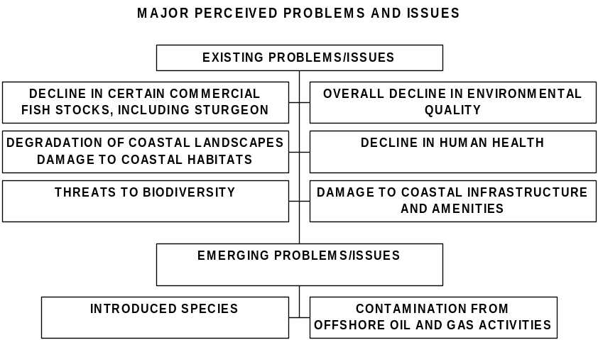

For each MPPI, the following questions need to be answered:
- What do we know about each problem/issue?
- What data support the quantification of the extent of the problem/issue?
- Do the data support these as real problems and issues, or just as perceptions?

In answering these questions we are in effect developing a status assessment. The next step was to undertake for each MPPI a Causal chain analysis to determine for each the root, primary and secondary causes. This work was done over two regional workshops in December 2000 and July 2001, and the CCAs produced are presented in Volume 3, Appendix 3.4.

The analysis recognizes that society commonly acts across a number of somewhat independent sectors (agriculture, industry, transport, fisheries, etc.), which are usually poorly coordinated and often have conflicting interests Sectors and their stakeholders may work in an uncoordinated and sometimes conflicting fashion, but they typically affect the Caspian environment in similar ways. Loss of habitat, for instance, may be caused by activities of various sectors (transport, farming, and industry), and by various groups of stakeholders (governmental policy-makers, ranchers’ grazing animals, and small farmers). This loss of habitat my in turn affect various stakeholders and ministries -- sometimes the very stakeholders or sectors that cause the damage in the first place.

2.2 Stakeholder Analysis

Global Environment Facilities TDA Guidance Documents recommend a stakeholder analysis be performed in support of the TDA, including “a description of all the stakeholders, including institutions, organizations, ministries, agencies, and industry related to the perceived problems and issues. The information pertaining to this list would include the effect of the issue on stakeholders, the nature and effectiveness of the interactions between the stakeholders as well as their strengths and weaknesses in view of their actual and/or potential role in managing water and water dependent resources.”

Consequently, a Regional Stakeholder Analysis for the Caspian Environment Programme was performed. Identification of the stakeholders and stakeholder groups provides a unique level of analysis of those most profoundly affected by environmental issues in the region. The stakeholder groups were identified generally by following Agenda 21 guidelines, and then adapting them to groups affected by Caspian-specific problems. The specific environmental issues, the population distribution, and other regional conditions were taken into consideration. Although government ministries are often considered as decision-makers, and not stakeholders, they were added to the analysis because they are such critical players in the environmental problems and their solutions (as recommended by the TDA guidance).

Although the TDA process attempted to achieve broad stakeholder participation, the sheer magnitude of the region, the geographic dispersion of its population and lack of budget made it difficult to include as broad a range of stakeholders as would have been ideal. The Regional National TDA meetings aimed at broad inclusion, as did the national Intersectoral Coordination Functions meetings, so the authors believe that the Stakeholder Analysis summarized here and contained in full detail in Matthews (2002) is the most systematic approach to quantifying the interests of all Stakeholders. Given the weakness in civil society throughout the region, this analysis takes on added importance. The full report can be reviewed to understand methodology and approach to the analysis.

Overall, it appears that stakeholders are optimistic about the environment. Across all stakeholder groups, people in the region said that environmental protection and economic development can be complimentary. Further, the stakeholder population felt that this goal could be achieved in the future.

A survey was developed to determine how stakeholders within the region view MPPI identified in the TDA. The survey was administered to approximately 50 stakeholders in each Caspian state. In all, 246 surveys were returned. Each MPPI was then ranked based on its importance to each stakeholder group (SHG) on a regional basis (Table 2.2.1, page 57). Each SHG also prioritized the root causes of these issues (Table 2.2.2, page 58). Each MPPI is broken down into sub-issues and individual SHG opinions regarding these sub issues have been evaluated (Volume three, Annex 3.5).

The most predominant concerns are ranked in Table 2.2.1. The high-level concerns are red, the mid-level concerns yellow, and the low-level concerns are green. Respondents were asked to rank the root causes from 1 to 3, with 1 being the least critical and 3 being most critical. Ranking of Root Causes for all stakeholder groups is listed in Table 2.2.2. Red signifies a high priority root cause, yellow a mid-level priority, and green a low-level root cause for environmental degradation. There is more variation among the stakeholder opinions about root causes than about MPPI. The most frequently identified root causes were “lack of enforcement of current environmental law,” “lack of legal status,” and “lack of public awareness.”

Environment ministries rank lack of advanced technologies as a low concern root cause, whereas energy ministries, regional and municipal governments, multinational corporations, industries, scientific community members, and public healthcare providers consider it a highly important root cause. There are also discrepancies between multinational corporations on the one hand and energy ministries, regional and municipal governments, and public healthcare providers on the other regarding the importance of the abuse of power in affecting the environment. Environment ministries, energy ministries, and industries say that public awareness of environmental problems is a high-level concern, whereas members of agriculture and fishing ministries, multinational corporations, the scientific community, NGOs, public healthcare providers, fishermen, and coastal zone residents see this as a low-level concern. The weakness of civil society is also contentious. Environment ministries, agriculture and fishing ministries, multinational corporations, industries, scientific communities, NGOs, fishermen, and coastal zone residents regard this as a low-level concern, whereas the energy ministry and public healthcare providers see it as a high priority root cause of environmental degradation. (It is somewhat worrying that NGOs see weakness of civil society as unimportant.)

Within the MPPI sub-issues, the level of stakeholder group prioritization was assessed based on mean response and standard deviation. The tables in Volume three, Annex 3.5 describe the sub-issues, and list the affected stakeholders, contributing stakeholders, nature of conflicts, and possible interventions.

Significant findings, listed by Major Perceived Problem and Issue

Decline in Certain Fisheries

All stakeholders listed decline in certain fisheries as a high-level concern. Within this issue the most dominant sub-issues are abuse of power, lack of law enforcement, natural habitat destruction, and lack of common agreement on management of stocks in the region. Poaching was also a concern, though of less significance.

Those groups most highly affected by the decline in certain fisheries are fishermen, agriculture and fishing ministries, and coastal zone residents. To a lesser degree, environment ministries, regional and municipal governments, and the scientific community are also affected by the decline in certain fisheries. It is perceived that environment ministries, agriculture and fishing ministries, and regional and municipal governments contribute to the decline by not effectively enforcing the current policies that would regulate the amount of fish taken from the Caspian. Also it is perceived that industries, energy ministries, and multinational corporations conduct activities that lead to decline in fishing stocks. Fishermen and coastal zone residents are also believed to contribute to the decline in certain fisheries by over-fishing certain stocks.

The analysis shows signs of polarization between several groups regarding the decline in certain fisheries. In response to the statement “I think it is safe and healthy to eat fish from the Caspian,” the multinational corporation stakeholder group and fishermen agreed, whereas energy ministries and NGOs disagreed. In response to the statement “Fishermen benefit the most from the fish they catch,” the energy ministries agreed, whereas the regional and municipal governments disagreed. Environment ministries, energy ministries, and regional and municipal governments agreed with the statement “An enforced system of mutually agreed upon fishing limits would be effective for reducing over-fishing in the Caspian,” whereas the multinational corporations disagreed. Public healthcare providers agreed with the statement “Radiation is the primary reason that there are fewer fish in the Caspian,” while the scientific community and the multinational corporations disagreed. These discrepancies suggest that Stakeholders tend to believe that others are responsible for the problem.

Overall Environmental Decline

Environmental decline encompasses a broad range of environmental issues. In general, there was agreement among Stakeholders regarding the relative importance of specific sub-issues. They expressed the most concern about environmental degradation from agricultural and industrial runoff. Though there is limited concern about industrial runoff causing human health problems, there is a high level of agreement among all stakeholder groups that industrial and agricultural runoff threatens the Caspian environment.

There are several issues that indicate potential conflict between stakeholder groups. The first of these is the statement “Unless there is a severe environmental crisis, care for the environment will not be a priority for the people.” Environment ministries, coastal zone residents, and healthcare providers agreed with the statement, and agriculture and fishing ministries, regional and municipal governments, NGOs, multinational corporations and fishermen agreed strongly. In contrast, energy ministries and industries did not agree. Though the level of disagreement was relatively mild, if environmental conditions worsen, it may lead to more polarization and significant conflict between these groups.

Stakeholder groups are also somewhat polarized over the actual causes of environmental degradation. In response to the statement “There is adequate scientific knowledge about the causes of environmental decline in the Caspian,” the environment ministries agreed somewhat, while fishermen disagreed strongly. This discrepancy suggests that there is inadequate information exchange between these two groups, or that the environment ministries feel defensive of the scientific knowledge they have accumulated, while fishermen do not understand the causes of the decline in environmental conditions in the Caspian.

The third issue where there are discrepancies among stakeholder groups is in response to the statement “Private industry should take all responsibility for reversing environmental degradation of the Caspian.” The agriculture and fishing ministries and industry agreed with this statement, whereas the environment ministries, regional and municipal governments, and health care providers agreed strongly. In contrast, multinational corporations disagreed. This suggests that the conflict between these groups may become more pronounced if environmental conditions worsen. Further, the responsibility for losses from deteriorating environmental conditions may be placed on private industry by the stakeholders mentioned above, while multinational corporations, primarily those related to the energy industry, are of the opinion that the Caspian was polluted prior to their involvement, and that therefore they do not bear the responsibility for the the Caspian environment beyond the scope of their immediate activities. This particular issue may warrant further CEP monitoring in order to lessen further division among these groups.

Decline in Biodiversity

Stakeholders are very concerned about perceived decline in biodiversity in the Caspian. They express the highest level of concern about decline in endemic species, factors that may be contributing to eutrophication, and loss of pristine areas untouched by human development. Lower priority sub-issues include concern about the loss of endangered species, concern about energy industry activities, and intensive fishing of some stocks.

The statement “It is more important for people to use the Caspian resources that they need than it is to leave them untouched because of environmental concerns” elicited different responses from different groups. Coastal zone residents, environment ministries, agriculture and fishing ministries, regional and municipal governments, the scientific community, public healthcare providers, and fishermen agreed, while energy ministries, industries, multinational corporations, and NGOs disagreed. Coastal zone residents agreed strongly with this statement, which is significant because this is one of the groups most dependent on the resources in the Caspian, and one that may be responsible for habitat destruction that could lead to a decline in biodiversity. Further, unless this population understands the immediate and long-range importance of environmental conservation, it will also be most affected by eventual losses as a result of biodiversity.

Decline in Human Health

Human health issues did not rank as an especially high priority among stakeholders, although human health is closely linked to environmental health issues. There was, however, clear sentiment that people would be healthier if the environment were cleaner. Only public healthcare providers deviated from this opinion, recognizing that there are other factors that contribute to human health decline. Greater government attention to basic human needs than to funding environmental protection, air quality, industrial pollution, and the need for sewage treatment, were of lower priority.

There were two specific issues where stakeholder groups disagreed. The first was in response to the statement “Air quality is a significant problem in the Caspian Region.” Public healthcare providers agreed very strongly, and energy ministries, regional and municipal governments, the scientific community, and fishermen also agreed. The NGOs, however, did not agree that air quality is a significant problem in the region. If civil society is expected to assist in the development of programs focusing on environmental issues, it may be important to educate NGOs about what other stakeholder groups see as important. This task is certainly within the realm of the CEP.

The second issue that elicited discrepancies among the stakeholder groups was the statement “The government should spend money on the basic needs of people, like housing, healthcare and good jobs, before it spends money protecting the environment.” Though none of the groups felt very strongly one way or another about this issue, polarization is beginning to occur. Those who agreed include energy ministries, regional and municipal governments, and fishermen. Environment ministries, the scientific community, industries, multinational corporations, NGOs, and public healthcare providers disagreed. The division between these groups may become problematic if government budgets become more strained.

Decline in Coastal Infrastructure and Amenities

Overall, Stakeholders considered the decline in coastal infrastructure and amenities in the Caspian region to be a lower-level concern. They listed most coastal infrastructure and amenities sub-issues (including deterioration of roadways, pressures on ports, destruction due to oil activities, deterioration of sea walls, and municipal waste treatment facility deterioration) as medium or low priorities. The only sub-issue that elicited a higher level of concern was soil erosion leading to the decline in environmental amenities. Municipal and regional governments and environment ministries agreed strongly that soil erosion was contributing to environmental decline in the region.

There were two areas of potential conflict of interests between stakeholder groups. The first is in response to the statement “Mining activities reduce the water quality of the Caspian.” Energy ministries disagreed with this statement, while every other group agreed strongly. This discrepancy may suggest that other groups hold energy ministries responsible for fouling the waters of the Caspian. This perception warrants continued CEP monitoring.

The second issue pertains to the statement “Sea level fluctuation has been responsible for most damage to the coastal infrastructure.” The environment ministries, energy ministries and regional and municipal governments agreed with this statement, whereas multinational corporations disagreed.

Degradation of Coastal Landscape

Stakeholders did not rank the degradation of coastal landscape as a high priority. Desertification, flooding, and freshwater flow disruption elicited mild concern. Soil erosion and the resulting silting of water ways was ranked as a higher priority issue. Within the degradation of coastal landscape sub-issue, the highest priority issue overwhelmingly is the need to create a coordinated coastal zone management plan in the Caspian region. Among those most strongly supporting an integrated coastal management plan are energy ministries, environment ministries, industries, regional and municipal governments, and coastal zone residents. Agriculture and fishing ministries are only moderately supportive of this plan. The only discrepancy was in response to the statement “There should be fees for water used in the irrigation of crops.” Energy ministries agreed with this statement, while the scientific community and industries disagreed. This suggests that water loss from the irrigation of crops may be causing concerns for energy ministries. Further, the tendency to shy away from imposing fees for water used for agriculture may indicate that this system may also be imposed on industry as well. This issue warrants monitoring by the CEP if drought conditions prevail in the region.

Emerging Issue Potential Damage from Offshore Oil and Gas Activities

Stakeholders perceive oil and gas activities as both a blessing and a curse for environmental stewardship in the region. There are several areas of high level of agreement between stakeholders, including the need to use the best available environmental technologies and the potential for development of an industry-led oil pollution agreement. The use of best available technologies to improve and protect environmental conditions may be applied to pipeline construction, shipping technologies, and safeguarding against destructive seismic activity. Lower priorities were assigned to increased demands on refineries and ports in the region.

There are two specific areas that are ripe for potential conflicts of interests between groups. The first came in response to the statement “The preservation of the Caspian eco-system cannot take place at the same time as oil drilling activities.” Environment ministries, agriculture and fishing ministries, public healthcare providers and fishermen agreed with this statement, but industries disagreed.

The second discrepancy appeared in response to the statement “Multinational corporations and the energy industry do not care about the environment.” Agriculture and fishing ministries and fishermen both agreed with this statement, while the regional and municipal governments, industries, and multinational corporations disagreed. These discrepancies should be addressed by the CEP, perhaps by facilitating forums to discuss concerns about the activities of each group. If left fallow, this conflict may become more critical in the future as more energy industry activities take place in the region.

Emerging Issue: Introduction of Exotic Species

The perceived problem of increase in exotic or invasive species ranked the lowest among most stakeholder groups. However, within the issue, sub-issues elicit higher concern among affected stakeholder groups. The first issue, regarding the observable presence of exotic species, is ranked high among fishermen, medium among agriculture and fishing ministries, NGOs and scientists, and low among environment ministries, coastal residents, energy ministries, and multinational companies. The main discrepancy between stakeholder groups was in response to the statement “I have seen unusual creatures in the Caspian that were not there ten years ago.” Agriculture and fishing ministries, fishermen, the scientific community and public healthcare providers all agreed with this statement. Energy ministries and multinational corporations disagreed. This discrepancy warrants monitoring, and perhaps managing, given that those responsible for increasing the flow of these life forms into the Caspian are those who appear least concerned about it.

Summary

This Stakeholder Analysis has studied the degree of concern among stakeholder groups empirically. Recommendations for overcoming or minimizing stakeholder conflicts are outlined in the supplemental tables. For the Major Perceived Problems and Issues, recommendations include:

- increasing educational and awareness programs for stakeholders to explain how their actions affect the environment and how changes can be made to reduce these impacts, and that focus on economic costs and benefits of sound environmental stewardship
- supporting an energy-industry oil-pollution management regime
- creating realistic regional standards for sound environmental stewardship
- introducing alternative technologies to reduce municipal and industrial wastes
- introducing agricultural practices that significantly reduce pesticide and herbicide use
- developing environmental monitoring programs utilizing NGO and oil company coordination
- creating achievable fishing restriction enforcement practices
- increasing monitoring for and minimization of exotic species
- requiring use of best available technologies.

This stakeholder analysis summary is supported in more depth by the “Regional Stakeholder Analysis” available through the Caspian Environment Programme PCU in Baku (Matthews, 2002).

Table 2.2-1 Stakeholder Group Prioritization of MPPI
(High Priority, Medium Priority, Low Priority)
 | Decline in Certain Fisheries | Degradation of Coastal Landscape | Decline in Biodiversity | Decline in Overall Environmental Quality | Decline in Human Health | Damage to Coastal Infrastructure and Amenities | Potential Damage from Oil and Gas Activities | Threats from Invasive Species
Environment ministries

Agriculture and Fishing Ministries
Energy Ministries

Regional and Municipal Governments
Multinational Corporations

Industry

Scientific Community

NGOs

Public Healthcare Providers
Fishermen

Coastal Zone Residents

Table 2.2-2 Stakeholder Groups Prioritization of Root Causes
(High Priority, Medium Priority, Low Priority)
 | Non-Sustainable Use of Resources | Lack of Advanced Technologies | Regional Poverty | Regional Over-Population | Abuse of Power | Lack of Sufficient Enforcement of Current Environm-ental Laws | Undefined Legal Status | Lack of Poverty Rights | Sea Level Change | Lack of Public Awareness of Environmental Problems |  | Weakness in Civil Society | Weakness in Rule of Law
Environment ministries

Agriculture and Fishing Ministries
Energy Ministries

Regional and Municipal Governments
Multinational Corporations

Industry

Scientific Community

NGOs

Public Healthcare
Providers
Fishermen

Coastal Zone Residents

2.3 Decline in certain commercial fish stocks, including sturgeon: strongly transboundary.

  - Statement of the problem:
Catches of various fish stocks, sturgeon, cyprinids, herring, salmon, mullet and others, have declined in recent years for a variety of reasons. Official sturgeon catch, for instance, has dropped from 13.8 thousand tons a year in the period from 1910-1930 to 1.8 thousand tons a year in the period from 1996 to 1998 (excluding Iran), while peaking in the 1970s at about 22 tons. In the year 2000 the official catch figure for sturgeon species by Russia, Azerbaijan and Turkmenistan was 470 tones, of which 44 tones were beluga.

  - Supporting data:
The major supporting data for decline in fish stocks comes from official catch data, rather than from periodic quantitative assessments of fish stock. However, the official catch represents only part of the true total, as illegal catch of commercially valuable species such as the sturgeon may far exceed the official catch by many fold – perhaps even as high as nine fold. (Vaisman and Raymakers 2001).

The investigation of a decline in fish stocks has been led by the CRTC on Fish and Other Commercial Bioresources, based in Astrakhan, as reported in the TDA on Relevant Important Commercial Bioresources (January 2000). A recent cruise to investigate fish stocks undertaken by the CRTC and supported by TACIS and the Government of Norway in the summer of 2001, has provided updated quantitative information.

Fish resources in the Caspian Sea are categorized for research and management purposes as follows:

- Sturgeons (six species)

- Bony fish (excluding sprat, i.e., “kilka”), mullet, salmon, bream, shad (e.g. Alosa spp.), several species of perch (river and sea species), pike, several species of Cyprinids

- “kilka” or sprat (Clupediae).

The structure of catch of the main commercial fish species in the Caspian basin since the beginning of the 20th century is presented in Table 2.3-1. This table shows a gradual decrease in both catch of individual species and total catch. This trend is especially clear when commercial catches of sprat are removed from the list. The share of sprats, primarily of anchovy-like sprats, had gradually increased with time (due to greater demand for them), though most recent data shows a decline in the sprat catch as well.

Table 2.3-1 Average Annual Caspian Fish Catch. CIS Countries 1910-1998 and Iran 1927-1998 (thousand tonnes per year and percent of change compared to 1932-1959

Fish | Unit | Commonwealth of Independent States |  |  |  |  |  |  | Iran
Fish | Unit | 1910-1930 | 1932-1959 | 1960-1970 | 1971-1978 | 1979-1980 | 1991-1995 | 1996-1998 | 1927-1998 | 1996-1998
Sturgeons | 1000 tonnes/y | 13.80 | 12.75 | 15.30 | 22.10 | 21.20 | 6.40 | 1.75 | 1.27 | 1.50
Sturgeons | % of 1932-1959 |  | 100% | 120% | 173% | 166% | 50% | 14% | 100% | 118%
Bony Fish # | 1000 tonnes/y | 382.00 | 349.00 | 106.84 | 86.36 | 60.54 | 72.08 | 72.54 | 6.16 | 16.56
(excluding Kilka) | % of 1932-1959 |  | 100% | 31% | 25% | 17% | 21% | 21% | 100% | 269%
Detailed data on Bony Fish catches:
Large chastik* | 1000 tonnes/y | 72.40 | 136.05 | 48.00 | 47.40 | 33.60 | 40.60 | 45.40 | 0.81 | 2.54
(excluding roach and shad) | % of 1932-1959 |  | 100% | 35% | 35% | 25% | 30% | 33% | 100% | 314%
Small chastik | 1000 tonnes/y | - | 31.05 | 20.7 | 18.00 | 15.80 | 10.00 | 11.70 | 4.51 | 8.64
Small chastik | % of 1932-1959 |  | 100% | 67% | 58% | 51% | 32% | 38% | 100% | 192%
Roach (Vobla) | 1000 tonnes/y | 139.80 | 98.40 | 24.70 | 18.80 | 9.10 | 19.70 | 12.90 | Included in  Large chastik
Roach (Vobla) | % of 1932-1959 |  | 100% | 25% | 19% | 9% | 20% | 13%
Shad (Sielt) | 1000 tonnes/y | 169.50 | 82.45 | 12.80 | 1.60 | 1.80 | 1.70 | 2.50 | 0.45 | .082
Shad (Sielt) | % of 1932-1959 |  | 100% | 16% | 2% | 2% | 2% | 3% | 100% | 182%
Mullet (Kefal) | 1000 tonnes/y | - | 0.28 | 0.63 | 0.55 | 0.22 | 0.05 | 0.02 | 0.39 | 4.56
Mullet (Kefal) | % of 1932-1959 |  | 100% | 225% | 196% | 79% | 18% | 7% | 100% | 1169%
Salmon (Lasos) | 1000 tonnes/y | 0.30 | 0.77 | 0.01 | 0.01 | 0.02 | 0.03 | 0.02 | 0.00 | 0.00
Salmon (Lasos) | % of 1932-1959 |  | 100% | 1% | 1% | 3% | 4% | 3% | - | -
Sub-total: Bony Fish | 1000 tonnes/y | 395.80 | 361.75 | 122.14 | 108.46 | 81.74 | 78.48 | 74.29 | 7.44 | 17.64
(excluding Kilka) + Sturgeons | % of 1932-1959 |  | 100% | 34% | 30% | 23% | 22% | 21% | 100% | 237%
Kilka (sprat) | 1000 tonnes/y | - | 37.3 | 308.2 | 357.20 | 283.40 | 148.70 | 132.80 | 2.00 | 63.30
Kilka (sprat) | % of 1932-1959 |  | 100% | 826% | 958% | 760% | 399% | 356% | 100% | 3165%
TOTAL | 1000 tonnes/y | 395.80 | 399.05 | 430.67 | 465.96 | 365.37 | 227.40 | 207.09 | 7.44 | 81.36
TOTAL | % of 1932-1959 |  | 100% | 108% | 117% | 92% | 57% | 52% | 100% | 1094%
* Chastik: in Russian, literally “ordinary fish.” Group may include, depending on the fishing gear used and the size, roach, beam, shad, darters, etc., even mullet.
# Bony Fish species consists of teleostei (bony) fishes as opposed to chondrostei (cartiligenous) to which group the sturgeon belong.
Sources: for CIS: CaspNIRKh Catches in 1998 Catch; for Iran: Shilat Catches in 1995

Figure 2.3-1 Estimated Total Stock of Commercial Fishes in the Caspian Sea (excluding Iran)
(Source: Dr D Katunin, CaspNIRKh, in litt., 1999, based on 1995 catch figures, in Anon. (TACIS) 2000)

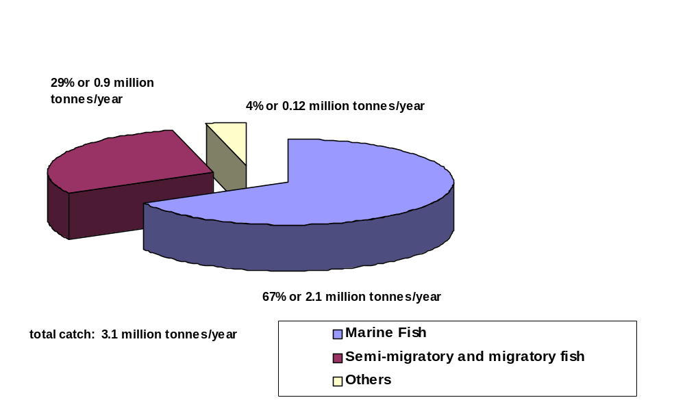

The commercial catch can be broken down another way: into marine, semi-migratory and migratory, and other fishes. In Figure 2.3-1,above, marine fish, which include, inter alia, kilka, shad, most gobies, silversides, mullets, and sea zanders, are seen to represent 67% of the total catch. That figure is more than twice that of the catch of semi-migratory and migratory fish such as lamprey, salmon, most sturgeons, shad, asp, barbel, vimba, kutum (roach), bream, vobla, carp, zander, white-eye, and sabrefish. The “others” category includes river fishes such as pike, rudd, tench, bleak, white bream, crucian carp, catfish, loaches, perch, turbot, and stickleback.

The long-term changes in fish are influenced by natural population dynamics, changing environmental conditions, the intensity of commercial exploitation, and also by anthropogenic factors affecting ecosystem processes.

Summary of Reasons for Changes in Fish Catches

Sturgeon
Annual catches of sturgeons have always fluctuated in relation to variations in natural river flows. These variations, following a decadal pattern, probably reflect changes in the numbers able to pass up the rivers to spawn more than changes in total population. However, besides the 1935-1945 drop caused by reduced fishing efforts during the second world war, the first significant reductions in catches were associated with the construction of dams on the Caspian tributaries, especially the Volga, Terek, Sulak, Kura, and rivers in Iran. The construction of these impoundments began in the 1930s and continued in the period between 1950 and 1970.
Figure 2.3-2 (Tacis CRTC BM 2000) illustrates the decline of sturgeon catches in both the CIS and Iran during the period from 1930 to 1998. Although the numerical values differ from those of Table 2.3-1, the decreasing trends are similar.

Figure 2.1-2 Sturgeon Catch 1929-1998 (tonnes/year)

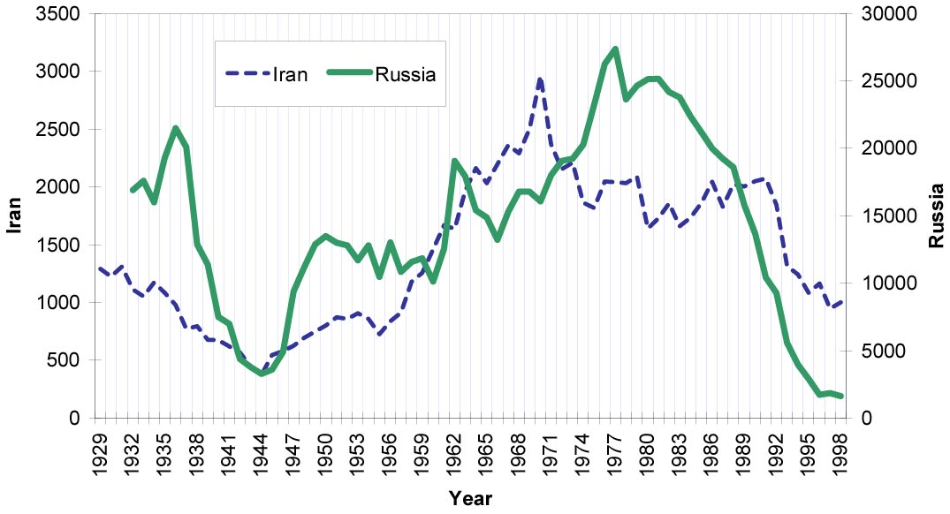

The variations between 1932 and 1950 are explained by the reduction of fishing during war and the gradual rehabilitation of the industry after the war. Two important events took place in the early 1960s, the construction of the Volgograd dam, which cut off access to upstream sturgeon spawning grounds, and a parallel ban on fishing with nets at sea to protect juvenile sturgeon. The fishery was transferred to the mouths of the rivers, which resulted in an initial substantial increase in annual catch that peaked in 1977 at 28,900 tonnes before declining rapidly to 12,000 tonnes in 1992. After the collapse of the Soviet Union, large-scale organized poaching developed and is considered to be one of the main factors responsible for the dramatic decline in officially recorded catch.

High catches during the period immediately following the construction of the dam were based largely on year-classes from before the damming of the Volga, as sturgeon mature very late. (Sturgeon reach spawning maturity between the ages of seven and 16 years, depending on the species.) It is estimated that poachers take about 12 times the volume of the officially recorded catch. Poaching also has an adverse impact on the sex structure of the spawning stocks. Recent (1998-1999) studies show that among sturgeon entering the Volga on spawning runs, about 22 to 30% were females and 70 to 78% were males: historically, the ratio was 45:55.

In summary, the main reasons for the dramatic decrease in catches are believed to be the following:

- Habitat degradation including:

- Reduced access to spawning sites beginning in the 1930s caused by the construction of weirs mostly for agricultural purposes, followed by the construction of large dams on the Volga River in the 1960s and on the Kura and Sefid Rud rivers in the early 1970s.
- Destruction of natural spawning grounds due to exploitation of materials (e.g. gravel and sand mining), stabilization of river banks and installation of pumping stations for irrigation; and
- Chemical and organic pollution from industrial activities and oil exploitation, as well as agricultural (pesticides and fertilizers) sources.

- Lack and mis-management of fisheries leading towards overexploitation:

- Adoption of potentially inappropriate legal measures on fisheries or slow adoption of protective measures. It wasn’t until 1962 that a change of fishery regulations was initiated in the USSR to ban open-sea catch of sturgeon;
- Absence of inter-governmental agreements on common fishery policy for shared stocks; and
- Lack of integrated fisheries management (e.g. single taxon of commercial fisheries management that does not take into account the interconnection between fish stocks and their impact on the food chain).

- Geopolitical changes:

- Increase in poaching due to a rapid decline in socio-economic conditions in the CIS following the collapse of some sectors, e.g. the industrial and agricultural sectors of the local economies. Coastal populations faced almost 100% unemployment because of the closure of state-owned agriculture farms (“kholkozes”);
- Reduction of State budgets,
- Weakened fisheries and trade regulations enforcement and increased corruption caused by poorly paid inspectors, border guards, police and customs officers; and
- Decrease in fisheries investments, particularly in fingerlings/juveniles restocking programs for the rehabilitation of fish population.

- Insufficient scientific knowledge on fish species biology adaptation to present Caspian situation (e.g. following dam construction) and the overall status of fish stock in recent years.

The catastrophic further reduction in official catches in the CIS since 1990 can be attributed to illegal fishing. The reduction in catch in Iran (where illegal catches are negligibly small) has been of a lesser order than the reduction in the CIS and reasons for the decline are less certain.

Bony Fish (excluding Kilka)
The majority of these species are migratory, semi-migratory and fluvial fish that are caught in the region of the Volga mouth (and to a lesser extent the Ural) where water chemistry and food resources favor their growth. However, regulation of the Volga flows following the construction of of the Volgograd cascade in the 1960s apparently resulted in serious changes to their spawning, living habitat, and productivity.

A fall in sea level during the period 1971-1978 probably further affected the life cycle of these fish species that rely on the high primary and secondary biological productivity of the northern shelf of the Caspian. Catches of these bony fishes fell to 55 percent of pre-1960 levels and never recovered. The recorded catch since 1990 does not reflect total catch, which must take into consideration apparently substantial poaching and unrecorded fisheries (CEP Report Raymakers 2001).

Salmon
Catches of salmon increased between 1932 and 1960, but since then have fallen to very low levels. This species is on the verge of extinction and efforts are being made to save it. Catches of large and small fish, the backbone of fishing for local consumption, have declined significantly for reasons not yet fully understood. The reported decline may be due to unrecorded catch and large subsistence fishing by the local population, but there are environmental factors affecting the state of these stocks. It is estimated that between 30% and 45% of juveniles hatched in the Volga do not reach commercial size due to pollution alone. Natural mortality and illegal fishing, also have adverse impact on the stocks.

Herring and mullet
Catches of herring and mullet increased during the early period of 20th century, peaking in the late 1950s, then declining to a fraction of the potential. There is a large unexploited stock of herrings and mullet, but only Iran has a sizeable mullet catch. Since the introduction of a ban on fishing with nets in the Caspian. The ban was meant to protect immature sturgeon, but it has aided herring and mullet because netting is the only viable fishing technique to catch them.

Sprat
The sprat catch increased dramatically with the introduction of light attraction and fish pumps in the early 1960s. A proportion of the catch was reduced to fishmeal, however, a significant volume was frozen or otherwise processed for human consumption. The overall catch of kilka in the countries, other than Iran, shows a declining trend since the 1990s due to an obsolete and unseaworthy fleet. Until 1999, the kilka catch in Iran was growing steadily following the national plans to optimize use of this resource. However, in recent times catches in both Russia and Iran have dropped. From January to November 2001, the Russian Federation catch amounted to only 30,000 tonnes and in 2000 and 2001 the Iranian kilka catch has declined each year by 30-35%, a total reduction of 50% since 1999. (Dr D. Katunin, CaspNIRKh, and Dr M. Pourkazemi, Iranian fisheries scientist, pers. comm. 27 November 2001) One of the possible threats to the state of kilka stocks may be the recent accidental introduction of Mnemiopsis to the Caspian Sea (see box 4, page 22).

Overview of stock enhancement and sturgeon aquaculture development

Stock enhancement has both positive and negative impacts. Positive impacts include the addition of fry or fingerlings to the Caspian to enhance stocks and compensate for lack of replacement from natural spawning. All countries except Turkmenistan have in the past introduced sturgeon fry or fingerlings to the Caspian Sea (see Tables 2.3-2 to 2.3-5.) At present, Russia estimates that it releases up to 55 million each year, and Iran estimates up to 19 million. These efforts are significant and could represent one avenue for long-term propagation of sturgeon. There are drawbacks however that need to be considered before relying on stocking programs as the primary mechanism for propagating the species. There is a lack of studies regarding the success of these introductions. Survival rates of individuals are unknown, as are the long-term impact on genetic diversity within populations due to the practice, and even the probability of species hybridization with the intentional or accidental introductions of exotic species, such as paddlefish. The Russian Federation, for instance, has more than 10 hybrids of sturgeons in its propagation facilities, which could erode the genetic integrity of the sturgeon if accidentally released.

Table 2.3-2 Estimated annual juvenile sturgeon release by three hatcheries in Azerbaijan (million fingerlings)

 | 1990 | 1991 | 1992 | 1993 | 1994 | 1995 | 1996 | 1997 | 1998 | 1999 | 2000
A. gueldenstaedtii | 13.370 | 5.330 | 2.130 | 1.230 | 0.750 | 0.940 | 3.030 | 3.770 | 4.490 | 10.186 | 8.869
A. stellatus | 3.747 | 2.870 | 0.400 | 0.608 | 0.392 | 0.302 | 1.040 | 2.100 | 1.320 | 8.822 | 6.869
H. huso | 0.406 | 0.144 | 0.450 | 0 | 0 | 0 | 0 | 0.072 | 0 | 0.162 | 0.357
Total | 17.523 | 9.082 | 2.980 | 1.838 | 1.142 | 1.242 | 4.070 | 6.065 | 6.220 | 20.290 | 16.965
Source: CITES Management Authority of Azerbaijan, in litt. to TRAFFIC Europe, 18 September 2000

Table 2.3-3 Annual juvenile sturgeon release in Iran (million fingerlings)

 | 1990 | 1991 | 1992 | 1993 | 1994 | 1995 | 1996 | 1997 | 1998 | 1999
A. persicus | 4.06 | 5.92 | 2.93 | 3.57 | 4.66 | 8.05 | 11.02 | 18.75 | 22.59 | 17.30
A. gueldenstaedtii |  | 0.04 |  |  | 0.30 | 0.52 | 0.67 | 0.92 | 0.42 | 0.96
A. stellatus | 0.36 | 0.47 | 0.07 | 0.30 | 0.46 | 0.27 | 0.22 | 0.29 | 0.18 | 0.13
H. huso | 0.14 | 0.17 | 0.45 | 0.30 | 0.49 | 0.29 | 0.34 | 1.44 | 0.69 | 0.41
Total | 4.56 | 6.60 | 3.45 | 4.17 | 5.91 | 9.13 | 12.35 | 21.63 | 24.56 | 19.10
Source: CITES Management Authority of Iran, in litt. to TRAFFIC Europe, 24 September 2000

Table 2.3-4 Annual juvenile sturgeon release in Kazakhstan (million fingerlings)

 | 1998 | 1999 | 2000
A. gueldenstaedtii | 0.647 | 1.493 | 1.266
A. stellatus | 1.058 | 2.581 | 3.771
H. huso |  | 0.515 | 0.192
Total | 1.706 | 5.318 | 5.507
Source: CITES Management Authority of Kazakhstan,
in litt. to TRAFFIC Europe, 21 September 2000

Table 2.3-5 Annual juvenile sturgeon release in the Volga River, former USSR and Russia (million fingerlings)

 |  | 1979-1980 | 1981-1985 | 1986-1990 | 1991-1995 | 1996-1998
Volga River | A. gueldenstaedtii | 25 | 35 | 40 | 42 | 28
 | A. stellatus | 16 | 19 | 16 | 10 | 15
 | Huso huso | 15 | 18 | 13 | 8 | 12
 | Total Volga-Caspian | 56 | 72 | 70 | 60 | 55

Aquaculture is an alternative to catching fish in the wild and has been quite successful in some countries, such as in China, where aquaculture accounts for nearly 62% of all freshwater and marine food products. Unfortunately, this trend is not valid for the CIS countries, where a decline in aquaculture has been recorded furing the last twelve years (Figure 2.1-5). Aquaculture of sturgeon is becoming more accepted now, with commercial plants operating in several countries including France and the United States. However, it is not yet a major activity in the Caspian region. One difficulty is the long period before production of caviar, ranging from 5 to 15 years depending on species. Aquaculture like this represents a long-term investment with little short-term payoff.

Figure 2.3-4 Aquaculture production in the USSR and CIS countries (FAO)

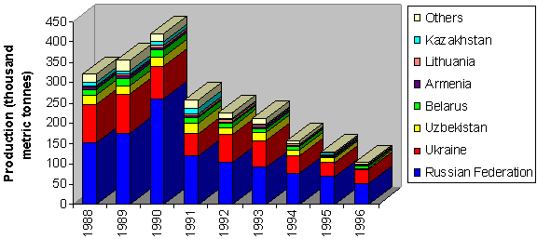

Levels of contaminants in Caspian fish

The effects of contaminants in fish tissues are commonly cited as a cause of decline in fisheries, though with little supporting data. A picture of the extent of the contamination can be developed from the ongoing ECOTOX study (funded by the World Bank) and by a review of the literature from environmental baseline studies conducted in support of oil and gas exploration activities. Full QA/QC (Quality assurance/Quality Control) documentation is available for these data, and has been reviewed. Unfortunately, there are no known documented dose-response studies on sturgeon or other commercial fish of the Caspian, other than some work done on smaller planktonic forms of these fish in support of oil and gas exploration and production.

Though the full results of the Ecotox study are not yet available, some data indicate high levels of accumulation of heavy metals in fish. Data from the northeast Caspian Sea and off Azerbaijan show accumulations of heavy metals in bony fish (especially gobies). The data are presented relative to the International Quality Criteria for Human Health (fish consumption), which for lead is 0.5 μg/g (part per billion). Similar exceedances exist for many heavy metals (see Annex 3.6). Unfortunately, the effects of these higher levels of various metals on the health and reproduction ability of the commercial fishes of the Caspian Sea are not currently known. The source of these heavy metals is also not clear. Heavy metals are naturally high in parts of the Caspian due to geological source materials.

DDT has also been reported in fish samples from the region. As section 2.6 will demonstrate, DDT and its degradation products are common in samples of sediments and seals in the Caspian Sea, so it is expected that they will be in fishes as well. Early results from the ECOTOX project show levels of DDT up to 1100 ng/g, and of PCB up to 600 ng/g in fishes from pollution hot-spots.

For the last 8-10 years there have been various reports of progressing anthropogenic eutrophication leading to the reduction of dissolved oxygen in the benthos and the development of anaerobic processes in sediments (Salmanov, 1999). As a result of this eutrophication, it is claimed that near Baku the Absheron peninsula and nearby archipelagos, the primary production due to phytoplankton has been reduced by more than 40 times and the phytobenthos has also been reduced.

In general, in the Caspian, reported oxygen levels are generally high, though near the coast of big cities and in river deltas, and eutrophication may be more common. Unfortunately, the data supporting the claims of eutrophication are not generally available. Even Salmanov’s book, which shows general trends, does not reproduce raw data. There is no evidence that there is either a basin-wide or a sub-basin-wide occurrence and eutrophication therefore appears to be, at worst, a local issue. More data with appropriate QA/QC documentation would help clarify the exact temporal and spatial extent of eutrophication. Interestingly, there is little mention of eutrophication in the Caspian literature of the thousands of scientific articles on the Caspian, only one, by Salmanov, has eutrophication in its title.

  - Causal chain analysis:
A Causal chain analysis revealed some of the major causes for fisheries decline of the three major commercial fisheries groups, sturgeons, kilka and other bony fishes, including:

- habitat degradation (e.g. dam construction, gravel and sand mining, water use for agriculture, and pollution);
- lack and/or mis-management of fisheries leading towards overexploitation (e.g. no interstate agreement on fisheries management, inadequate national fishery regulation (quotas, seasons, location, size));
- worsening geopolitical and economic climate causing negative impacts such as poor enforcement of and compliance with fishing regulations, increased poaching by jobless coastal populations);
- insufficient scientific knowledge of how fish species may adapt to a changing Caspian environment (e.g. new spawning grounds adopted by sturgeon species since old ones are no longer accessible); and
- possible eutrophication effects on plankton, in some river deltas and near the Absheron peninsula, due to higher nutrient levels.

  - Sectors and stakeholders:
The main sectors involved in the fisheries issues are:

- government: ministries (e.g. environment, agriculture/fisheries, irrigation and energy (perhaps for both oil and gas sector impacts as well as hydropower)), municipal and regional governments, inter-government commissions and international institutions such as FAO, CITES and CBD (Convention on Biodiversity);
- co-operatives; and
- private sector (including non-governmental organizations).

Affected stakeholders include local fishermen, processors and traders in fish products, coastal zone residents and scientific the community.

The Stakeholder analysis showed that all Stakeholder Groups except the Public Healthcare Providers see this MPPI as a critical issue.

  - Environmental impacts:
The environmental impacts of commercial fisheries decline include a possible imbalance in the shallow deltaic and benthic ecosystems of the rivers and the pelagic ecosystems of the whole Caspian Sea (e.g. apparent increase of goby populations possibly caused by the decline of predator stocks such as sturgeon) and in the Caspian biodiversity. Another possible impact might include a decline in seal populations (e.g., if fish resources such as kilka were to be depleted). Enhancement of fish stocks through artificial stocking will have an impact on the wild gene pool (genetic structure/variability) and on the population dynamics of other species of fish, micro- and macrobenthos, etc. (e.g. increased feeding pressure).

  - Socio-economic impacts:
Socio-economic impacts of declining fisheries are widespread. Local fishermen are being adversely affected due to loss of livelihood and since fish can be a major part of residents’ diet, a decline in health may also result. The overall fishing industry and wide range of related economic activities including fishing vessel construction and repair industries, processing industry extending as far as restaurants and recently developing sport fishing could be affected by reduced fish stocks. Artificially high prices for caviar could, for instance, encourage fishermen to turn to illegal poaching activities. Caviar is a major regional export and a decline in annual revenue may limit State initiatives and investment in the fishing industry (including artificial stock enhancement). A detailed description of the socio-economic impacts is provided by Raymakers (2001) in a report to the CEP.

  - Threats and trends:
In case of persistence of pollution and overexploitation (legal and illegal) of fish and their habitat , the following threats and trends are envisioned:
- further decline and commercial extinction of endangered species such as sturgeon (almost all six species), trout species (Salmo truta caspius), Caspian inconnu (Stenodus leucichthys salmon-like species, called “bellarybitsa” in Russian);
- further loss of natural spawning grounds;
- further loss of genetic diversity of commercial fish populations caused by:
- reduction of natural spawning
- adverse impact of stock enhancement (restocking) and
- introduction of exotic species and hybrids due to the development of aquaculture.
- further loss of biodiversity caused by adverse ecological impacts such as targeting and overfishing certain key species (e.g. population and ecosystem imbalance);
- continued reduction of economic income for coastal communities and States; and
- lower government and private investments in fisheries research, rehabilitation, and management.

2.4 Degradation of coastal landscapes and damage to coastal habitats: strongly transboundary.

  - Statement of the problem:
The coastal landscapes and habitats are damaged by a variety of natural and man-made factors. Natural factors include water level fluctuations (on both storm and decadal scales), earthquakes, and climate change. Man-made causes include: desertification/deforestation, regulation of rivers, urbanization/ industrial development, improperly planned agricultural/aquaculture development, improperly planned recreational development, and land-based and sea-based pollution. About 40 percent of the Caspian coastal hinterland is arid; of this arid area, about 32 percent has been decertified.

Figure 2.4-1 Desertification

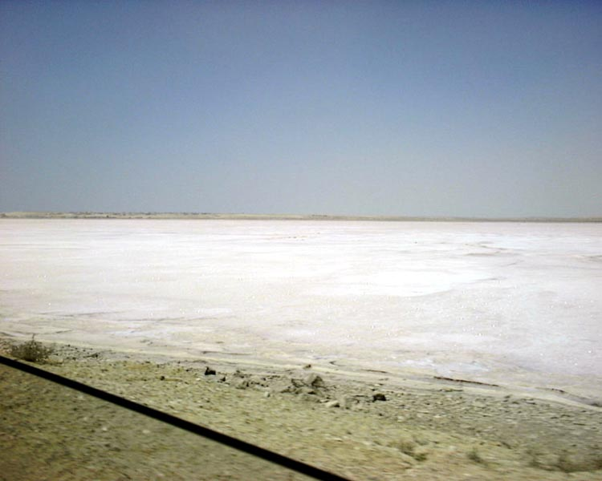

Desertification arises from many factors, including salinization of soils and periodic overwash by storm surges.

  - Supporting data:
The extent of desertification has been well documented by the CRTC on Combating Desertification. Extensive mapping of the degradation has been undertaken for each littoral country, identifying temporal trends in desertification as well as intensity.

Figure 2.4-2 Regional Desertification Map

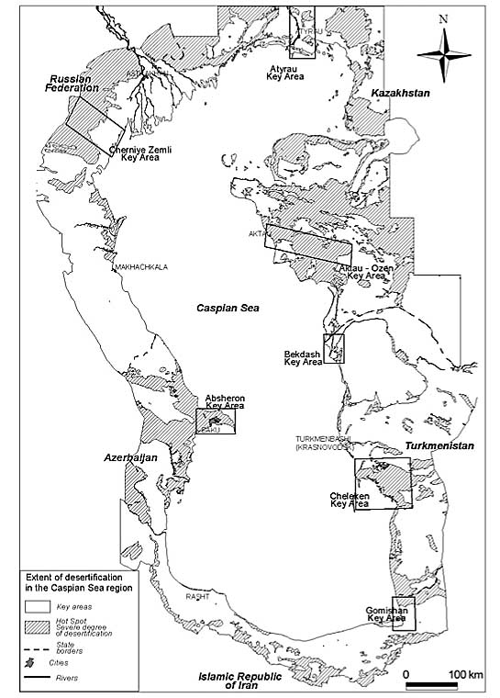

Much of the coastal zone of the Caspian consists of fragile ecosystems susceptible to overexploitation and poor management practices. Damage caused by various processes contributes to their desertification:

- Soil erosion (overgrazing, poorly designed transport corridors, deforestation)
- Salinization (high groundwater levels, high rates of evaporation, transient flooding by seawater, poor irrigation practices)
- Urbanization (population increase, transportation, industrial activities, agriculture/ aquaculture)

Figure 2.4-3 Desertification in the Caspian Region

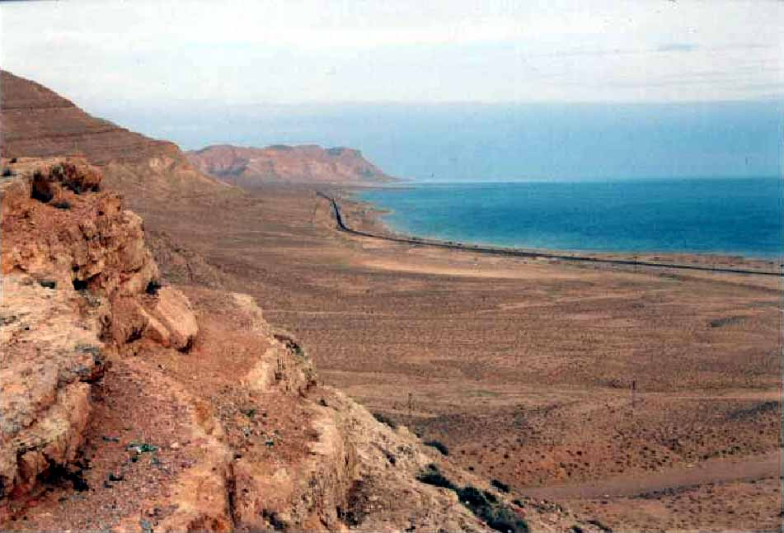
The Caspian coast has many fragile overexploited and poorly managed ecosystems.

Land quality, rural population densities and activities, and groundwater quality are all inter-related. Deterioration of land productivity and groundwater quality lead to reduced quality of life, reduced economic yield from the land, and human migration out of the affected area.

No institution or agency in the five littoral countries has in the past conducted an overview of desertification in the whole Caspian Sea region. Furthermore, Azerbaijan, Russia and Kazakhstan have had no scientific-technical institutes specializing in desertification. Thus, the Caspian Centre for Combating Desertification, Ashgabad (CCCD) was given a task to investigate the current status of desertification, including:

- investigation and assessment of the desertification status in the Caspian region (up to about 100 km from the coast) using remote sensing images and field trips

- summarizing and comparing the desertification conditions and processes (causes, types and degrees) in the region

- identification and assessment of interrelations with other environmental or economic factors and conditions (such as water level rise, technological pressure, climate change)

- addressing social or economical impacts on population (such as public health, water supply need, migration and living conditions).

The mapping and analysis indicates the following current extent of desertification in the coastal zone; desertification status for each country is summarized below, in Table 2.4-1.

Table 2.4-1 Areas Subject to Heavy and Very Heavy Degree of Desertification

Types of Desertification | Area in km² with Severe and Very Severe Degree of Desertification  Differentiated in Desertification Types
Caspian Sea Region of | Degradation of Vegetation | Water Erosion | Wind Erosion | Flooding, Salinazation | Technogenic Desertification | Total
Azerbaijan | 7987 | 2892 | 281 | 3269 | 1178 | 15607
Russia | 3049 | 0 | 13150 | 6918 | 0 | 23117
Kazakhstan | 9658 | 9671 | 9578 | 11325 | 18625 | 58857
Turkmenistan | 524 | 1993 | 3610 | 6026 | 1796 | 13949
Iran | 8969 | 4691 | 74 | 185 | 0 | 13919
Total Region | 30187 | 19247 | 26693 | 27723 | 21599 | 125449

The salinization processes, even on marine terraces and alluvial plains, have developed naturally due to the rise of the ground water table, and in agricultural areas, salinization has been caused by irrigation.

Loss of coastal habitats has not yet been quantified. The coastal habitat reports produced by the littoral countries are quite general, containing qualitative descriptions only of habitat loss. The extent and rate of coastal habitat loss are unknown. Figure 2.2-4 identifies some of the actual critical habitat areas.

  - Causal chain analysis:
For water level fluctuation and earthquakes, the impact of these natural events is exacerbated by low technology, inadequate compliance with and enforcement of legal regulations, weak economic situations, absent or inadequate national and regional EIA processes, lack of government commitment, lack of integrated coastal area planning and management, population growth, lack of regional environmental agreements, and inadequate public awareness/participation.

The root cause of land desertification and habitat loss are similar: low technology, inadequate compliance with and enforcement of regulatory regimes, a weak economic situation, lack of integrated coastal area planning and management, population growth, and inadequate knowledge and awareness.

  - Sectors and stakeholders:
The major government stakeholders are municipal and regional governments, environment ministries, energy ministries, and agriculture/fishing ministries. Industries are other major stakeholders contributing to the problem. Primary affected stakeholders include coastal zone residents, environment ministries, regional and municipal governments, and public healthcare providers.

The Stakeholder Analysis generally indicated that Land Degradation was a medium priority issue for the major Stakeholder Groups, except multinational corporations, who deemed it high priority.

  - Environmental impacts:
Degradation of coastal landscapes and damage to coastal habitat adversely affect the coastal ecosystems. Both land-based and water-based organisms are adversely affected. Vegetation systems are destroyed or replaced by vegetation of low value, and migratory animals leave the area. Migrating birds lose valuable habitat and are forced to find alternative habitat. Landscape degradation and damage to coastal habitats alters the species composition, density, and distribution patterns.

  - Socio-economic impacts:
Approximately 10 million people in the Caspian region have been forced to migrate from desert lands as ecological refugees as a result of desertification. Land is lost to agriculture and other development activities. Increased wind-blown soil and salts lead to declining health. Salinization of groundwaters increases risks to human health risk because there are few alternative drinking water sources. Damage to coastal habitat alters land use patterns, especially in cases of recreational activity. It reduces the aesthetic and economic value of the land.

g. Future threats and trends:
Studies suggest that within the next 15 to 20 years, the center of gravity of the Caspian coastal population will move towards the south and east, whereas the north will face negative growth. It is likely that with the expansion of oil and gas activities and population growth in the region there will be increased urbanization, land filling, and industrial development. The combined socio-economic pressures accompanying these stressors will result in increased land encroachment and possibly more contamination, and in turn more degradation of landscapes and habitats. Ecological function and structure and biodiversity therefore may be sacrificed in favor of development unless national and regional policies clearly support conservation efforts.

2.5 Threats to biodiversity: strongly transboundary.

  - Statement of the problem:
Concern over loss of biodiversity in the Caspian Sea (at species, genetic, and habitat levels) is widespread internationally and regionally. Species biodiversity of the Caspian is low compared to other more open seas, across nearly all phyla. The clear threats to some of the economically important fish species (including sturgeon) heighten concern over general loss of biodiversity. Two major flagship species in the Caspian, the Caspian Seal and the Beluga sturgeon, are officially classified as threatened. The high rate of species endemism in the Caspian Sea would suggest that biodiversity may be particularly sensitive to threats from industrial pollution, overfishing, invasion of exotic species, and other human activities.

  - Supporting data:
Documentation of the loss of biodiversity in the Caspian region is generally sparse. Basin-wide, regular assessments of biodiversity have not been undertaken. Red books of the four northern Caspian countries list rare and endangered species, but there is no general statement regarding overall biodiversity. Knowledge about even the most high-profile species, is scant, with little idea of population levels. The country reports on biodiversity and coastal habitats commissioned by CEP provide largely qualitative detail or quantitative but incomplete lists that do not permit quantitative assessment of loss of biodiversity in the Caspian Sea. There are several old reviews of Caspian fauna, but not enough modern data are available. There is clearly an information gap for this issue: The damage to biodiversity appears evident, but quantitative evidence is sparse.

Table 2.5-1 List of Approximate Numbers* of Species, Endemic Species, Alien Species, and Listed Species in Different Biota Groups

Biota Group | Total number of Species in the Caspian | Number of Endemic Species | Number of Alien Species | Number of Listed Species  (Red Book)
Phytoplankton | 441 (449) | 17 | 6 | ?
Zooplankton | 315 | 64+ | 7 | 10
Sponge | 1 (4) | 1 | 0 | 0
Hydrozoans | 5 | 2 | 2 | 0
Zoobenthos | 380 (855) | 190 | 12 | 20
Phytobenthos | 87 (350) | 8 | ? | 6
Fishes | 133 (123) | 54 | 17 | 27
Marine mammals | 1 | 1 | 0 | 1 (WWF)
Land Mammals | 124 | 0 | 3 | 40
Birds | 466 (312) | - | - | 63
Reptiles and amphibians | 66 | - | - | 13
*(numbers approximate since literature does not agree on values)

The Biodiversity CRTC (Aladin 2001) reviewed the major threats to biodiversity in the Caspian Sea and summarized the knowledge of habitats in the Caspian Sea Ogar (2001). Their findings are summarized below.

The major factors threatening decreased biodiversity of the Caspian are:

- Regulation of the Caspian rivers
- Illegal fishing and over-fishing
- Water level changes
- Pollution
- Invasive and Introduced species
- Climate change
A more comprehensive review of the status of threats to Caspian biodiversity is given in the Caspian Biodiversity Strategic Action Plan prepared by CEP with the assistance of Flora and Fauna International.

River Regulation

Regulation of rivers that flow into the Caspian is one of the most significant anthropogenic impacts on the biodiversity of the Sea. From the period of the early 1930s to the 1970s, dozens of reservoirs were built on the Caspian rivers for the purposes of agriculture and hydroelectric power. The Volga above Volgograd is contained by a chain of huge man-made reservoirs known as the Volga cascade.

Regulation of river flow has both chronic and acute impacts. Changes in the hydrological regimes, reducing spring run-off, can lead to increased shoaling of river delta and reduction in the area of delta vegetation (reeds, cat-tail, and bushes). This loss of vegetation can result in a loss of aquatic and coastal fauna and many migratory and semi-migratory species are deprived of their natural spawning grounds. As spring flows are reduced, fish migration upriver for spawning is impeded and essential nursery areas are limited (see table 2.5.2). The construction of dams floods and destroys spawning sites immediately upstream, and even with fish ways and lifts, sturgeon and salmon cannot overcome obstacles to reach potential spawning ground further upstream. The loss of natural spawning grounds resulted in almost complete loss of the Caspian salmon population, and as for the sturgeon, it is now mainly bred in fish hatcheries. Known details of what remains of the natural spawning grounds are shown in the table below.

Table 2.5-2 Spawning Grounds of Sturgeon

River | Area of Spawning before River Regulation, hectares | Area of remaining spawning grounds, hectares
Kura | - | 160
Terek | - | 130
Sulak | - | 200
Ural | 1700 | 1100
Volga | 3390 | 372

The only major natural spawning grounds for Caspian sturgeon remaining are located on the Ural. In many Iranian rivers extraction of sand and gravels from river beds also has led to loss of spawning ground, however, natural spawning grounds still exist on unimpeded rivers.

In addition to long-term and chronic problems, discharges of hydropower plants have an acute (short-term) impact on the Caspian. Early releases are made prior to the main spring thaw, in order to prevent dangerous over-topping of the dam. These early releases carry heavy sediment loads and can alter the flux of biogeochemically active substances to the Caspian Sea (Aubrey 1994b). Higher inputs of nutrients early in the year when ice covers the North Caspian Sea alters location and timing of the entire North Caspian phytoplankton-based food web. These man-made floods may also damage bottom and coastal ecosystems and make spring spawning migrations difficult. On the other hand, regulation of the dam releases reduces river input during low-flow periods in the summer and winter; keeping the water level high in the reservoirs for hydro-power production. This can cause braided channels downstream to dry up and is particularly dangerous for shallow river arms and flood plains.

Over-Fishing and Illegal Fishing

Biological resources of the Caspian (mainly fish resources) are estimated to be valued at 5-6 billion USD per year (Aubrey et al., 1994b; Glukhovtsev, 1997). Over-fishing has contributed to the complete loss of some species of fish. In the 1920-40s typical commercial species were Caspian lamprey, Volga shad, Caspian trout, and Caspian inconnu. The total catch of these species was about 80 thousand tonnes. All these species are now included in the Red Books of the Republic of Kazakhstan, Russian Federation, and other Caspian states.

A large percent of world sturgeon reserves are concentrated in the Caspian, and at present there is a real threat to the survival of a number of Caspian species. The catch of sturgeon in the Caspian has declined from 25,000 tons per year to 1,000 tones, with illegal fishing the main threat to the survival of sturgeon. Russian specialists believe that illegal fishing increases the official catch by a factor of 11, i.e., by a factor of 8 offshore and three times in the rivers. The poaching problem is most severe along the Azerbaijan, Daghestan, and Kalmykiya coasts.

The problem of over-fishing affects other species, as well. In Iran over-fishing of Caspian trout, bream, and zander, along with the damage of their habitats and spawning grounds, has resulted in an almost complete loss of these species. The Caspian zander disappeared due to massive unregulated catches in Azerbaijan and Turkmenistan. Nowadays, it is believed that the kilka or sprat could be showing symptoms of over-fishing, a dangerous situation considering that the population is under other stress factors, such as competition from the ctenophore Menmiopsis leidyi.

Caspian Water Level Change

Caspian water level change is one of the most important natural phenomena affecting the biodiversity of this huge water body (Aubrey, 1994b; Dumont, 1995). Historical natural water level fluctuations, due to changes of climate and river discharge into the Caspian, have a long-term impact. Short-term impacts include seasonal or wind-induced changes of water level. Seasonal changes of water level of the North Caspian can reach almost 0.5 m, whereas under the influence of surges, it can rise 1.5-2 m. In the west of the North Caspian, surges cause inundation of the coastline up to 30 km onshore, while retreats cause exposure of 10 km of the seabed.

From late 1930 to 1978, the level of the Caspian decreased by almost 3 m. Such a significant change had a negative impact on its flora and fauna. Shallow waters of the North Caspian, deltas of Caspian rivers, and coastal wetlands suffered the most. Shallow bays such as Kaidak and Mertviy Kultuk dried and the river delta areas reduced significantly. New islands formed and existing islands formed peninsulas or merged with the land.

Changes in the level of the Caspian Sea caused by human activity can have an indirect impact on biodiversity. Dredging to enhance navigation is an example. Construction of a dam at the head of the Kara Bogaz Gol serves as another example. As water levels began to rise, in 1992 the Kara Bogaz Gol was totally destroyed, and within nine years the gulf was partially rehabilitated (see box 1)..

From 1978 to 1995, continuous water level rise caused significant damage to plant life in deltas of Caspian rivers; but the ecosystem, when allowed, can adapt and there can be positive impacts of long-term water level rise; including the improvement of spawning ground conditions, increased spawning ground areas, reinforced water exchange between different sections of the sea, extension of fresh water in the buffer zone, and increased productivity of the North Caspian. However, these positive impacts will only materialize where natural succession is allowed to develop. On the Iranian coast, where urban development puts a constraint on the retreat of wetlands in the face of advancing saline waters, loss of habitat and biodiversity will ensue. Short-term impacts of water level changes due to seasonal fluctuations or surges and retreats do not have any significant long-term impact on biodiversity of the Caspian.

Pollution

Pollution is an often-quoted threat to the biodiversity of the Caspian. The sources of pollution are industry, agriculture, accidental discharges, and sewage. The main flow of pollution comes from the Volga, according to conventional wisdom, but the levels of contaminants (section 2.5.4) detected in the river sediments indicate a relatively clean river. Of more concern are the pollution hot-spots of Baku Bay and Sumgait and the impact of persistent toxic substances throughout the basin. The highest level of pollution was observed in the late 1980s, later inputs were reduced due to economic crisis, reduction of industrial capacity, and abandonment of plants. The next section (2.5.4) discusses a more recent perspective on Caspian pollution.

Impact of Introduced Species on the Caspian Biodiversity

The impact of exotic species on the biological diversity of the Caspian Sea falls into two groups: chronic and acute. Acute impact is identified during the early years after the introduction of the new species into the Caspian. Its positive or negative impact is highlighted most clearly during these years. Later the ecosystem adapts to the introduced species, and its positive or negative effect weakens while its impact on the biodiversity becomes chronic. In one sense, many resident species in the Caspian can be described as exotic (see, for example, Aladin, 2001). The only difference is the time of introduction. Some species were introduced so long ago that they can now be considered resident.
A notable recent introduction has been the ctenophore (Mnemiopsis leidyi), introduced into the Caspian with ballast waters of ships within the last few years. The ctenophore is an example of an acute negative impact on the biodiversity of the Caspian (Ivanov et al., 2000). The species feeds on zooplankton and competes with other plankton feeders, such as the kilka or sprat. According to some researchers, the sprat fishery in Iranian water is already impacted adversely (Kideys et al, 2001) and the ctenophore may cause the complete collapse of the Caspian sprat (Aladin, Plotnikov, 2000) in the near future. If the sprat collapses basin-wide, the Caspian seal population will certainly encounter additional stress. Studies into the possible introduction of predatory ctenophore Beroe to control Mnemiopsis are being executed by CEP. The effects of Mnemiopsis invasion on planktonic biodiversity are being monitored by the riparian countries with partial support from TACIS/CEP.

Climate Change Impact

The impact of climate changes on the biological diversity of the Caspian is not well studied. A majority of the scientists believe that the impact of climate changes on the biodiversity of the ancient Caspian is indirect, through climate impact on the sea level and its salinity, which could significantly alter its biodiversity. However, the impact of climate change on biodiversity is weak compared to other causes.

The six threats to biodiversity outlined above have resulted in the opinion of all regional experts consulted in a loss of certain species and habitat, their effects on genetic diversity are unknown. However, with the exception of the Red Book listings, the loss of habitat diversity and species are unquantified. Information on loss of species diversity is largely anecdotal, as regional data gathering and analysis is inadequate.

In summary, there is a strong feeling of loss or threat to biodiversity in the Caspian Sea, but lack of complete data prevents quantification of such loss or its continued threats in the future.

  - Causal chain analysis:
A causal chain analysis was performed for degradation of habitats (main causes being socio-economic pressures, including urbanization, industrial development, and agriculture, and the root cause being increasing population); and loss of species/genetic diversity (root causes including non-rational use of resources, human-induced introduction of species, particularly via ships, and urbanization/ industrial development). Annex 3.4 contains the causal chain shown graphically.

  - Sectors and stakeholders:
Survey results showed that the decline in biodiversity is a priority regional issue, primarily for agriculture and fishing ministries, and secondarily, surprisingly, by the scientific community, environment ministries, NGOs, and fishermen. The primary government stakeholders include regional and municipal governments, state industries, agriculture/fisheries ministries, and the scientific community. Primary affected stakeholders include coastal residents, fishermen, environment ministries, agriculture and fisheries ministries, and NGOs.

All five Caspian littoral states are signatories to the Biodiversity Convention, whose Article 6 addresses the need for national multi-sectoral strategies aimed at preservation and sustainable use of biodiversity.

  - Environmental impacts:
The environmental impacts of loss of biodiversity may include imbalance in ecosystems, loss of species, loss of habitat for transboundary organisms (e.g., birds and fishes), explosive growth of invasive or nuisance species, and other issues.

  - Socio-economic impacts:
Socio-economic impacts may be high, particularly if economically important fisheries decline, fishermen no longer have work, the sea becomes less productive overall, the natural habitat declines thus reducing the aesthetic value of the region (affecting tourism for example), or nuisance species create social or economic stresses.

g. Future threats
Biodiversity faces some severe future challenges. Over-fishing, exotic species, and expanded oil and gas development (production, refining, transport, etc.) are a few specific threats. Increased population in the region will put more pressure on Caspian resources and habitat. The poor economic condition of the region also continues to deny adequate attention to biodiversity. Generally, there is little hope that problems with biodiversity will improve in the near term. However, without conducting a complete survey of Caspian biodiversity in the near future, there will be no way to tell.

2.6 Overall decline in environmental quality: strongly transboundary.

  - Statement of the problem:
Decline in environmental quality includes the decline in air, water and sediment quality, damage to ecosystems due to human activities, loss of aesthetic appeal, and related issues. There have been widespread fears of an increasing rate of decline in overall environmental quality due to the strong dependence of the economies of all five nations on oil and gas extraction from the sea or its coastal zone. Widespread die-offs of seals in 2000, a kilka mortality in 2001, and other similar natural disasters create fear of widespread decline in environmental quality.

  - Supporting data:
This particular MPPI exhibits extensive overlap with the other seven MPPI. While it is poorly defined, the experts decided to retain this MPPI, but to constrain its coverage during the TDA analytical process.

Data for air, water and sediment quality have been gathered for the CEP by the Pollution Control and Effective Regional Assessment of Containment Levels CRTCs, and regional experts have provided assessments of these and past data. The data situation in the region is critical. Historically, few data were acquired by Iran in the sea itself, and much of the data from the Soviet Union were kept outside the region, for instance in St. Petersburg or Moscow. Most of the historical raw data are not available for review, and much of the reporting has taken place on the basis of averaged data of uncertain or poorly documented quality. QA/QC procedures are not always documented, and there is no such concept as chain of custody for old samples. Verification and validation of the results are nearly impossible. In addition, the break-up of the Soviet Union has led to adverse economic conditions in the former Soviet states, and routine monitoring has been sparse for the past ten years. This large data gap comes at a time when industrial use has declined rapidly due to introduction of market forces into the economies of the Caspian states. In Azerbaijan, for instance, the factories in the formerly highly developed industrial city of Sumgait are virtually closed down, and pollution from this site is mainly due to historical sources, not current ones. Assessment of point sources of pollution has been completed in the four northern countries, showing several hot spots of pollution (Baku and its environs, Cheleken, Atyrau, Astrakhan, and some others). However, due to the distribution of population centers around the Caspian, these hot spots of point sources are few and far between. Iran has little in the way of major industrial point sources of pollution, though it has extensive dispersed sources such as agricultural input. Sewage and other municipal input is a problem in Iran and near Baku, since sewage treatment plants are either absent or functioning poorly.

An overview of the available data and information is provided in Table 2.6-1. This table represents data sources that will be discussed briefly here, as well as other sources of information to support the analysis of decline in environmental quality. Much of the data and information comes from the CEP’s CRTC for Pollution Control (PC), the CRTC for Effective Regional Assessment of Contaminant Levels (ERACL), reports and various other CEP Reports (Tuzhilkin 2001; de Mora and Sheikholeslami 2002; Mitrofanov, 2001; etc.). Other data sources included the oil and gas industry, published books and articles, and the CEP’s Ecotoxicology Project.

Table 2.6-1 Data and Information Availability and Reliability

Major Indicative Symptoms | Major Sources |  | Specific Sources | Availability of the Data | Source and Type of Data | Status of Symptoms | Data Reliability
Sources of Pressure | Natural | Volcanic Mud Activities | Sediments | Available | Geological References/Oil Companies | Indirect | Reliable
 |  | Natural Oil Seeps | Seafloor Sediments | Available | Geological References/Oil Companies | Indirect | Reliable
 |  | Water Level Fluctuations | Meteorology/ climatology | Available | CRTC Water Levels  Maps / DIM | Indirect | Reliable
 |  | Geological erosion | Rocks | Available | Geological Studies of sources rocks | Indirect | Reliable
 | Human Impact | Oil and Gas Activities | Exploration and Exploitation | Available | Environmental Baseline Reports; Environmental Impact Reports;  Maps / DIM | Indirect | Reliable
 |  |  | Pipelines | Available | Maps / DIM | Indirect | Reliable
 |  |  | Refineries | Available | Rapid Assessments; Audits;  Maps / DIM | Indirect | Reliable
 |  |  | Terminals | Available | Environmental Assessment Reports;  Maps / DIM | Indirect | Reliable
 |  | Main ports/terminals |  | Available | Maps / DIM | Indirect | Reliable
 |  | Shipping |  | Available | Maps / DIM | Indirect | Reliable
 |  | Mining |  | Insufficient | Ministries of Environment;  Ministries of Mines and Minerals; Ministries of Natural Resources | Indirect | Unknown
 |  | Urban Center | Sewage | Available | CRTC PC estimated | Indirect | Estimates only
 |  |  | Solid Waste | Available | CRTC PC estimated | Indirect | Estimates only
 |  | Agriculture Activities |  | Available for Iran only | CRTC-ERACL,  (Mirkoo) | Indirect | Reliable
Pollution Load |  | Air Emission |  | Insufficient | Environmental Impact Assessments; Rapid Assessment (Mahmudov) | Indirect | Reliable/ estimates
 |  | Industrial Discharges to Waters |  | Insufficient | Rapid Assessment and CRTC PC | Indirect | Estimates only
 |  | Sewage |  | Insufficient | CRTC PC and CRTC ERACL (Abaee) estimated | Indirect | Estimates
 |  | Urban Runoff |  | Insufficient | None | Indirect | no
 |  | Agrochemical |  | Insufficient | CRTC EARCL report on Iran | Indirect | no
 |  | Hot Spots | Industries | Available | CRTC PC and CRTC ERACL (ASTP) | Indirect | Reliable
 |  |  | Rivers/  Estuaries | Available | CRTC PC | Indirect | Estimates
 |  |  | Offshore Dumping Sites | Insufficient | CRTC PC | Indirect | Poor
 |  | Flooded Area |  | Available | CRTC PC | Indirect | Reliable?
 |  | Oil Spills |  | Partly Available | Recorded accident / images | Indirect | Poor coverage
 |  | Radioactive discharges | Nuclear energy; military | Not available | Shaw et al., 1998 | Indirect | Poor
Ambient Contaminant Level | Water | Organic Contaminant |  | Insufficient | Oil and Gas Industry/ research insitutes | Direct | Reliable/ questionable
 |  | Inorganic |  | Insufficient | Oil and Gas Industry | Direct | Reliable
 |  | Radionuclides |  | Insufficient | IAEA Cruise  ASTP Cruise | Direct | Reliable
 |  | Microbial |  | Insufficient | Oil and Gas Industry | Direct | Reliable
 |  | Water properties (dissolved oxygen, water clarity) |  | Insufficient | Historical data base; oil and gas industry; research reports | Indirect | Mixed reliability
 | Sedim-ent | Organic Contaminant |  | Available | ASTP/Oil and Gas Company | Direct | Reliable
 |  | Inorganic |  | Available | ASTP/Oil and Gas Company | Direct | Reliable
 |  | Radionuclides |  | Insufficient | IAEA Cruise | Direct | Reliable
 | Biota | Organic Contaminant |  | Available | ECOTOX; Oil and Gas Industry | Direct | Reliable
 |  | Inorganic |  | Available | ECOTOX: Oil and Gas Industry | Direct | Reliable
 |  | Radionuclides |  | None | None | Direct | None
 |  | Microbial |  | Available | ECOTOX; Oil and Gas Industry | Direct | Reliable
Damages | Seal Mortal-ity |  |  | Available | ECOTOX; Oil and Gas Industry | Direct | Reliable
 | Kilka Mortal-ity |  |  | Available | ECOTOX,  Fisheries Institutes | Direct | Reliable
- CRTC PC: Caspian Regional Thematic Center for Pollution Control
- IAEA: International Atomic Energy Agency
- CRTC ERACL: CRTC for Effective Regional Assessment of Contaminant Levels

Sources of Pressure on the Caspian Sea

Both natural phenomena and human activity can be major sources of pressure on the environment.

Natural Factors:
Natural factors have contributed to environmental decline. Water level fluctuations cause a number of indirect effects, such as introducing contaminants from flooded lands that were previously emergent, alteration of coastal habitats, and massive die-offs of coastal reed beds. Water level fluctuations (see section 2.4) are primarily natural events responding to climatological forcing.

Other natural factors include geological conditions. The tectonically active setting of the Caspian Sea contributes several geological imprints. For instance, mud volcanoes dot the landscape and sea bottom along the Absheron ridge. These mud volcanoes are a source of hydrocarbons, methane, certain metals, and other materials. They are one form of natural seep of hydrocarbons to the environment (see Section 2.10). There are mud volcanoes on land near Baku, where they rise as low hills. (Their extreme erodability prevents them from attaining great heights.) Recent, Exxon/Mobil Corporation investigated one marine mud volcano near their offshore Oguz Field. The mud volcanoes have soils that are only weakly competent, presenting challenging geotechnical design requirements for offshore industry.

The local geology is another source of contaminants. The CEP’s At-Sea Training Programme (ASTP) documented heavy metal distribution throughout the Caspian region. One major finding was that concentrations of a group of heavy metals, including Aluminum, Cadmium, Chromium, Copper, Lead, Nickel, Silver, Vanadium, and Zinc are high in the Caucasus region and in the south (primarily Azerbaijan and Iran). Some of these concentrations (for Nickel, Copper, Chromium, and Arsenic) exceed sediment quality guidelines from the U.S. and Canada. However, the distribution of these elements suggests a regional distribution related to source rocks and local geology. Interspersed within these general elevated distributions, however, are some local high levels of contaminants due to sewage discharge, industrial discharge, etc. Other heavy metals (e.g., Mercury) are high throughout the region due to industrial sources, not local geology. Figure 2.6-1 shows the elevated levels of inorganic lead in marine sediments, with elevations primarily along the entire Azeri and Iranian coasts of the Sea, presumably due to local source rocks. Some local elevated levels (off Baku and off the mouth of the Ural River) seem to suggest local sources superimposed on this regional signature.

Human Factors:
Oil and gas activities provide another source of inputs of contaminants to the environment. These generally occur due to drilling practices (uses of various types of drilling fluids, or muds), maintenance on rigs, transport of oil, and release of oil and gas from drilling operations. Oil spills are a good example of such inputs. Section 2.10 discusses the recent estimates made of the contribution of the oil and gas industry to hydrocarbons in the Caspian, suggesting that only 5% or less of the hydrocarbons in the Caspian come from this industrial activity (compared, for instance, with estimates that twice that amount comes from natural seeps).

Oil and gas issues are of particular concern, partly due to extensive oil slicks observed in some portions of the Caspian Sea. These slicks can have only negative consequences, though their magnitude and source are uncertain. Figure 2.6-2 shows one example of a slick (from Shaw et al., 1998). These slicks have sometimes been traced to industrial activities; many times they simply exist in the region with no obvious source.

Figure 2.6-1 Inorganic Lead in Sediments

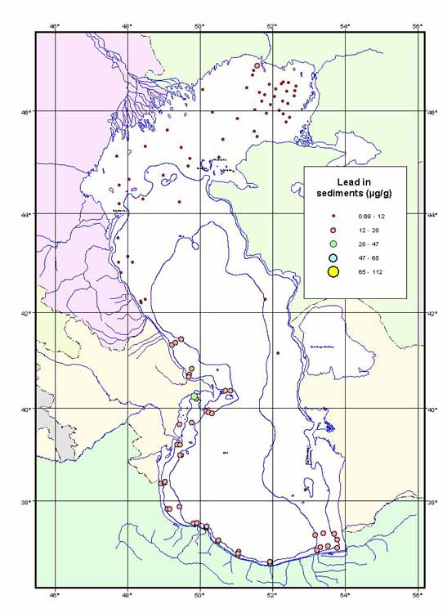
Figure 2.6-2 A large oil slick in the western Caspian off Baku

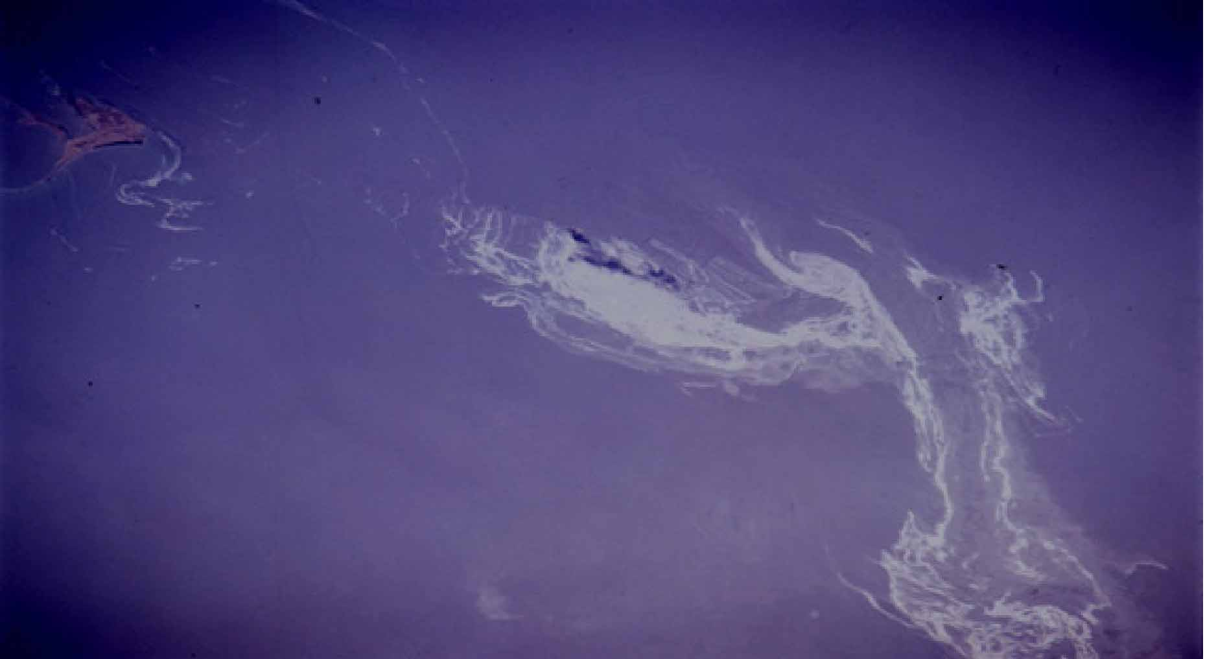
The source of this spill near some offshore oil platforms is unknown, but the slick itself is one of the largest ever photographed from space. (Satellite photograph NM21-773-060A, NASA 1998)

Mining is another unquantified source. Chromium mines, for instance, discharge tailings into the Caspian along the upper Ural River, which may reach the Caspian in a relatively short period since there are no impediments on the river. Uranium mining in southern Kazakhstan near Aktau provides another potential source of contaminants to the Caspian, particularly given historical discharge practices. Mines along Iranian rivers discharge various tailings to the rivers, some of which can be seen in the sediment data. Finally, mining in the Caucasus region may create discharges into the main rivers such as the Kura, for instance. However, the discharge is not quantified.

Agriculture also releases chemicals, including fertilizers, pesticides, and insecticides, into the environment. Many agrochemicals are persistent organic forms. This agricultural activity extends most intensively along the Iranian coast (where the area is small but the density is intense), southern Azerbaijan, parts of the Russian coast, and parts of Kazakhstan. There is some agriculture in Turkmenistan, but little near the coast. Use of banned pesticides such as DDT is commonly reported in the region, and they appear to be widely available. Recent infestations of locusts in Russian Federation and Kazakhstan resulted in aerial spraying of DDT-based pesticides in these countries, according to reports.

Pollution Loads

The PC CRTC in Baku performed studies of the pollution loads of the major industries and activities in the region. Their results have been supported by further rapid assessment methods in all five Caspian littoral states. These data are based on questionnaires distributed in the region, site visits, and expert review. These pollution loads are discussed briefly below.

Little is known about Air Emissions in the region. No regional monitoring has taken place, and the only quantitative data seem to come from Environmental Baseline Reports and EIAs for new oil and gas activities (such as construction of new oil and gas storage and processing terminals at Sangachal, AZ, and in Cheleken, TK; as well as offshore activities). However, these reports do not give a regional view of the status of air emissions. Flaring of gas still occurs at some offshore terminals in Azerbaijan and Turkmenistan due to lack of facilities and technology (and markets) to recover these valuable resources. However, pressure on the oil and gas industry from international development banks and others is bringing the companies’ attention to flaring and reducing these emissions. Mahmudov (2001) applied the UNIDO rapid assessment methodology to estimate air emissions in both Azerbaijan and Turkmenistan, but his analysis was incomplete due to contradictory information available on those industries; his results are summarized in Table 2.6-2.

Industrial discharges to waters were summarized by the Pollution Control CRTC (Charalambous 2001), with additional input from ERACL CRTC performed by Iranian specialists (Abaae 2001). Table 2.6-3 summarizes BOD nitrogen, phosphorus and oil data regionally and by source. Sewage and riverine discharges were estimated based on questionnaires. There are, however, considerable uncertainties in these values. For instance, it is often said that 80% (or 85%) of the hydrocarbons (or total pollution) entering the Caspian Sea come from the Volga River. Most reports on Caspian pollution report this figure, and it is repeated in PC CRTC reports (e.g., 91% of yearly flow comes from the Volga, 79% of the yearly BOD, 95% of the hydrocarbons, 84% of the cadmium, etc.). These figures are based on estimates made from discharge questionnaires, but don’t take account of the effects of dams and wetlands in sequestering many of these materials from the Caspian Sea. There is at present inadequate mass balance data to provide a quantitative estimate of existing pollution loads from the Volga or other Caspian rivers. Indeed, pollution levels in Volga sediments and deltaic sediments do not confirm the large load purported to come from the Volga.

Biological oxygen demand load (BOD), total suspended solids (TSS), total nitrogen, and total phosphorus are available for all the five Caspian countries. These data are of uncertain quality, as they cannot be verified independently from the national records. Data from an initial rapid assessment for above contaminants, plus some heavy metals, were determined using by GIWA methodology, are contained in the Pollution Control report (Charalambous 2001), again, however, these data are of uncertain reliability. The GIWA methodology for example estimated mercury input in Azerbaijan to be very low, despite being known that large quantities of the metal were introduced to the environment at Sumgait, Azerbaijan; presently the topic of a World Bank demonstration phase clean-up project as part of its NEAP.

These data therefore do not reflect the real level of pollution load into the Caspian and to give them credibility would be unwise. At present the only general conclusions regarding pollution load we can draw are:
- Regionally the rivers, treated as point sources, are the major sources of pollution, but no systematized analyzes of hot-spots with the river basins has yet been performed.
- Pollution from municipal and industrial coastal sources are of secondary importance, except on coasts, such as Turkmenistan, where run-off is negligible. A thorough land base source assessment (point and non-point) of the near Caspian basin is urgently required and should be made a priority of the CEP’s future work programme.

Data on agricultural input are sparse. The PC CRTC did not undertake a rapid assessment of the agricultural input for the entire Caspian region, however, an audit was performed by ERACL CRTC (Mirkoo 2001) for the Iranian sector, perhaps the most densely agricultural area of the Caspian region. A large percentage of the agricultural produce of Iran comes from this rainy, humid northern sector of the country. The analysis divided the agriculture into two categories: perennial crops and yearly crops. Ninety percent of cultivated land in the Iranian Caspian coastal area is given to nine major agricultural plants: rice, wheat, citrus, oil seeds, barley, vegetables and cash crops, cotton, tea, grains and tobacco, ranking from the highest to the lowest allocated land area. Since 1978, the government has fully controlled the production and import of agrochemical materials and has tried to extend its control of distribution of chemical fertilizers and pesticides directly to the individual farmer. Therefore the application rate of agrochemicals has been directly dependent on the amount of fertilizer and pesticides delivered from the government to the farmer. The major fertilizers in use in the country are Urea, Di-ammonium phosphate, Ammonium sulphate, Potassium sulfate, Super phosphate, and Potassium chloride in addition to various types of insecticides, fungicides, herbicides, rodenticides and other types of pesticides.

Table 2.6-2 Air Emission Inventory for Absheron Peninsula including Baku and Sumgait

Industry | ISIC | SO₂ | NO₂ | CO | VOC | Fine Particulates | Total Suspended Particulates
Industry |  | Kg/Year
Meat Products | 3111 | 5.1 | 52.6 | 13.2 | 0.3 | 0.2 | 1.5
Dairy Products | 3112 | 1.3 | 1.8 | 0.3 | 0.1 | 0.00 | 0.7
Malt Liquors And Malt | 3133 | 18.8 | 14.8 | 0.9 | 1.5 | 0.03 | 1.03
Industrial Chemicals Except Fertilizer | 3511 | 10215.9 | 7588.2 | 5860.7 | 5929.4 | 346.3 | 1641.6
Synthetic Resins. Plastics Materials. & Manmade Fibres | 3513 | 1397.4 | 3631.9 | 537 | 2657.8 | 1.13 | 213.5
Petroleum Refineries | 3530 | 76067 | 43756 | 39516 | 40272.9 | 768.1 | 6710.8
Glass And Glass Products | 3620 | 141.1 | 280.7 | 75.6 | 36 | 5.9 | 56.3
Structural Clay Products | 3691 | 19.6 | 188.9 | 44.8 | 15.4 | 30.2 | 148.3
Cement, Lime, And Plaster | 3692 | 11921 | 5535.2 | 673.7 | 31.5 | 9912.5 | 5765.6
Nonferrous Metals | 3720 | 4514.7 | 147.1 | 2100.1 | 164.2 | 41.5 | 379.2
Structural Metal Products | 3813 | 16.1 | 68 | 27.2 | 74.4 | 1.1 | 3.5
Special Industrial Machinery & Equipment | 3824 | 124.5 | 106.6 | 18.9 | 80.6 | 0.3 | 24.7
Electrical Apparatus And Supplies. N.E.C. | 3839 | 3.9 | 8.4 | 17.6 | 4.11 | 0.11 | 3.04
Shipbuilding And Repairing | 3841 | 45.2 | 20.2 | 2.7 | 167.3 | 45.2 | 14.1
Aircraft | 3845 | 12.4 | 10.1 | 25.8 | 38.3 | 0.4 | 1.9
TOTAL On Absheron |  | 104504 | 61411 | 48915 | 49473.8 | 11153 | 14965.9

Table 2.6-3 Pollution load from rivers, municipalities and industry in Caspian Sea as well as each country

Countries | Sources | River flow | BOD | Nitrogen | Phosphorus | Oil
 |  | Km3/y * | t/y | t/y | t/y | t/y
Azerbaijan | Rivers | 15.2 | 36000 | 19000 | 1000 | 600
 | Municipalities |  | 38000 | 13000 | 3300 | 9400
 | Industry |  | 7100 | 1100 | 300 | 14000
Sub-total |  | 15.2 | 81100 | 33100 | 4600 | 24000
IR-Iran | Rivers | 17 | 49500 | 12000 | 1200 | 400
 | Municipalities |  | 68000 | 16000 | 4400 | 7800
 | Industry |  | 28200 | 600 | 210 | 12500
Sub-total |  | 17 | 145700 | 28600 | 5810 | 20700
Kazakhstan | Rivers | 9.8 | 13200 | 6000 | 600 | 400
 | Municipalities |  | 800 | 500 | 100 | 200
 | Industry |  | 2900 | 7100 | 100 | 1800
Sub-total |  | 9.8 | 16900 | 13600 | 800 | 2400
Russian Federation | Rivers | 257.4 | 807900 | 805000 | 87500 | 73100
 | Municipalities |  | 16000 | 5000 | 1400 | 3800
 | Industry |  | 4900 | 300 | 100 | 8900
Sub-total |  | 257.4 | 828800 | 810300 | 89000 | 85800
Turkmenistan | Rivers | 0 | 0 | 0 | 0 | 0
 | Municipalities |  | 1600 | 400 | 100 | 100
 | Industry |  | 1500 | 100 | 3970 | 5400
Sub-total |  | 0 | 3100 | 500 | 4070 | 5500
All countries | Rivers | 299.4 | 906600 | 842000 | 90300 | 74500
 | Municipalities |  | 124400 | 34900 | 9300 | 21300
 | Industry |  | 44600 | 9200 | 4680 | 42600
TOTAL FOR CASPIAN | ALL SOURCES | 299.4 | 1075600 | 886100 | 104280 | 138400

The ERACL CRTC agrochemical audit concluded as follows:

- On average, 70 Kg Nitrogen (N) and 20 Kg Phosphorous (P) per hectare/year were used in the Caspian region of Iran, mostly in form of Urea, Di-ammonium phosphate, and Super phosphate (triple).
- The rate of application is high, since the chemicals are widely available and because of government subsidies.
- About 8000 tons per year of pesticides were used in Caspian region: 70% of which were insecticides, 20% herbicides, and 10% fungicides.
- The major insecticides used are Diazinon (60%), an Organo-phosphate-based group, and Endosulfan (3.6%), an Organo-chlorinated compound; the rest are mainly from Organo-phosphate compound origin.
- The major portion of nitrogen fertilizer and pesticides is used in rice paddy culture;, it is highly subject to leaching and transportation of residues to both ground and surface water, and finally to the Sea.
- Transportation of the phosphate will be minimal due to high absorption rate of heavy soils in rice cultivation and alkalinity of irrigation water as well as soil. The only acid soil exists in tea cultivation areas.

Similar studies are required in the other Caspian countries. The report suggests that there may be significant input of inorganic and organic agrochemicals to the Caspian region.

Based on their analyses, the PC CRTC and the ERACL CRTC have published a hot spots list (Table 2.6-4 and Figure 2.4-3), which is focused, not unexpectedly, on major urban centers, on river mouths (as conduits for disperse sources), and on ports and harbors.

Table 2.6-4 Pollution Hot Spots

Country | Hot Spots
Azerbaijan | - Baku Bay/ Absheron Peninsula  - Sumgait  - Kura River
Iran | - Sefid-Rood River area/ Bandar Anzali  - Chalus/Now Shahr ports  - Gorgan Lagoon
Kazakhstan | - Ural River Delta  - Bautino/Fort Shevchenko  - Aktau
Russian Federation | - Astrakhan/ Volga River delta  - Lopatin  - Makhachkala  - Derbent

Figure 2.6-3 Pollution Hot Spots
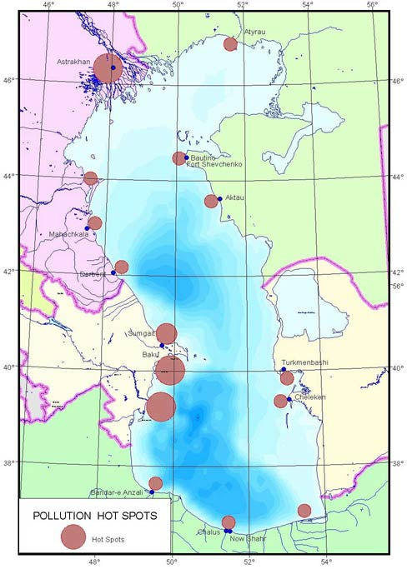

Of the various issues associated with decline in Environmental Quality, the issue of radioactivity exerts a strong sense of concern, partly because so little is known of this issue. There are few data supporting allegations of widespread contamination by radioactive materials, but the ideas persist strongly amongst various Stakeholders. The only regional data available is from sediments taken during the ASTP cruise in 2000-2001 (See Figure 2.4-4). High levels of uranium are to be found around the Caspian shoreline of Turkmenistan and Kazakhstan. Too few data exist for Russia, and Iran. Clearly, these data are insufficient to draw conclusions. One of the better sources of information on a Caspian-wide basis is the study by the U.S. Department of Energy (Shaw et al., 1998). Table 2.4-5 lists the reactors in the vicinity of the Caspian Sea. Though these are not all even in the watersheds of the Caspian, all have been cited as concerns for the Caspian.

Figure 2.6-4 Uranium in Sediments

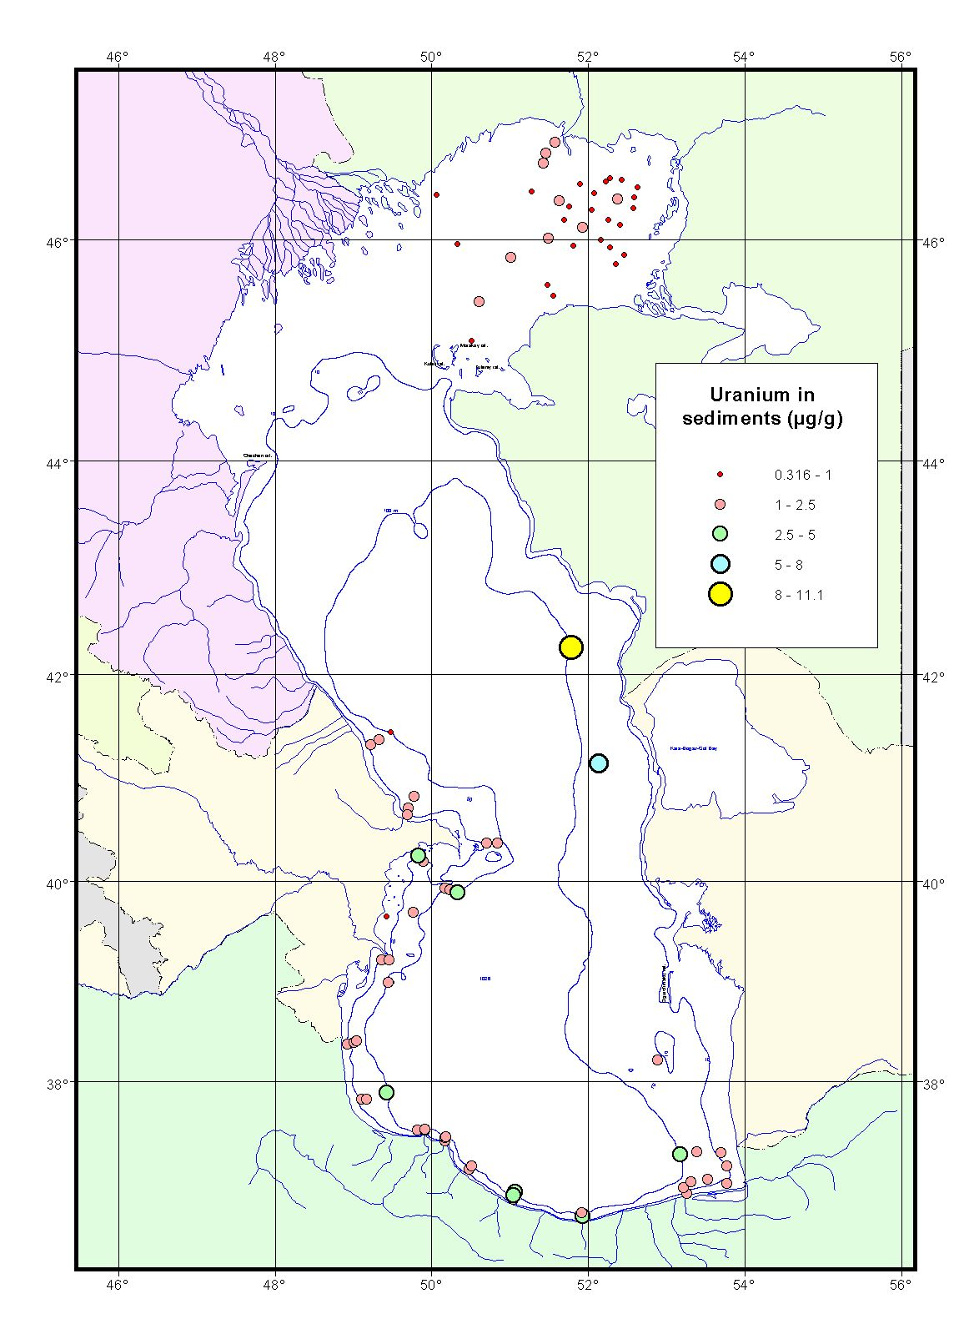
Table 2.6-5 Nuclear Reactors in the Caspian Sea Vicinity

Country | Location | Reactor | Purpose | Reference
Armenia | Madzamor  (Yerevan) | PWRª | Electricity | INSC 1997
Iran | Tehran | Unknown | Research | EIA 1998;  INSC 1998a
 | Esfahan | ENTC GSCR^{b}  ENTC HWZPR^{c}  ENTC LWSCR^{d}  ENTC TRR^{e} | Research | INSC 1998a
Kazakhstan | Aktau | LMFBR^{f}  (BN-350) | Electricity | INSC 1998b
Russia | Novovoronezh | PWR (7 units) | Electricity | PNL 1998a
 |  | VVER^{g} (210 through 1000) |  | INSC 1998e
 | Rostov (Volgadonsk) | PWR VVER  (4 units) | Electricity | INSC 1998g
 | Balakovo | PWR (4 units) | Electricity | PNL 1998b
 |  | VVER-1000 |  | INSC 1998f
 | Dmitrovgrad | BWR^{h}  (4 units) | Research | INSC 1998c
a) PWR pressurized water reactor.
b) ENTC GSCR subcritical water reactor.
c) HWZPR tank-in-pool heavy water reactor.
d) LWSCR subcritical light water reactor.
e) TRR pool water reactor.
f) LMFBR liquid metal cooled fast breeder reactor.
g) VVER is a Soviet-designed PWR.
h) BWR boiling water reactor; at Dmitrovgrad.

Table 2.6-6 (from Shaw et al., 1998) lists the major nuclear fuel processing facilities and other potential sources of nuclear wastes in the Caspian region. Shaw et al. reports radioactive material storage sites near the Caspian Sea in Azerbaijan, Russia and Turkmenistan.

Shaw et al. (1998) further refer to a study by Bradley (1997):“On the Turkmenistan coast of the Caspian, two chemical factories that use activated charcoal in their industrial processes have released radioactive wastes onsite at Cheleken Chemical Factory and Nebit Dag Iodine-Bromide Factory. The total radioactive pollution at the former site has been monitored at 200,000 Bq/kg (average 80,000 Bq/kg) of wastes, in a total of 15,000 to 18,000 mt of wastes that are accumulated around the factory (Berkeliev 1997), which would equal a total maximum activity of about 40 Ci (D. Bradley, personal communication). There are also deposits of radiobarites in old wells drilled for oil, gas, and industrial salts at Cheleken, the total radioactivity of which was estimated at 10 million Bq (.0003 Ci) in 1966 (Berkeliev 1997).”

Table 2.6-6 Nuclear Fuel Processing Facilities, Radons, and Other Potential Sources of Radioactive Pollution in the Caspian Sea

Country | Location | Facility | Facility type | Reference
Armenia | Yerevan | Radonª | Radioactive waste storage | Bradley 1997
Azerbaijan | Baku | Radon | Radioactive waste storage site | IAEA 1995 (in  Bradley 1997)
Kazakhstan | Mangyshlak | Uranium strip mine | Uranium processing | Berkeliev 1997
 | Mangyshlak | Underground nuclear test site | Peaceful nuclear explosions (three) | Bradley 1997
 | Aktau | Kaskor uranium mill | Uranium tailings | Bradley 1997
 | Plato Ustijurt | Underground nuclear blast site | Peaceful nuclear explosion | Bradley 1997
 | Sarykamys area | Underground nuclear blast site | Peaceful nuclear explosion | Bradley 1997
 | North shore Caspian near Kazakhstan western border | Underground nuclear blast site | Peaceful nuclear explosions (series) | Bradley 1997
Russia | Novovoronezh | Novovoronezh Reactor site | Spent fuel storage | INSC 1998d
 | Lermontov | Uranium mine | Uranium mine | Bradley 1997
 | Volgograd and Samara on the Volga River  Dmitrovgrad | Radon  Dmitrovgrad Research Institute | Radioactive waste storage site  Radioactive waste injection | Bradley 1997  Bradley 1997
 | Dmitrovgrad | Dmitrovgrad Research Institute | Accidental discharge | Kudrik 1997
Turkmenistan | Cheleken | Cheleken Chemical Factory | Industry using activated charcoal | Berkeliev 1997
 | Nebit Dag | Nebit Dag Iodine-Bromide Factory | Industry using activated charcoal | Berkeliev 1997
 | Kizilkaya | Gyusha transfer station | Uranium mining, transfer | Berkeliev 1997
 | Karakumskij Canal, Ashkabad |  | Radioactive waste storage site | Bradley 1997
Uzbekistan | Kyzlkum near Kazakhstan border | Underground nuclear blast site | Peaceful nuclear explosion | Berkeliev 1997
a) Radon is a regional radioactive waste storage site in the FSU republics.

The suggestion of widespread use of peaceful nuclear explosions in Kazakhstan and Turkmenistan, if true, would also provide additional sources of radioactive contamination. Although the data on radioactivity in the environment are missing, clear indications of nuclear activity in the region point to potential radioactive contamination.

Water
The sources of information for water quality are varied, but generally not systematic nor comprehensive. In the former USSR, the Hydrometeorology Service used to perform routine monitoring of the water and sediments of the Soviet part of the Caspian Sea. The coverage was quite comprehensive (See Figure 2.6-5), consisting of shore-normal transects around the coast. There are some concerns about the reliability of some of these data and about methodology, particularly with ammonia, phenols, and heavy metals. Ammonia is quite difficult to measure in the water. Phenols are a constant source of discussion in the region; former methods for detecting phenols lumped with them numerous biological signals, thereby making the phenol measurements unreliable. Recent measurements of phenol concentrations in various parts of the Caspian Sea, using modern methods, show phenols to be orders of magnitude lower than originally estimated in Volume three, Annex 3.7. Finally, heavy metals measurements did not take into account the problems with contamination by sea salts, as is indicated by the unreasonable values obtained for these parameters at times. Tzhilkin (2001) provides an overview of these data.

At present, however, the Hydromet services are not providing the same level of measurement, and quality-controlled data are sparse for the past decade. In addition, Iran has virtually no sediment or water quality data in the Caspian Sea and there is no data base from which to begin assessment.

Previous sections have addressed oil and gas input to the Caspian Sea,. In general, other than slicks and surface expressions, the modern data show relatively low amounts of petroleum hydrocarbons in the waters, but still levels appear to be of concern for ecotoxicology of the Caspian organisms. However, the contamination does not appear to be a Caspian-wide problem; rather it is more localized. Concentrations are on the order of 10-100 μg/L.

Heavy metals are similarly low, with arsenic, cadmium, chromium, mercury, lead, nickel, and vanadium often below detection limits. Barium is of the order of 10s’ of μg/L, and copper, iron and zinc are similar. Exceptions exist, of course, in hot spots. However, measurements are insufficient both temporally and spatially to characterize these concentrations. CEP focused little effort on characterizing the dissolved metals and organics in seawater, because of the sampling effort, expense, and low levels reported elsewhere in the recent literature. Also, characterization of water column concentrations at any single time doesn’t provide much information other than screening, since concentrations vary rapidly with currents. It was therefore decided to place more effort on characterizing sediments, which could provide a more historical perspective.

Generally, nutrients are shown to be quite low, with nitrates in the neighborhood of <1 μg/L, ammonia nitrogen less than 1 μg/L, and total nitrogen ranging up to 10s of μg/L. Phosphate ranges from a few to 10s of μg/L, in general. These are all low values, which describe waters far from eutrophic. There is no evidence of widespread eutrophication of the Caspian, though some deltaic and lagoonal areas may be slightly eutrophied. Water clarity in general is quite good. (One of the first indicators of eutrophication is adverse water clarity, so the good clarity indicates that eutrophication is not a basin-wide issue.) However, some parts of the Caspian do have poor water clarity, including the shallow northern section. Here, the wave agitation is so great that water clarity is often poor for periods following storms. Other areas having reduced clarity include zones of river inflow, and possibly upwelling zones. In particular, the Volga Delta has periods of slight eutrophication, and the lagoons of Iran occasionally are eutrophied due to nutrient inputs and vegetal matter. Salmanov (2000) discusses eutrophication in the Sea and shows some tendencies in some areas owards eutrophication. However, the major part of the Sea is not eutrophic.

Figure 2.6-5 Network of Hydrometeorological Stations for the Caspian Sea

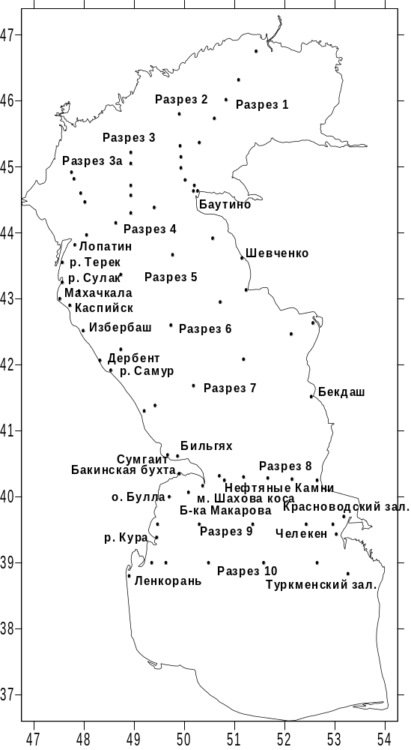
Profile 2
Profile 1
Profile 3
Profile 3a
Profile 4
Profile 5
Profile 6
Profile 7
Profile 8
Profile 9
Profile 10
Turkmen Bay
Lenkoran
Shevchenko
Bautino
Lopatin
River Terek
River Sulak
Makhachkala
Kaspiysk
Izberbash
River Samur
Derbent
Bilgyakh
River Kura
Sumgait
Baku Bay
Oily Rocks
Bulla island
Shahov spit
Makarov Bank
Krasnovodsk Bay
Cheleken
Bekdash

In general, the waters are well oxygenated in the Caspian Sea. Occasionally, the waters exceed 100% saturation, particularly on the shallow northern shelf, where wave agitation helps prevent anoxia, which might otherwise occur near the deltas. Even in deeper waters, water is not anoxic (about 20% saturation). The recent Caspian Marine Expedition (CRTC MB, 2001) indicates no areas of bottom anoxia in the North Caspian, though there are some areas of hypoxia. Of the total area of the North Caspian (about 80,000 км2), about 6,800 км2 had dissolved oxygen between 80% saturation and 30% saturation.

Data on radionuclides and microbial contamination are not available on a regional basis.

Sediments
Sediments are a good marker for contaminant levels. Though water quality may vary significantly in time and space, sediment quality represents an average condition. Therefore, for many contaminant programs, sediment is the matrix of choice for long-term quality and trends monitoring. Sediment data are available from the Hydromet network and are summarized by Tuzhilkin (2001). The CEP also conducted a Caspian wide, coastal At-Sea Training Program (ASTP) that took sediment samples during 2000 and 2001. The entire coastal zone was covered except for the Turkmen waters, where permission to enter was not granted. De Mora and Sheikholeslami (2002) report on the results of this sediment cruise. All sediments were analyzed at the International Atomic Energy Agency (IAEA) laboratories in Monaco, with the exception of the Russian sector samples, which were analyzed in a Russian laboratory. Oil and gas industry data also were used for this assessment, when QA/QC procedures were well documented.

The general results of the sediment monitoring indicate:

- Many heavy metals (Aluminum, Cadmium, Chromium, Copper, Lead, Nickel, Silver, Vanadium, and Zinc) are high in the Caucasus region and the south Caspian (primarily Azerbaijan and Iran). This heavy metal signature is probably geological in origin, rather than industrial. However, there are some heavy metal signatures from industry.
- Mercury is a contaminant of concern (Figure 2.5-17), especially around Baku, where the source of Mercury from industrial facilities in Sumgait have been identified.
- Barium is found in sediments at elevated levels (see Volume three, Annex 3.10), particularly in the mid-eastern and mid-western sections of the Sea.
- Arsenic exceeds sediment quality levels in many parts of the Caspian, including the Kazakh sector and the Azeri sector particularly (Volume three, Annex 3.10).
- Chromium has two hot spots, one near the mouth of the Ural River, the second near the mouth of the Kura River. These could represent industrial or mining discharges.
- Copper is high in several areas, including the Sefid Rood river mouth and the Kura River mouth, possibly due to use of copper sulfate-based pesticides for orchards.
- Lead is high near Sumgait, and has a slight elevation near the mouth of the Ural River.
- Nickel is high near the Ural River mouth, and in Russian sediments.
- Uranium has distributed hot spots in the sediments, in several countries.
- In general, the sediments of the Kazakh sector are remarkably unpolluted by heavy metals. Only one station located near the Ural River mouth has high levels of heavy metals.
- Sediments near the Russian coast are also remarkably clear of heavy metals, with some exceptions near industrial areas.
- The Baku/Absheron region is the most contaminated area, high in many heavy metals.
- The Iranian coast has high concentrations of heavy metals, apparently of geological origin. The Sefid Rood river mouth shows some higher industrial concentrations (of copper and zinc, for instance).
- The distribution of heavy metals is consistent with the main circulation of the south Caspian area, which consists of a major cyclonic (anticlockwise) gyre which brings river flow, sediments, and perhaps contaminants from the Azeri to the Iranian sector of the shoreline.

These distributions have not been normalized for organic carbon or percent fine material. Since some contaminants tend to concentrate in finer sediments, having higher organic carbon content, some of the contaminant signal is likely due to the sediment type. However, there is little overall correlation between level of pollution and sediment type, so the contaminant signals likely mirror sources. There is also some concern that the shallow water combined with large waves of the North Caspian may also bias the results. However, the deeper Ural Furrow in the northeast Caspian has both high fine content and high levels of organic carbon, exceeding 2% in some cases. Therefore, the contaminant levels are not low due to wave agitation alone.

The organic signal shows different results. These data can be summarized as follows:

- Baku Bay has high levels of HCH, Aldrin, PAHs, PCBs, Chlordane, total hydrocarbons, DDT, Lindane, HCB, endosulfan, Endrin, and Dieldrin in the sediments.
- The Kura River mouth has high levels of HCH, Aldrin, PAH, endosulfan, chlordane, total hydrocarbons, DDTs, and HCB.
- Iranian waters in general are cleaner, having some aldrin, ensodulfan, DDTs and endrin.
- Kazakh waters were the lowest in all organics, though some levels were slightly elevated, notably endosulfan and endrin. These findings mirror the results of the multinational oil and gas sector studies of the region, but are contrary to public perceptions.
- Russian waters are relatively clean of organics as well, except endosulfan (one peak off the Volga delta), PCBs, DDTs, methoxychlor (the highest values are in Russian sediments), Lindane (the highest values are in Russian sediments), Heptachlor, and dieldrin. Since the Russian lab did not use the same techniques as AIEA, not all analyses were repeated by the Russians. Quality control also cannot be guaranteed for the Russian results.

Figure 2.6-6 Mercury in Sediments
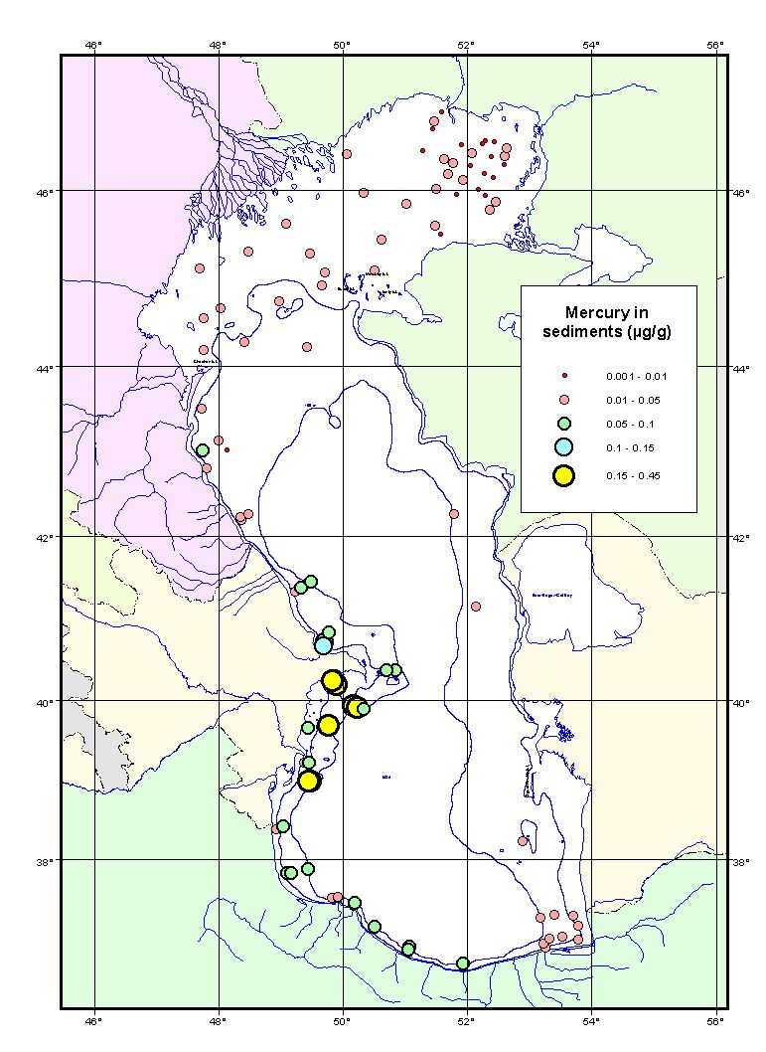

In summary, the major contaminants of concern in the Caspian sediments appear to be agrochemicals (notably DDT and endosulfans), PCBs in RF and AZ, and PAHs near Baku only. PCBs and PAHs are not very widespread (consistent with sparse distribution of industrial centers around the coast). Of these contaminants, DDT generally exceeds sediment quality guidelines (Figure 2.6-7), whereas PAHs and PCBs do not.

The DDT story is interesting. Banned in all countries for the past twenty years or more, it still seems to be in use. Anecdotal remarks about abundant local supply, use in combating locusts during the past two years, and “local” knowledge suggest that this banned agrochemical is still widely available. Some support for this contention comes from the ASTP cruise, where off the Kura Delta a recent input of DDT was observed (CEP infers that the input was recent because of the high ratio of DDT to its breakdown products). Alternatives to DDT must be sought and supplied, and enforcement of the ban must be pursued.

Figure 2.6-7 DDT in Sediment
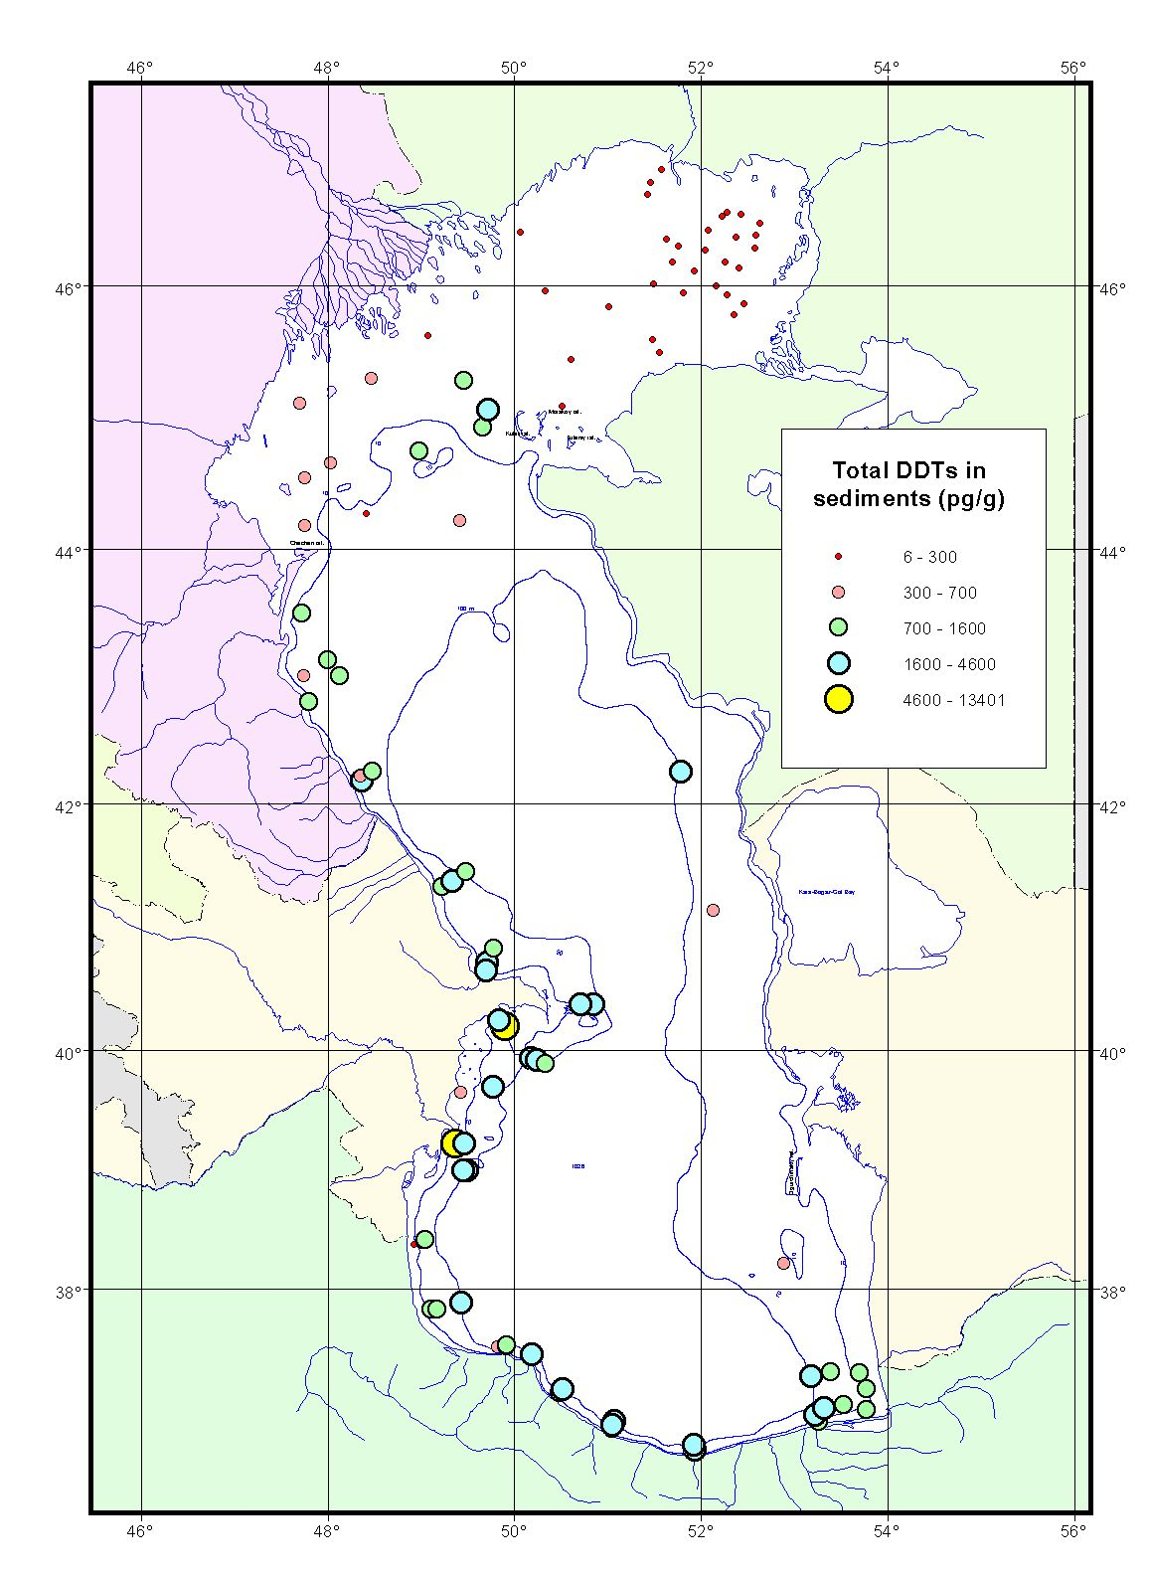

Measurements of contaminants in rivers are more difficult to come by. For the Volga River, original data was not released to the CEP; rather, only reports and aggragated data were available. The general literature supports the notion that contamination in the Volga River is significant, and because of the river’s vast reservoirs and wetlands, a large percentage of these contaminants must be sequestered prior to reaching the Caspian Sea. The sediment data from the ASTP cruise (analyzed by the Russian Laboratory Typhoon) supports the idea that the Volga may not be as contaminated as has been reported, at least in its lower reaches. Winkels et al. (1998) analyzed six sediment cores taken in sedimentation zones of the lower Volga River. They analyzed 9 metals, 7 PCBs, and 10 PAHs for all cores, which were sectioned for geochronology using Cs chronology. The core sections represent the past several hundred years. Results showed that the sum of the seven PCBs in the Volga Delta were below 0.04 mg/kg; the six PAHs totaled 0.4 mg/kg; Cd and Hg were below detection; Ni, Zn, and Cr were about 50 mg/kg; As about 4 mg/kg; and Pb about 9 mg/kg (all figures are averages). Of the three deltas that Winkels et al. (1998) investigated – the Volga, Rhine and Danube -- the Volga was the cleanest. These heavy metal data were corroborated by a study by Mueller and Yahya (undated: University of Heidelberg).

Biota
This TDA focuses mainly on the recent data, from the ECOTOX CEP ecotoxicology study undertaken in 2000-2001 and other activities in the region. Mitrofanov (2001) provides an overview of some of the major findings for the North Caspian Sea.

Sturgeon: Sturgeon have been measured with high concentrations of DDT metabolites, chlordane, PCBs, HCH, and other organics, as well as some heavy metals (zinc, copper, cadmium, and lead). Reports of sturgeon dysfunction due to high contaminant loads have been published. The ECOTOX studies are not yet complete for sturgeon, so these results are not yet available. In principle, since sturgeon spend much of their time migrating, one might expect high levels of contaminants. For instance, Beluga and Russian sturgeon migrate along the western Caspian, where contamination appears to be high. Sevryuga, by contrast, migrates primarily along the eastern Caspian, where the contaminant levels may be lower (since the ASTP could not sample Turkmenistan, data are sparse here). Therefore, a hypothesis can be posed regarding the contamination levels of sturgeon based on their known different migration routes.

Gobies: Gobies are good indicators of local pollution, since they live in the sediments where pollutants tend to accumulate, and do not migrate. ECOTOX data shows concentrations of some low levels of hydrocarbons, significant DDT metabolites, and some heavy metals in gobies from AZ. Gobies from KZ waters, where the sediments are much less contaminated, have lower levels of contaminants (e.g., Mitrofanov, 2001). Therefore, goby populations, at least, show some spatial variability that appears to reflect directly the sediment and water quality.

Seals: Seals have been observed to have high concentrations of heavy metals and organics for the past several decades. Recent data acquired by ECOTOX and the oil and gas industry support the previous findings. Seals are high in PCBs, DDT metabolites (Figure 2.6-8), HCH, chlordane, HCB, and certain heavy metals (e.g., zinc), which have been demonstrated to affect their fecundity and other physiological functions. A recent mass mortality in the North Caspian Sea showed increased incidence of canine distemper virus (CDV), which was interpreted to be the proximate cause of the mortality, as discussed below.
No radionuclide data on biota have been reported, so it is not clear whether radioactivity plays any role in mortality of seals and other fishes.

Figure 2.6-8 DDT in Seal Tissue

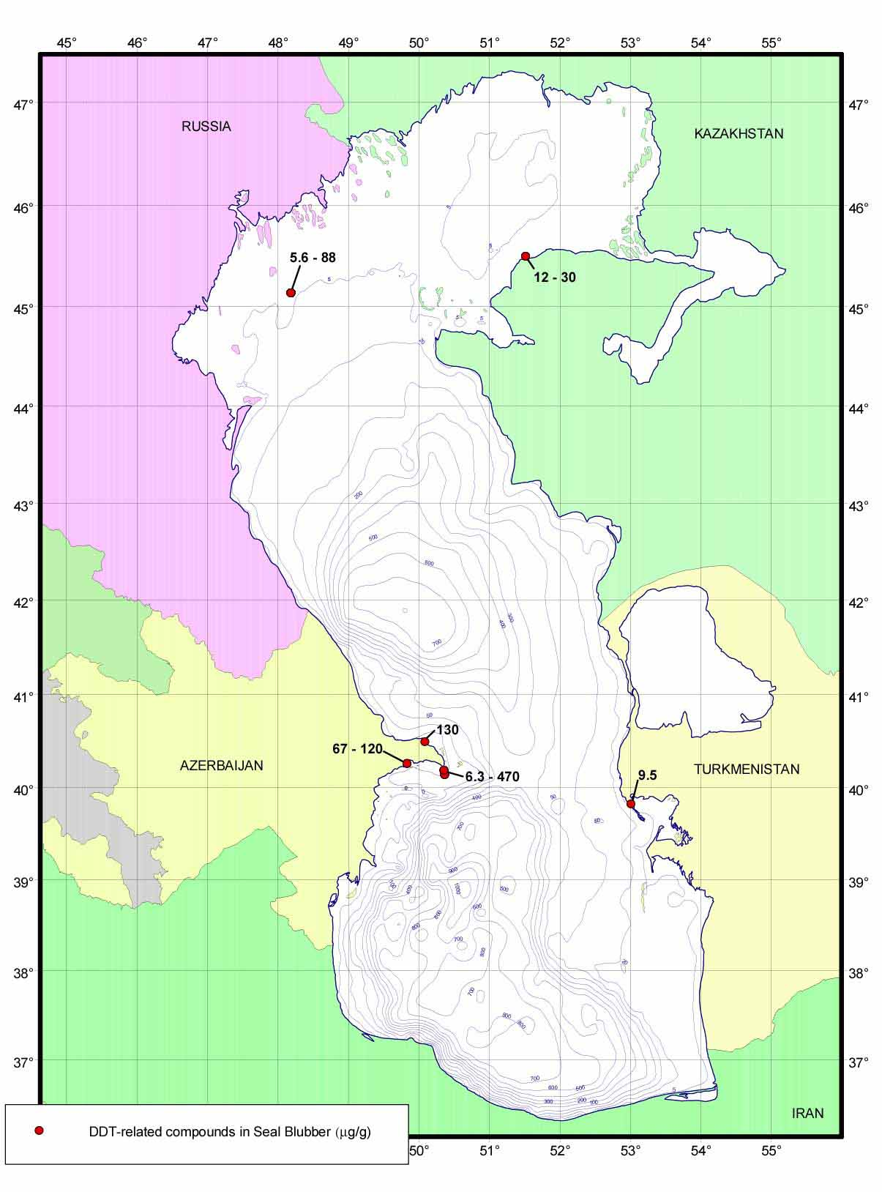

The seal mass mortality of 2000 was one of two recent such events reported in the literature of the Caspian. In 2001, there was a reported mass mortality of kilka. These are discussed briefly below.

- Seal mortality: In 2000, more than 15,000 seals deaths were reported in the Caspian Sea. Many were reported in the North Caspian off Kazakhstan (reports up to 10,000 or more), some off Russia (numbers uncertain), and many off Azerbaijan. A few dozen were reported off Turkmenistan, but there appears to have been no mass mortality there. The proximate cause of the mortality was CDV (see above). However, there were other chronic causes. Contaminant loads in seals have been known to be high for decades, affecting many physiological functions including fecundity. The winter was a mild one, and ice didn’t form extensively in the North Caspian Sea. Instead, pupping took place on the numerous small islands (shaligi) in the North Caspian, where the seals were exposed to predators (a possible source of the CDV). In addition, crowding on the ice may have increased the pressure on the seal pups to enter the water prior to achieving sufficiently robust immune capabilities. Thus, they may have been more prone to infections. All these factors contributed in some complex way to the mortality of the seals. It is not clear how unique this mortality was. With population estimates of Caspian seals ranging up to 400,000 individuals, and life spans ranging from 10-20 years, one would expect to have mortalities annually of some 20,000 to 40,000 individuals. How the mortality of 2000 relates to this overall rate is unclear. What is clear is that externalities such as pollution and CDV have severely reduced the health of the seal population. See Figure 2.6-9 for a chart showing threats to Caspian Seals.

Figure 2.6-9 Seal Mortality
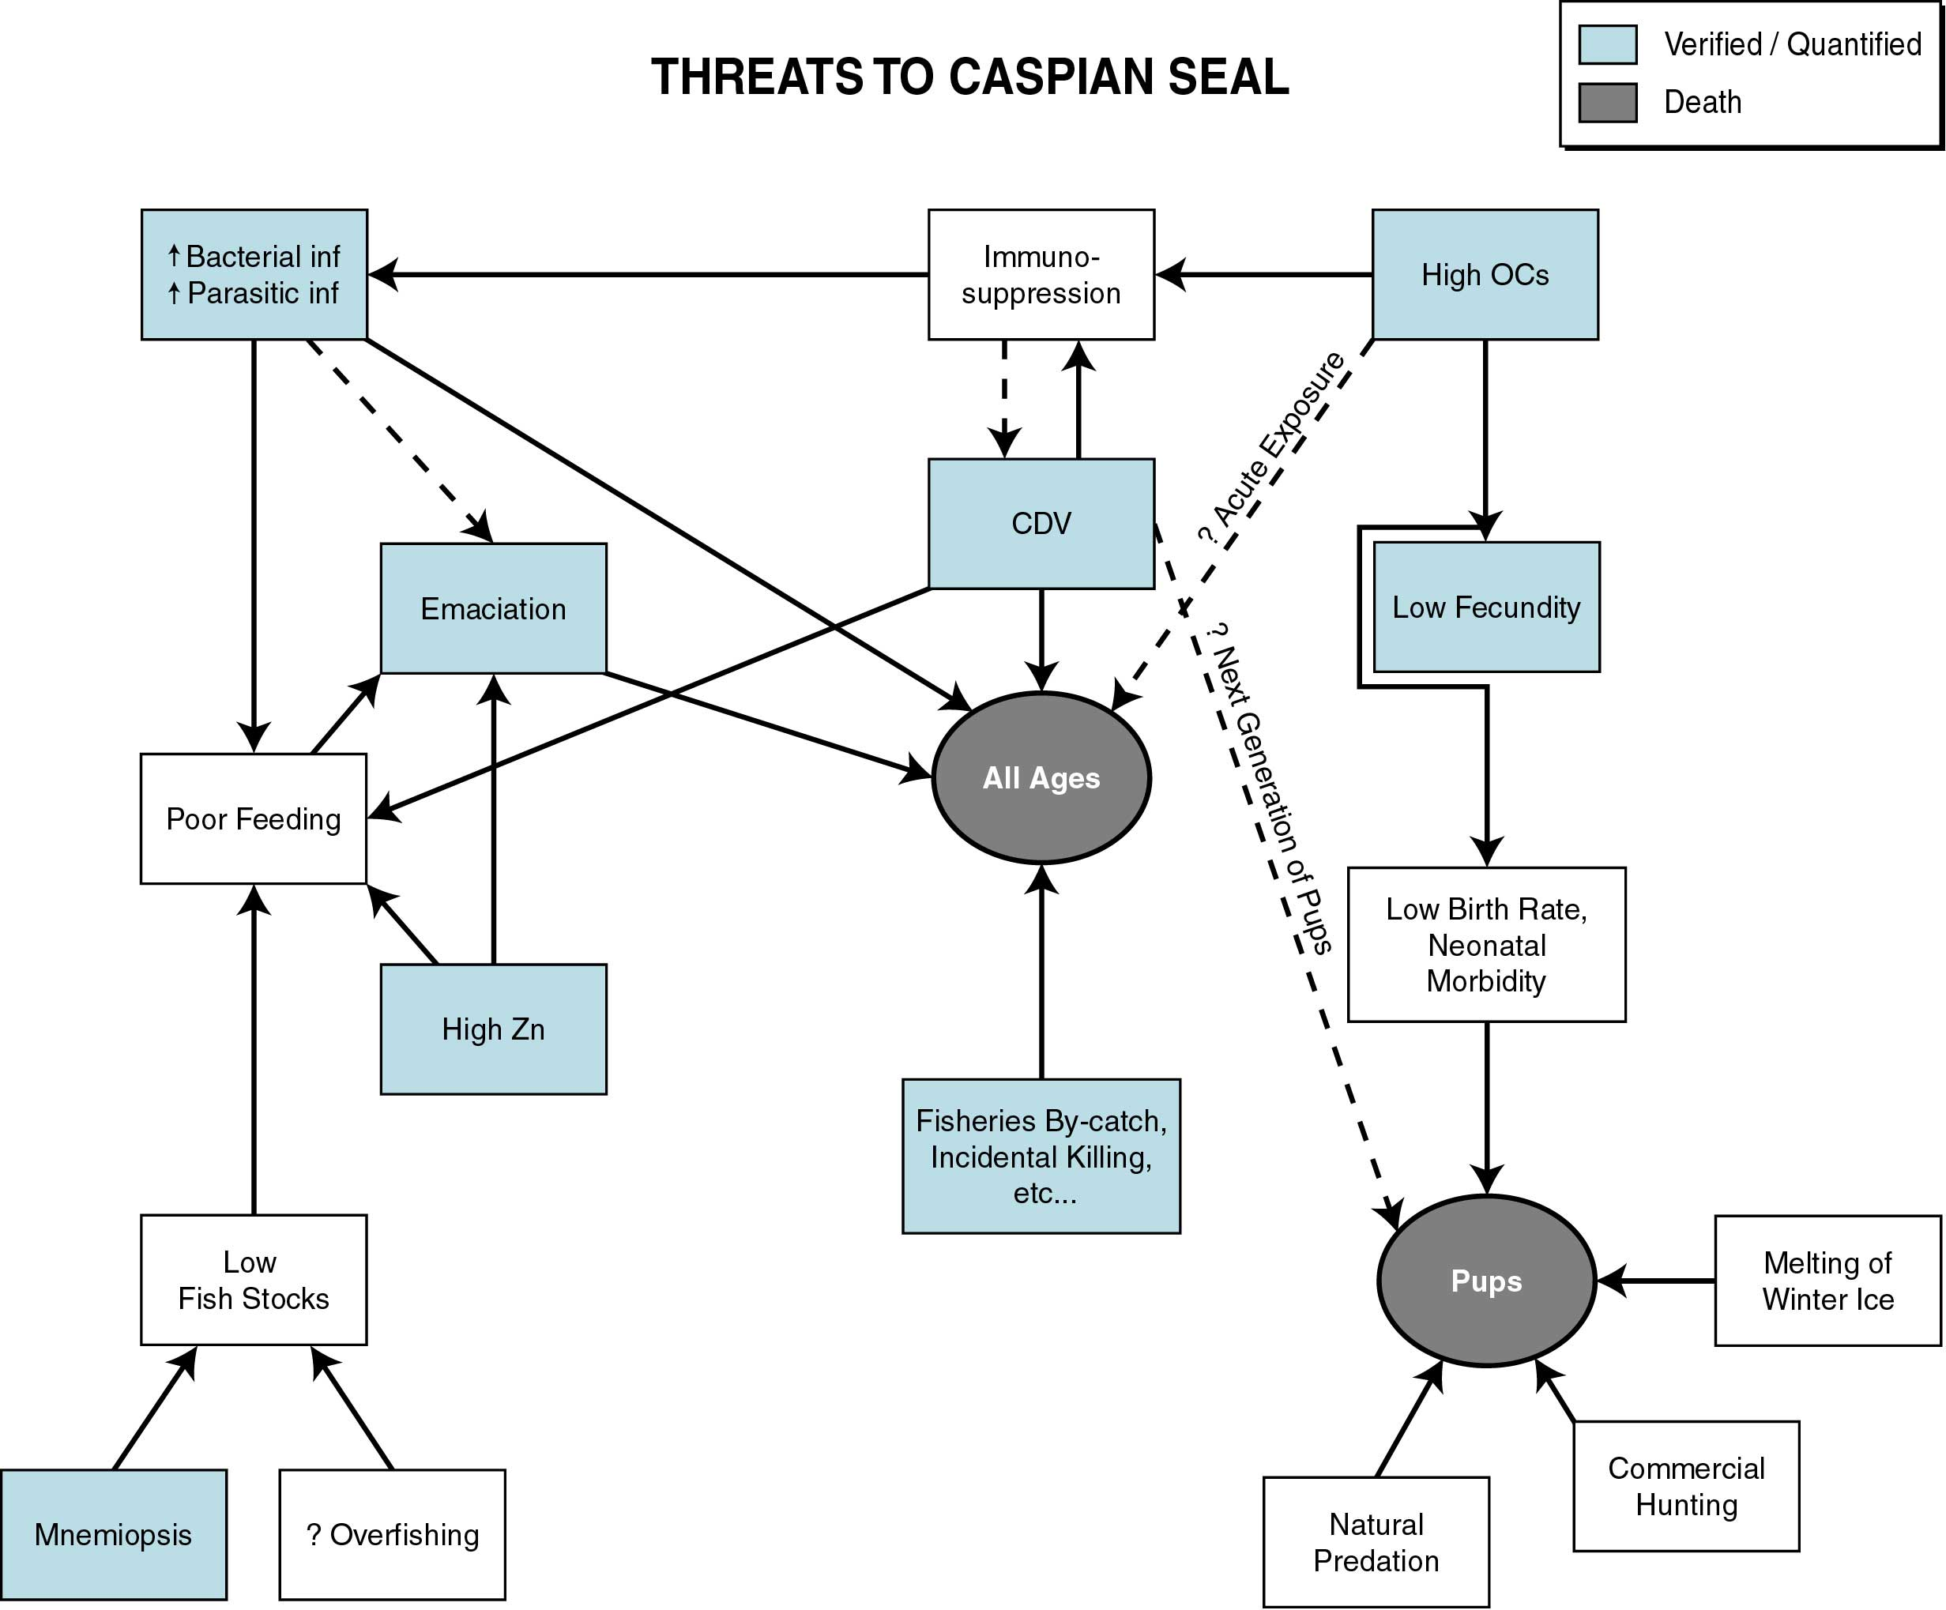

- Kilka mortality: In 2001, a kilka mortality was reported in the Caspian Sea. KaspNirkh, the Russian Fisheries Institute out of Astrakhan, while undertaking regular cruises in the late spring, found large mortalities of kilka, a fish that lives in the mid-water (some 30 to 50 m below the surface). The cause of this mortality and its extent were not clear: high hydrocarbon content was found in the kilka, as were some heavy metals. Pollution and/or a depressed oxygen level may have contributed to the mortality. The interaction of the kilka with the new invader, Mnemiopsis, adds to this concern.

  - Causal chain analysis:
Causal chain analyses have identified some of the root causes of the overall environmental decline, including socio-economic conditions (transition economies), inadequate enforcement, lack of NGO involvement in EIA process, lack of market forces, lack of government will, poverty, and lack of government funds to combat the problem.

  - Sectors and stakeholders:
Public healthcare providers, multinational corporations, regional and municipal governments, and fishermen ranked this issue as one of high priority. The major governmental players include Agriculture and Fisheries Ministries, municipal and regional governments, Environment ministries, and State industries. Affected stakeholders include coastal residents, NGOs, public health care providers, Agricultural and Fisheries Ministries, and multinational corporations. Environment ministries are also affected stakeholders, though not to the extent of the stakeholders above.

This issue of overall environmental decline achieved the second highest ranking amongst all the Stakeholders, the majority of whom ranked this as a high priority concern. There were few disagreements amongst stakeholders on this issue.

  - Environmental impacts:
Environmental impacts are varied. Biodiversity may be threatened. Fish, seals, and other organisms have high levels of some contaminants (particularly organochlorines) which affect their life history; die-offs have been reported. Habitats could be altered and perhaps lost, though the extent of this effect is inadequately documented. Human health effects may result (again, documentation is poor), especially if fears of radioactivity are borne out.

  - Socio-economic impacts:
Human health may be affected by industrial pollution, both through direct contact with the waters (for instance, microbiological contamination in swimming/bathing/ fishing waters), as well as contact through eating fish and drinking water. Air quality may also affect human health. Radioactivity in air, water, and soil may also pose a health hazard.

g. Future trends:
The future is difficult to predict, but there are several aspects worth considering. First, reduced industrial and agricultural output in the CIS countries will continue in the near future. Market forces have closed many industries and agricultural areas (e.g., rice in the Volga Delta). Whether these areas can recover in the next decade while protecting the environment remains to be seen.

The one area where rapid growth is expected is in oil and gas industries, both upstream and downstream activities. If companies adhere to international standards and the present industry is brought up to international standards, the risk to the environment can be minimized. However, any increased activity in offshore activities will increase risk, with the potential for a major spill threatening the Caspian ecosystem. Therefore, international standards and technology must be combined with emergency planning and preparedness, on a regional basis.

2.7 Decline in human health: weakly transboundary.

  - Statement of the problem:

The CEP has undertaken only a limited review of human health problems due to the low level of project funding earmarked for this activity. The World Health Organization (WHO) participated in some activities, such as recreational/ground waters monitoring pilot projects in Azerbaijan, Iran and Turkmenistan, in this arena in 2000 and 2001, but the reports will not available until Autumn of 2002. Compilation of a Caspian Health Profile on the basis of existing information was attempted but the final results were not to hand in time for the TDA Final Report.

The health situation for most of the region is perceived to be not fully adequate. However, definite links to the Caspian environment are not confirmed and cannot be easily quantified. Many of the MPPI point to the decline in human health as one of their socio-economic impacts. These perceived links suggest that this is a wide-ranging concern and may have significant impact if left unaddressed in the future.

Life expectancy, one indicator of health, fell slightly during the past decade, although it generally remains high across the region, ranging from 64.1 in Kazakhstan to 68 in Iran in 1999. Towards the end of the 1990s, as the economy strengthened, infant mortality rates began to improve slightly and life expectancy began to rise in all Caspian countries. Iran stands as an exception in the region, as life expectancy has increased appreciably in recent years and access to health care has improved during the past decade. In Iran the policy shift to reduce health subsidies has created noticeable pressure on household budgets, but the likely impacts on health conditions have not yet been perceptible.

In general there is inadequate health care in the region. Access to essential drugs is reported to be 66 percent in the new republics and 85 percent for Iran. The number of physicians per 100,000 is 421 for Russia, 353 for Kazakhstan, 360 for Azerbaijan, 300 for Turkmenistan and 85 for Iran. The number of hospital beds appears to be fairly high, however, the problem is the quality of the medical services and the financial burden of these services on the already strained economic resources. With the dissolution of the Soviet Union, access to and quality of healthcare in the four CIS countries declined severely. The economically constrained new republics were unable to finance adequately the existing healthcare system. Emphasis shifted from preventive to restorative care. This shift, combined with an overall lack of nutrition (in 1996 studies determined that half of Azerbaijan’s children were undernourished) concern over food safety, and often inadequate access to clean water, has led to increased disease and infant mortality rates in the Caspian region. Tuberculosis and AIDS are beginning to spread fairly rapidly. Typhoid is also a problem in the region, with cases in Daghestan 15 times higher than the Russian average. During the mid-1990s, infant mortality rates in some regions soared to as high as four times the average in industrial countries.

  - Supporting data:

Existing data are from both CEP and international agency compilations, which often do not break down the information according to oblast or rayon or county, at a level that permits quantitative assessment of the linkage with the Caspian environment. The data are sometimes anecdotal, are certainly not complete, and in some cases are outdated. However, based on available information, the region has generally shown some decrease in infant mortality and increase in life spans during the past decade or so.

The tables in Volume three, Annex 3.11, derived from published reports from the UNDP and other sources, illustrate some of the human health issues. Data for Iran comes partly from their excellent Coastal Profile Report (ITCAMP CRTC, 2001). The available data from all Caspian states that are comparable, and that relate to environmentally induced health impacts, are at a national level and may not adequately reflect the specific local situation. They do, however, provide some insight into human health issues in the broader region.

Tables 2.7-1 and 2.7-2 contain summary data on infant mortality, low birth weights and under-five mortality. Newborns, infants, and young children are more susceptible to environmental stresses and developmentally more vulnerable to poor environmental conditions than adults. Though the causes of low birth rates and mortality are not specifically environmental, they may indicate the presence of environmental stressors. Critical environmental conditions may include lack of access to potable drinking water, lack of a varied and healthy diet, exposure to air borne and water borne diseases and contaminants, exposure to hazardous chemicals including pesticides that affect cell and tissue development, exposure to radiation, and overall poverty.

Table 2.7-1 Survival Rates (UNDP Human Development Report 2001)

 | Life expectancy at birth (years)  1995-2000 | Infant mortality rate (per 1000 births) 1999 | Under-five mortality rate (per 1000 live births) 1999 | Maternal mortality rates reported (per 100,000 live births)  1980-99
Azerbaijan | 71.0 | 35 | 45 | 43
Iran | 68.0 | 37 | 46 | 37
Kazakhstan | 64.1 | 35 | 42 | 70
Russian Fed. | 66.1 | 18 | 22 | 50
Turkmenistan | 65.4 | 52 | 71 | 65

Table 2.7-2 Leading Global Health Crises and Challenges (UNDP Human Development Report 2001)

 | Undernourished people (% total)  1996/98 | Infants with low birthweight (%)  1995-99 | Adults with HIV/AIDS (%)  1999 | Tuberculosis cases (per 100,000)  1998
Azerbaijan | 32 | 6 | <0.01 | 61
Iran | 6 | 10 | <0.01 | 18
Kazakhstan | 5 | 9 | 0.04 | 126
Russian Fed. | 6 | 7 | 0.18 | 82
Turkmenistan | 10 | 5 | 0.01 | 89

Analogous OECD country data for infant mortality is 12 per 1000, the percentage of infants with low birth weight is 4-7, and the under-five mortality rate 14 per 1000 live births. In general, the data from Caspian countries are much worse than the OECD data.

Populations often lack nourishing foods due to poor environmental conditions, including crop failures due to droughts or lack of water due to its diversion elsewhere, poor soil quality due to desertification, or massive pest invasions. The especially high rate of undernourished people in Azerbaijan reflects the strains in that country from internally displaced persons and international refugees from other Caucasus states.

The average life expectancy at birth is also a reflection of environmental conditions in the region. Again, although these data do not necessarily reflect environmental causes for shortened life expectancy, the increase in environmental stressors can certainly contribute to harsher living conditions and shortened life spans. The OECD average life expectancy at birth is 76.2, some 5 to 12 years longer than in the Caspian region.

Figure 2.7-2 Life expectancy at birth (average and Caspian coast) and (years)

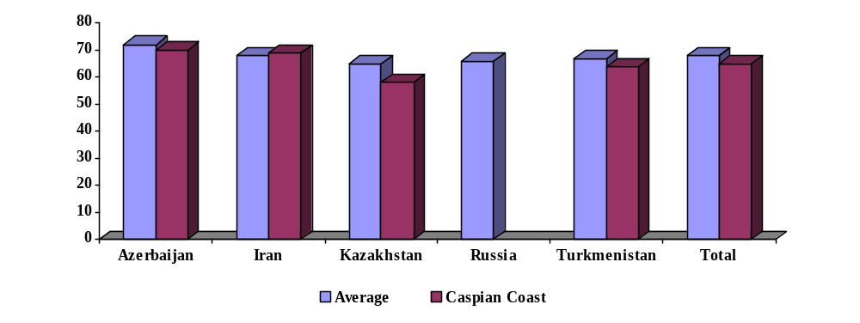

For most of the countries, health within coastal communities does not much differ from that of the country as a whole. An exception is Kazakhstan, as shown in Table 3.11-7 in Annex 3.11, Volume three, which would seem to indicate poor health in the coastal areas compared to the national average: greater number of cases of tuberculosis, skin diseases, infectious and parasitic diseases (water-related), and blood disease.

It is generally acknowledged that environmental degradation – in the form of air, soil, and water pollution –contributes to declining health status of the local population. Particular and site-specific case studies (see below) seem to attest to this link in the Caspian region.

In the region under consideration (see figure 2.7-1), the fact that about 14% of the population have no access to safe water, 27% of the population in Iran and 10% of the population in Russia have no access to the public health services, 19% of the population of Iran and 1% of the population of Kazakhstan have no access to sanitary prophylactics, plays a consequential part in the contraction of the population life duration.

The health related indices in coastal areas of the littoral countries differ to various degrees from the average corresponding national rates. The life expectancy is slightly lower than the national rates in the coastal region of the Caspian, except for Iran (Figure 2.7-2). The birth rate at the coast (table 2.7.3) is higher than national averages but the can be seen from table (table 2.7.4) the death rate of hinterland is lower than the national averages.

Table 2.7.3 National and Caspian coastal region birth rates, per 1000

Country | Azerbaijan | Iran | Kazakhstan | Russia | Turkmenistan | Average in the region
National figure | 14.9 | 19.5 | 14.2 | 8.3 | 18.5 | 15.1
Caspian coastal figure | 15.0 | 34.8 | 17.2 | 10.4 | 17.3 | 19.0

Table 2.7.4 National and Caspian Coastal death region rates, per 1000

Country | Azerbaijan | Iran | Kazakhstan | Russia | Turkmenistan | Average in the region
Total | 5.9 | 6.5 | 9.8 | 14.7 | 5.4 | 8.5
Hinterlands | 5.7 | 6.4 | 7.5 | 13.7 | 6.5 | 8.0

Figure 2.7-1 Caspian Coastal Region

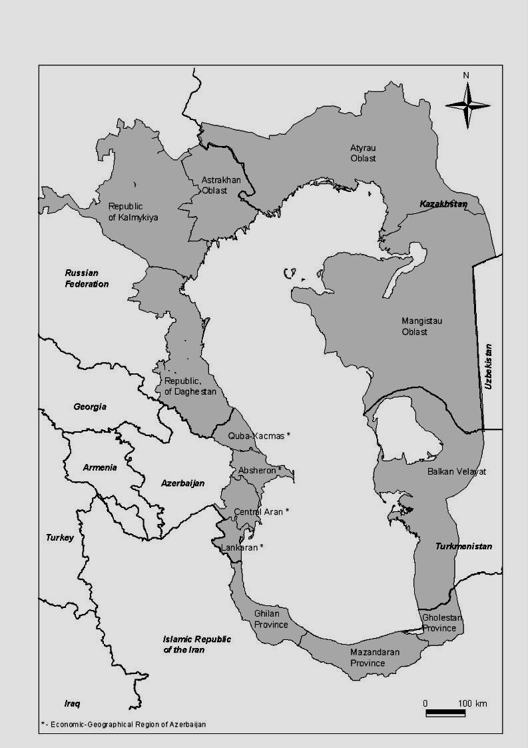

The following examples of human health problems linked to the state of the environment have been extracted from available reports:

The Resource Center "Medical Professional Information" of Atyrau, KZ, argues that, because of the intensification of industrial production in the coastal areas of KZ, there is a tendency towards uncontrolled increase of number of illness caused by environmental hazards, such as child allegros (ChA) in Atyrau. In 1999 in Atyrau, 358 cases of ChA were registered, 57 of which were first-time cases and 16 life-threatening; in 2000 there were 570 cases, 196 of which were first-time cases and 39 life-threatening (data from the report of the head pediatrician of Atyrau to the Head Child Allergist of Kazakhstan).

The Astrakhan State Medical Academy reports that environmental hazards such as emissions from a gas processing plant and other industrial contamination of the Volga river combined with natural conditions of this region (abrupt seasonal fluctuations in temperature, oscillating atmospheric pressure, prolonged solar radiation) contribute to higher incidences of illnesses among the Astrakhan population. Local anthropogenic impacts in Zamyany also include environmental contamination with hydrocarbons and their derivatives from the oil-refinery. Preventive medical examination in Kozlovo revealed a high percentage of children with an enlarged thyroid gland that can allow one to conclude on microelement deficiency of iodine.

In Iran, the rapid urbanization and industrialization of coastal areas has not been followed by adequate construction of sanitary and solid waste infrastructure. The resulting deficiencies are most clearly noticeable in relation to water pollution in coastal areas, especially rivers that pass through populated and industrial areas. The most conspicuous example of this phenomenon is the Zarjab river that enters Anzali lagoon and carries the pollution load of numerous factories and towns (particularly the city of Rasht) into this water body. It is estimated that there are 500 and 473 large industrial units in Mazandaran and Gilan provinces respectively (2001 Caspian Regional Coastal Profile).

The CEP Caspian Regional Coastal Profile (2001) spells out the increased level of risks in the Caspian region of KZ of contracting infectious and parasitic diseases, blood and hemogenic diseases, circulatory problems and pregnancy complications. The problem of tuberculosis is also acute in that region, with Atyrau holding first rank in the country with figures twice the national average (178 cases a year per 100,000 people) and Mangistau taking fifth place (92 cases a year per 100,000), as reported in the Kazakhstan Coastal Profile (2000).

The Azerbaijan National Oncology Center reports that in an analysis of prepubescent children in Sumgait, the chronic presence of atmospheric pollutants (three times higher than national averages) results in an increased rate in endocrine diseases, neurological diseases, cardio and pulmonary disorders and sinus, bronchial and musculoskeletal diseases. They conclude that the combined influence of pollutants causes central nervous system disorders as well as other problems with solid organs, such as liver, kidneys, spleen and pancreas in younger school aged children.

Causes for death in the Caspian region vary with age. Main cause for mortality of children under 5 is diseases of respiratory organs, and for able-bodied and elder persons is diseases of cardiac-vascular system. For elder persons diseases of the system of blood circulation hold the leading place. In Kazakhstan and Russia the level of mortality out of this ailment has grown by 15% and 43%, respectively since 1991. In 1999 this ailment was the major reason for mortality of 76% of people at 60 and above in Turkmenistan.

Despite certain achievements in public health care in the Caspian littoral countries, in general, infectious diseases are still the principal reason a large proportion of deaths. Decline in the quality of the drinking water appear to have contributed to the growth in intestinal diseases cases. The number of tuberculosis cases has abruptly grown. Tuberculosis of respiratory organs cause almost half of mortality cases from infectious and parasitic diseases although the rate varies across the region. Tuberculosis related mortality in Azerbaijan and Russia increased 1.5 and in Kazakhstan 3 times respectively in 1997 compared to 1991. In Turkmenistan it grew by 1.3 times. Cases of virus hepatitis have been growing in comparison with past years and insufficient preparedness has led to spread of malaria in parts of Azerbaijan- see Table 2.7.5.

Table 2.7.5 Cases of infections diseases by country

Characteristic | Azerbaijan | Iran | Kazakhstan | Russia | Turkmenistan
Tuberculosis cases per 100,000 people (1998) | 61 | 18 | 126 | 82 | 89
Malaria cases per 100,000 people (1997) | 130 | 60 | - | - | -
People living with HIV/AIDS % age 15-49, (1999) | <0.01 | <0.01 | 0.04 | 0.18 | 0.01
Pregnant women with anemia, % (1975-1991) | 36 | 17 | 27 | 30 | -

In transition to market relations in many post-Soviet states the access to public health care services has contracted because of economic difficulties. Low quality of medical services aggravates position of patients with hereditary diseases.

Table 2.7.6 Public Health Care by country

Characteristic | Azerbaijan | Iran | Kazakhstan | Russia | Turkmenistan
Doctors per 100,000 (1990-1999) | 360 | 85 | 353 | 421 | 300
Nurses per 100,000 (1992-1995) | 1081 | - | 874 | 659 | 1195
Hospital beds per 100,000 people (1999) | 890 | - | 725 | 1085 | 600
One year olds fully immunized against Tuberculosis (% 1997-1999) | 91 | 99 | 99 | 100 | 99
One year olds fully immunized against Measles (% 1997-1999) | 87 | 99 | 87 | 97 | 97
Oral rehydration therapy use rate (%) (1995-2000) | - | 48 | 32 | - | 98

Poor quality of and recreational water has been perceived as a major health stressor in the region. In order to have a better understanding of the likely relation between water and health a water monitoring programme was conducted at a number of selected sites in Azerbaijan , Turkmenistan and Iran. The WHO Collaborating Centre Robens Centre for Public and Environmental Health undertook to technically assist the initiative. The interim findings of the programme were released in June 2002 and a summary of results are as follows:

Iran: The bathing beaches in Iran along the Caspian coast are well developed for tourism but there appears to be very little management particularly concerning solid and liquid waste disposal. There are many hotels and settlements along the coastline discharging waste directly into the sea. In addition, run-off and river discharges contribute significantly to the contamination of the Caspian Sea. A total of ten bathing beaches were chosen for monitoring between September 22nd 2001 and November 24th 2001 outside the main tourist season. Ramsar, Salman, Chalous and Noshahre failed the EC Guideline level for E. coli. Counts of faecal streptococci are generally lower, but there are noticeable peaks in concentrations.

Azerbaijan: Three sites for monitoring were selected around Baku. Two of these sites are designated bathing areas - Novhni and Shihof - and one is undesignated but heavily used by the population of a nearby settlement. Novhani is a beach on the North west side of Baku approximately 30 kilometres from the city centre. Low counts of both E. coli and faecal streptococci are recorded. Both sites are below the Mandatory and Guideline standards set by the EC bathing water Directive for E. coli and faecal streptooccci (CEC, 1976).The Azerbaijan findings are slightly surprising and in need of further investigation.

Turkmenistan: Four bathing beaches were selected in Turkmenbashi. Three sites were chosen as sites which are most popular with bathers. The fourth site was is an oil base, where ships dump their waste and for this reason the site was chosen; however, it is not accessible to the public. In general, the results for Turkmenistan show the water quality to be of fairly good quality. Two of the sites - regularly show counts of E. coli greater than 100 per 100 ml - thus exceeding the EC Guide value, however, all the sites are within the mandatory standard (95% of samples <2000 E. coli/100 ml) set by the EC bathing water Directive. Faecal streptococci counts were also low - less than 100 per 100 ml for all sites. The EC does not set a Mandatory standard for faecal streptococci, only a guideline standard of 100 per 100 ml.

The project has highlighted a number of issues concerned with monitoring the chosen bathing areas. The microbiological results show considerable temporal and spatial variation which indicates changing health risks over time. This highlights the inherent difficulties associated with the commonly used practice of defining a bathing water as passing or failing a defined microbiological standard. The WHO advocate moving away from a single standard for this reason. However, it should also be appreciated that the WHO Guideline values may need to be adapted to take account of different local conditions. WHO recommend that the Guideline values are used within a classification system currently being developed, which takes into account the results of the sanitary survey enabling managers to respond to local or sporadic pollution incidents and thereby improve the condition of the bathing area. The indications from the limited results presented here are that the bathing beaches monitored in Turkmenistan and Azerbaijan were of generally acceptable quality over the period of monitoring, with some peaks in pollution, particularly at Hotel Hazar and Hotel Florida, Turkmenistan. The bathing areas monitored in Iran are generally more polluted.

Table 2.7-7 Descriptive statistics of the data obtained for E. coli and faecal streptococci from sampling sites in Iran, Turkmenistan and Azerbaijan.

 | E. coli |  |  |  |  | Faecal streptococci
 | N | Median | Max. | Min. | 95th Percentile | N | Median | Max. | Min. | 95th Percentile
IRAN
Ramsar | 10 | 1550 | 9300 | 220 | 8850 | 10 | 215.5 | 380 | 22 | 366.5
Salman | 10 | 1096.5 | 9500 | 270 | 6696.5 | 10 | 186.5 | 380 | 53 | 380
Noshahre | 10 | 916.5 | 5260 | 95 | 4432 | 10 | 205 | 350 | 13 | 341
Nashtaroud | 10 | 320 | 4970 | 38 | 4151 | 10 | 45 | 340 | 6 | 237.85
Chalouse | 10 | 2385 | 9500 | 480 | 9365 | 10 | 266 | 380 | 70 | 380
Tonekabon | 10 | 278.5 | 7760 | 40 | 5078 | 10 | 27.5 | 340 | 8 | 290.5
TURKMENISTAN
Hotel Avaza | 51 | 4 | 52 | 0 | 35.9 | 51 | 1 | 32 | 0 | 11
Hotel Hazar | 51 | 6 | 165 | 0 | 51.4 | 51 | 2 | 57 | 0 | 28.8
Hotel Florida | 51 | 48 | 132 | 0 | 260 | 51 | 10 | 87 | 0 | 63.6
Resort Ufra | 51 | 2 | 105 | 0 | 29.4 | 51 | 0 | 72 | 0 | 3.6
AZERBAIJAN
Novkhana | 75 | 20 | 26 | 14 | 24 | 75 | 27 | 39 | 20 | 34.4
Shihovo | 39 | 15 | 19 | 11 | 18 | 39 | 22 | 28 | 18 | 28

  - Causal chain analysis:
The root causes of poor quality drinking water were identified as weak technical and economic situations; of poor domestic living conditions, the weak economic situation. Natural processes such as fluctuating climate and saltwater intrusion due to water level rise (decadal and storm-related) also contribute to the reduced human condition. A graphic summary of the Causal chain is contained in Annex 3.11, Volume three.

  - Sectors and stakeholders:
Stakeholders ranking this issue of high priority include public healthcare providers, multinational corporations, and industry. The major government agencies involved in this issue include regional and municipal governments, environment ministries, international organizations, agriculture ministries, and to a lesser extent, energy ministries. Major affected stakeholders include coastal residents, public healthcare providers, NGOs, and agriculture and fisheries ministries.

Stakeholder groups disagree over the impact of air quality on public health, with the public health care providers disagreeing with the scientific community and NGO representatives. Governments also face an apparent choice between spending on basic human needs such as housing, healthcare and good jobs, or spending money on protecting the environment. The energy ministries, regional and municipal governments, and health care providers argue that basic human needs should take precedence, where as environment ministries, NGOs, multinational corporations and the scientific community felt that spending should also cover environmental protection. There are also disputes about the negative human health impacts of lack of safe drinking water between public healthcare providers and Energy Ministries on one side as opposed to the Agriculture and Fishing Ministries, NGOs, and regional and municipal governments on the other. Public health care providers and fishermen disagree with Agriculture and Fishing Ministries, regional and municipal governments, NGOs, the scientific community and coastal zone residents over the impact of exposure to radioactive materials (Coastal residents do not see this as a high level concern).

  - Environmental Impact:
Because the actual causes of human health decline are often unclear and inconclusive, the use of proxy measures for environmental stressors should be used. These include:

- increase in infant mortality, increase in infants with low birthrate, increase in under five mortality rate, increase in undernourished people, and decrease in life expectancy in the region.
- access to potable water
- infectious disease rates increase
- increase in pollution related disease rates and birth defects
- increase in water borne illnesses
- decline in caloric intake

  - Socio-economic impacts:
Socio-economic conditions may be severe, including increased loss of life; increased level of illness and disease, thereby increasing social costs for health care; loss of economic labor base; loss of productivity by coastal residents; undesirable conditions for ecotourism; foreign industry investment and others.

  - Future trends:
Human health could be affected by many ongoing factors.

- If municipal wastes remain largely untreated there will be an increase in water-borne illnesses, especially if droughts prevail. Water level fluctuations may significantly affect the disposal of municipal wastes
- The collapse of the USSR led to a complete lack of high quality affordable and accessible healthcare for most of the population of the former Soviet states.
- In Iran, population pressure has compromised health care provisions, and is resulting in a drive to privatize healthcare and rationalize health care services.
- Budget cutting and rationalization of the budget strategies results in less money available for services for water distribution, and healthcare distributions which are critical for improving human health.

2.8 Damage to coastal infrastructure and amenities: weakly transboundary.

  - Statement of the problem:
The present day water level fluctuations of the Caspian negatively affect coastal infrastructure and related amenities. As the water level drops, water-related structures (piers, docks, etc.) may no longer be useable, and as water level rises, previously dry areas will be inundated, causing damage to infrastructure In addition to long-term water level fluctuations, wind-induced or storm-induced surges can cause considerable flooding of exposed coastal areas, particularly in the North Caspian region where favorable wind directions are prevalent and there are low-lying coastal zones (slopes of 1:10,000 or 1:20,000 are commonly found there). Lack of planning at all levels has led to development that ignores water level fluctuations.

Figure 2.8-1 Water level fluctuations

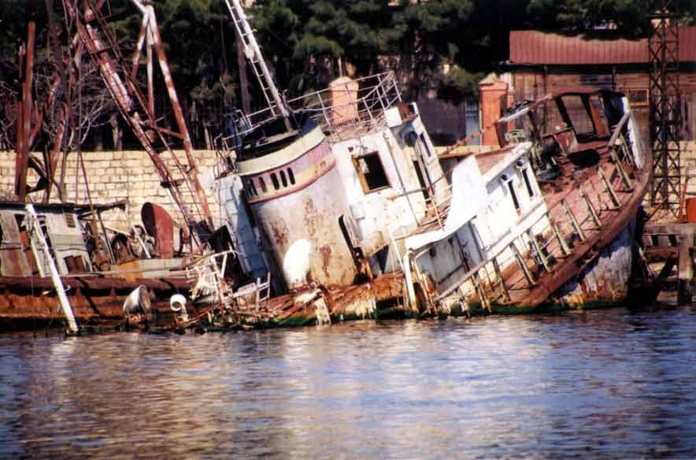
Damages to docks and piers accompanied Caspian water level rise from 1978 to 1995,
particularly along the industrialized port of Baku
Photo by Farid Kharulin

  - Supporting data:
There is considerable data documenting the loss of property and infrastructure caused by the water level rise from 1978 to 1998. Data sources include national reports, UNEP-sponsored studies, and other reports provided by the international community (e.g., World Bank). The rise in water levels from 1978 through 1995 caused damage to settlements and infrastructure over a width of some 50 to 70 km on the Kazakh coast zone, and a width of 5 to 35 km on the Turkmen coast zone. UNEP (1997) estimated that some 7 million ha of land, inhabited by some 600,000 people, were affected. Damages to infrastructure due to the water level rise have amounted to billions of dollars in Azerbaijan alone, according to recent studies. UNEP estimated that if the water level were to rise to the -25 m level (the maximum recent transgression shoreline according to Kaplin, 1997), damages to the region would exceed $12 billion, much of that occurring in Iran (with its heavily populated coast), with damages to Russia and Azerbaijan next in scale. On the other hand, drops in water level decrease natural water depths, creating the need for increased dredging to sustain shipping.

The features of water-level change have been studied by the CRTC for Water Level Fluctuations, located in Almaty, KZ. Much of the material in this section comes from various studies emanating from this CRTC. In addition, UNEP’s 1997 study of implications of water level change in the Caspian provides rich source material for this topic. A report by Schrader (2001) examined the potential inundation in the region, and possible impacts on the human and natural environments.

The Caspian water level has fluctuated throughout its history. Compared to open ocean sea-level change, Caspian rates are quite fast (some 100 times faster), and therefore their effects are more noticeable and damaging. Natural causes of water level change include altered climatology (rainfall, evaporation), as well as tectonic adjustments (a much more minor effect). However, man has exerted considerable influence on water levels in the Caspian Sea, both directly and indirectly. Direct effects include the loss of water due to damming the major rivers, increased annual evaporation loss due to the vast reservoirs created by the dams, and increased water use by industry and agriculture, etc. Indirect effects include the possible impacts of man-induced climate change (greenhouse warming). Therefore, the water level change can be shown to be influenced by man’s actions, and warrants policy, legal, or other responses to counter negative impacts.

The rapid rise in water levels from 1978 through 1995 caused significant damages to coastal infrastructure throughout the Caspian Sea, and raised awareness about possible damage due to future rise in water levels. Though water levels have dropped since 1995, some predictions for the future indicate a continued rise in water levels.

Unfortunately, prognosis of long-term water level change is difficult because climate variability is not itself easily predicted. The CRTC for Water Level Fluctuations has, however, established a regional basin-scale model to assist in predictions of water level fluctuations in the Caspian and to assist with decision making.

Recent mapping of the coastal zone shows the areas that may be flooded if water levels continue to increase (Figure 2.8-2). Table 2.8-1 shows the most susceptible geomorphological areas.

Table 2.8-1 Most affected geomorphologic structures (CEP 2001, Schrader)

Geomorphologic Structures | Examples
Recent marine terraces, dunes and lagoons (sometimes connected with lower older marine coastal terraces) | - Sand spit from Kara Bogaz Gol (Turkmenistan)  - Lagoon and sand spit from Halig-e-Gorgan (Iran)  - Sand dunes area of Cheleken (middle Turkmenistan)
Depressions with solonchaks | Large areas along southern coast of Turkmenistan
Large geological depressions | - Sor Oli Kultuk  - Sor Kajdak (northern Mangistau Oblast, Kazakhstan)
Dry (or only episodically filled) fallen river valleys | - Emba River (Kazakhstan)  - Atrek River (between Turkmenistan and Iran)
Alluvial fans (but with a distinctive higher slope) | - Caucasus Mountains foothills fans (Azerbaijan)  - Talysh Mountains foothills fans (Azerbaijan, Iran)  - Elburs Mountains foothills fans (Iran)
River valleys and deltas | - Volga, Ural, Terek (all Russian Federation)  - Kura, Samur (Azerbaijan)  - Sefid Rud (Iran)

As the sea level rises, more of the coast becomes susceptible to flooding caused by wind-induced surges, particularly in the North Caspian, where flat coastal lands and shallow water depth exacerbate the problem.

The water depth also controls the extent of the wind’s effect, since frictional drag against the bottom is greater in shallow water; without frictional drag, there is no such wind effect. Winds acting on the surface of the shallow North Caspian therefore can cause the water level to rise when the wind is moving with the coast to its right, or to fall when the wind is moving with the coast to its left. In the Middle and South Caspian the narrower and deeper coastal shelves help explain why surges are much smaller than along the northern shelf. These effects are known as wind set-up or wind set-down. Surges up to 4 m in height have been observed in the North Caspian. Wind surges of 2-3 m in height can flood up to 20 or 30 km inland, in some cases affecting tens of thousands of hectares of coastal area. Similarly, wind set-down may reach some 0.5 m or so (generally less than set-up), exposing considerable nearshore areas to open air. Damage to infrastructure may result from such flooding (in 1990 one oil installation was reported to have suffered damages of $1.2 million in a single storm).

Prediction of storm surges in the North Caspian can now be done in near-real time, due to improved modeling capabilities in Kazakhstan and Russia. However, the system in Kazakhstan is not an operational, real-time warning system, due to lack of appropriate infrastructure.

The borders and seabed of the Caspian Sea lie in a tectonically active area. In the southern part of the Sea, seismic activity is high. Earthquakes, landslides, and flash floods occur frequently. The existence of active faults in the western and southern region also adds to the vulnerability of the region to tremors.

In Azerbaijan, Iran, the Russian Federation and Turkmenistan, significant portions of the coasts are located in seismic zones of magnitude ranging from 6 to 7. The 1970 Daghestan earthquake with magnitude of 9 caused extensive structural damage and an acceleration in landslide activity. In Azerbaijan, from 1903 to 1999 more than 424 events of intensities of 4 to 9 and magnitude of 3.0 to 6.6 took place near the coastal zone. In 2000 there was extensive earthquake activity in both Azerbaijan and Turkmenistan. Figure 2.8-3 illustrates the earthquake patterns of the Caspian region.

In addition to the natural forces causing earthquakes, there is some concern that human activities (groundwater extraction, oil and gas extraction, seismic exploration) may aggravate and perhaps intensify the natural seismic activity on a local basis.

Figure 2.8-2 Potential for coastal inundation (CEP 2001, Schrader)

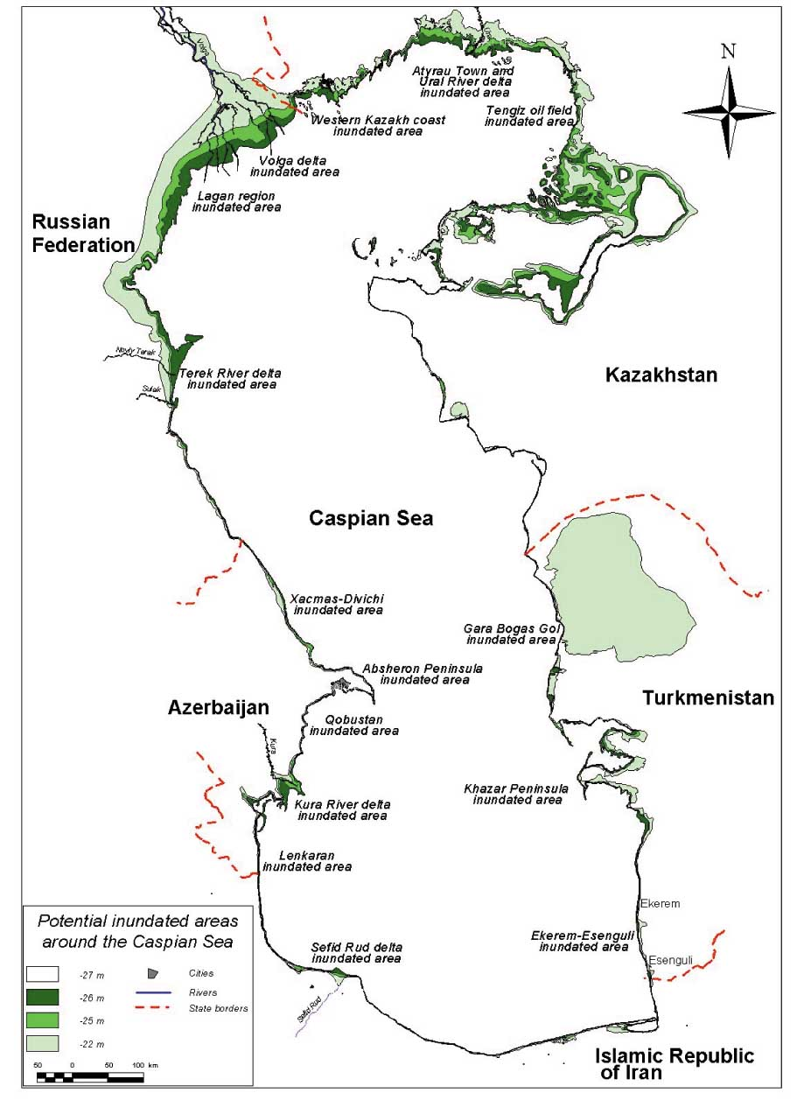

Figure 2.8-3 Caspian Region Earthquake Locations

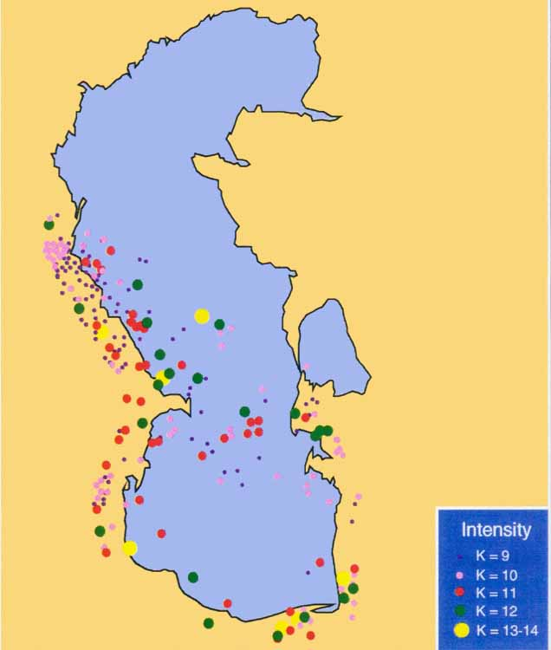
Source: Aubrey et al, 1994a

  - Causal chain analysis:
Causal chain analysis for this issue was difficult to complete, because many of the causes are natural. Therefore, much of the causal chain focuses on the human response to the forces causing water level change. Primary root causes include inadequate knowledge of long-term trends of changes in water levels; lack of regional processes to predict and alert residents to storm surges; lack of integrated coastal area planning and management (legislative basis; infrastructure; multi-sectoral coordination); and lack of public awareness and participation. Lack of understanding of how to live with water level changes also is a root cause. Annex 3.4 shows the Causal chain analysis in a graphical format.

  - Sectors and stakeholders:
According to the Stakeholder Analysis, multinational corporations are the primary Stakeholders who consider damage to coastal infrastructure a high priority. Other stakeholders consider this a lesser priority than other issues identified by the CEP. Even coastal zone residents do not consider this as high a priority as, say, decline in overall environmental quality or decline in certain fisheries. Primary interested parties in the governments include environment ministries, municipal and regional governments, multinational corporations and transport ministries. Those stakeholders most affected by damage to coastal infrastructure include multinational corporations, coastal zone residents, municipal governments, and environment ministries.

  - Environmental impacts:
Environmental impacts related to this issue include change of groundwater table responding to fluctuations in surface water level; changes in salinity of groundwater near the coastal zone (including saline intrusion); loss of coastal habitats as infrastructure needs compete with coastal habitats that normally migrate with the fluctuating water table (e.g., reed beds, coastal wetlands); inundation of contaminated coastal lands, leading to increased flow of contaminants in the coastal zone; interruption of natural coastal processes (longshore sand transport, coastal erosion) as a result of human responses to fluctuating water levels and threatened coastal infrastructure; and general lack of consideration of the significance of natural ecosystems, resulting in their loss or damage as water levels change.

  - Socio-economic impacts:
Socio-economic impacts of damage to coastal infrastructure include loss of livelihood, cost of infrastructure repair at the expense of other regional social programs, loss of jobs and displacement of coastal populations. In general, national budgets may be diverted towards commercial interests (shipping, ports, flood protection) and hard engineering solutions, and away from sustainable development solutions (such as coastal area planning and management; learning to live with water level rise).

g. Future threats:
The future of water level change is quite unknown. Some predict a rise, while others argue that the sea level will fall. Schrader (2001) made estimates of the potential threat to the different countries for different sea-level rise scenarios (table 2.6-2). The most exposed countries are Kazakhstan and the Russian Federation. The entire Caspian may gain between 12,500 км² (1 meter rise) and 46,000 км² (5 meter rise) in surface area. For the higher levels, Turkmenistan becomes more vulnerable, as its coastal plain, while higher than the coasts of Kazakhstan or Russia, is susceptible to higher surges and water level rise. This sudden increase in inundation is primarily due to flooding of the Kara Bogaz Gol area.

Table 2.8-2 Extent of inundation in the five littoral countries (CEP 2001, Schrader)

Inundation extent in km²  Country/region | + 1m rise | + 2 m rise | + 5 m rise
Azerbaijan | 730 | 1,410 | 2,420
Iran | 300 | 650 | 1,480
Kazakhstan | 6,340 | 12,930 | 23,500
Russian Federation | 4,170 | 7,240 | 18,620
Turkmenistan | 930 | 1,500 | 22,690
Entire Caspian region | 12,470 | 23,730 | 46,020

Given this susceptibility, it is imperative that the countries develop mechanisms to adapt to these large, frequent water level fluctuations, as envisioned in the GEF Project Brief in 1998. Because large oil and gas facilities are located near the coasts in Azerbaijan, Kazakhstan, and Turkmenistan, water level rises would threaten these facilities. Inundation of previously contaminated lands is another strong possibility.

2.9 Invasive and Introduced species: strongly transboundary.

  - Statement of the problem:
Invasion of exotic species is a natural phenomenon in the Caspian Sea. More recently, man has introduced species, and assisted invasive species gain access to the Caspian. Certain annelids have been introduced into the North Caspian Sea in the past, for instance, to increase the productivity of Caspian fisheries. Plant species have been introduced to coastal wetlands in Iran, and some of these species (e.g., Azolla pinnata) have unexpectedly caused anoxia in lagoons as a result of decreasing light penetration. New fish have been introduced for economic purposes. Some invasive species have organisms entered the Caspian via navigation routes, including most recently the ctenophore, or comb jelly Mnemiopsis leidyi (ML), that has devastated the Black Sea fisheries and now threatens the Caspian Sea.

Figure 2.9-1 Mnemiopsis leidyi

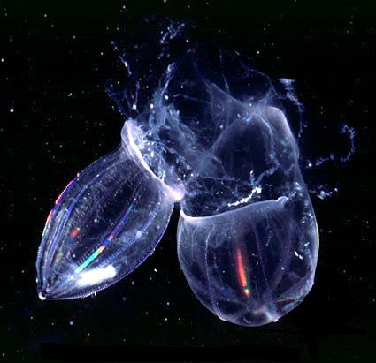
Mnemiopsis leidyi

  - Supporting data:
Invasive and Introduced species have long been an environmental concern in the Caspian Sea. Previous sections of the TDA describe the panoply of recent invasive and introduced species, and their effects. Section 2.5 (Biodiversity MPPI) describes some of the invasions introductions in the 20th century, including 17 fish species, at least six phytoplankton sp, seven zooplankton sp, numerous phytobenthos sp, and at least 11 zoobenthos sp. The invasions have taken place largely through the Volga-Don Canal (which opened in 1954) and the canal connecting to the Baltic basin.
Some introductions have been beneficial with no noticeable negative impacts, examples include the introduction of nut lotus (Nelumbo nuciferum) and water chestnut (Trapa natans). Both of the species are of high resource and aesthetic values. Cultivation of these species on local sites of the Volga Delta has led to further natural recovery in the interfluvial areas. However some deliberate introductions have been less than successful, for example the introduction of the Grass Carp (ctenopharyndon idell) into the Hamoon Wetland of the Iranian Caspian has led to loss of ecosystem integrity (Iranian Coastal Profile, 2001).

A major environmental concern is Mnemiopsis leidyi (ML). Mnemiopsis, first identified in the Caspian Sea in 1999, presumably after being transported with ballast waters from vessels traveling the Volga-Don Canal. The Caspian Sea is an isolated basin with optional conditions for Mnemiopsis development throughout the year (particularly in its southern parts), and the organism may create a serious problem for Caspian fisheries. Both the Black and Azov seas experienced a dramatic decrease of zooplankton biomass and a change in kilka biomass after Mnemiopsis appeared.

This particular invasive species may be a threat to biodiversity. A recent decrease has been observed in zooplanktonic biodiversity in Azerbaijani and Iranian waters (Kideys et al., 2001), mirroring Mnemiopsis’ effects in the Black Sea. During the summer 2001, Acartia clausi was the only abundant copepod in several samples examined; other Copepod species were either very seldom or absent.In May 2000, Mnemiopsis was observed in the western part of the mid-Caspian Sea, near Nabran settlement, in the Northern Absheron Gulf, the coastal waters of the islands Pirallahi (Artem) and Oily Rocks, and in the western part of Southern Caspian – from Shikhov to Bandovan areas - and at the offshore oil fields of Chirag, Azeri, Nakhichevan, Oguz, the gas field Shakh-Deniz, along pipeline Chirag-Sngachal terminal, and in the waters of Sangachal terminal.

Once alerted to this threat, CEP helped organize targeted surveys in 2001, which were carried out regionally and by the five countries. The maximum biomass record in summer 2001 in Iranian waters of the south Caspian was 2.1 kg/m². This value exceeds the threshold value of 1 kg/m² set as an “action” level by the CEP Mnemiopsis Advisory Group (see Workshop Report, First Meeting of the CEP Mnemiopsis Advisory Group - 2001). Lower concentrations were found in Turkmen and Kazakh waters, Azeri waters had concentrations occasionally exceeding 1 kg/m², and southern Russian waters had significant concentrations. The CEP has conducted preliminary laboratory experiments on introduction of the ctenophore Beroe, a predator of Mnemiopsis, with encouraging results to date.

  - Causal chain analysis:
The root causes identified include the lack of regional agreements on review and approval of introduction of exotic species within the Caspian; lack of ballast water management policing/testing; inadequate regulations governing the pet trade; inadequate customs procedures; and lack of public awareness and involvement.

  - Sectors and stakeholders:
No stakeholder groups ranked invasive species and introduced as a high priority issue/problem. Fishermen, public healthcare providers, and multinational corporations expressed the greatest concern. The primary interested government parties include fisheries and environment ministries. Contributing stakeholders include transport companies and some multinational companies/corporations. Affected stakeholders include fishermen, agriculture/fisheries ministries, scientific community, coastal communities, and NGOs.

The Stakeholder analysis rated the threat from introduced species as medium-to-low. However, the results of this analysis would certainly change invasive and as the new information on the spread and threats from Mnemiopsis are communicated more effectively.

  - Environmental impacts:
Invasive and Introduced species may take over an ecological niche unfilled by existing organisms, or they may out-compete local organisms. Local organisms may disappear and perhaps become extinct, decreasing biodiversity. Competition for food resources may disrupt the food chain. Habitats may be disrupted and destroyed. Fisheries may collapse if recruitment processes are affected.

f. Socio-economic impacts:
A variety of socio-economic impacts may occur, including loss of livelihood, resulting in poverty and/or increased pressure for poaching; decline in commercial activity, in for instance, the fisheries sector; and destruction of aesthetic quality (eutrophication, for instance, leading to decreased air quality or visual corridors).

g. Future threats:
Work performed to date on the introduction of Mnemiopsis shows this species to be spreading much faster than in the Black Sea (e.g., CEP 2001). Lacking a natural predator, or an introduced control, the Caspian may suffer environmentally and socio-economically in the next few years from this invader. Strong actions must be directed towards the halt of spread of Mnemiopsis, in particular, and on stronger control of all exotic species introduction in general. That the Caspian Sea is a closed basin enhances the dangers of invasive and introduced species.

2.10 Contamination from offshore oil and gas activities: strongly transboundary.

  - Statement of the problem:
Commercial oil and gas exploration and production have taken place in the Caspian Sea for nearly 150 years, following nearly two millennia of local extraction and use. Production has waxed and waned during this period, but the current international focus on the Caspian raises the possibility that oil and gas extraction and processing will become the primary economic driver for the economies of most of the Caspian countries. These activities lead to concerns over the environmental impacts of oil and gas development. First, because the Caspian Sea is a closed basin, spills will not flush from the system other than via natural degradation or response clean-up. Second, Soviet oil extraction in the region was environmentally unsound and used outdated and obsolescent technology. High levels of pollution in Caspian air and waters have been reported due to these exploitation activities. Downstream activities such as oil refining, transport, and related industries may also increase the environmental pressures on the sea, sediments, and air.

Figure 2.10-1 A history of exploitation

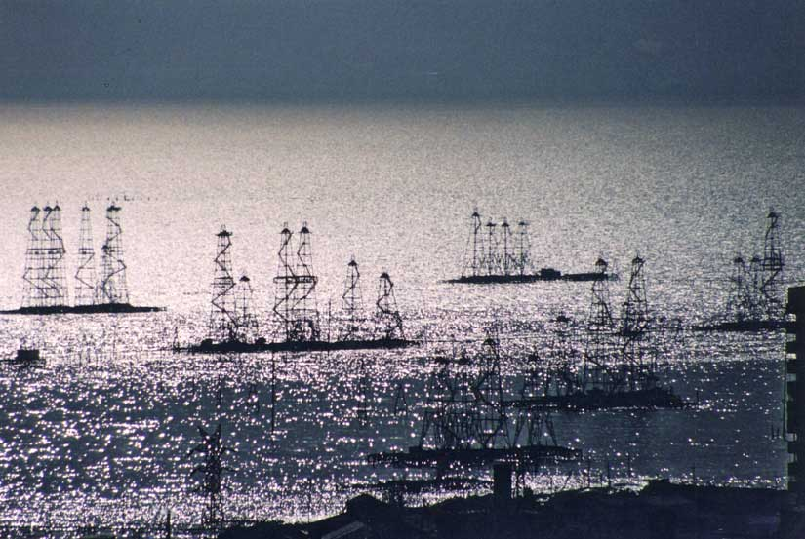
Oil fields off Baku were first developed in the late 19th century by land reclamation.
Photo by Farid Khayrulin

  - Supporting data:
The region’s experience of oil and gas activities is not good: widespread pollution and inattention to the environment and human health predominated in the closing era of the Soviet Union as investment in the industry came to a virtual halt. Stakeholders recall this era, and associate oil and gas activities with pollution and human health risk. With the Caspian Sea being heralded as the third largest oil and gas find in human history, Stakeholders’ concerns are clear. If the projections of some 50 to 200 billion barrels of oil reserves in the Caspian prove true, the risks to the environment from oil and gas activities will increase, and must be managed properly.

The supporting data for oil pollution arising from historical practices comes from satellite imagery of oil on the sea surface, routine monitoring of the sea by Hydromet and industry, from contaminants in biota, and from contaminant levels in sediments. These historical data commonly show high levels of hydrocarbons, particularly phenols, in the water column. More recent water column data taken using modern methods cannot verify these earlier values, and in general the water quality has internationally acceptable levels of most hydrocarbons in most parts of the Caspian Sea. Certain hot spots occur, such as near leaking capped oil wells; areas where water level rise has encroached on well oiled soils; Baku Bay, where major spills have occurred over a century; Cheleken, in Turkmenistan where nearshore activities date back more than 100 years; Makhachkala, where oil transport and storage takes place; and other locations. However, away from hot spots the Caspian Sea appears to have relatively low levels of hydrocarbons. Periodic oil slicks are seen on the surface of the sea. Sources of these slicks may be oil extraction, flooding of oiled soils, release from capped wells, or natural seepage. In general, data coverage and quality for this issue (including water column concentrations, effects on biota and habitats) are inadequate to quantify the degree of risk or degree of existing damage.

Potential sources of contamination include not only oil and gas extraction, but also transport, refining, downstream industries, and accidental releases. Flooding of former oil wells by rising water levels has been another documented source of contamination, and one that may get worse in the future. In particular, flooded wells in Azerbaijan, Kazakhstan, and Turkmenistan are known to have released hydrocarbon to the environment (See Figure 2.10-2).

Figure 2.10-2 Danger of leaks

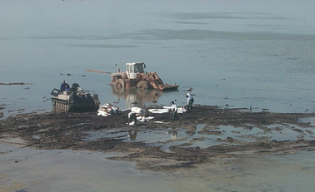
Leaks from a well at Tazhigali, oil fields, Kazakhstan

The Pollution Control CRTC performed a study on oil contamination of the Caspian Sea (CRTC PC, 2000). This report concluded “there is no indication that the petroleum hydrocarbon pollution is the major contributing factor to the general impairment of the Caspian ecosystems. Clearly, there is oil pollution in the Caspian, coming from flooded wells, offshore production, accidental releases and discharges of oil, natural seeps, and from the major rivers (Table 2.10-1). However, direct measurement appears to show that oil and gas activities are not the major cause of ecosystem imbalance in the Caspian Sea that may result from oil to the sea. Oil industry activities are estimated to input less than half of natural seeps, and only 5% of annual oil inputs.

Table 2.10-1 Estimated Total Annual Oil Input to the Caspian Sea (CRTC PC, 2001)

Source | Oil input  ton/y | Oil input range  ton/y | Percentage
Seepage and erosion | 20,000 | 10,000 – 50,000 | 12.5
Oil industry activities | 8,000 | 5,000 – 13,000 | 5.0
Municipalities | 21,000 | 10,000 – 40,000 | 13.1
Other industry | 35,000 | 15,000 – 50,000 | 21.9
Rivers | 75,000 | 50,000 – 260,000 | 46.9
Atmosphere | 1,000 | 300 – 2,000 | 0.6
Total | 160,000 | 90,000 – 300,000 | 100.0

Of the oil industry activities contributing oil to the Caspian, the largest source appears to be flooded oil fields, followed by onshore production and by transportation. Offshore production, largely from the aging Azerbaijani production platforms, accounts for about 12.5% of the input. Refineries are responsible for about half of the offshore production input, according to estimates.

Table 2.10-2 Estimated Oil Input from Oil Industry Activities (CRTC PC, 2001)

Source | Oil input  ton/y | Oil input range  Ton/y | Percentage
Offshore production | 1,000 | 500 – 5,000 | 12.5
Onshore production | 2,000 | 500 – 5,000 | 25.0
Flooded fields | 2,500 | 300 – 3,000 | 31.2
Transportation | 2,000 | 1,000 – 4,000 | 25.0
Refineries | 500 | 250 – 1,000 | 6.3
Total | 8,000 | 5,000 – 13,000 | 100.0
Note: This table excludes oil contamination from catastrophic events (well blow-outs, tanker accidents, storage tank failures, and pipeline ruptures).

Despite these findings, some Stakeholders (see Stakeholder Analysis) feel this is the most important emerging problem in the Caspian region.

  - Causal chain analysis:
Causal chain analysis shows that historically, oil production has not taken into account environmental costs associated with pollution from spills and leaks. There has been inadequate public awareness and participation, a lack of consideration of social costs of hydrocarbon pollution (human health, loss of aesthetic quality), and a lack of modern technology. Many of these root causes are being addressed in the newer Production Sharing Agreements, partially as a response to increased stakeholder involvement.

  - Sectors and stakeholders:
The scientific community and fishermen considered damage from offshore oil and gas activities to be a high priority. Interestingly, NGOs and coastal zone residents did not consider this issue as high a priority as other environmental issues. Primary interested governmental parties include energy ministries, environment ministries, and regional and municipal governments. Oil companies are viewed as primary stakeholders contributing to this issue. Primary affected Stakeholders include coastal zone residents, NGOs, fishermen, regional and municipal governments, and agriculture/fisheries ministries. The environment ministries were not perceived as major affected stakeholders.

The Stakeholder groups, in general, perceive this MPPI to be of medium to high priority.

  - Environmental impacts:
Potential environmental impacts of increased offshore oil and gas activity are broad in geographic and biological scope. Because the currents in the Caspian are large-scale and ignore geographic boundaries, a spill from one part of the Caspian Sea may be transported to other parts. For instance, modeling performed for the Early Oil Project in Azerbaijan showed that oil from an offshore spill had a chance of hitting any of the Caspian littoral country coasts, depending on the weather at the time. Large-scale mortalities of seals, fish, and other commercially important species could result from a large oil spill. Habitats could be damaged by exploration, construction, or extraction. Increased shipping traffic arising from oil and gas activities could disrupt migration patterns of birds or fish or seals. Decreased air quality could affect human health and possibly ecosystem health.

The environmental impacts can be separated into two categories. Impacts from historically poor oil and gas industry practices have, and still are, adversely affecting the environment. Impacts from recent oil and gas activities involving multi-national corporations may be less severe due the strict international standards being applied in most Production Sharing Agreements. Any improvement in environmental record of individual activities may be offset in part by the expected vast expansion of these activities in the next twenty years. Although the chronic impact may not be as intense, there is increased risk of a major spill, which must be addressed by emergency planning and preparedness.

  - Socio-economic impacts:
If governance were effective, trickle-down effects from oil and gas activities would have a beneficial effect on social and economic structures. New jobs would arise, more investment would take place, new industries would sprout, and new opportunities would exist for residents. However, if good governance is not practiced, the socio-economic impacts of oil and gas activities may be negative: imported labor instead of local labor, air and water pollution adversely affecting human health, and requisite infrastructure displacing traditional uses of land and resources. Initial results from the last five years in Azerbaijan, for instance, where heavy foreign investment has taken place, show not much relief from poverty has occurred.

g. Future trends:
Dissolution of the Soviet Union has led to adverse economic condition of the CIS, and industrial activities have declined rapidly, but in parallel the oil and gas exploration, extraction and transportation activities in the Caspian Sea have been growing significantly faster than the previous two decades. This growth has been fueled by the international oil industry.

According to U.S. Energy Information Administration forecasts, oil production will increase by 227% (excluding Iran), and gas by 64% (excluding Iran and Russia) in the Caspian Sea Region in the period 1990 to 2010, which would put the Caspian among the world's major energy-producing regions. Therefore oil pollution could be a problem, and in particular there is a risk of major, catastrophic oil spills. On-going cooperation among the littoral states, using the most up-to-date technology and observing environmental standards might actually lead to a better environment in the future.

"Perceived" is used to include issues which may not have been identified or proved to be major problems as yet due to data gaps or lack of analysis or which are expected to lead to major problems in the future under prevailing conditions.
With Kara Bogaz Gol

